The terminal driver accepts seven messages types:
- Read from the terminal (from FS on behalt of a user process).
- Write to the terminal (from FS on behalt of a user process).
- Set terminal parameters for IOCTL (from FS on behalt of a user process).
4. I/O occurred during last clock tick (from the clock interrupt).
5. Cancel previous request (from the file system when a signal occurs).
6. Open a device.
7. Close a device.
The messages for reading and writing have the same format as shown in Fig. 3-15, except that no POSITION field is needed. With a disk, the program has to specify which block it wants to read. With a terminal, there is no choice: the program always gets the next character typed in. Terminals do not support seeks.
The POSIX functions tcgetattr and tcgetattr, used to examine and modify terminal attributes (properties), are supported by the ioctl system call. Good programming practice is to use these functions and others in include/termios.h and leave it to the C library to convert library calls to IOCTL system calls. There are, however, some control operations needed by MINIX that are not provided for in POSIX, for example, loading an alternate keymap, and for these the programmer must use IOCTL explicitly.
The message sent to the driver by an IOCTL system call contains a function request code and a pointer. For the tcsetattr function, an IOCTL call is made with a TCSETS, TCSETSW, or TCSETSF request type, and a pointer to a termios structure like the one shown in Fig. 3-34. All such calls replace the current set of attributes with a new set, the differences being that a TCSETS request takes effect immediately, a TCSETSW request does not take effect until all output has been transmitted, and a TCSETSF waits for output to finish and discards all input that has not yet been read. Tcgetattr is translated into an IOCTL call with a TCGETS request type and returns a filled in termios structure to the caller, so the current state of a device can be examined. IOCTL calls that do not correspond to functions defined by POSIX, like the KIOCSMAP request used to load a new keymap, pass pointers to other kinds of structures, in this case to a keymap_t which is a 1536-byte structure (16-bit codes for 128 keys x 6 modifiers). Figure 3-43 summarizes how standard POSIX calls are converted into IOCTL system calls.
The terminal driver uses one main data structure, tty_table, which is an array of tty structures, one per terminal. A standard PC has only one keyboard and display, but MINIX can support up to eight virtual terminals, depending upon the amount of memory on the display adapter card. This permits the person at the console to log on multiple times, switching the display output and keyboard input from one "user" to another. With two virtual consoles, pressing ALT-F2 selects the second one and ALT-F1 returns to the first. ALT plus the arrow keys also can be used. In addition, serial lines can support two users at remote locations, connected by RS-232 cable or modem, and pseudo terminals can support users connected through a network. The driver has been written to make it easy to add additional terminals. The standard configuration illustrated in the source code in this text has two virtual consoles, with serial lines and pseudo terminals disabled.
Each tty structure in tty_table keeps track of both input and output. For input, it holds a queue of all characters that have been typed but not yet read by the program, information about requests to read characters that have not yet been received, and timeout information, so input can be requested without the task blocking permanently if no character is typed. For output, it holds the parameters of write requests that are not yet finished. Other fields hold various general variables, such as the termios structure discussed above, which affects many properties of both input and output. There is also a field in the tty structure to point to information which is needed for a particular class of devices but is not needed in the tty_table entry for every device. For instance, the hardware-dependent part of the console driver needs the current position on the screen and in the video RAM, and the current attribute byte for the display, but this information is not needed to support an RS-232 line. The private data structures for each device type are also where the buffers that receive input from the interrupt service routines are located. Slow devices, such as the keyboard, do not need buffers as large as those needed by fast devices.
Terminal Input
To better understand how the driver works, let us first look at how characters typed in on the terminal work their way through the system to the program that wants them.
When a user logs in on the system console, a shell is created for him with /dev/console as standard input, standard output, and standard error. The shell starts up and tries to read from standard input by calling the library procedure read. This procedure sends a message that contains the file descriptor, buffer address, and count to the file system. This message is shown as (1) in Fig. 3-37. After sending the message, the shell blocks, waiting for the reply. (User processes execute only the SEND_REC primitive, which combines a SEND with a RECEIVE from the process sent to.)
The file system gets the message and locates the i-node corresponding to the specified file descriptor. This i-node is for the character special file /dev/console and contains the major and minor device numbers for the terminal. The major device type for terminals is 4; for the console the minor device number is 0.
The file system indexes into its device map, dmap, to find the number of the terminal task. Then it sends a message to the terminal task, shown as (2) in Fig. 3-37. Normally, the user will not have typed anything yet, so the terminal driver will be unable to satisfy the request. It sends a reply back immediately to unblock the file system and report that no characters are available, shown as (3). The file system records the fact that a process is waiting for terminal input in the console's structure in tty_table and then goes off to get the next request for work. The user's shell remains blocked until the requested characters arrive, of course.
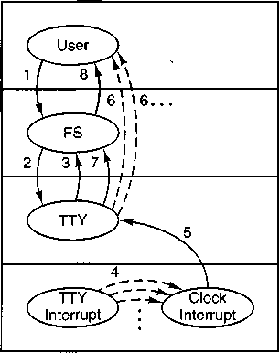
Figure 3-37. Read request from terminal when no characters are pending. FS is the file system. TTY is the terminal task. The interrupt handler for the terminal queues characters as they are entered, but it is the clock interrupt handler that awakens TTY.
When a character is finally typed on the keyboard, it causes two interrupts, one when the key is depressed and one when it is released. This rule also applies to modifier keys such as CTRL and SHIFT, which do not transmit any data by themselves but still cause two interrupts per key. The keyboard interrupt is IRQ 1, and -hwintOl in the assembly code file mpx386.s activates kbd-hw_-int (line 13123), which in turn calls scan'-keyboard (line 13432) to extract the key code from the keyboard hardware. If the code is for an ordinary character, it is put into the keyboard input queue, ibuf, if the interrupt was generated by a key being depressed, but it is ignored if the interrupt was generated by the release of a key. Codes for modifier keys like CTRL and SHIFT are put into the queue for both types of interrupt but can be distinguished later by a bit that is set only when a key is released. Note that at this point the codes received and stored in ibuf are not ASCII codes; they are simply the scan codes produced by the IBM keyboard. Kbd—hw-int then sets a flag, tty-events (part of the keyboard's section of the tty_table), calls force _timeout, and returns.
Unlike some other interrupt service routines, kbd_hw_int does not send a message to wake up the terminal task. The call to force-timeout is indicated by the dashed lines marked (4) in the figure. These are not messages. They set the tty -timeout variable in the address space common to the interrupt service routines. On the next clock interrupt clock-handler finds that tty-timeout indicates it is time for a call to tty-wakeup (line 11452) which then sends a message (5) to the terminal task. Note that although the source code for tty-wakeup is in the file
tty.c, it runs in response to the clock interrupt, and thus we say the clock interrupt sends the message to the terminal task. If input is arriving rapidly, a number of character codes may be queued this way, which is why multiple calls to force-timeout (4) are shown in the figure.
Upon receiving the wakeup message the terminal task inspects the tty—events flag for each terminal device, and, for each device which has the flag set, calls handle_events (line 12256). The tty_events flag can signal various kinds of activity (although input is the most likely), so handle-events always calls the device-specific functions for both input and output. For input from the keyboard this results in a call to kb^read (line 13165), which keeps track of keyboard codes that indicate pressing or releasing of the CTRL, SHIFT, and ALT keys and converts keyboard codes into ASCII codes. Kb_read in turn calls in_process (line 12367), which processes the ASCII codes, taking into account special characters and different flags that may be set, including whether or not canonical mode is in effect. The effect is normally to add characters to the console's input queue in tt\-table. although some codes, for instance BACKSPACE, have other effects. Normally. also, In-process initiates echoing of the ASCII codes to the display.
When enough characters have come in, the terminal task calls the assembly language procedure phys_copy to copy the data to the address requested by the shell. This operation also is not message passing and for that reason is shown by dashed lines (6) in Fig. 3-37. There is more than one such line shown because there may be more than one such operation before the user's request has been completely fulfilled. When the operation is finally complete, the terminal driver sends a message to the file system telling it that the work has been done (7), and the file system reacts to this message by sending a message back to the shell to unblock it (8).
The definition of when enough characters have come in depends upon the terminal mode. In canonical mode a request is complete when a linefeed, end-of-line, or end-of-file code is received, and, in order for proper input processing to be done, a line of input cannot exceed the size of the input queue. In noncanonical mode a read can request a much larger number of characters, and in_process may have to transfer characters more than once before a message is returned to the file system to indicate the operation is complete.
Note that the terminal driver copies the actual characters directly from its own address space to that of the shell. It does not first go through the file system. With block I/O, data do pass through the file system to allow it to maintain a buffer cache of the most recently used blocks. If a requested block happens to be in the cache, the request can be satisfied directly by the file system, without doing any disk I/O.
For terminal I/O, a cache makes no sense. Furthermore, a request from the file system to a disk driver can always be satisfied in at most a few hundred milliseconds, so there is no real harm in having the file system just wait. Terminal I/O may take hours to complete, or may never be complete (in canonical mode the
terminal task waits for a complete line, and it may also wait a long time in non-canonical mode, depending upon the settings of MIN and TIME). Thus, it is unacceptable to have the file system block until a terminal input request is satisfied.
Later on, it may happen that the user has- typed ahead, and that characters are available before they have been requested, from previous occurrences of events 4 and 5. In that case, events 1, 2, 6, 7, and 8 all happen in quick succession after the read request; 3 does not occur at all.
If the terminal task happens to be running at the time of a clock interrupt, no message can be sent to it because it will not be waiting for one. However, in order to keep input and output flowing smoothly when the terminal task is busy, the tty_events flags for all terminal devices are inspected at several other times, for instance, immediately after processing and replying to a message. Thus, it is possible for characters to be added to the console queue without the aid of a wakeup message from the clock. If two or more clock interrupts occur before the terminal driver finishes what it is doing, all the characters are stored in ibuf, and tty-flags is repeatedly set. Ultimately, the terminal task gets one message; the rest are lost. But since all the characters are safely stored in the buffer, no typed input is lost. It is even possible that by the time a message is received by the terminal task the input is complete and a reply has already been sent to the user process.
The problem of what to do in an unbuffered message system (rendezvous principle) when an interrupt routine wants to send a message to a process that is busy is inherent in this kind of design. For most devices, such as disks, interrupts occur only in response to commands issued by the driver, so only one interrupt can be pending at any instant. The only devices that generate interrupts on their own are the clock and terminals (and when enabled, the network). The clock is handled by counting pending ticks, so if the clock task does not receive a message from the clock interrupt, it can compensate later. Terminals are handled by having the interrupt routine accumulate the characters in a buffer and raising a flag to indicate characters have been received. If the terminal task is running, it checks all of these flags before it goes to sleep and postpones going to sleep if there is more work it can do.
The terminal task is not awakened directly by terminal interrupts due to the excessive overhead doing so would entail. The clock sends an interrupt to the terminal task on the next tick following each terminal interrupt. At 100 words per minute a typist enters fewer than 10 characters per second. Even with a fast typist the terminal task will probably be sent an interrupt message for each character typed at the keyboard, although some of these messages may be lost. If the buffer should fill before being emptied, excess characters are discarded, but experience shows that, for the keyboard, a 32-character buffer is adequate. In the case of other input devices higher data rates are probable—rates 1000 or more times faster than those of a typist are possible from a serial port connected to a 28,800-bps modem. At that speed approximately 48 characters may be received between clock ticks by the modem, but to allow for data compression on the modem link
the serial port connected to the modem must be able to handle at least twice as many. For serial lines, MINIX provides a buffer of 1024 characters.
We have some regrets that the terminal task cannot be implemented without some compromise of our general design principles, but the method we use does the job without too much additional software complexity and no loss in performance. The obvious alternative, to throw away the rendezvous principle and have the system buffer all messages sent to destinations not waiting for them, is much more complicated and also slower.
Real system designers are often faced with a trade-off between using the general case, which is elegant all the time but somewhat slow, and using simpler techniques, which are usually fast but in one or two cases require a trick to make them work properly. Experience is really the only guide to which approach is better under given circumstances. A considerable amount of experience on designing operating systems is summarized by Lampson (1984) and Brooks (1975). While old, these references are still classics.
We will complete our overview of terminal input by summarizing the events that occur when the terminal task is first activated by a read request and when it is reactivated after receipt of keyboard input (see Fig. 3-38). In the first case, when a message comes in to the terminal task requesting characters from the keyboard, the main procedure, tty-task (line 11817) calls do_read (line 11891) to handle the request. Do_read stores the parameters of the call in the keyboard's entry in tty-table, in case there are insufficient characters buffered to satisfy the request.
Then it calls in-transfer (line 12303) to get any input already waiting, and then handle-events (line 12256) which in turn calls kb_read (line 13165) and then in_transfer once again, in order to try to milk the input stream for a few more characters. Kb_read calls several other procedures not shown in Fig. 3-38 to accomplish its work. The result is that whatever is immediately available is copied to the user. If nothing is available, nothing is copied. If the read is completed by in—transfer or by handle-events, a message is sent to the file system when all characters have been transferred, so the file system can unblock the caller. If the read was not completed (no characters, or not enough characters) do^read reports back to the file system, telling it whether it should suspend the original caller, or, if a nonblocking read was requested, cancel the read.
The right side of Fig. 3-38 summarizes the events that occur when the terminal task is awakened subsequent to an interrupt from the keyboard. When a character is typed, the interrupt procedure kb_hw_int (line 13123) puts the character code received into the keyboard buffer, sets a flag to identify that the console device has experienced an event, and then arranges for a timeout to occur on the next clock tick. The clock task sends a message to the terminal task telling it something has happened. Upon receiving this message, tty-task checks the event flags of all terminal devices and calls handle^event for each device with a raised flag. In the case of the keyboard, handle_event calls kb_read and in-transfer, just as was done on receipt of the original read request. The events shown on the
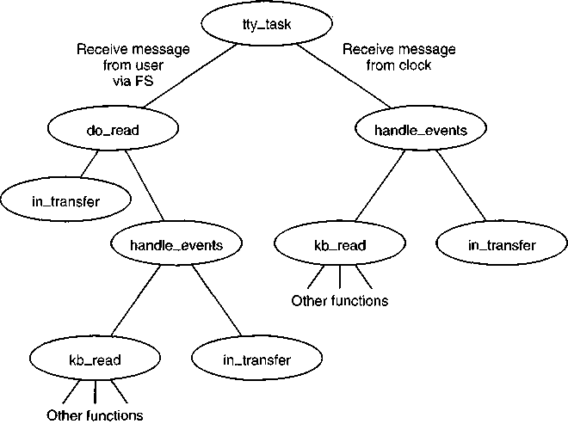
Figure 3-38. Input handling in the terminal driver. The left branch of the tree is taken to process a request to read characters. The right branch is taken when a character-has-been-typed message is sent to the driver.
right side of the figure may occur several times, until enough characters are received to fulfill the request accepted by do__read after the first message from the FS. If the FS tries to initiate a request for more characters from the same device before the first request is complete, an error is returned. Of course, each device is independent; a read request on behalf of a user at a remote terminal is processed separately from one for a user at the console.
The functions not shown in Fig. 3-38 that are called by kb_read include map_key, which converts the key codes (scan codes) generated by the hardware into ASCII codes, make_break, which keeps track of the state of modifier keys such as the SHIFT key, and in_process, which handles complications such as attempts by the user to backspace over input entered by mistake, other special characters, and options available in different input modes. In_process also calls echo (line 12531), so the typed characters will be displayed on the screen.
Terminal Output
In general, console output is simpler than terminal input, because the operating system is in control and does not need to be concerned with requests for output arriving at inconvenient times. Also, because the MINIX console is a memory-
mapped display, output to the console is particularly simple. No interrupts are needed; the basic operation is to copy data from one memory region to another. On the other hand, all the details of managing the display, including handling escape sequences, must be handled by the driver software. As we did with keyboard input in the previous section we will trace through the steps involved in sending characters to the console display. We will assume in this example that the active display is being written; minor complications caused by virtual consoles will be discussed later.
When a process wants to print something, it generally calls print/. Printfcalh WRITE to send a message to the file system. The message contains a pointer to the characters to be printed (not the characters themselves). The file system then sends a message to the terminal driver, which fetches them and copies them to the video RAM. Figure 3-39 shows the main procedures involved in output.
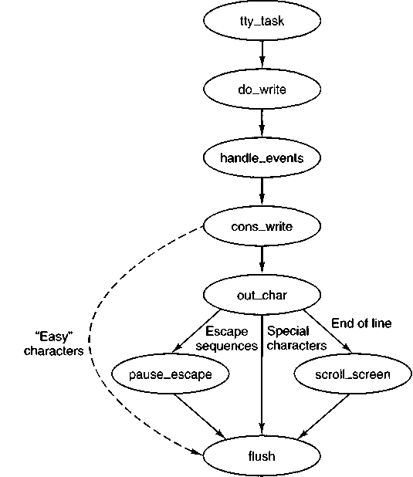
Figure 3-39. Major procedures used on terminal output. The dashed line indicates characters copied directly to ramqueue by cons^write.
When a message comes in to the terminal task requesting it to write on the screen, do^write (line 11964) is called to store the parameters in the console's /tv
struct in the tty_table. Then handle-events (the same function called whenever the tty. events flag is found set) is called. On every call this function calls both the input and output routines for the device selected in its argument. In the case of the console display this means that any keyboard input that is waiting is processed first. If there is input waiting, characters to be echoed are added to whatever characters are already awaiting output. Then a call is made to cons_write (line 13729), the output procedure for memory-mapped displays. This procedure uses phys_copy to copy blocks of characters from the user process to a local buffer, possibly repeating this and the following steps a number of times, since the local buffer holds only 64 bytes. When the local buffer is full, each 8-bit byte is transferred to another buffer, ramqueue. This is an array of 16-bit words. Alternate bytes are filled in with the current value of the screen attribute byte, which determines foreground and background colors and other attributes. When possible, characters are transferred directly into ramqueue, but certain characters, such as control characters or characters that are parts of escape sequences, need special handling. Special handling is also required when a character's screen position would exceed the width of the screen, or when ramqueue becomes full. In these cases out_char (line 13809) is called to transfer the characters and take whatever additional action is called for. For instance, scroll_screen (line 13896) is called when a linefeed is received while addressing the last line of the screen, and parse-escape handles characters during an escape sequence. Usually out_char calls flush (line 13951) which copies the contents of ramqueue to the video display memory, using the assembly language routine mem^vid^copy. Flush is also called after the last character is transferred into ramqueue to be sure all output is displayed. The final result of flush is to command the 6845 video controller chip to display the cursor in the correct position.
Logically, the bytes fetched from the user process could be written into the video RAM one per loop iteration. However, accumulating the characters in ramqueue and then copying the block with a call to mem_vid_copy are more efficient in the protected memory environment of Pentium-class processors. Interestingly, this technique was introduced in early versions of MINIX that ran on older processors without protected memory. The precursor of mem_vid_copy dealt with a timing problem—with older video displays the copy into the video memory had to be done when the screen was blanked during vertical retrace of the CRT beam to avoid generating visual garbage all over the screen. minix no longer provides this support for obsolete equipment as the performance penalty is too great. However, the modern version of MINIX benefits in other ways from copying ramqueue as a block.
The video RAM available to a console is delimited in the console structure by the fields c_start and c_limit. The current cursor position is stored in the c_column and c^row fields. The coordinate (0. 0) is in the upper left corner of the screen, which is where the hardware starts to fill the screen. Each video scan begins at the address given by c_org and continues for 80 x 25 characters (4000
bytes). In other words, the 6845 chip pulls the word at offset c^org from the video RAM and displays the character byte in the upper left-hand corner, using the attribute byte to control color, blinking, and so forth. Then it fetches the next word and displays the character at (1, 0). This process continues until it gets to (79, 0), at which time it begins the second line on the screen, at coordinate (0, 1).
When the computer is first started, the screen is cleared, output is written into the video RAM starting at location c_start, and c_org is assigned the same value as c_start. Thus the first line appears on the top line of the screen. When output must go to a new line, either because the first line is full or because a newline character is detected by out_char, output is written into the location given by c-Start plus 80. Eventually all 25 lines are filled, and scrolling of the screen is required. Some programs, editors, for example, require scrolling in the downward direction too, when the cursor is on the top line and further movement upward within the text, is required.
There are two ways scrolling the screen can be managed. Tn software scrolling the character to be displayed at position (0, 0) is always in the first location in video memory, word 0 relative to the position pointed to by c-start, and the video controller chip is commanded to display this location first by keeping the same address in c_org. When the screen is to be scrolled, the contents of relative location 80 in the video RAM, the beginning of the second line on the screen, is copied to relative location 0, word 81 is copied to relative location 1. and so on. The scan sequence is unchanged, putting the data at location 0 in the memory at screen position (0, 0) and the image on the screen appears to have moved up one line. The cost is that the CPU has moved 80x24= 1920 words. Tn hardware scrolling the data are not moved in the memory; instead the video controller chip is instructed to start the display at a different point, for instance, with the data at word 80. The bookkeeping is done by adding 80 to the contents of c_org, saving it for future reference, and writing this value into the correct register of the video controller chip. This requires either that the controller be smart enough to wrap around the video RAM, taking data from the beginning of the RAM (the address in c_start) when it reaches the end (the address in c__limit), or that the video RAM have more capacity than just the 80 x 2000 words necessary to store a single screen of display. Older display adapters generally have smaller memory but are able to wrap around and do hardware scrolling. Newer adapters generally have much more memory than needed to display a single screen of text, but the controllers are not able to wrap. Thus an adapter with 32768 bytes of display memory can hold 204 complete lines of 160 bytes each, and can do hardware scrolling 179 times before the inability to wrap becomes a problem. But, eventually a memory copy operation will be needed to move the data for the last 24 lines back to location 0 in the video memory. Whichever method is used, a row of blanks is copied to the video RAM to ensure that the new line at the bottom of the screen is empty.
When virtual consoles are configured, the available memory within a video adapter is divided equally between the number of consoles desired by properh
initializing the c_start and c_limit fields for each console. This has an effect upon scrolling. On any adapter large enough to support virtual consoles, software scrolling takes place every so often, even though hardware scrolling is nominally in effect. The smaller the amount of memory available to each console display, the more frequently software scrolling must be used. The limit is reached when the maximum possible number of consoles is configured. Then every scroll operation will be a software scroll operation.
The position of the cursor relative to the start of the video RAM can be derived from c_column and c_row, but it is faster to store it explicitly (in c_cur). When a character is to be printed, it is put into the video RAM at location c_cwr, which is then updated, as is c^column. Figure 3-40 summarizes the fields of the console structure that affect the current position and the display origin.
Field | Meaning
c_start | Start of video memory for this console
c_limit | Limit of video memory for this console
c_column | Current column (0-79) with 0 at left
c_row | Current row (0-24) with 0 at top
c_cur | Offset into video RAM for cursor
c_org | Location in RAM pointed to by 6845 base register
Figure 3-40. Fields of the console structure that relate to the current screen position.
The characters that affect the cursor position (e.g., linefeed, backspace) are handled by adjusting the values of c_column, c_row, and c_cur. This work is done at the end of flush by a call to set_6845 which sets the registers in the video controller chip.
The terminal driver supports escape sequences to allow screen editors and other interactive programs to update the screen in a flexible way. The sequences supported are a subset of an ANSI standard and should be adequate to allow many programs written for other hardware and other operating systems to be easily ported to MINIX. There are two categories of escape sequences: those that never contain a variable parameter, and those that may contain parameters. In the first category the only representative supported by MINIX is ESC M, which reverse indexes the screen, moving the cursor up one line and scrolling the screen downward if the cursor is already on the first line. The other category can have one or two numeric parameters. Sequences in this group all begin with ESC [. The "[" is the control sequence introducer. A table of escape sequences defined by the ANSI standard and recognized by MINIX was shown in Fig. 3-36.
Parsing escape sequences is not trivial. Valid escape sequences in MINIX can be as short as two characters, as in ESC M, or up to 8 characters long in the case
of a sequence that accepts two numeric parameters that each can have a two-digit values as in ESC [20;60H, which moves the cursor to line 20, column 60. In a sequence that accepts a parameter, the parameter may be omitted, and in a sequence that accepts two parameters either or both may be omitted. When a parameter is omitted or one that is outside the valid range is used, a default is substituted. The default is the lowest valid value.
Consider the following ways one could construct a sequence to move to the upper-left corner of the screen:
1. ESC [H is acceptable, because if no parameters are entered the lowest valid parameters are assumed.
2. ESC [1;1H will correctly send the cursor to row 1 and column 1 (with ANSI, the row and column numbers start at 1).
3. Both ESC [1;H and ESC [;1H have an omitted parameter, which defaults to 1 as in the first example.
4. ESC [0;OH will do the same, since each parameter is less than the minimum valid value the minimum is substituted.
These examples are presented not to suggest one should deliberately use invalid parameters but to show that the code that parses such sequences is nontrivial.
MINIX implements a finite state automaton to do this parsing. The variable c_esc_state in the console structure normally has a value of 0. When out_char detects an ESC character, it changes c_esc_state to 1, and subsequent characters are processed by parse_escape (line 13986). If the next character is the control sequence introducer, state 2 is entered; otherwise the sequence is considered complete, and do_escape (line 14045) is called. In state 2, as long as incoming characters are numeric, a parameter is calculated by multiplying the previous value of the parameter (initially 0) by 10 and adding the numeric value of the current character. The parameter values are kept in an array and when a semicolon is detected the processing shifts to the next cell in the array. (The array in MINIX has only two elements, but the principle is the same). When a nonnumeric character that is not a semicolon is encountered the sequence is considered complete, and again do^escape is called. The current character on entry to do_escape then is used to select exactly what action to take and how to interpret the parameters, either the defaults or those entered in the character stream. This is illustrated in Fig. 3-48.
Loadable Keymaps
The IBM PC keyboard does not generate ASCII codes directly. The keys are each identified with a number, starting with the keys that are located in the upper left of the original PC keyboard—1 for the "ESC" key, 2 for the "1", and so on. Each key is assigned a number, including modifier keys like the left SHIFT and
right SHIFT keys, numbers 42 and 54. When a key is pressed, MINIX receives the key number as a scan code. A scan code is also generated when a key is released, but the code generated upon release has the most significant bit set (equivalent to adding 128 to the key number). Thus a key-press and a key release can be distinguished. By keeping track of which modifier keys have been pressed and not yet released, a large number of combinations arc possible. For ordinary purposes, of course, two-finger combinations, such as SHIFT-A or CTRL-D, are most manageable for two-handed typists, but for special occasions three-key (or more) combinations are possible, for instance, CTRL-SHIFT-A, or the well-known CTRL-ALT-DEL combination that PC users recognize as the way to reset and reboot the system.
The complexity of the PC keyboard allows for a great deal of flexibility in how it used. A standard keyboard has 47 ordinary character keys defined (26 alphabetic, 10 numeric, and 11 punctuation). If we are willing to use three-fingered modifier key combinations, such as CTRL-ALT-SHIFT, we can support a character set of 376 (8 x 47) members. This is by no means the limit of what is possible, but for now let us assume we do not want to distinguish between the left-and right-hand modifier keys, or use any of the numeric keypad or function keys. Indeed, we are not limited to using just the CTRL, ALT, and SHIFT keys as modifiers; we could retire some keys from the set of ordinary keys and use them as modifiers if we desired to write a driver that supported such a system.
Operating systems that use such keyboards use a keymap to determine what character code to pass to a program based upon the key being pressed and the modifiers in effect. The MINIX keymap logically is an array of 128 rows, representing possible scan code values (this size was chosen to accommodate Japanese keyboards; U.S. and European keyboards do not have this many keys) and 6 columns. The columns represent no modifier, the SHIFT key, the Control key, the left ALT key, the right ALT key, and a combination of either ALT key plus the SHIFT key. There are thus 720 ((128 - 6) x 6) character codes that can be generated by this scheme, given an adequate keyboard. This requires that each entry in the table be a 16-bit quantity. For U.S. keyboards the ALT and ALT2 columns are identical. ALT2 is named ALTGR on keyboards for other languages, and many of these keymaps support keys with three symbols by using this key as a modifier.
A standard keymap (determined by the line
#include keymaps/us-std.src
in keyboard.c) is compiled into the MINIX kernel at compilation time, but an
ioctl(0, KIOCSMAP, keymap)
call can be used to load a different map into the kernel at address keymap. A full keymap occupies 1536 bytes (128x6x2). Extra keymaps are stored in compressed form. A program called genmap is used to make a new compressed
keymap. When compiled, genmap includes the keymap.src code for a particular keymap, so the map is compiled within genmap. Normally, genmap is executed immediately after being compiled, at which time it outputs the compressed version to a file, and then the genmap binary is deleted. The command loadkeys reads a compressed keymap, expands it internally, and then calls IOCTL to transfer the keymap into the kernel memory. MINIX can execute loadkeys automatically upon starting, and the program can also be invoked by the user at any time.
Scan code | Character | Regular | SHIFT | ALT1 | ALT2 | ALT+SHIFT | CTRL
00 | none | 0 | 0 | 0 | 0 | 0 | 0
01 | ESC | C(T) | C(T) | CA('[') | CA('[') | CA(T) | cm
02 | '1' | '1' | '!' | A(T) | A(T) | A(T) | C('A')
13 | '=' | '=' | '+' | A('=') | A('=') | A(V) | C('@')
16 | 'q' | L('q') | 'Q' | A('q') | A('q') | A('Q') | C('Q')
28 | CR/LF | C('M') | C('M') | CA('M') | CA('M') | CA('M') | C('J')
29 | CTRL | CTRL | CTRL | CTRL | CTRL | CTRL | CTRL
59 | F1 | F1 | SF1 | AF1 | AF1 | ASF1 | CF1
127 | ??? | 0 | 0 | 0 | 0 | 0 | 0
Figure 3-41. A few entries from a keymap source file.
The source code for a keymap defines a large initialized array, and in the interest of saving space a keymap file is not printed with the source code. Figure 3-41 shows in tabular form the contents of a few lines of src/kernel/keymaps/us-std.src which illustrate several aspects of keymaps. There is no key on the IBM-PC keyboard that generates a scan code of 0. The entry for code 1, the ESC key, shows that the value returned is unchanged when the SHIFT key or CTRL key are pressed, but that a different code is returned when an ALT key is pressed simultaneously with the ESC key. The values compiled into the various columns are determined by macros defined in include/minix/keymap.h:
#define C(c) ((c) & 0x1 F) /* Map to control code */
#define A(c) ((c) I 0x80) /* Set eight bit (ALT) */
#define CA(c) A(C(c)) /* CTRL-ALT */
#define L(c) ((c) I HASCAPS) /* Add "Caps Lock has effect" attribute */
The first three of these macros manipulate bits in the code for the quoted character to produce the necessary code to be returned to the application. The last one sets the HASCAPS bit in the high byte of the 16-bit value. This is a flag that indicates that the state of the capslock variable has to be checked and the code possibly modified before being returned. In the figure, the entries for scan codes 2, 13. and
16 show how typical numeric, punctuation, and alphabetic keys are handled. For code 28 a special feature is seen—normally the ENTER key produces a CR (OxOD) code, represented here as C('M'). Because the newline character in UNIX files is the LF (OxOA) code, and it is sometimes necessary to enter this directly, this keyboard map provides for a CTRL-ENTER combination, which produces this code, C('J').
Scan code 29 is one of the modifier codes and must be recognized no matter what other key is pressed, so the CTRL value is returned regardless of any other key that may be pressed. The function keys do not return ordinary ASCII values, and the row for scan code 59 shows symbolically the values (defined in include/minix/keymap.h) that are returned for the Fl key in combination with other modifiers. These values are Fl: 0x0110, SF1: 0x1010, API: 0x0810, ASF1: OxOCIO, and CF1: 0x0210. The last entry shown in the figure, for scan code 127, is typical of many entries near the end of the array. For many keyboards, certainly most of those used in Europe and the Americas, there are not enough keys to generate all the possible codes, and these entries in the table are filled with zeroes.
Loadable Fonts
Early PCs had the patterns for generating characters on a video screen stored only in ROM, but the displays used on modern systems provide RAM on the video display adapters into which custom character generator patterns can be loaded. This is supported by MINIX with a
ioctl(0, TIOCSFON, font)
IOCTL operation. MINIX supports an 80 lines x 25 rows video mode, and font files contain 4096 bytes. Each byte represents a line of 8 pixels that are illuminated if the bit value is 1, and 16 such lines are needed to map each character. However the video display adapter uses 32 bytes to map each character, to provide higher resolution in modes not currently supported by MINIX. The loadfont command is provided to convert these files into the 8192-byte/o«? structure referenced by the IOCTL call and to use that call to load the font. As with the keymaps, a font can be loaded at startup time, or at any time during normal operation. However, every video adapter has a standard font built into its ROM that is available by default. There is no need to compile a font into MINIX itself, and the only font support necessary in the kernel is the code to carry out the TIOCSFON IOCTL operation.
3.9.4 Implementation of the Device-Independent Terminal Driver
In this section we will begin to look at the source code of the terminal driver in detail. We saw when we studied the block devices that multiple tasks supporting several different devices could share a common base of software. The case with the terminal devices is similar, but with the difference that there is one
terminal task that supports several different kinds of terminal device. Here we will start with the device-independent code. In later sections we will look at the device-dependent code for the keyboard and the memory-mapped console display.
Terminal Task Data Structures
The file tty.h contains definitions used by the C files which implement the terminal drivers. Most of the variables declared in this file are identified by the prefix tiy_. There is also one such variable declared in glo.h as EXTERN. This is tty-timeout, which is used by both the clock and terminal interrupt handlers.
Within tty.h, the definitions of the O-NOCTTY and O_NONBLOCK flags (which are optional arguments to the OPEN call) are duplicates of definitions in include/fcntl.h but they are repeated here so as not to require including another file. The devfun_t and devfunarg_t types (lines 11611 and 11612) are used to define pointers to functions, in order to provide for indirect calls using a mechanism similar to what we saw in the code for the main loop of the disk drivers.
The most important definition in tty.h is the tty structure (lines 11614 to 11668). There is one such structure for each terminal device (the console display and keyboard together count as a single terminal). The first variable in the restructure, tty_events, is the flag that is set when an interrupt causes a change that requires the terminal task to attend to the device. When this flag is raised, the global variable tty-timeout is also manipulated to tell the clock interrupt handler to awaken the terminal task on the next clock tick.
The rest of the tty structure is organized to group together variables that deal with input, output, status, and information about incomplete operations. In the input section, tty-inhead and tty-intail define the queue where received characters are buffered. Tty_incount counts the number of characters in this queue, and tty-eotct counts lines or characters, as explained below. All device-specific calls are done indirectly, with the exception of the routines that initialize the terminals, which are called to set up the pointers used for the indirect calls. The tty_devread and tty-icancel fields hold pointers to device-specific code to perform the read and input cancel operations. Tty_min is used in comparisons with tty_eotct. When the latter becomes equal to the former, a read operation is complete. During canonical input, tty^min is set to 1 and tty_eotct counts lines entered. During noncanonical input, tty-eotct counts characters and tty^min is set from the MIN field of the termios structure. The comparison of the two variables thus tells when a line is ready or when the minimum character count is reached, depending upon the mode.
7Yy_time holds the timer value that determines when the terminal task should be awakened by the clock interrupt handler, and tty-timenext is a pointer used to chain the active tty-time fields together in a linked list. The list is sorted whenever a timer is set, so the clock interrupt handler only has to look at the first entry. MINIX can support many remote terminals, of which only a few may have timer--
set at any time. The list of active timers makes the job of the clock handler easier than it would be if it had to check each entry in tty-table.
Since queueing of output is handled by the device-specific code, the output section of tty declares no variables and consists entirely of pointers to device-specific functions that write, echo, send a break signal, and cancel output. In the status section the flags tty-reprint, tty_escaped, and tty-inhibited indicate that the last character seen has a special meaning; for instance, when a CTRL-V (LNEXT) character is seen, tty_escaped is set to 1 to indicate that any special meaning of the next character is to be ignored.
The next part of the structure holds data about DEV-READ, DEV_WRITE, and DEV_IOCTL operations in progress. There are two processes involved in each of these operations. The server managing the system call (normally FS) is identified in tty-incaller (line 11644). The server calls the tty task on behalf of another process that needs to do an I/O operation, and this client is identified in tty_inproc (line 11645). As described in Fig. 3-37, during a READ, characters are transferred directly from the terminal task to a buffer within the memory space of the original caller. Tty_inproc and zty_m_vz> locate this buffer. The next two variables, tty_inleft and tty-incum, count the characters still needed and those already transferred. Similar sets of variables are needed for a WRITE system call. For IOCTL there may be an immediate transfer of data between the requesting process and the task, so a virtual address is needed, but there is no need for variables to mark the progress of an operation. An IOCTL request may be postponed, for instance, until current output is complete, but when the time is right the request is carried out in a single operation. Finally, the tty structure includes some variables that fall into no other category, including pointers to the functions to handle the DEV-IOCTL and DEV-CLOSE operations at the device level, a POSIX-style termios structure, and a winsize structure that provides support for window-oriented screen displays. The last part of the structure provides storage for the input queue itself in the array tty_inbuf. Note that this is an array of u!6-t, not of 8-bit char characters. Although applications and devices use 8-bit codes for characters, the C language requires the input function getchar to work with a larger data type so it can return a symbolic EOF value in addition to all 256 possible byte values.
The tty^table, an array of tty structures, is declared using the EXTERN macro (line 11670). There is one element for each terminal enabled by the NR_CONS, NR^RS^LINES, and NR-PTYS definitions in include/minix/config.h. For the configuration discussed in this book, two consoles are enabled, but MINix may be recompiled to add up to 2 serial lines, and up to 64 pseudo terminals.
There is one other EXTERN definition in tty.h. Tty ^timelist (line 11690) is a pointer used by the timer to hold the head of the linked list of tty-.time fields. The tty.h header file is included in many files and storage for tty-table and tty-timelist is allocated during compilation of table.c, in the same way as the EXTERN variables that are defined in the glo. h header file.
At the end of tty.h two macros, buflen and bufend, are defined. These are used frequently in the terminal task code, which does much copying of data into and out of buffers.
The Device-Independent Terminal Driver
The main terminal task and the device-independent supporting functions are all in tty.c. Since the task supports many different devices, the minor device numbers must be used to distinguish which device is being supported on a particular call, and they are defined on lines 11760 to 11764. Following this there are a number of macro definitions. If a device is not initialized, the pointers to that device's device-specific functions will contain zeroes put there by the C compiler. This makes it possible to define the tty-active macro (line 11774) which returns FALSE if a null pointer is found. Of course, the initialization code for a device cannot be accessed indirectly if part of its job is to initialize the pointers that make indirect access possible. On lines 11777 to 11783 are conditional macro definitions to equate initialization calls for RS-232 or pseudo terminal devices to calls to a null function when these devices are not configured. Do-pty may be similarly disabled in this section. This makes it possible to omit the code for these devices entirely if it is not needed.
Since there are so many configurable parameters for each terminal, and there may be quite a few terminals on a networked system, a termios-defaults structure is declared and initialized with default values (all of which are defined in include/termios.h) on lines 11803 to 11810. This structure is copied into the tty-table entry for a terminal whenever it is necessary to initialize or reinitialize it. The defaults for the special characters were shown in Fig. 3-33. Figure 3-42 shows the default values for the various flags. On the following line the winsize-defaults structure is similarly declared. It is left to be initialized to all zeroes by the C compiler. This is the proper default action; it means "window size is unknown, use /etc/termcap."
Field | Default values
c_iflag | BRKINT ICRNL IXON IXANY
c_oflag | OPOST ONLCR
c_cflag | CREAD CS8 HUPCL
cJflag | ISIG IEXTEN ICANON ECHO ECHOE
Figure 3-42. Default termios flag values.
The entry point for the terminal task is tty—task (line 11817). Before entering the main loop, a call is made to tty-init for each configured terminal (in the loop on line 11826), and then the MINIX startup message is displayed (lines 11829 to
11831). Although the source code shows a call to print/, when this code is compiled the macro that converts calls to the print/ library routine into calls to printk is in effect. Printk uses a routine called putk within the console driver, so the FS is not involved. This message goes only to the.primary console display and cannot be redirected.
The main loop on lines 11833 to 11884 is, in principle, like the main loop of any task—it receives a message, executes a switch on the message type to call the appropriate function, and then generates a return message. However, there are some complications. First, much work is done by low-level interrupt routines, especially in handling terminal input. In the previous section we saw that individual characters from the keyboard are accepted and buffered without sending a message to the terminal task for each character. Thus, before attempting to receive a message, the main loop always sweeps through the entire tty-table, inspecting each terminal's tp->tty__events flag and calling handle-events as necessary (lines 11835 to 11837), to take care of unfinished business. Only when there is nothing demanding immediate attention is a call made to receive. If the message received is from the hardware a continue statement short-circuits the loop, and the check for events is repeated.
Second, this task services several devices. If a received message is from a hardware interrupt, the device or devices that need service are identified by checking the tp->tty-events flags. If the interrupt is not a hardware interrupt the TTY_LINE field in the message is used to determine which device should respond to the message. The minor device number is decoded by a series of comparisons, by means of which tp is pointed to the correct entry in the tty-table (lines 11845 to 11864). If the device is a pseudo terminal, do_pty (in pty.c) is called and the main loop is restarted. In this case do_pty generates the reply message. Of course, if pseudo terminals are not enabled, the call to do^pty uses the dummy macro defined earlier. One would hope that attempts to access nonexistent devices would not occur, but it is always easier to add another check than to verify that there are no errors elsewhere in the system. In case the device does not exist or is not configured, a reply message with an ENXIO error message is generated and, again, control returns to the top of the loop.
The rest of the task resembles what we have seen in the main loop of other tasks, a switch on the message type (lines 11874 to 11883). The appropriate function for the type of request, do-read, do-write, and so on, is called. In each case the called function generates the reply message, rather than pass the information needed to construct the message back to the main loop. A reply message is generated at the end of the main loop only if a valid message type was not received, in which case an EINVAL error message is sent. Because reply messages are sent from many different places within the terminal task a common routine, tty-reply, is called to handle the details of constructing reply messages.
If the message received by tty-task is a valid message type, not the result of an interrupt, and does not come from a pseudo terminal, the switch at the end of
the main loop will dispatch to one of the functions do_read, do^write, do_ioctl, do_open, do_close, or do_cancel. The arguments to each of these calls are tp, a pointer to a tty structure, and the address of the message. Before looking at each of them, we will mention a few general considerations. Since tty_task may service multiple terminal devices, these functions must return quickly so the main loop can continue. However, do_read, do^write, and do_ioctl may not be able to complete immediately all the requested work. In order to allow FS to service other calls, an immediate reply is required. If the request cannot be completed immediately, the SUSPEND code is returned in the status field of the reply message. This corresponds to the message marked (3) in Fig. 3-37 and suspends the process that initiated the call, while unblocking the FS. Messages corresponding to (7) and (8) in the figure will be sent later when the operation can be completed. If the request can be fully satisfied, or an error occurs, either the count of bytes transferred or the error code is returned in the status field of the return message to the FS. In this case a message will be sent immediately from the FS back to the process that made the original call, to wake it up.
Reading from a terminal is fundamentally different from reading from a disk device. The disk driver issues a command to the disk hardware and eventually data will be returned, barring a mechanical or electrical failure. The computer can display a prompt upon the screen, but there is no way for it to force a person sitting at the keyboard to start typing. For that matter, there is no guarantee that anybody will be sitting there at all. In order to make the speedy return that is required, do_read (line 11891) starts by storing information that will enable the request to be completed later, when and if input arrives. There are a few error checks to be made first. It is an error if the device is still expecting input to fulfill a previous request, or if the parameters in the message are invalid (lines 11901 to 11908). If these tests are passed, information about the request is copied into the proper fields in the device's tp->tty_table entry on lines 11911 to 11915. The last step, setting tp->tty_inleft to the number of characters requested, is important. This variable is used to determine when the read request is satisfied. In canonical mode tp->tty_inleft is decremented by one for each character returned, until an end of line is received, at which point it is suddenly reduced to zero. In noncanonical mode it is handled differently, but in any case it is reset to zero whenever the call is satisfied, whether by a timeout or by receiving at least the minimum number of bytes requested. When tp->tty—inleft reaches zero, a reply message is sent. As we will see, reply messages can be generated in several places. It is sometimes necessary to check whether a reading process still expects a reply; a nonzero value of tp->tty^inleft serves as a flag for that purpose.
In canonical mode a terminal device waits for input until either the number of characters asked for in the call has been received, or the end of a line or the end of the file is reached. The ICANON bit in the termios structure is tested on line 11917 to see if canonical mode is in effect for the terminal. If it is not set, the termios MIN and TIME values are checked to determine what action to take.
In Fig. 3-35 we saw how MIN and TIME interact to provide different ways a read call can behave. TIME is tested on line 11918. A value of zero corresponds to the left-hand column in Fig. 3-35, and in this case no further tests are needed at this point. If TIME is nonzero, then MIN is tested. If it is zero, settimer is called on to start the timer that will terminate the DEV_READ request after a delay, even if no bytes have been received. Tp->tty_min is set to 1 here, so the call will terminate immediately if one or more bytes are received before the timeout. At this point no check for possible input has yet been made, so more than one character may already be waiting to satisfy the request. In that case, as many characters as are ready, up to the number specified in the READ call, will be returned as soon as the input is found. If both TIME and MIN are nonzero, the timer has a different meaning. The timer is used as an inter-character timer in this case. It is started only after the first character is received and is restarted after each successive character. Tp->tty_eotct counts characters in noncanonical mode, and if it is zero at line 11931, no characters have been received yet and the inter-byte timer is inhibited. Lock and unlock are used to protect both of these calls to settimer, to prevent clock interrupts when settimer is running.
In any case, at line 11941, in_transfer is called to transfer any bytes already in the input queue directly to the reading process. Next there is a call to handle-events, which may put more data into the input queue and which calls in ^transfer again. This apparent duplication of calls requires some explanation. Although the discussion so far has been in terms of keyboard input, do_read is in the device-independent part of the code and also services input from remote terminals connected by serial lines. It is possible that previous input has filled the RS-232 input buffer to the point where input has been inhibited. The first call to in_transfer does not start the flow again, but the call to handle_events can have this effect. The fact that it then causes a second call to in_transfer is just a bonus. The important thing is to be sure the remote terminal is allowed to send again. Either of these calls may result in satisfaction of the request and sending of the reply message to the FS. Tp->tty_inleft is used as a flag to see if the reply has been sent; if it is still nonzero at line 11944, do_read generates and sends the reply message itself. This is done on lines 11949 to 11957. If the original request specified a nonblocking read, the FS is told to pass an EAGAIN error code back to original caller. If the call is an ordinary blocking read, the FS receives a SUSPEND code, unblocking it but telling it to leave the original caller blocked. In this case the terminal's tp->tty-inrepcode field is set to REVIVE. When and if the READ is later satisfied, this code will be placed in the reply message to the FS to indicate that the original caller was put to sleep and needs to be revived.
Do-write (line 11964) is similar to do_read, but simpler, because there are fewer options to be concerned about in handling a WRITE system call. Checks similar to those made by do_read are made to see that a previous write is not still in progress and that the message parameters are valid, and then the parameters of the request are copied into the tty structure. Handle-events is then called, and
tp->tty_outleft is checked to see if the work was done (lines 11991 and 11992). If so, a reply message already has been sent by handle_events and there is nothing left to do. If not, a reply message is generated, with the message parameters depending upon whether or not the original write call was called in nonblocking mode.
POSIX function | POSIX operation | IOCTL type | IOCTL parameter
tcdrain | (none) | TCDRAIN | (none)
tcflow | TCOOFF | TCFLOW | int=TCOOFF
tcflow | TCOON | TCFLOW | int=TCOON
tcflow | TCIOFF | TCFLOW | int=TCIOFF
tcflow | TCION | TCFLOW | int=TCION
tcflush | TCIFLUSH | TCFLSH | int=TCIFLUSH
tcflush | TCOFLUSH | TCFLSH | int=TCOFLUSH
tcflush | TCIOFLUSH | TCFLSH | int=TCIOFLUSH
tcgetattr | (none) | TCGETS | termios
tcsetattr | TCSANOW | TCSETS | termios
tcsetattr | TCSADRAIN | TCSETSW | termios
tcsetattr | TCSAFLUSH | TCSETSF | termios
tcsendbreak | (none) | TCSBRK | int=duration
Figure 3-43. POSIX calls and IOCTL operations.
The next function, do^ioctl (line 12012), is a long one, but not difficult to understand. The body of do^ioctl is two switch statements. The first determines the size of the parameter pointed to by the pointer in the request message (lines 12033 to 12064). If the size is not zero, the parameter's validity is tested. The contents cannot be tested here, but what can be tested is whether a structure of the required size beginning at the specified address fits within the segment it is specified to be in. The rest of the function is another switch on the type of IOCTL operation requested (lines 12075 to 12161). Unfortunately, supporting the POSIX-re-quired operations with the IOCTL call meant that names for IOCTL operations had to be invented that suggest, but do not duplicate, names required by POSIX. Figure 3-43 shows the relationship between the POSIX request names and the names used by the MINIX IOCTL call. A TCGETS operation services a tcgetattr call by the user and simply returns a copy of the terminal device's tp->tty _termios structure. The next four request types share code. The TCSETSW, TCSETSF, and TCSETS request types correspond to user calls to the POSIX-defined function tcsetattr, and all have the basic action of copying a new termios structure into a terminal's rr
structure. The copying is done immediately for TCSETS calls and may be done for TCSETSW and TCSETSF calls if output is complete, by a phys_copy call to get the data from the user, followed by a call to setattr, on lines 12098 and 12099. If tcsetattr was called with a modifier requesting postponement of the action until completion of current output, the parameters for the request are placed in the terminal's tty structure for later processing if the test of tp->tty_outleft on line 12084 reveals output is not complete. Tcdrain suspends a program until output is complete and is translated into an IOCTL call of type TCDRAIN. If output is already complete, it has nothing more to do. If not, it also must leave information in the tty structure.
The POSIX tcflush function discards unread input and/or unsent output data, according to its argument, and the IOCTL translation is straightforward, consisting of a call to the tty-icancel function that services all terminals, and/or the device-specific function pointed to by tp->tty-ocancel (lines 12102 to 12109). Tcflow is similarly translated in a straightforward way into an IOCTL call. To suspend or restart output, it sets a TRUE or FALSE value into tp->tty-inhibited and then sets the tp->tty-events flag. To suspend or restart input, it sends the appropriate STOP (normally CTRL-S) or START (CTRL-Q) code to the remote terminal, using the device-specific echo routine pointed to by tp->tty_echo (lines 12120 to 12125).
Most of the rest of the operations handled by do^ioctl are handled in one line of code, by calling an appropriate function. In the cases of the KIOCSMAP (load keymap) and TIOCSFON (load font) operations, a test is made to be sure the device really is a console, since these operations do not apply to other terminals. If virtual terminals are in use the same keymap and font apply to all consoles, the hardware does not permit any easy way of doing otherwise. The window size operations copy a winsize structure between the user process and the terminal task. Note, however, the comment under the code for the TIOCSWINSZ operation. When a process changes its window size, the kernel is expected to send a SIGWINCH signal to the process group under some versions of UNIX. The signal is not required by the POSIX standard. But, anyone thinking of using these structures should consider adding code here to initiate this signal.
The last two cases in do-ioctl support the POSIX required tcgetpgrp and tcsetpgrp functions. There is no action associated with these cases, and they always return an error. There is nothing wrong with this. These functions support job control, the ability to suspend and restart a process from the keyboard. Job control is not required by POSIX and is not supported by MINIX. However, POSIX requires these functions, even when job control is not supported, to ensure portability of programs.
Do-open (line 12171) has a simple basic action to perform—it increments the variable tp—>tty-openct for the device so it can be verified that it is open. However, there are some tests to be done first. POSIX specifies that for ordinary terminals the first process to open a terminal is the session leader, and when a session
leader dies, access to the terminal is revoked from other processes in its group. Daemons need to be able to write error messages, and if their error output is not redirected to a file, it should go to a display that cannot be closed. For this purpose a device called /dev/log exists in MINIX.-Physically it is the same device as /dev/console, but it is addressed by a separate minor device number and is treated differently. It is a write-only device, and thus do_open returns an EACCESS error if an attempt is made to open it for reading (line 12183). The other test done by do-open is to test the O_NOCTTY flag. If it is not set and the device is not /dev/log, the terminal becomes the controlling terminal for a process group. This is done by putting the process number of the caller into the tp->tty_pgrp field of the tty_table entry. Following this, the tp->tty_openct variable is incremented and the reply message is sent.
A terminal device may be opened more than once, and the next function, do-dose (line 12198), has nothing to do except decrement tp->tty_openct. The test on line 12204 foils an attempt to close the device if it happens to be /dev/log. If this operation is the last close, input is canceled by calling tp->tty-icancel. Device-specific routines pointed to by tp->tty_ocancel and tp->tty_close are also called. Then various fields in the tty structure for the device are set back to their default values and the reply message is sent.
The last message type handler is do_cancel (line 12220). This is invoked when a signal is received for a process that is blocked trying to read or write. There are three states that must be checked:
1. The process may have been reading when killed.
2. The process may have been writing when killed.
3. The process may have been suspended by tcdrain until its output was complete.
A test is made for each case, and the general tp->tty_icancel, or the device-specific routine pointed to by tp->tty-ocancel, is called as necessary. In the last case the only action required is to reset the flag tp->tty_ioreq, to indicate the IOCTL operation is now complete. Finally, the tp->tty^events flag is set and a reply message is sent.
Terminal Driver Support Code
Now that we have looked at the top-level functions called in the main loop of tty_task, it is time to look at the code that supports them. We will start with handle-events (line 12256). As mentioned earlier, on each pass through the main loop of the terminal task, the tp->tty_events flag for each terminal device is checked and handle-events is called if it shows that attention is required for a particular terminal. Do-read and do-.write also call handle-events. This routine must work fast. It resets the tp->tty_events flag and then calls device-specific
routines to read and write, using the pointers to the functions tp->tty_devread and tp->tty_devwrite (lines 12279 to 12282). These are called unconditionally, because there is no way to test whether a read or a write caused the raising of the flag—a design choice was made here, that checking two flags for each device would be more expensive than making two calls each time a device was active. Also, most of the time a character received from a terminal must be echoed, so both calls will be necessary. As noted in the discussion of the handling of tcsetattr calls by do_ioctl, POSIX may postpone control operations on devices until current output is complete, so immediately after calling the device-specific tty_devwrite function is a good time take care of ioctl operations. This is done on line 12285, where dev_ioctl is called if there is a pending control request.
Since the tp->tty—events flag is raised by interrupts, and characters may arrive in a rapid stream from a fast device, there is a chance that by the time the calls to the device-specific read and write routines and dev^ioctl are completed, another interrupt will have raised the flag again. A high priority is placed on getting input moved along from the buffer where the interrupt routine places it initially. Thus handle-events repeats the calls to the device-specific routines as long as the tp->tty^events flag is found raised at the end of the loop (line 12286). When the flow of input stops (it also could be output, but input is more likely to make such repeated demands), in-transfer is called to transfer characters from the input queue to the buffer within the process that called for a read operation. In-transfer itself sends a reply message if the transfer completes the request, either by transferring the maximum number of characters requested or by reaching the end of a line (in canonical mode). If it does so, tp->tty-left will be zero upon the return to handle ^events. Here a further test is made and a reply message is sent if the number of characters transferred has reached the minimum number requested. Testing tp->tty-inleft prevents sending a duplicate message.
Next we will look at in ^transfer (line 12303), which is responsible for moving data from the input queue in the task's memory space to the buffer of the user process that requested the input. However, a straightforward block copy is not possible. The input queue is a circular buffer and characters have to be checked to see that the end of the file has not been reached, or, if canonical mode is in effect, that the transfer only continues up through the end of a line. Also, the input queue is a queue of 16-bit quantities, but the recipient's buffer is an array of 8-bit characters. Thus an intermediate local buffer is used. Characters are checked one by one as they are placed in the local buffer, and when it fills up or when the input queue has been emptied, phys-copy is called to move the contents of the local buffer to the receiving process' buffer (lines 12319 to 12345).
Three variables in the tty structure, tp->tty_inleft, tp->tty_eotct, and tp->tty_min, are used to decide whether in_transfer has any work to do, and the first two of these control its main loop. As mentioned earlier, tp—>tty-inleft is set initially to the number of characters requested by a READ call. Normally, it is decremented by one whenever a character is transferred but it may be abruptly
decreased to zero when a condition signaling the end of input is reached. Whenever it becomes zero, a reply message to the reader is generated, so it also serves as a flag to indicate whether or not a message has been sent. Thus in the test on line 12314, finding that tp->tty—inleft is already zero is a sufficient reason to abort execution of in^transfer without sending a reply.
In the next part of the test, tp->tty_eotct and tp->tty_min are compared. In canonical mode both of these variables refer to complete lines of input, and in noncanonical mode they refer to characters. Tp->tty_eotct is incremented whenever a "line break" or a byte is placed in the input queue and is decremented by in_transfer whenever a line or byte is removed from the queue. Thus it counts the number of lines or bytes that have been received by the terminal task but not yet passed on to a reader. Tp->tty_min indicates the minimum number of lines (in canonical mode) or characters (in noncanonical mode) that must be transferred to complete a read request. Its value is always 1 in canonical mode and may be any value from 0 up to MAX_INPUT (255 in MINIX) in noncanonical mode. The second half of the test on line 12314 causes in^transfer to return immediately in canonical mode if a full line has not yet been received. The transfer is not done until a line is complete so the queue contents can be modified if. for instance, an ERASE or KILL character is subsequently typed in by the user before the ENTER key is pressed. In noncanonical mode an immediate return occurs if the minimum number of characters is not yet available.
A few lines later, tp->tty_inleft and tp->tty_eotct are used to control the main loop of in-transfer. In canonical mode the transfer continues until there is no longer a complete line left in the queue. In noncanonical mode tp->tty_eotct is a count of pending characters. Tp—>tty_min controls whether the loop is entered but is not used in determining when to stop. Once the loop is entered, either all available characters or the number of characters requested in the original call will be transferred, whichever is smaller.
0 j V D__N__c__c__c__c__7__6__5__4__3__2__1__0_
V: IN_ESC, escaped by LNEXT (CTRL-V)
D: IN_EOF, end of file (CTRL-D)
N: IN_EOT, line break (ML and others)
cccc: count of characters echoed
7: Bit 7, may be zeroed if ISTRIP is set
6-0: Bits 0-6, ASCII code
Figure 3-44. The fields in a character code as it is placed into the input queue.
Characters are 16-bit quantities in the input queue. The actual character >. -j; to be transferred to the user process is in the low 8 bits. Fig. 3-44 shows hov-. in; high bits are used. Three are used to flag whether the character is being e>ju?ec
(by CTRL-V), whether it signifies end-of-file, or whether it represents one of several codes that signify a line is complete. Four bits are used for a count to show how much screen space is used when the character is echoed. The test on line 12322 checks whether the IN-EOF bit (D in the figure) is set. This is tested at the top of the inner loop because an end-of-file (CTRL-D) is not itself transferred to a reader, nor is it counted in the character count. As each character is transferred, a mask is applied to zero the upper 8 bits, and only the ASCII value in the low 8 bits is transferred into the local buffer (line 12324).
There is more than one way to signal the end of input, but the device-specific input routine is expected to determine whether a character received is a linefeed, CTRL-D, or other such character and to mark each such character. In-transfer only needs to test for this mark, the IN-EOT bit (N in Fig. 3-44), on line 12340. If this is detected, tp->tty_eotct is decremented. In noncanonical mode every character is counted this way as it is put into the input queue, and every character is also marked with the IN_EOTbit at that time, so tp->tty_eotct counts characters not yet removed from the queue. The only difference in the operation of the main loop of in-transfer in the two different modes is found on line 12343. Here tp->tty-inleft is zeroed in response to finding a character marked as a line break, but only if canonical mode is in effect. Thus when control returns to the top of the loop, the loop terminates properly after a line break in canonical mode, but in non-canonical line breaks are ignored.
When the loop terminates there is usually a partially full local buffer to be transferred (lines 12347 to 12353). Then a reply message is sent if tp->tty-inleft has reached zero. This is always the case in canonical mode, but if noncanonical mode is in effect and the number of characters transferred is less than the full request, the reply is not sent. This may be puzzling if you have a good enough memory for details to remember that where we have seen calls to in_transfer (in do_read and handle-events), the code following the call to in-transfer sends a reply message if in-transfer returns having transferred more than the amount specified in tp->tty-min, which will certainly be the case here. The reason why a reply is not made unconditionally from in-transfer will be seen when we discuss the next function, which calls in-transfer under a different set of circumstances.
That next function is in-process (line 12367). It is called from the device-specific software to handle the common processing that must be done on all input. Its parameters are a pointer to the tty structure for the source device, a pointer to the array of 8-bit characters to be processed, and a count. The count is returned to the caller. In-process is a long function, but its actions are not complicated. It adds 16-bit characters to the input queue that is later processed by in-transfer.
There are several categories of treatment provided by in-transfer.
1. Normal characters are added to the input queue, extended to 16 bits.
2. Characters which affect later processing modify flags to signal the effect but are not placed in the queue.
3. Characters which control echoing are acted upon immediately without being placed in the queue.
4. Characters with special significance have codes such as the EOT bit added to their high byte as they are placed in the input queue.
Let us look first at a completely normal situation, an ordinary character, such as "x" (ASCII code 0x78), typed in the middle of a short line, with no escape sequence in effect, on a terminal that is set up with the standard MINIX default properties. As received from the input device this character occupies bits 0 through 7 in Fig. 3-44. On line 12385 it would have its most significant bit, bit 7, reset to zero if the ISTRIP bit were set, but the default in MINIX is not to strip the bit, allowing full 8-bit codes to be entered. This would not affect our "x" anyway. The MINIX default is to allow extended processing of input, so the test of the IEX-TEN bit in tp->tty_termios.c-Iflag (line 12388) passes, but the succeeding tests fail under the conditions we postulate: no character escape is in effect (line 12391), this input is not itself the character escape character (line 12397), and this input is not the REPRINT character (line 12405).
Tests on the next several lines find that the input character is not the special _POSIX_VDISABLE character, nor is it a CR or an NL. Finally, a positive result: canonical mode is in effect, this is the normal default (line 12424). However our "x" is not the ERASE character, nor is it any of the KILL, EOF (CTRL-D), NL, or EOL characters, so by line 12457 still nothing will have happened to it. Here it is found that the IXON bit is set, by default, allowing use of the STOP (CTRL-S) and START (CTRL-Q) characters, but in the ensuing tests for these no match is found. On line 12478 it is found that the ISIG bit, enabling the use of the INTR and QUIT characters, is set by default, but again no match is found.
In fact, the first interesting thing that might happen to an ordinary character occurs on line 12491, where a test is made to see if the input queue is already full. If this were the case, the character would be discarded at this point, since canonical mode is in effect, and the user would not see it echoed on the screen. (The continue statement discards the character, since it causes the outer loop to restart). However, since we postulate completely normal conditions for this illustration, let us assume the buffer is not full yet. The next test, to see if special noncanonical mode processing is needed (line 12497), fails, causing a jump forward to line 12512. Here echo is called to display the character to the user, since the ECHO bit in tp->tty_termios.c_lflag is set by default.
Finally, on lines 12515 to 12519 the character is disposed of by being put into the input queue. At this time tp->tty_incount is incremented, but since this is an ordinary character, not marked by the £Orbit, tp->tty_eotct is not changed.
The last line in the loop calls in_transfer if the character just transferred into the queue fills it. However, under the ordinary conditions we postulate for this example, in-transfer would do nothing, even if called, since (assuming the queue has been serviced normally and previous input was accepted when the preview
line of input was complete) tp->tty_eotct is zero, tp->tty_min is one, and the test at the start of in_transfer (line 12314) causes an immediate return.
Having passed through in_process with an ordinary character under ordinary conditions, let us now go back to the start of in^process and look at what happens in less ordinary circumstances. First, we will look at the character escape, which allows a character which ordinarily has a special effect to be passed on to the user process. If a character escape is in effect, the tp->tty_escaped flag is set, and when this is detected (on line 12391) the flag is reset immediately and the IN^ESC bit, bit V in Fig. 3-44, is added to the current character. This causes special processing when the character is echoed—escaped control characters are displayed as """ plus the character to make them visible. The IN_ESC bit also prevents the character from being recognized by tests for special characters. The next few lines process the escape character itself, the LNEXT character (CTRL-V by default). When the LNEXT code is detected the tp->tty_escaped flag is set, and rawecho is called twice to output a """ followed by a backspace. This reminds the user at the keyboard that an escape is in effect, and when the following character is echoed, it overwrites the """. The LNEXT character is an example of one that affects later characters (in this case, only the very next character). It is not placed in the queue, and the loop restarts after the two calls to rawecho. The order of these two tests is important, making it possible to enter the LNEXT character itself twice in a row, in order to pass the second copy on to a process.
The next special character processed by in_process is the REPRINT character (CTRL-R). When it is found a call to reprint ensues (line 12406), causing the current echoed output to be redisplayed. The REPRINT itself is then discarded with no effect upon the input queue.
Going into detail on the handling of every special character would be tedious, and the source code of in ^process is straightforward. We will mention just a few more points. One is that the use of special bits in the high byte of the 16-bit value placed in the input queue makes it easy to identify a class of characters that have similar effects. Thus, EOT (CTRL-D), LF, and the alternate EOL character (undefined by default) are all marked by the EOT bit, bit D in Fig. 3-44 (lines 12447 to 12453), making later recognition easy. Finally, we will justify the peculiar behavior of in_tmnsfer noted earlier. A reply is not generated each time it terminates, although in the calls to in_tmnsfer we have seen previously, it seemed that a reply would always be generated upon return. Recall that the call to in-transfer made by in^process when the input queue is full (line 12522) has no effect when canonical mode is in effect. But if noncanonical processing is desired, every character is marked with the EOT bit on line 12499, and thus every character is counted by tp->tty_eotct on line 12519. In turn, this causes entry into the main loop of in_transfer when it is called because of a full input queue in noncanonical mode. On such occasions no message should be sent at the termination of in^transfer, because there are likely to be more characters read after returning to in_process. Indeed, although in canonical mode input to a single READ
is limited by the size of the input queue (255 characters in MINIX), in noncanoni-cal mode a READ call must be able to deliver the POSlx-required _POSIX_SSIZE_MAX number of characters. Its value in MINIX is 32767.
The next few functions in tty.c support character input. Echo (line 12531) treats a few characters in a special way, but most just get displayed on the output side of the same device being used for input. Output from a process may be going to a device at the same time input is being echoed, which makes things messy if the user at the keyboard tries to backspace. To deal with this, the tp->tty_reprint flag is always set to TRUE by the device-specific output routines when normal output is produced, so the function called to handle a backspace can tell that mixed output has been produced. Since echo also uses the device-output routines, the current value of tp->tty-reprint is preserved while echoing, using the local variable rp (lines 12552 to 12585). However, if a new line of input has just begun, rp is set to FALSE instead of taking on the old value, thus assuring that tp->tty__reprint will be reset when echo terminates.
You may have noticed that echo returns a value, for instance, in the call on line 12512 in in_process:
ch = echo(tp, ch)
The value returned by echo contains the number of spaces used on the screen for the echo display, which may be up to eight if the character is a TAB. This count is placed in the cccc field in Fig. 3-44. Ordinary characters occupy one space on the screen, but if a control character (other than TAB, NL, or CR or a DEL (Ox7F) is echoed, it is displayed as a """ plus a printable ASCII character and occupies two positions on the screen. On the other hand an NL or CR occupies zero spaces. The actual echoing must be done by a device-specific routine, of course, and whenever a character must be passed to the device, an indirect call is made using tp->tty__echo, as, for instance, on line 12580, for ordinary characters.
The next function, rawecho, is used to bypass the special handling done by echo. It checks to see if the ECHO flag is set, and if it is, sends the character along to the device-specific tp->tty_echo routine without any special processing. A local variable rp is used here to prevent rawecho's own call to the output routine from changing the value of tp->tty_reprint.
When a backspace is found by in_process, the next function, backover (line 12607), is called. It manipulates the input queue to remove the previous head of the queue if backing up is possible—if the queue is empty or if the last character is a line break, then backing up is not possible. Here the tp->tty_reprint flag mentioned in the discussions of echo and rawecho is tested. If it is TRUE, then reprint is called (line 12618) to put a clean copy of the output line on the screen. Then the len field of the last character displayed (the cccc field of Fig. 3-44) is consulted to find out how many characters have to be deleted on the display, and for each character a sequence of backspace-space-backspace characters is sent through rawecho to remove the unwanted character from the screen.
Reprint is the next function. In addition to being called by backover, it may be invoked by the user pressing the REPRINT key (CTRL-R). The loop on lines 12651 to 12656 searches backward through the input queue for the last line break. If it is found in the last position filled, there is nothing to do and reprint returns. Otherwise, it echos the CTRL-R, which appears on the display as the two character sequence "~R", and then moves to the next line and redisplays the queue from the last line break to the end.
Now we have arrived at out_process (line 12677). Like in_process, it is called by device-specific output routines, but it is simpler. It is called by the RS-232 and pseudo terminal device-specific output routines, but not by the console routine. Out_process works upon a circular buffer of bytes but does not remove them from the buffer. The only change it makes to the array is to insert a CR character ahead of an NL character in the buffer if the OPOST (enable output processing) and ONLCR (map NL to CR-NL) bits in tp->tty_termios.oflag are set. Both bits are set by default in MINIX. Its job is to keep the tp—>tty-position variable in the device's tty structure up to date. Tabs and backspaces complicate life.
The next routine is dev_ioctl (line 12763). It supports do_ioctl in carrying out the tcdrain function and the tcsetattr function when it is called with either the TCSADRAIN or TCSAFLUSH options. In these cases, do^ioctl cannot complete the action immediately if output is incomplete, so information about the request is stored in the parts of the tty structure reserved for delayed IOCTL operations. Whenever handle ^events runs, it checks the tp->tty _ioreq field after calling the device-specific output routine and calls dev-ioctl if an operation is pending. Dev-ioctl tests tp->tty_outleft to see if output is complete, and if so, carries out the same actions that do_ioctl would have carried out immediately if there had been no delay. To service tcdrain, the only action is to reset the tp->tty_ioreq field and send the reply message to the FS, telling it to wake up the process that made the original call. The TCSAFLUSH variant of tcsetattr calls tty_icancel to cancel input. For both variants of tcsetattr, the termios structure whose address was passed in the original call to IOCTL is copied to the device's tp->tty-termios structure. Setattr is then called, followed, as with tcdrain, by sending a reply message to wake up the blocked original caller.
Setattr (line 12789) is the next procedure. As we have seen, it is called by do_ioctl or dev_ioctl to change the attributes of a terminal device, and by do_close to reset the attributes back to the default settings. Setattr is always called after copying a new termios structure into a device's tty structure, because merely copying the parameters is not enough. If the device being controlled is now in noncanonical mode, the first action is to mark all characters currently in the input queue with the IN^EOT bit, as would have been done when these characters were originally entered in the queue if noncanonical mode had been in effect then. It is easier just to go ahead and do this (lines 12803 to 12809) than to test whether the characters already have the bit set. There is no way to know which attributes have just been changed and which still retain their old values.
The next action is to check the MIN and TIME values. In canonical mode tp—>tty-min is always 1; that is set on line 12818. In noncanonical mode the combination of the two values allows for four different modes of operation, as we saw in Fig. 3-35. On lines 12823 to 12825 tp->tty_min is first set up with the value passed in tp->tty^termiso.cc[VMIN], which is then modified if it is zero and tp->tty-termiso.cc[VTIME] is not zero.
Finally, setattr makes sure output is not stopped if XON/XOFF control is disabled, sends a SIGHUP signal if the output speed is set to zero, and makes an indirect call to the device-specific routine pointed to by tp->tty-ioctl to do what can only be done at the device level.
The next function, tty-reply (line 12845) has been mentioned many times in the preceding discussion. Its action is entirely straightforward, constructing a message and sending it. If for some reason the reply fails, a panic ensues. The following functions are equally simple. Sigchar (line 12866) asks MM to send a signal. If the NOFLSH flag is not set, queued input is removed—the count of characters or lines received is zeroed and the pointers to the tail and head of the queue are equated. This is the default action. When a SIGHUP signal is to be caught, NOFLSH can be set, to allow input and output to resume after catching the signal. Tty^icancel (line 12891) unconditionally discards pending input in the way described for sigchar, and in addition calls the device-specific function pointed to by tp->tty-icancel, to cancel input that may exist in the device itself or be buffered in the low-level code.
Tty^init (line 12905) is called once for each device when tty-task first starts. It sets up defaults. Initially a pointer to tty—devnop, a dummy function that does nothing, is set into the tp—>tty—icancel, tp->tty_ocancel, tp—>tty_ioctl, and tp->tty-dose variables. Tty_init then calls a device-specific initialization functions for the appropriate category of terminal (console, serial line, or pseudo terminal). These set up the real pointers to indirectly called device-specific functions. Recall that if there are no devices at all configured in a particular category, a macro that returns immediately is created, so no part of the code for a noncon-figured device need be compiled. The call to scr_init initializes the console driver and also calls the initialization routine for the keyboard.
Tty^wakeup (line 12929), although short, is extremely important in the functioning of the terminal task. Whenever the clock interrupt handler runs, that is to say, for every tick of the clock, the global variable tty_timeout (defined in glo.h on line 5032), is checked to see if it contains a value less than the present time. If so tty_wakeup is called. Tty-timeout is set to zero by the interrupt service routines for terminal drivers, so wakeup is forced to run at the next clock tick after any terminal device interrupt. Tty-timeout is also altered by settimer when a terminal device is servicing a READ call in noncanonical mode and needs to set a timeout, as we will see shortly. When tty-wakeup runs, it first disables the next wakeup by assigning TIME_NEVER, a value very far in the future, to tty-timeout. Then it scans the linked list of timer values, which is sorted with the
earliest scheduled wakeups first, until it comes to one that is later than the current time. This is the next wakeup, and it is then put into tty-timeout. Tty_wakeup also sets tp->tty^min for that device to 0, which ensures that the next read will succeed even if no bytes have been received, sets the tp->tty_events flag for the device to ensure it gets attention when the terminal task runs next, and removes the device from the timer list. Finally, it calls interrupt to send the wakeup message to the task. As mentioned in the discussion of the clock task, tty—wakeup is logically part of the clock interrupt service code, since it is called only from there.
The next function, settimer (line 12958), sets timers for determining when to return from a READ call in noncanonical mode. It is called with parameters of tp, a pointer to a tty structure, and on, an integer which represents TRUE or FALSE. First the linked list of tty structures pointed to by tirnelist is scanned, searching for an existing entry that matches the tp parameter. If one is found, it is removed from the list (lines 12968 to 12973). If settimer is called to unset a timer, this is all it must do. If it is called to set a timer, the tp->tty_time element in the tty structure of the device is set to the current time plus the increment in tenths of a second specified in the TIME value in the device's termios structure. Then the entry is put into the list, which is maintained in sorted order. Finally, the timeout just entered on the list is compared with the value in the global tty_timeout, and the latter is replaced if the new timeout is due sooner.
Finally, the last definition in tty.c is tty—devnop (line 12992), a "no-operation" function to be indirectly addressed where a device does not require a service. We have seen tty-devnop used in tty_init as the default value entered into various function pointers before calling the initialization routine for a device.
3.9.5 Implementation of the Keyboard Driver
Now we turn to the device-dependent code that supports the MINIX console, which consists of an IBM PC keyboard and a memory-mapped display. The physical devices that support these are entirely separate: on a standard desktop system the display uses an adapter card (of which there are at least a half-dozen basic types) plugged into the backplane, while the keyboard is supported by circuitry built into the parentboard which interfaces with an 8-bit single-chip computer inside the keyboard unit. The two subdevices require entirely separate software support, which is found in the files keyboard.c and console.c.
The operating system sees the keyboard and console as parts of the same device, /dev/console. If there is enough memory available on the display adapter, virtual console support may be compiled, and in addition to /dev/console there may be additional logical devices, /dev/ttycl, /dev/ttyc2, and so on. Output from only one goes to the display at any given time, and there is only one keyboard to use for input to whichever console is active. Logically the keyboard is subservient to the console, but this is manifested in only two relatively minor ways. First, tty_table contains a tty structure for the console, and where separate fields are provided for input and output, for instance, the tty-devread and tty^devwrite
fields, pointers to functions in keyboard.c and console.c are filled in at startup time. However, there is only one tty_priv field, and this points to the console's data structures only. Second, before entering its main loop, tty_task calls each logical device once to initialize it. The routine called for /dev/console is in console.c, and the initialization code for the keyboard is called from there. The implied hierarchy could just as well have been reversed, however. We have always looked at input before output in dealing with I/O devices and we will continue that pattern, discussing keyboard.c in this section and leaving the discussion of console.c for the following section.
Keyboard.c begins, like most source files we have seen, with several #include statements. One of these is unusual, however. The file keymaps/its-std.src (included on line 13014) is not an ordinary header; it is a C source file that results in compilation of the default keymap within keyboard.o as an initialized array. The keymap source file is not included in the listings at the end of the book because of its size, but some representative entries are illustrated in Fig. 3-41. Following the #includes are macros to define various constants. The first group are used in low-level interaction with the keyboard controller. Many of these are I/O port addresses or bit combinations that have meaning in these interactions. The next group includes symbolic names for special keys. The macro kb_addr (line 13041) always returns a pointer to the first element of the kb^lines array, since the IBM hardware supports only one keyboard. On the next line the size of the keyboard input buffer is symbolically defined as KB_IN_BYTES, with a value of 32. The next 11 variables are used to hold various states that must be remembered to properly interpret a key press. They are used in different ways. For instance, the value of the capslock flag (line 13046) is toggled between TRUE and FALSE each time the Caps Lock key is pressed. The shift flag (line 13054) is set to TRUE when the Shift key is pressed and to FALSE when the Shift key is released. The esc variable is set when a scan code escape is received. It is always reset upon receipt of the following character.
The kb_s structure on lines 13060 to 13065 is used to keep track of scan codes as they are entered. Within this structure the codes are held in a circular buffer, in the array ibuf, of size KB_IN_BYTES. An array kb^lines[NR_CONS} of these structures is declared, one per console, but in fact only the first one is used, since the kbaddr macro is always used to determine the address of the current kb_s. However, we usually refer to variables within kb_lines[Q] using a pointer to the structure, for example, kb->ihead, for consistency with the way we treat other devices and to make the references in the text consistent with those in the source code listing. A small amount of memory is wasted because of the unused array elements, of course. However, if someone manufactures a PC with hardware support for multiple keyboards, MINIX is ready; only a modification of the kbaddr macro is required.
Map^keyO (line 13084) is defined as a macro. It returns the ASCII code that corresponds to a scan code, ignoring modifiers. This is equivalent to the first
column (unshifted) in the keymap array. Its big brother is map-key (line 13091), which performs the complete mapping of a scan code to an ASCII code, including accounting for (multiple) modifier keys that are depressed at the same time as ordinary keys.
The keyboard interrupt service routine is kbd_h\V-int (line 13123), called whenever a key is pressed or released. It calls scan ^keyboard to get the scan code from the keyboard controller chip. The most significant bit of the scan code is set when a key release causes the interrupt, and in this case the key is ignored unless it is one of the modifier keys. If the interrupt is caused by a press of any key, or the release of a modifier key, the raw scan code is placed in the circular buffer if there is space, the tp->tty ^events flag for the current console is raised (line 13154), and then force-timeout is called to make sure the clock task will start the terminal task on the next clock tick. Figure 3-45 shows scan codes in the buffer for a short line of input that contains two upper case characters, each preceded by the scan code for depression of a shift key and followed by the code for the release of the shift key.
42 | 35 | 170 | 18 | 38 | 38 | 24 | 57 | 54 | 17 | 182 | 24 | 19 | 38 | 32 | 28
L+ | h | L- | e | I | I | o | SP | R+ | w | R- | o | r | I | d | CR
Figure 3-45. Scan codes in the input buffer, with corresponding key presses below, for a line of text entered at the keyboard. L+, L-, R+, and R- represent, respectively, pressing and releasing the left and right Shift keys. The code for a key release is 128 more than the code for a press of the same key.
When the clock interrupt occurs, the terminal task itself runs, and upon finding the tp->tty_events flag for the console device set, it calls kb_read (line 13165), the device-specific routine, using the pointer in the tp->tty_devread field of the console's tty structure. Kb_read takes scan codes from the keyboard's circular buffer and places ASCII codes in its local buffer, which is large enough to hold the escape sequences that must be generated in response to some scan codes from the numeric keypad. Then it calls in_process in the hardware-independent code to put the characters into the input queue. On lines 13181 to 13183 lock and unlock are used to protect the decrement of kb->icount from a possible keyboard interrupt arriving at the same time. The call to make-break returns the ASCII code as an integer. Special keys, such as keypad and function keys, have values greater than OxFF at this point. Codes in the range from HOME to INSRT (0x101 to Oxl OC, defined in include/minix/keymap.h) result from pressing the numeric keypad, and are converted into 3-character escape sequences shown in Fig. 3-46 using the numpad_map array. The sequences are then passed to in_process (lines 13196 to 13201). Higher codes are not passed on to in_process, but a check is made for the codes for ALT-LEFT-ARROW, ALT-RIGHT-ARROW, or ALT-F1
through ALT-F12, and if one of these is found, select-console is called to switch virtual consoles.
Key | Scan code | "ASCII" | Escape sequence
Home | 71 | 0x101 | ESC[H
Up Arrow | 72 | 0x103 | ESC [A
PgUp | 73 | 0x107 | ESC[V
- | 74 | 0x1 OA | ESC[S
Left Arrow | 75 | 0x105 | ESC[D
5 | 76 | 0x109 | ESC[G
Right Arrow | 77 | 0x106 | ESC[C
+ | 78 | 0x1 OB | ESC[T
End | 79 | 0x102 | ESC[Y
Down Arrow | 80 | 0x104 | ESC[B
Pg Dn | 81 0x108 |  | ESC[U
Ins | 82 | 0x1 OC | ESC[ @
Figure 3-46. Escape codes generated by the numeric keypad. When scan codes for ordinary keys are translated into ASCII codes the special keys are assigned "pseudo ASCII" codes with values greater than OxFF.
Make^break (line 13222) converts scan codes into ASCII and then updates the variables that keep track of the state of modifier keys. First, however, it checks for the magic CTRL-ALT-DEL combination that PC users all know as the way to force a reboot under MS-DOS. An orderly shutdown is desirable, however, so rather than try to start the PC BIOS routines, a SIGABRT signal is sent to init, the parent process of all other processes. Init is expected to catch this signal and interpret it as a command to begin an orderly process of shutting down, prior to causing a return to the boot monitor, from which a full restart of the system or a reboot of minix can be commanded. Of course, it is not realistic to expect this to work every time. Most users understand the dangers of an abrupt shutdown and do not press CTRL-ALT-DEL until something is really going wrong and normal control of the system has become impossible. At this point it is likely that the system may be so disrupted that an orderly sending of a signal to another process may be impossible. This is why there is a static variable CAD_count in make-break. Most system crashes leave the interrupt system still functioning, so keyboard input can still be received and the clock task can keep the terminal task running. Here MINIX takes advantage of the expected behavior of computer users, who are likely to bang on the keys repeatedly when something does not seem to work correctly. If the attempt to send the SIGABRT to init fails and the user press?--
CTRL-ALT-DEL twice more, a call to wreboot is made directly, causing a return to the monitor without going through the call to init.
The main part of make_break is not hard to follow. The variable make records whether the scan code was generated by a key press or a key release, and then the call to map-key returns the ASCII code to ch. Next is a switch on ch (lines 13248 to 13294). Let us consider two cases, an ordinary key and a special key. For an ordinary key, none of the cases match, and nothing should happen in the default case either (line 13292), since ordinary keys codes are supposed to be accepted only on the make (press) phase of a key press and release. If somehow an ordinary key code is accepted at key release, a value of-1 is substituted here, and this is ignored by the caller, kb_read. A special key, for example CTRL, is identified at the appropriate place in the switch, in this case on line 13249. The corresponding variable, in this case control, records the state of make, and -1 is substituted for the character code to be returned (and ignored). The handling of the ALT, CALOCK, NLOCK, and SLOCK keys is more complicated, but for all of these special keys the effect is similar: a variable records either the current state (for keys that are only effective while pressed) or toggles the previous state (for the lock keys).
There is one more case to consider, that of the EXTKEY code and the esc variable. This is not to be confused with the ESC key on the keyboard, which returns the ASCII code OxlB. There is no way to generate the EXTKEY code alone by pressing any key or combination of keys; it is the PC keyboard's extended key prefix, the first byte of a 2-byte scan code that signifies that a key that was not part of the original PC's complement of keys but that has the same scan code, has been pressed. In many cases software treats the two keys identically. For instance, this is almost always the case for the normal "/" key and the gray "/" key on the numeric keyboard. In other cases, one would like to distinguish between such keys. For instance, many keyboard layouts for languages other than English treat the left and right ALT keys differently, to support keys that must generate three different character codes. Both ALT keys generate the same scan code (56), but the EXTKEY code precedes this when the right-hand ALT is pressed. When the EXTKEY code is returned, the esc flag is set. In this case, make-break returns from within the switch, thus bypassing the last step before a normal return, which sets esc to zero in every other case (line 13295). This has the effect of making the esc effective only for the very next code received. If you are familiar with the intricacies of the PC keyboard as it is ordinarily used, this will be both familiar and yet a little strange, because the PC BIOS does not allow one to read the scan code for an ALT key and returns a different value for the extended code than does MINIX.
Set-leds (line 13303) turns on and off the lights that indicate whether the Num Lock, Caps Lock, or Scroll Lock keys on a PC keyboard have been pressed. A control byte, LED^CODE, is written to an output port to instruct the keyboard that the next byte written to that port is for control of the lights, and the status of

the three lights is encoded in 3 bits of that next byte. The next two functions support this operation. Kb_wait (line 13327) is called to determine that the keyboard is ready to receive a command sequence, and kb^ack (line 13343) is called to verify that the command has been acknowledged. Both of these commands use busy waiting, continually reading until a desired code is seen. This is not a recommended technique for handling most I/O operations, but turning lights on and off on the keyboard is not going to be done very often and doing it inefficiently does not waste much time. Note also that both kb_wait and kb^ack could fail, and one can determine from the return code if this happens. But setting the light on the keyboard is not important enough to merit checking the value returned by either call, and set^leds just proceeds blindly.
Since the keyboard is part of the console, its initialization routine, kb_init (line 13359), is called from scr_init in console.c, not directly from tty^init in tty.c. If virtual consoles are enabled, (i.e., NR_CONS in include/minix/config.h is greater than 1), kb^init is called once for each logical console. After the first time the only part of kb^init that is essential for additional consoles is setting the address of kb_read into tp->tty-devread (line 13367), but no harm is done by repeating the rest of the function. The rest of kb-init initializes some variables, sets the lights on the keyboard, and scans the keyboard to be sure no leftover keystroke is read. When all is ready, it calls put_irq-handler and then enable^irq, so kbd_hw_int will be executed whenever a key is pressed or released.
The next three functions are all rather simple. Kbd_loadmap (line 13392) is almost trivial. It is called by do^ioctl in tty.c to do the copying of a keymap from user space to overwrite the default keymap compiled by the inclusion of a keymap source file at the start of keyboards.
Func_key (line 13405) is called from kb_read to see if a special key meant for local processing has been pressed. Figure 3-47 summarizes these keys and their effects. The code called is found in several files. The Fl and F2 codes activate code in dmp.c, which we will discuss in the next section. The F3 code activates toggle_scroll, which is in console.c, also to be discussed in the next section. The CF7, CF8, and CF9 codes cause calls to sigchar, in tty.c. When networking is added to MINix, an additional case, to detect the F5 code, is added to display Ethernet statistics. A large number of other scan codes are available that could be used to trigger other debugging messages or special events from the console.
Scan-keyboard (line 13432) works at the hardware interface level, by reading and writing bytes from I/O ports. The keyboard controller is informed that a character has been read by the sequence on lines 13440 to 13442, which reads a byte, writes it again with the most significant bit set to 1, and then rewrites it with the same bit rest to 0. This prevents the same data from being read on a subsequent read. There is no status checking in reading the keyboard, but there should be no problems in any case, since scan_keyboard is only called in response to an interrupt, with the exception of the call from kb-init to clear out any garbage.
Key | Purpose
F1 | Display process table
F2 | Display details of process memory use
F3 | Toggle between hardware and software scrolling
F5 | Show Ethernet statistics (if network support compiled)
CF7 | Send SIGQUIT, same effect as CTRLA
CF8 | Send SIGINT, same effect as DEL
CF9 | Send SIGKILL, same effect as CTRL-U
Figure 3-47. The function keys detected byfunc-key().
The last function in keyboard.c is wreboot (line 13450). If invoked as a result of a system panic, it provides an opportunity for the user to use the function keys to display debugging information. The loop on lines 13478 to 13487 is another example of busy waiting. The keyboard is read repeatedly until an ESC is typed. Certainly no one can claim that a more efficient technique is needed after a crash, while awaiting a command to reboot. Within the loop, fane-key is called to provide a possibility of obtaining information that might help analyze the cause of a crash. We will not discuss further details of the return to the monitor. The details are very hardware-specific and do not have a lot to do with the operating system.
3.9.6 Implementation of the Display Driver
The IBM PC display may be configured as several virtual terminals, if sufficient memory is available. We will examine the console's device-dependent code in this section. We will also look at the debug dump routines that use low-level services of the keyboard and display. These provide support for limited interaction with the user at the console, even when other parts of the MINIX system are not functioning and can provide useful information even following a near-total system crash.
Hardware-specific support for console output to the PC memory-mapped screen is in console.c. The console structure is defined on lines 13677 to 13693. In a sense this structure is an extension of the tty structure defined in tty.c. At initialization the tp->tty-priv field of a console's tty structure is assigned a pointer to its own console structure. The first item in the console structure is a pointer back to the corresponding tty structure. The components of a console structure are what one would expect for a video display: variables to record the row and column of the cursor location, the memory addresses of the start and limit of memory used for the display, the memory address pointed to by the controller chip's base pointer, and the current address of the cursor. Other variables are used
for managing escape sequences. Since characters are initially received as 8-bit bytes and must be combined with attribute bytes and transferred as 16-bit words to video memory, a block to be transferred is built up in c_ramqueue. an array big enough to hold an entire 80-column row of 16-bit character-attribute pairs. Each virtual console needs one console structure, and the storage is allocated in the array cons_table (line 13696). As we did with the tty and kb_s structures, we will usually refer to the elements of a console structure using a pointer, for example, cons->c-tty.
The function whose address is stored in each console's tp->tty_devwrite entry is cons_write (line 13729). It is called from only one place, handle -events in tty.c. Most of the other functions in console.c exist to support this function. When it is called for the first time after a client process makes a WRITE call, the data to be output are in the client's buffer, which can be found using the tp->tty-outproc and tp->out_vir fields in the tty structure. The tp->tty-outleft field tells how many characters are to be transferred, and the tp->tty_outcum field is initially zero, indicating none have yet been transferred. This is the usual situation upon entry to cons-write, because normally, once called, it transfers all the data requested in the original call. However, if the user wants to slow the process in order to review the data on the screen, he may enter a STOP (CTRL-S) character at the keyboard, resulting in raising of the tp->tty—inhibited flag. Cons-write returns immediately when this flag is raised, even though the WRITE has not been completed. In such a case handle-events will continue to call cons-write, and when tp—>tty-inhibited is finally reset, by the user entering a START (CTRL-Q) character, cons-write continues with the interrupted transfer.
Cons_write's sole argument is a pointer to the particular console's tty structure, so the first thing that must be done is to initialize cons, the pointer to this console's console structure (line 13741). Then, because handle-events calls cons-write whenever it runs, the first action is a test to see if there really is work to be done. A quick return is made if not (line 13746). Following this the main loop on lines 13751 to 13778 is entered. This loop is very similar in structure to the main loop of in-transfer in tty.c. A local buffer that can hold 64 characters is filled by calling phys-copy to get the data from the client's buffer, the pointer to the source and the counts are updated, and then each character in the local buffer is transferred to the cons->c_ramqueue array, along with an attribute byte, for later transfer to the screen by flush. There is more than one way to do this transfer, as we saw in Fig. 3-39. Out^char can be called to do this for each character, but it is predictable that none of the special services of out-char will be needed if the character is a visible character, an escape sequence is not in progress, the screen width has not been exceeded, and cons->c_ramqueue is not full. If the full service of out_char is not needed, the character is placed directly into cons->c_ramqueue, along with the attribute byte (retrieved from cons->c_attr\. and cons->C—rwords (the index into the queue), cons->c_colutnn (which keep^ track of the column on the screen), and tbuf, the pointer into the buffer, are uli
incremented. This direct placement of characters into cons->c_ramqueue corresponds to the dashed line on the left side of Fig. 3-39. If needed, out_char is called (lines 13766 to 13777). It does all of the bookkeeping, and additionally calls flush, which does the final transfer to -screen memoiy, when necessary. The transfer from the user buffer to the local buffer to the queue is repeated as long as tp->tty_outleft indicates there are still characters to be transferred and the flag tp->tty-inhibited has not been raised. When the transfer stops, whether because the WRITE operation is complete or because tp—>tty-inhibited has been raised, flush is called again to transfer the last characters in the queue to screen memory. If the operation is complete (tested by seeing if tp->tty-outleft is zero), a reply message is sent by calling tty-reply (lines 13784 and 13785).
In addition to calls to cons-write from handle ^events, characters to be displayed are also sent to the console by echo and rawecho in the hardware-independent part of the terminal task. If the console is the current output device, calls via the tp->tty-echo pointer are directed to the next function, cons^echo (line 13794). Cons-echo does all of its work by calling out_char and then flush. Input from the keyboard arrives character by character and the person doing the typing wants to see the echo with no perceptible delay, so putting characters into the output queue would be unsatisfactory.
Now we arrive at out-char (line 13809). It does a test to see if an escape sequence is in progress, calling parse—escape and then returning immediately if so (lines 13814 to 13816). Otherwise, a switch is entered to check for special cases: null, backspace, the bell character, and so on. The handling of most of these is easy to follow. The linefeed and the tab are the most complicated, since they involve complicated changes to the position of the cursor on the screen and may require scrolling as well. The last test is for the ESC code. If it is found, the cons->c_esc-State flag is set (line 13871), and future calls to out-char are diverted to parse^escape until the sequence is complete. At the end, the default is taken for printable characters. If the screen width has been exceeded, the screen may need to be scrolled, and flush is called. Before a character is placed in the output queue a test is made to see that the queue is not full, and flush is called if it is. Putting a character into the queue requires the same bookkeeping we saw earlier in cons-write.
The next function is scroll ^screen (line 13896). Scroll-screen handles both scrolling up, the normal situation that must be dealt with whenever the bottom line on the screen is full, and scrolling down, which occurs when cursor positioning commands attempt to move the cursor beyond the top line of the screen. For each direction of scroll there are three possible methods. These are required to support different kinds of video cards.
We will look at the scrolling up case. To begin, chars is assigned the size of the screen minus one line. Softscrolling is accomplished by a single call to vid—vid-copy to move chars characters lower in memory, the size of the move being the number of characters in a line. Vid-vid—copy can wrap, that is, if asked
to move a block of memory that overflows the upper end of the block assigned to the video display, it fetches the overflow portion from the low end of the memory block and moves it to an address higher than the part that is moved lower, treating the entire block as a circular array. The simplicity of the call hides a fairly slow operation. Even though vid_vid_copy is an assembly language routine defined in klib386.s, this call requires the CPU to move 3840 bytes, which is a large job even in assembly language.
The softscroll method is never the default; the operator is supposed to select it only if hardware scrolling does not work or is not desired for some reason. One such reason might be a desire to use the screendump command to save the screen memory in a file. When hardware scrolling is in effect, screendump is likely to give unexpected results, because the start of the screen memory is likely not to coincide with the start of the visible display.
On line 13917 the wrap variable is tested as the first part of a compound test. Wrap is true for older displays that can support hardware scrolling, and if the test fails, simple hardware scrolling occurs on line 13921, where the origin pointer used by the video controller chip, cons->c_org, is updated to point to the first character to be displayed at the upper-left corner of the display. If wrap is FALSE, the compound test continues with a test of whether the block to be moved up in the scroll operation overflows the bounds of the memory block designated for this console. If this is so, vid_vid_copy is called again to make a wrapped move of the block to the start of the console's allocated memory, and the origin pointer is updated. If there is no overlap, control passes to the simple hardware scrolling method always used by older video controllers. This consists of adjusting cons->c^org and then putting the new origin in the correct register of the controller chip. The call to do this is done later, as is a call to blank the bottom line on the screen.
The code for scrolling down is very similar to that for scrolling up. Finally, mem^vid_copy is called to blank out the line at the bottom (or top) addressed by new^line. Then set_6845 is called to write the new origin from cons->c_org into the appropriate registers, and flush makes sure all changes become visible on the screen.
We have mentioned flush (line 13951) several times. It transfers the characters in the queue to the video memory using mem_vid_copy, updates some variables, and then makes sure the row and column numbers are reasonable, adjusting them if, for instance, an escape sequence has tried to move the cursor to a negative column position. Finally a calculation of where the cursor ought to be is made and is compared with cons->c_cur. If they do not agree, and if the video memory that is currently being handled belongs to the current virtual console, a call to set^6845 is made to set the correct value in the controller's cursor register.
Figure 3-48 shows how escape sequence handling can be represented as a finite state machine. This is implemented by parse ^escape (line 13986) which is called at the start of out-char if cons->c_esc_state is nonzero. An ESC itself i>
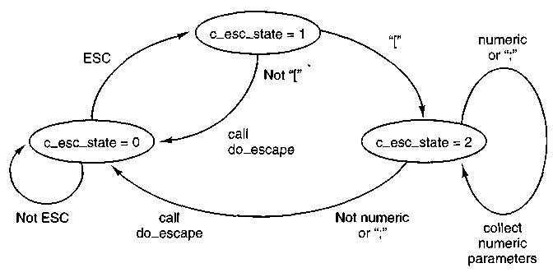
Figure 3-48. Finite state machine for processing escape sequences.
detected by out_char and makes cons->c_esc_state equal to 1. When the next character is received, parse ^escape prepares for further processing by putting a '\0' in cons->c_esc_intro, a pointer to the start of the array of parameters, con$->c_esc_parmv[0] into cons->c_esc_parmp, and zeroes into the parameter array itself. Then the first character following the ESC is examined—valid values are either "[" or "M". In the first case the "[" is copied to cons—>c_esc-intro and the state is advanced to 2. In the second case, do _escape is called to carry out the action, and the escape state is reset to zero. If the first character after the ESC is not one of the valid ones, it is ignored and succeeding characters are once again displayed normally.
When an ESC [ sequence has been seen, the next character entered is processed by the escape state 2 code. There are three possibilities at this point. If the character is a numeric character, its value is extracted and added to 10 times the existing value in the position currently pointed to by cons->c_esc^parmp, initially cons->C-esc-parmv[G\ (which was initialized to zero). The escape state does not change. This makes it possible to enter a series of decimal digits and accumulate a large numeric parameter, although the maximum value currently recognized by MINIX is 80, used by the sequence that moves the cursor to an arbitrary position (lines 14027 to 14029). If the character is a semicolon, the pointer to the parameter string is advanced, so succeeding numeric values can be accumulated in the second parameter (lines 14031 to 14033). If MAX_ESC-FARMS were to be changed to allocate a larger array for the parameters, this code would not have to be altered to accumulate additional numeric values after entry of additional parameters. Finally, if the character is neither a numeric digit nor a semicolon, do ^escape is called.
Do^escape (line 14045) is one of the longer functions in the MINIX system source code, even though MINIX's complement of recognized escape sequences is relatively modest. For all its length, however, the code should be easy to follow.
After an initial call to flush to make sure the video display is fully updated, there in a simple if choice, depending upon whether the character immediately following the ESC character was a special control sequence introducer or not. If not, there is only one valid action, moving the cursor up one line if the sequence was ESC M. Note that the test for the "M" is done within a switch with a default action, as a validity check and in anticipation of addition of other sequences that do not use the ESC [ format. The action is typical of many escape sequences: the cons->c_row variable is inspected to determine if scrolling is required. If the cursor is already on row 0, a SCROLL_DOWN call is made to scroll-screen; otherwise the cursor is moved up one line. The latter is accomplished just by decrementing cons->c_row and then calling flush. If a control sequence introducer is found, the code following the else on line 14069 is taken. A test is made for "[", the only control sequence introducer currently recognized by MINK. If the sequence is valid, the first parameter found in the escape sequence, or zero if no numeric parameter was entered, is assigned to value (line 14072). If the sequence is invalid, nothing happens except that the large switch that ensues (lines 14073 to 14272) is skipped and the escape state is reset to zero before returning from do^escape. In the more interesting case that the sequence is valid, the switch is entered. We will not discuss all the cases; we will just note several that are representative of the types of actions governed by escape sequences.
The first five sequences are generated, with no numeric arguments, by the four "arrow" keys and the Home key on the IBM PC keyboard. The first two, ESC [A and ESC [B, are similar to ESC M, except they can accept a numeric parameter and move up and down by more than one line, and they do not scroll the screen if the parameter specifies a move that exceeds the bounds of the screen. In such cases, flush catches requests to move out of bounds and limits the move to the last row or the first row, as appropriate. The next two sequences, ESC [C and ESC [D, which move the cursor right and left, are similarly limited by flush. When generated by the "arrow" keys there is no numeric argument, and thus the default movement of one line or column occurs.
The next sequence, ESC [H, can take two numeric parameters, for instance, ESC [20;60H. The parameters specify an absolute position rather than one relative to the current position and are converted from 1-based numbers to 0-based numbers for proper interpretation. The Home key generates the default (no parameters) sequence which moves the cursor to position (1, 1).
The next two sequences, ESC [si and ESC [sK, clear a part of either the entire screen or the current line, depending upon the parameter that is entered. In each case a count of characters is calculated. For instance, for ESC [U, count gets the number of characters from the start of the screen to the cursor position, and the count and a position parameter, dst, which may be the start of the screen. cons->c_org, or the current cursor position, cons->c_citr, are used as parameters to a call to meni-vid_copy. This procedure is called with a parameter that causes it to fill the specified region with the current background color.
The next four sequences insert and delete lines and spaces at the cursor position, and their actions do not require detailed explanation. The last case, ESC [nm (note the n represents a numeric parameter, but the "m" is a literal character) has its effect upon cons->c_attr, the attribute-byte that is interleaved between the character codes when they are written to video memory.
The next function, set_6845 (line 14280), is used whenever it is necessary to update the video controller chip. The 6845 has internal 16-bit registers that are programmed 8 bits at a time, and writing a single register requires four I/O port write operations. Lock and unlock calls are used to disable interrupts, which can cause problems if allowed to disrupt the sequence. Some of the registers of the 6845 video controller chip are shown in Fig. 3-49
Registers | Function
10-11 | Cursor size
12-13 | Start address for drawing screen
14-15 | Cursor position
Figure 3-49. Some of the 6845's registers.
The beep function (line 14300) is called when a CTRL-G character must be output. It takes advantage of the built-in support provided by the PC for making sounds by sending a square wave to the speaker. The sound is initiated by more of the kind of magic manipulation of I/O ports that only assembly language programmers can love, again with some concern that a critical part of the process should be protected from interrupts. The more interesting part of the code is the use of the clock task's capability to set an alarm, which can be used to initiate a function. The next routine, stop^beep (line 14329), is the one whose address is put into the message to the clock task. It stops the beep after the designated time has elapsed and also resets the beeping flag which is used to prevent superfluous calls to the beep routine from having any effect.
Scr^init (line 14343) is called by tty_init NR-CONS times. Each time its argument is a pointer to a tty structure, one element of the tty_table. On lines 14354 and 14355 line, to be used as the index into the cons_table array, is calculated, tested for validity, and, if valid, used to initialize cons, the pointer to the current console table entry. At this point the cons->c_tty field can be initialized with the pointer to the main tty structure for the device, and, in turn, tp->tty_priv can be pointed to this device's consoles structure. Next, kb_init is called to initialize the keyboard, and then the pointers to device specific routines are set up, tp->tty_devwrite pointing to cons_write and tp->tty_echo pointing to cons_echo. The I/O address of the base register of the CRT controller is fetched and the address and size of the video memory are determined on lines 14368 to 14378, and the wrap flag (used to determine how to scroll) is set according to the
class of video controller in use. On lines 14382 to 14384 the segment descriptor for the video memory is initialized in the global descriptor table.
Next comes the initialization of virtual consoles. Each time scr_init is called, the argument is a different value of tp, and thus a different line and cons are used on lines 14393 to 14396 to provide each virtual console with its own share of the available video memory. Each screen is then blanked, ready to start, and finally console 0 is selected to be the first active one.
The remaining routines in console.c are short and simple and we will review them quickly. Putk (line 14408) has been mentioned earlier. It prints a character on behalf of any code linked into the kernel image that needs the service, without going through the FS. Toggle ^scroll (line 14429) does what its name says, it toggles the flag that determines whether hardware or software scrolling is used. It also displays a message at the current cursor position to identify the selected mode. Cons_stop (line 14442) reinitializes the console to the state that the boot monitor expects, prior to a shutdown or reboot. Cons^orgO (line 14456) is used only when a change of scrolling mode is forced by the F3 key, or when preparing to shut down. Select_console (line 14482) selects a virtual console. It is called with the new index and calls set_6845 twice to get the video controller to display the proper part of the video memory.
The last two routines are highly hardware-specific. Con_loadfont (line 14497) loads a font into a graphics adapter, in support of the IOCTL TIOCSFON operation. It calls ga_program (line 14540) to do a series of magical writes to an I/O port that cause the video adapter's font memory, which is normally not addressable by the CPU, to be visible. Then phys_copy is called to copy the font data to this area of memory, and another magic sequence is invoked to return the graphics adapter to its normal mode of operation.
Debugging Dumps
The final group of procedures we will discuss in the terminal task were originally intended only for temporary use when debugging MINIX. They can be removed when this assistance is no longer needed, but many users find them useful and leave them in place. They are particularly helpful when modifying MINIX.
As we have seen, func_key is called at the start of kb_read to detect scan codes used for control and debugging. The dump routines called when the Fl and F2 keys are detected are in dmp.c. The first, p_dmp (line 14613) displays basic process information for all processes, including some information on memory use. when the Fl key is pressed. The second, map_dmp (line 14660), provides more detailed information on memory use in response to F2. Proc_name (line 14690) supports p_dmp by looking up process names.
Since this code is completely contained within the kernel binary itself and does not run as a user process or task, it frequently continues to function correcth.
even after a major system crash. Of course, these routines are accessible only from the console. The information provided by the dump routines cannot be redirected to a file or to any other device, so hardcopy or use over a network connection are not options.
We suggest that the first step in trying to add any improvement to MINIX might very well be to extend the dumping routines to provide more information on the aspect of the system you wish to improve.
3.10 THE SYSTEM TASK IN MINIX
One consequence of making the file system and memory manager server processes outside the kernel is that occasionally they have some piece of information that the kernel needs. This structure, however, forbids them from just writing it into a kernel table. For example, the FORK system call is handled by the memory manager. When a new process is created, the kernel must know about it, in order to schedule it. How can the memory manager tell the kernel?
The solution to this problem is to have a kernel task that communicates with the file system and memory manager via the standard message mechanism and which also has access to all the kernel tables. This task, called the system task, is in layer 2 in Fig. 2-26, and functions like the other tasks we have studied in this chapter. The only difference is that it does not control any I/O device. But, like I/O tasks, it implements an interface, in this case not to the external world, but to the most internal part of the system. It has the same privileges as the I/O tasks and is compiled with them into the kernel image, and it makes more sense to study it here than in any other chapter.
The system task accepts 19 kinds of messages, shown in Fig. 3-50. The main program of the system task, sys-task (line 14837), is structured like other tasks. It gets a message, dispatches to the appropriate service procedure, and then sends a reply. We will now look at each of these messages and its service procedure.
The SYS_FORK message is used by the memory manager to tell the kernel that a new process has come into existence. The kernel needs to know this in order to schedule it. The message contains the slot numbers within the process table corresponding to the parent and child. The memory manager and file system also have process tables, with entry k referring to the same process in all three. In this manner, the memory manager can specify just the parent and child slot numbers, and the kernel will know which processes are meant.
The procedure do_fork (line 14877) first makes a check (line 14886) to see if the memory manager is feeding the kernel garbage. The test uses a macro, isok-susern, defined in proc.h, to test that the process table entries of the parent and child are valid. Similar tests are made by most of the service procedures in systems. This is pure paranoia, but a little internal consistency checking does no
Message type | From | Meaning
SYS_FORK | MM | A progess has forked
SYS_NEWMAP | MM | Install memory map for a new process
SYS_GETMAP | MM | MM wants memory map of a process
SYS_EXEC | MM | Set stack pointer after EXEC call
SYS_XIT | MM | A process has exited
SYS_GETSP | MM | MM wants a process' stack pointer
SYS_TIMES | FS | FS wants a process' execution times
SYS_ABORT | Both | Panic: MINIX is unable to continue
SYS_SENDSIG | MM | Send a signal to a process
SYS_SIGRETURN | MM | Cleanup after completion of a signal.
SYS_KILL | FS | Send signal to a process after KILL call
SYS_ENDSIG | MM | Cleanup after a signal from the kernel
SYS_COPY | Both | Copy data between processes
SYS_VCOPY | Both | Copy multiple blocks of data between processes
SYS_GBOOT | FS | Get boot parameters
SYS_MEM | MM | MM wants next free chunk of physical memory
SYS_UMAP | FS | Convert virtual address to physical address
SYS_TRACE | MM | Carry out an operation of the PTRACE call
Figure 3-50. The message types accepted by the system task.
harm. Then do_fork copies the parent's process table entry to the child's slot. Some things need adjustment here. The child is freed from any pending signals for the parent, and the child does not inherit the parent's trace status. And, of course, all the child's accounting information is set to zero.
After a FORK, the memory manager allocates memory for the child. The kernel must know where the child is located in memory so it can set up the segment registers properly when running the child. The SYS^NEWMAP message allows the memory manager to give the kernel any process' memory map. This message can also be used after a brk system call changes the map.
The message is handled by do^newmap (line 14921), which must first copy the new map from the memory manager's address space. The map is not contained in the message itself because it is too big. In theory, the memory manager could tell the kernel that the map is at address m, where m is an illegal address. The memory manager is not supposed to do this, but the kernel checks anyway. The map is copied directly into the p_map field of the process table entry for the
process getting the new map. The call to alloc_segments extracts information from the map and loads it into the p-reg fields that hold the segment registers. This is not complicated, but the details are processor dependent and are segregated in a separate function for this reason. -
The SYS_NEWMAP message is much used in the normal operation of a MINIX system. A similar message, SYS_GETMAP, is used only when the file system initially starts up. This message requests a transfer of the process map information in the opposite direction, from the kernel to the memory manager. It is carried out by do_getmap (line 14957). The code of the two functions is similar, differing mainly in the swapping of the source and destination arguments of the call to phys_copy used by each function.
When a process does an exec system call, the memory manager sets up a new stack for it containing the arguments and environment. It passes the resulting stack pointer to the kernel using SYS_EXEC, which is handled by do_exec (line 14990). After the usual check for a valid process, there is a test of the PROC2 field in the message. This field is used here as a flag to indicate whether the process is being traced and has nothing to do with identifying a process. If tracing is in force, cause_sig is called to send a SIGTRAP signal to the process. This does not have the usual consequences of this signal, which would normally terminate a process and cause a core dump. In the memory manager all signals to a traced process except for S1GKILL are intercepted and cause the signaled process to stop so a debugging program can then control its further execution.
The EXEC call causes a slight anomaly. The process invoking the call sends a message to the memory manager and blocks. With other system calls, the resulting reply unblocks it. With EXEC there is no reply, because the newly loaded core image is not expecting a reply. Therefore, do_exec unblocks the process itself on line 15009. The next line makes the new image ready to run, using the lock-ready function that protects against a possible race condition. Finally, the command string is saved so the process can be identified when the user presses the Fl function key to display the status of all processes.
Processes can exit in MINIX either by doing an EXIT system call, which sends a message to the memory manager, or by being killed by a signal. In both cases, the memory manager tells the kernel by the SYS_XIT message. The work is done by do_xit (line 15027), which is more complicated than you might expect. Taking care of the accounting information is straightforward. The alarm timer, if any, is killed by storing a zero on top of it. It is for this reason that the clock task always checks when a timer has run out to see if anybody is still interested. The tricky part of do_xit is that the process might have been queued trying to send or receive at the time it was killed. The code on lines 15056 to 15076 checks for this possibility. If the exiting process is found on any other process' message queue, it is carefully removed.
In contrast to the previous message, which is slightly complicated, SYS_GETSP is completely trivial. It is used by the memory manager to find out
the value of the current stack pointer for some process. This value is needed for the BRK and SBRK system calls to see if the data segment and stack segment have collided. The code is in do_getsp (line 15089).
Now we come to one of the few message types used exclusively by the file system, SYS_TIMES. It is needed to implement the TIMES system call, which returns the accounting times to the caller. All daytimes (line 15106) does is put the requested times into the reply message. Calls to lock and unlock are used to protect against a possible race while accessing the time counters.
It can happen that either the memory manager or the file system discovers an error that makes it impossible to continue operation. For example, if upon first starting up the file system sees that the super-block on the root device has been fatally corrupted, it panics and sends a SYS-ABORT message to the kernel. It is also possible for the super-user to force a return to the boot monitor and/or a reboot, using the reboot command, which in turn calls the REBOOT system call. In any of these cases, the system task executes do^abort (line 15131), which copies instructions to the monitor, if necessary, and then calls wreboot to complete the process.
Most of the work of signal handling is done by the memory manager, which checks to see if the process to be signaled is enabled to catch or ignore the signal, if the sender of the signal is entitled to do so, and so on. However, the memory manager cannot actually cause the signal, which requires pushing some information onto the stack of the signaled process.
Signal handling previous to POSIX was problematic, because catching a signal restored the default response to signals. If continued special handling of subsequent signals were required, the programmer could not guarantee reliability. Signals are asynchronous, and a second signal could very well arrive before the handling were reenabled. POSIX-style signal handling solves this problem, but the price is a more complicated mechanism. Old-style signal handling could be implemented by the operating system pushing some information onto the signaled process' stack, similar to the information pushed by an interrupt. The programmer would then write a handler that ended with a return instruction, popping the information needed to resume execution. POSIX saves more information when a signal is received than can be conveniently handled this way. There is additional work to do afterward, before the signaled process can resume what it was doing. The memory manager thus has to send two messages to the system task to process a signal. The payoff for this effort is more reliable handling of signals.
When a signal is to be sent to a process, the SYS^SENDSIG message is sent to the system task. It is handled by do_sendsig (line 15157). The information needed to handle POSIX-style signals is in a sigcontext structure, which contains the processor register contents, and a sigframe structure, which contains information about how signals are to be handled by the process. Both of these structure-need some initialization, but the basic work of do_sendsig is just to put the required information on the signaled process' stack, and adjust the signaled proce^'
program counter and stack pointer so the signal handling code will be executed the next time the scheduler allows the process to execute.
When a POSIX-style signal handler completes its work, it does not pop the address where execution of the interrupted process resumes, as is the case with old-style signals. The programmer writing the handler writes a return instruction (or the high-level language equivalent), but the manipulation of the stack by the SENDSIG call causes the return to execute a SIGRETURN system call. The memory manager then sends the system task a SYS^SIGRETURN message. This is handled by do_sigreturn (line 15221), which copies the sigcontext structure back into the kernel's space and then restores the signaled process' registers. The interrupted process will resume execution at the point where it was interrupted the next time the scheduler allows it to run, retaining any special signal handling that was previously set up.
The SIGRETURN system call, unlike most of the others discussed in this section, is not required by POSIX. It is a MINIX invention, a convenient way to initiate the processing needed when a signal handler is complete. Programmers should not use this call; it will not be recognized by other operating systems, and in any case there is no need to refer to it explicitly.
Some signals come from within the kernel image, or are handled by the kernel before they go to the memory manager. These include signals originating from tasks, such as alarms from the clock task, or signal-causing key presses detected by the terminal task, as well as signals caused by exceptions (such as division by zero or illegal instructions) detected by the CPU. Signals originating from the file system are also handled first by the kernel. The SYS_KILL message is used by the file system to request that such a signal be generated. The name is perhaps a bit misleading. This has nothing to do with handling of the KILL system call, used by ordinary processes to send signals. This message is handled by do^kill (line 15276), which makes the usual check for a valid origin of the message, and then calls cause_sig to actually pass the signal on to the process. Signals originating in the kernel are also passed on by a call to this function, which initiates signals by sending a KSIG message to the memory manager.
Whenever the memory manager has finished with one of these KSIG-type signals, it sends a SYS_ENDSIG message back to the system task. This message is handled by do-endsig (line 15294), which decrements the count of pending signals, and, if it reaches zero, resets the SIG_PENDING bit for the signaled process. If there are no other flags set indicating reasons the process should not be run-nable, lock_ready is then called to allow the process to run again.
The SYS_COPY message is the most heavily used one. It is needed to allow the file system and memory manager to copy information to and from user processes.
When a user does a READ call, the file system checks its cache to see if it has the block needed. If not, it sends a message to the appropriate disk task to load it into the cache. Then the file system sends a message to the system task telling it
to copy the block to the user process. In the worst case, seven messages are needed to read a block; in the best case, four messages are needed. Both cases are shown in Fig. 3-51. These messages are a significant source of overhead inMINIX and are the price paid for the highly modular, design.

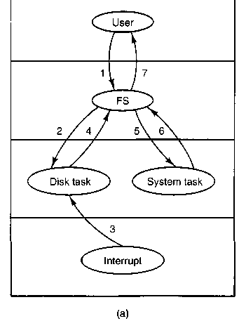
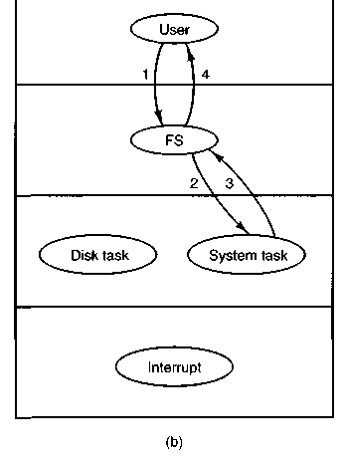

Figure 3-51. (a) Worst case for reading a block requires seven messages, (b) Best case for reading a block requires four messages.
As an aside, on the 8088, which had no protection, it would have been easy enough to cheat and let the file system copy the data to the caller's address space, but this would have violated the design principle. Anyone with access to such an antique machine who is interested in improving the performance of MINIX should look carefully at this mechanism to see how much improper behavior one can tolerate for how much gain in performance. Of course, this means of improvement is not available on Pentium-class machines with protection mechanisms.
Handling a SYS^COPY request is straightforward. It is done by do_copy (line 15316) and consists of little more than extracting the message parameters and calling phys_copy.
One way to deal with some of the inefficiency of the message passing mechanism is to pack multiple requests into a message. The SYS_VCOPY message does this. The content of this message is a pointer to a vector specifying multiple blocks to be copied between memory locations. The function do^vcopy (line 15364) executes a loop, extracting source and destination addresses and block lengths and calling phys_copy repeatedly until all the copies are complete. This i>

similar to the capability of disk devices to handle multiple transfers based on a single request.
There are several more message types received by the system task, most of which are fairly simple. Two of these are normally used only during system startup. The file system sends a SYS_GBOOT message to request the boot parameters. This is a structure, bparam_s, declared in include/minix/boot.h, which allows various aspects of system configuration to be specified by the boot monitor program before minix is started. The do^gboot (line 15403) function carries out this operation, which is just a copy from one part of memory to another. Also at startup time, the memory manager sends the system task a series of SYS-MEM messages to request the base and size of the available chunks of memory. Do_mem (line 15424) handles this request.
The SYS_UMAP message is used by a nonkernel process to request calculation of the physical memory address for a given virtual address. Do_umap (line 15445) carries this out by calling umap, which is the function called from within the kernel to handle this conversion.
The last message type we will discuss is SYS_TRACE, which supports the PTRACE system call, used for debugging. Debugging is not a fundamental operating system function, but operating system support can make it easier. With help from the operating system, a debugger can examine and modify the memory used by a process under test, as well as the contents of the processor registers that are stored in the process table whenever the debugged program is not running.
Normally, a process runs until it blocks to wait for I/O or uses up a time quantum. Most CPU designs also provide means by which a process can be limited to executing just a single instruction, or can be made to execute only until a particular instruction is reached, by setting a breakpoint. Taking advantage of such facilities makes possible detailed analysis of a program.
There are eleven operations that can be carried out using ptrace. A few are carried out totally by the memory manager, but for most of them the memory manager sends a SYS-TRACE message to the system task, which then calls do-trace (line 15467). This function implements a switch on the trace operation code. The operations are generally simple. A P_STOP bit in the process table is used by MINIX to recognize that debugging is in progress and is set by the command to stop the process (case T_STOP) or reset to restart it (case T_RESUME). Debugging depends upon hardware support, and on Intel processors is controlled by a bit in the CPU's flag register. When the bit is set, the processor executes just one instruction, then generates a SIGTRAP exception. As mentioned earlier, the memory manager stops a program being traced when a signal is sent to it. This TRACEBIT is manipulated by the T_STOP and T_STEP commands. Breakpoints can be set in two ways: either by using the T^SETINS command to replace an instruction with a special code that generates a SIGTRAP, or by using the T_SETUSER command to modify special breakpoint registers. On any kind of system to which MINIX may be ported, it will probably be possible to implement a
debugger using similar techniques, but porting these functions will require study of the particular hardware.
Most of the commands carried out by dotrace either return or modify values in the traced process' text or data space, er in its process table entry, and the code is straightforward. Altering certain registers and certain bits of the CPU flags is too dangerous to allow, so there are many checks in the code that handle the T_SETUSER command to prevent such operations.
At the end of system.c are several utility procedures used in various places throughout the kernel. When a task needs to cause a signal (e.g., the clock task needs to cause a SJGALRM signal, or the terminal task needs to cause a SIGINT signal), it calls cause_sig (line 15586). This procedure sets a bit in the p^pending field of the process table entry for the process to be signaled and then checks to see if the memory manager is currently waiting for a message from ANY, that is, if it is idle and waiting for the next request to process. If it is idle, inform is called to tell the memory manager to handle the signal.
Inform (line 15627) is called only after a check that the memory manager is not busy, as described above. In addition to the call from cause^sig, it is called from mini^rec (in proc.c), whenever the memory manager blocks and there are kernel signals pending. Inform builds a message of type KSIG and sends it to the memory manager. The task or process calling cause_sig continues running as soon as the message has been copied into the memory manager's receive buffer. It does not wait for the memory manager to run, as would be the case if the normal send mechanism, which causes the sender to block, were to be used. Before it returns, however, inform calls lock_pick_proc, which schedules the memory manager to ran. Since tasks have a higher priority than servers, the memory manager will not run until all tasks are satisfied. When the signaling task finishes, the scheduler will be entered. If the memory manager is the highest priority runnable process, it will run and process the signal.
The procedure umap (line 15658) is a generally useful procedure that maps a virtual address onto a physical address. As we have noted, it is called by do_umap, which services the SYS-UMAP message. Its parameters are a pointer to the process table entry for the process or task whose virtual address space is to be mapped, a flag specifying the text, data, or stack segment, the virtual address itself, and a byte count. The byte count is useful because umap checks to make sure that the entire buffer starting at the virtual address is within the process' address space. To do this, it must know the buffer's size. The byte count is not used for the mapping itself, just this check. All the tasks that copy data to or from user space compute the physical address of the buffer using umap. For device drivers it is convenient to be able to get the services of umap starting with the process number instead of a pointer to a process table entry. Numap (line 15697) does this. It calls proc^addr to convert its first argument and then calls umap.
The last function defined in system.c is alloc_segments (line 15715). It i< called by do_newmap. It is also called by the main routine of the kernel during
initialization. This definition is very hardware dependent. It takes the segment assignments that are recorded in a process table entry and manipulates the registers and descriptors the Pentium processor uses to support protected segments at the hardware level.
3.11 SUMMARY
Input/output is an often neglected, but important, topic. A substantial fraction of any operating system is concerned with I/O. We started out by looking at I/O hardware, and the relation of I/O devices to I/O controllers, which are what the software has to deal with. Then we looked at the four levels of I/O software: the interrupt routines, the device drivers, the device-independent I/O software, and the I/O libraries and spoolers that run in user space.
Next we studied the problem of deadlock and how it can be tackled. Deadlock occurs when a group of processes each have been granted exclusive access to some resources, and each one wants yet another resource that belongs to another process in the group. All of them are blocked and none will ever run again. Deadlock can be prevented by structuring the system so it can never occur, for example, by allowing a process to hold only one resource at any instant. It can also be avoided by examining each resource request to see if it leads to a situation in which deadlock is possible (an unsafe state) and denying or delaying those that lead to trouble.
Device drivers in MINIX are implemented as processes embedded in the kernel. We have looked at the RAM disk driver, hard disk driver, clock driver, and terminal driver. The synchronous alarm task and the system task are not device drivers but are structurally very similar to one. Each of these tasks has a main loop that gets requests and processes them, eventually sending back replies to report on what happened. All the tasks are located in the same address space. The RAM disk, hard disk, and floppy disk driver tasks all use a single copy of the same main loop and also share common functions. Nevertheless, each one is an independent process. Several different terminals, using the system console, the serial lines, and network connections are all supported by a single terminal task.
Device drivers have varying relationships to the interrupt system. Devices which can complete their work rapidly, such as the RAM disk and the memory-mapped display, do not use interrupts at all. The hard disk driver task does most of its work in the task code itself, and the interrupt handlers just return status information. The clock interrupt handler does a number of bookkeeping operations itself and only sends a message to the clock task when there is some work that cannot be taken care of by the handler. The keyboard interrupt handler buffers input and never sends a message to its task. Instead it changes a variable inspected by the clock interrupt handler; the latter sends a message to the terminal task.
PROBLEMS
1. Imagine that advances in chip technology make it possible to put an entire controller, including all the bus access logic, on an inexpensive chip. How will that affect the model of Fig. 3-1?
2. If a disk controller writes the bytes it receives from the disk to memory as fast as it receives them, with no internal buffering, is interleaving conceivably useful? Discuss.
3. Based on the rotation speed and geometry of the disks, what are the bit rates for transfers between the disk itself and the controller's buffer for a floppy disk and a hard disk? How does this compare with other forms of I/O (serial lines and networks)?
4. A disk is double interleaved, as in Fig. 3-4(c). It has eight sectors of 512 bytes per track, and a rotation rate of 300 rpm. How long does it take to read all the sectors of a track in order, assuming the arm is already correctly positioned, and 1/2 rotation is needed to get sector 0 under the head? What is the data rate? Now repeat the problem for a noninterleaved disk with the same characteristics. How much does the data rate degrade due to interleaving?
5. The DM-11 terminal multiplexer, which was used on the PDP-11 many, many years ago, sampled each (half-duplex) terminal line at seven times the baud rate to see if the incoming bit was a 0 or a 1. Sampling the line took 5.7 microsec. How many 1200-baud lines could the DM-11 support?
6. A local area network is used as follows. The user issues a system call to write data packets to the network. The operating system then copies the data to a kernel buffer. Then it copies the data to the network controller board. When all the bytes are safely inside the controller, they are sent over the network at a rate of 10 megabits/sec. The receiving network controller stores each bit a microsecond after it is sent. When the last bit arrives, the destination CPU is interrupted, and the kernel copies the newly arrived packet to a kernel buffer to inspect it. Once it has figured out which user the packet is for, the kernel copies the data to the user space. If we assume that each interrupt and its associated processing takes 1 msec, that packets are 1024 bytes (ignore the headers), and that copying a byte takes 1 microsec, what is the maximum rate at which one process can pump data to another? Assume that the sender is blocked until the work is finished at the receiving side and an acknowledgement comes back. For simplicity, assume that the time to get the acknowledgement back is so small it can be ignored.
7. What is "device independence?"
8. In which of the four I/O software layers is each of the following done.
(a) Computing the track, sector, and head for a disk read.
(b) Maintaining a cache of recently used blocks.
(c) Writing commands to the device registers.
(d) Checking to see if the user is permitted to use the device.
(e) Converting binary integers to ASCII for printing.
9. Why are output files for the printer normally spooled on disk before being printed⁰
10. Consider Fig. 3-8. Suppose that in step (o) C requested S instead of requesting R. Would this lead to deadlock? Suppose that it requested both S and Rl
11. Take a careful look at Fig. 3-1 l(b). If Suzanne asks for one more unit, does this lead to a safe state or an unsafe one? What if the request came from Marvin instead of Suzanne?
12. All the trajectories in Fig. 3-12 are horizontal or vertical. Can you envision any circumstances in which diagonal trajectories were also possible?
13. Suppose that process A in Fig. 3-13 requests the last tape drive. Does this action lead to a deadlock?
14. A computer has six tape drives, with « processes competing for them. Each process may need two drives. For which values of n is the system deadlock free?
15. Can a system be in a state that is neither deadlocked nor safe? If so, give an example. If not, prove that all states are either deadlocked or safe.
16. A distributed system using mailboxes has two IPC primitives, SEND and RECEIVE. The latter primitive specifies a process to receive from, and blocks if no message from that process is available, even though messages may be waiting from other processes. There are no shared resources, but processes need to communicate frequently about other matters. Is deadlock possible? Discuss.
17. In an electronic funds transfer system, there are hundreds of identical processes that work as follows. Each process reads an input line specifying an amount of money, the account to be credited, and the account to be debited. Then it locks both accounts and transfers the money, releasing the locks when done. With many processes running in parallel, there is a very real danger that having locked account x it will be unable to lock y because y has been locked by a process now waiting for x. Devise a scheme that avoids deadlocks. Do not release an account record until you have completed the transactions. (In other words, solutions that lock one account and then release it immediately if the other is locked are not allowed.)
18. The banker's algorithm is being run in a system with m resource classes and n processes. In the limit of large m and n, the number of operations that must be performed to check a state for safety is proportional to mªn . What are the values of a and bl
19. Cinderella and the Prince are getting divorced. To divide their property, they have agreed on the following algorithm. Every morning, each one may send a letter to the other's lawyer requesting one item of property. Since it takes a day for letters to be delivered, they have agreed that if both discover that they have requested the same item on the same day, the next day they will send a letter canceling the request. Among their property is their dog, Woofer, Woofer's doghouse, their canary, Tweeter, and Tweeter's cage. The animals love their houses, so it has been agreed that any division of property separating an animal from its house is invalid, requiring the whole division to start over from scratch. Both Cinderella and the Prince desperately want Woofer. So they can go on (separate) vacations, each spouse has programmed a personal computer to handle the negotiation. When they come back from vacation, the computers are still negotiating. Why? Is deadlock possible? Is starvation (waiting forever) possible? Discuss.
20. The message format of Fig. 3-15 is used for sending request messages to drivers foi block devices. Which fields, if any, could be omitted for messages to character devices?
21. Disk requests come in to the disk driver for cylinders 10, 22, 20, 2, 40, 6, and 38, in that order. A seek takes 6 msec per cylinder moved. How much seek time is needed for
(a) First-come, first served.
(b) Closest cylinder next.
(c) Elevator algorithm (initially moving upward).
In all cases, the arm is initially at cylinder 20.
22. A personal computer salesman visiting a university in South-West Amsterdam remarked during his sales pitch that his company had devoted substantial effort to making their version of UNIX very fast. As an example, he noted that their disk driver used the elevator algorithm and also queued multiple requests within a cylinder in sector order. A student, Harry Hacker, was impressed and bought one. He took it home and wrote a program to randomly read 10,000 blocks spread across the disk. To his amazement, the performance that he measured was identical to what would be expected from first-come, first-served. Was the salesman lying?
23. A UNIX process has two parts—the user part and the kernel part. Is the kernel part like a subroutine or a coroutine?
24. The clock interrupt handler on a certain computer requires 2 msec (including process switching overhead) per clock tick. The clock runs at 60 Hz. What fraction of the CPU is devoted to the clock?
25. Two examples of watchdog timers were given in the text: timing the startup of the floppy disk motor and allowing for carriage return on hardcopy terminals. Give a third example.
26. Why are RS232 terminals interrupt driven, but memory-mapped terminals not interrupt driven?
27. Consider how a terminal works. The driver outputs one character and then blocks. When the character has been printed, an interrupt occurs and a message is sent to the blocked driver, which outputs the next character and then blocks again. If the time to pass a message, output a character, and block is 4 msec, does this method work well on 110-baud lines? How about 4800-baud lines?
28. A bit-map terminal contains 1200 by 800 pixels. To scroll a window, the CPU (or controller) must move all the lines of text upward by copying their bits from one part of the video RAM to another. If a particular window is 66 lines high by 80 characters wide (5280 characters, total), and a character's box is 8 pixels wide by 12 pixels high, how long does it take to scroll the whole window at a copying rate of 500 nsec per byte? If all lines are 80 characters long, what is the equivalent baud rate of the terminal? Putting a character on the screen takes 50 microsec. Now compute the baud rate for the same terminal in color, with 4 bits/pixel. (Putting a character on the screen now takes 200 microsec.)
29. Why do operating systems provide escape characters, such as CTRL-V in MINIX?
30. After receiving a DEL (SIGINT) character, the MINIX driver discards all output currently queued for that terminal. Why?
31. Many RS232 terminals have escape sequences for deleting the current line and moving all the lines below it up one line. How do you think this feature is implemented inside the terminal?
32. On the original IBM PC's color display, writing to the video RAM at any time other than during the CRT beam's vertical retrace caused ugly spots to appear all over the screen. A screen image is 25 by 80 characters, each of which fits in a box 8 pixels by 8 pixels. Each row of 640 pixels is drawn on a single horizontal scan of the beam, which takes 63.6 microsec, including the horizontal retrace. The screen is redrawn 60 times a second, each of which requires a vertical retrace period to get the beam back to the top. What fraction of the time is the video RAM available for writing in?
33. Write a graphics driver for the IBM color display, or some other suitable bit-map display. The driver should accept commands to set and clear individual pixels, move rectangles around the screen, and any other features you think are interesting. User programs interface to the driver by opening /dev/graphics and writing commands to it.
34. Modify the MINIX floppy disk driver to do track-at-a-time caching.
35. Implement a floppy disk driver that works as a character, rather than a block device, to bypass the file system's block cache. In this way. users can read large chunks of data from the disk, which are DMA'ed directly to user space, greatly improving performance. This driver would primarily be of interest to programs that need to read the raw bits on the disk, without regard to the file system. File system checkers fall into this category.
36. Implement the UNIX PROFIL system call, which is missing from MINIX.
37. Modify the terminal driver so that in addition to a having a special key to erase the previous character, there is a key to erase the previous word.
38. A new hard disk device with removable media has been added to a minix system. This device must spin up to speed every time the media are changed, and the spin up time is quite long. It is anticipated media changes will be made frequently while the system is running. Suddenly the waitfor routine in at^wini.c is unsatisfactory. Design a new waitfor routine in which, if the bit pattern being awaited is not found after 1 second of busy waiting, a phase will be entered in which the disk task will sleep for 1 second, test the port, and go back to sleep for another second until either the sought-for pattern is found or the preset TIMEOUT period expires.
4
MEMORY MANAGEMENT
Memory is an important resource that must be carefully managed. While the average home computer nowadays has fifty times as much memory as the IBM 7094, the largest computer in the world in the early 1960s, programs are getting bigger just as fast as memories. To paraphrase Parkinson's law, "Programs expand to fill the memory available to hold them." In this chapter we will study how operating systems manage their memory.
Ideally, what every programmer would like is an infinitely large, fast memory that is also nonvolatile, that is, does not lose its contents when the electric power fails. While we are at it, why not also ask for it to be inexpensive, too. Unfortunately technology does not provide such memories. Consequently, most computers have a memory hierarchy, with a small amount of very fast, expensive, volatile cache memory, some number of megabytes of medium-speed, medium-price, volatile main memory (RAM), and hundreds or thousands of megabytes of slow, cheap, nonvolatile disk storage. It is the job of the operating system to coordinate how these memories are used.
The part of the operating system that manages the memory hierarchy is called the memory manager. Its job is to keep track of which parts of memory are in use and which parts are not in use, to allocate memory to processes when they need it and deallocate it when they are done, and to manage swapping between main memory and disk when main memory is too small to hold all the processes.
In this chapter we will investigate a number of different memory management schemes, ranging from very simple to highly sophisticated. We will start at the
beginning and look first at the simplest possible memory management system and then gradually progress to more and more elaborate ones.
4.1 BASIC MEMORY MANAGEMENT
Memory management systems can be divided into two classes: those that move processes back and forth between main memory and disk during execution (swapping and paging), and those that do not. The latter are simpler, so we will study them first. Later in the chapter we will examine swapping and paging. Throughout this chapter the reader should keep in mind that swapping and paging are largely artifacts caused by the lack of sufficient main memory to hold all the programs at once. As main memory gets cheaper, the arguments in favor of one kind of memory management scheme or another may become obsolete—unless programs get bigger faster than memory gets cheaper.
4.1.1 Monoprogramming without Swapping or Paging
The simplest possible memory management scheme is to run just one program at a time, sharing the memory between that program and the operating system. Three variations on this theme are shown in Fig. 4-1. The operating system may be at the bottom of memory in RAM (Random Access Memory), as shown in Fig. 4-1 (a), or it may be in ROM (Read-Only Memory) at the top of memory, as shown in Fig. 4-l(b), or the device drivers may be at the top of memory in a ROM and the rest of the system in RAM down below, as shown in Fig. 4-l(c). The latter model is used by small MS-DOS systems, for example. On IBM PCs, the portion of the system in the ROM is called the BIOS (Basic Input Output System).

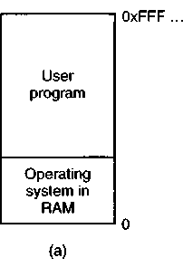
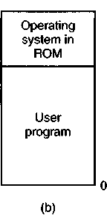
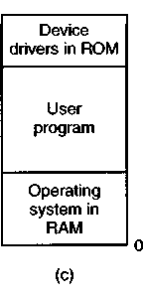

Figure 4-1. Three simple ways of organizing memory with an operating system and one user process. Other possibilities also exist.
When the system is organized in this way, only one process at a time can be running. As soon as the user types a command, the operating system copies the

requested program from disk to memory and executes it. When the process finishes, the operating system displays a prompt character and waits for a new command. When it receives the command, it loads a new program into memory, overwriting the first one.
4.1.2 Multiprogramming with Fixed Partitions
Although monoprogramming is sometimes used on small computers with simple operating systems, often it is desirable to allow multiple processes to run at once. On timesharing systems, having multiple processes in memory at once means that when one process is blocked waiting for I/O to finish, another one can use the CPU. Thus multiprogramming increases the CPU utilization. However, even on personal computers it is often useful to be able to run two or more programs at once.
The easiest way to achieve multiprogramming is simply to divide memory up into n (possibly unequal) partitions. This partitioning can, for example, be done manually when the system is started up.
When a job arrives, it can be put into the input queue for the smallest partition large enough to hold it. Since the partitions are fixed in this scheme, any space in a partition not used by a job is lost. In Fig. 4-2(a) we see how this system of fixed partitions and separate input queues looks.

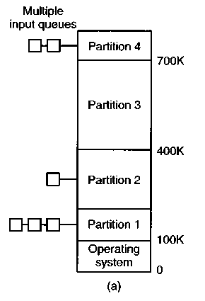
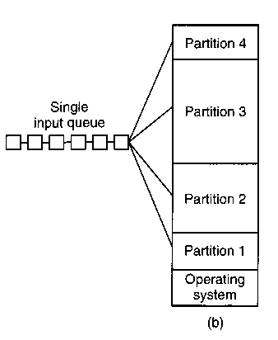

Figure 4-2. (a) Fixed memory partitions with separate input queues for each partition, (b) Fixed memory partitions with a single input queue.
The disadvantage of sorting the incoming jobs into separate queues become^ apparent when the queue for a large partition is empty but the queue for a sinal'.

partition is full, as is the case for partitions 1 and 3 in Fig. 4-2(a). An alternative organization is to maintain a single queue as in Fig. 4-2(b). Whenever a partition becomes free, the job closest to the front of the queue that fits in it could be loaded into the empty partition and run. Since it is undesirable to waste a large partition on a small job, a different strategy is to search the whole input queue whenever a partition becomes free and pick the largest job that fits. Note that the latter algorithm discriminates against small jobs as being unworthy of having a whole partition, whereas usually it is desirable to give the smallest jobs (assumed to be interactive jobs) the best service, not the worst.
One way out is to have at least one small partition around. Such a partition will allow small jobs to run without having to allocate a large partition for them.
Another approach is to have a rule stating that a job that is eligible to run may not be skipped over more than k times. Each time it is skipped over, it gets one point. When it has acquired k points, it may not be skipped again.
This system, with fixed partitions set up by the operator in the morning and not changed thereafter, was used by OS/360 on large IBM mainframes for many years. It was called MFT (Multiprogramming with a Fixed number of Tasks or OS/MFT). It is simple to understand and equally simple to implement: incoming jobs are queued until a suitable partition is available, at which time the job is loaded into that partition and run until it terminates. Nowadays, few, if any, operating systems, support this model.
Relocation and Protection
Multiprogramming introduces two essential problems that must be solved— relocation and protection. Look at Fig. 4-2. From the figure it is clear that different jobs will be run at different addresses. When a program is linked (i.e., the main program, user-written procedures, and library procedures are combined into a single address space), the linker must know at what address the program will begin in memory.
For example, suppose that the first instruction is a call to a procedure at absolute address 100 within the binary file produced by the linker. If this program is loaded in partition 1, that instruction will jump to absolute address 100, which is inside the operating system. What is needed is a call to 100K + 100. If the program is loaded into partition 2, it must be carried out as a call to 200K + 100, and so on. This problem is known as the relocation problem.
One possible solution is to actually modify the instructions as the program is loaded into memory. Programs loaded into partition 1 have 100K added to each address, programs loaded into partition 2 have 200K added to addresses, and so forth. To perform relocation during loading like this, the linker must include in the binary program a list or bit map telling which program words are addresses to be relocated and which are opcodes, constants, or other items that must not be relocated. OS/MFT worked this way. Some microcomputers also work like this.
Relocation during loading does not solve the protection problem. A malicious program can always construct a new instruction and jump to it. Because programs in this system use absolute memory addresses rather than addresses relative to a register, there is no way to stop a program from building an instruction that reads or writes any word in memory. In multiuser systems, it is undesirable to let processes read and write memory belonging to other users.
The solution that IBM chose for protecting the 360 was to divide memory into blocks of 2K bytes and assign a 4-bit protection code to each block. The PSW contained a 4-bit key. The 360 hardware trapped any attempt by a running process to access memory whose protection code differed from the PSW key. Since only the operating system could change the protection codes and key, user processes were prevented from interfering with one another and with the operating system itself.
An alternative solution to both the relocation and protection problems is to equip the machine with two special hardware registers, called the base and limit registers. When a process is scheduled, the base register is loaded with the address of the start of its partition, and the limit register is loaded with the length of the partition. Every memory address generated automatically has the base register contents added to it before being sent to memory. Thus if the base register is 100K, a CALL 100 instruction is effectively turned into a CALL 100K + 100 instruction, without the instruction itself being modified. Addresses are also checked against the limit register to make sure that they do not attempt to address memory outside the current partition. The hardware protects the base and limit registers to prevent user programs from modifying them.
The CDC 6600—the world's first supercomputer—used this scheme. The Intel 8088 CPU used for the original IBM PC used a weaker version of this scheme—base registers, but no limit registers. Starting with the 286, a better scheme was adopted.
4.2 SWAPPING
With a batch system, organizing memory into fixed partitions is simple and effective. Each job is loaded into a partition when it gets to the head of the queue. It stays in memory until it has finished. As long as enough jobs can be kept in memory to keep the CPU busy all the time, there is no reason to use anything more complicated.
With timesharing systems or graphically oriented personal computers, the situation is different. Sometimes there is not enough main memory to hold all the currently active processes, so excess processes must be kept on disk and brought in to run dynamically.
Two general approaches to memory management can be used, depending un part) on the available hardware. The simplest strategy, called swapping. coiim>i>
of bringing in each process in its entirety, running it for a while, then putting it back on the disk. The other strategy, called virtual memory, allows programs to run even when they are only partially in main memory. Below we will studying swapping; in Sec. 4-3 we will examine virtual memory.
The operation of a swapping system is illustrated in Fig. 4-3. Initially only process A is in memory. Then processes B and C are created or swapped in from disk. In Fig. 4-3(d) A terminates or is swapped out to disk. Then D comes in and B goes out. Finally E comes in.
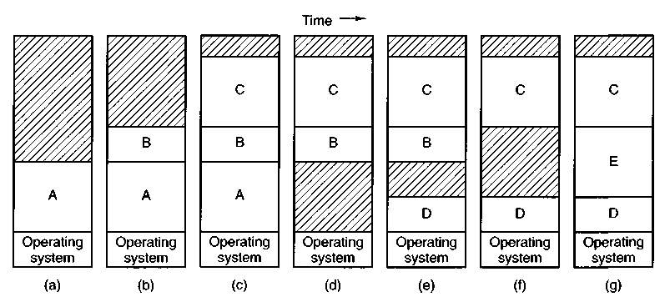
Figure 4-3. Memory allocation changes as processes come into memory and leave it. The shaded regions are unused memory.
The main difference between the fixed partitions of Fig. 4-2 and the variable partitions of Fig. 4-3 is that the number, location, and size of the partitions vary dynamically in the latter as processes come and go, whereas they are fixed in the former. The flexibility of not being tied to a fixed number of partitions that may be too large or too small improves memory utilization, but it also complicates allocating and deallocating memory, as well as keeping track of it.
When swapping creates multiple holes in memory, it is possible to combine them all into one big one by moving all the processes downward as far as possible. This technique is known as memory compaction. It is usually not done because it requires a lot of CPU time. For example, on a 32-MB machine that can copy 16 bytes per microsecond, it takes 2 sec to compact all of memory.
A point that is worth making concerns how much memory should be allocated for a process when it is created or swapped in. If processes are created with a fixed size that never changes, then the allocation is simple: you allocate exactly what is needed, no more and no less.
If, however, processes' data segments can grow, for example, by dynamically allocating memory from a heap, as in many programming languages, a problem occurs whenever a process tries to grow. If a hole is adjacent to the process, it
can be allocated and the process allowed to grow into the hole. On the other hand, if the process is adjacent to another process, the growing process will either have to be moved to a hole in memory large enough for it, or one or more processes will have to be swapped out to create a large enough hole. If a process cannot grow in memory and the swap area on the disk is full, the process will have to wait or be killed.
If it is expected that most processes will grow as they run, it is probably a good idea to allocate a little extra memory whenever a process is swapped in or moved, to reduce the overhead associated with moving or swapping processes that no longer fit in their allocated memory. However, when swapping processes to disk, only the memory actually in use should be swapped; it is wasteful to swap the extra memory as well. In Fig. 4-4(a) we see a memory configuration in which space for growth has been allocated to two processes.
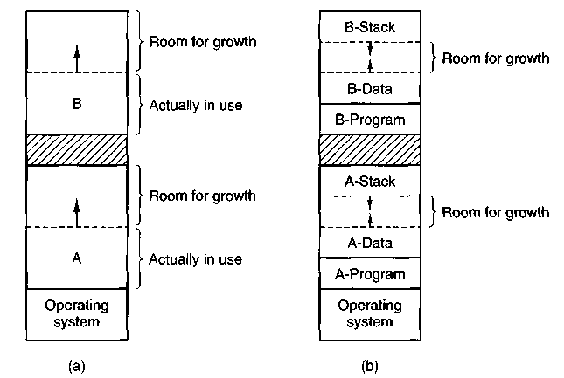
Figure 4-4. (a) Allocating space for a growing data segment, (b) Allocating space for a growing stack and a growing data segment.
If processes can have two growing segments, for example, the data segment being used as a heap for variables that are dynamically allocated and released and a stack segment for the normal local variables and return addresses, an alternative arrangement suggests itself, namely that of Fig. 4-4(b). In this figure we see that each process illustrated has a stack at the top of its allocated memory that is growing downward, and a data segment just beyond the program text that is growing upward. The memory between them can be used for either segment. If it runs out, either the process will have to be moved to a hole with enough space, swapped out of memory until a large enough hole can be created, or killed.
4.2.1 Memory Management with Bit Maps
When memory is assigned dynamically, the operating system must manage it. In general terms, there are two ways to keep'track of memory usage: bit maps and free lists. In this section and the next one we will look at these two methods in turn.
With a bit map, memory is divided up into allocation units, perhaps as small as a few words and perhaps as large as several kilobytes. Corresponding to each allocation unit is a bit in the bit map, which is 0 if the unit is free and 1 if it is occupied (or vice versa). Figure 4-5 shows part of memory and the corresponding bit map.
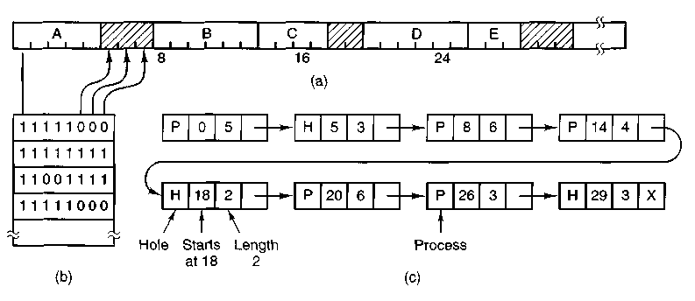
Figure 4-5. (a) A part of memory with five processes and three holes. The tick marks show the memory allocation units. The shaded regions (0 in the bit map) are free, (b) The corresponding bit map. (c) The same information as a list.
The size of the allocation unit is an important design issue. The smaller the allocation unit, the larger the bit map. However, even with an allocation unit as small as 4 bytes, 32 bits of memory will require only 1 bit of the map. A memory of 32« bits will use n map bits, so the bit map will take up only 1/33 of memory. If the allocation unit is chosen large, the bit map will be smaller, but appreciable memory may be wasted in the last unit if the process size is not an exact multiple of the allocation unit.
A bit map provides a simple way to keep track of memory words in a fixed amount of memory because the size of the bit map depends only on the size of memory and the size of the allocation unit. The main problem with it is that when it has been decided to bring a k unit process into memory, the memory manager must search the bit map to find a run of k consecutive 0 bits in the map. Searching a bit map for a run of a given length is a slow operation (because the run may straddle word boundaries in the map); this is an argument against bit maps.
4.2.2 Memory Management with Linked Lists
Another way of keeping track of memory is to maintain a linked list of allocated and free memory segments, where a segment is either a process or a hole between two processes. The memory of Fig. 4-5(a) is represented in Fig. 4-5(c) as a linked list of segments. Each entry in the list specifies a hole (H) or process (P), the address at which it starts, the length, and a pointer to the next entry.
In this example, the segment list is kept sorted by address. Sorting this way has the advantage that when a process terminates or is swapped out, updating the list is straightforward. A terminating process normally has two neighbors (except when it is at the very top or bottom of memory). These may be either processes or holes, leading to the four combinations of Fig. 4-6. In Fig. 4-6(a) updating the list requires replacing a P by an H. In Fig. 4-6(b) and Fig. 4-6(c), two entries are coalesced into one, and the list becomes one entry shorter. In Fig. 4-6(d), three entries are merged and two items are removed from the list. Since the process table slot for the terminating process will normally point to the list entry for the process itself, it may be more convenient to have the list as a double-linked list, rather than the single-linked list of Fig. 4-5(c). This structure makes it easier to find the previous entry and to see if a merge is possible.
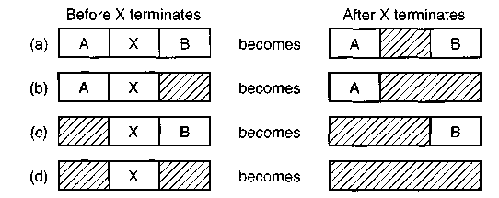
Figure 4-6. Four neighbor combinations for the terminating process, X.
When the processes and holes are kept on a list sorted by address, several algorithms can be used to allocate memory for a newly created or swapped in process. We assume that the memory manager knows how much memory to allocate. The simplest algorithm is first fit. The memory manager scans along the list of segments until it finds a hole that is big enough. The hole is then broken up into two pieces, one for the process and one for the unused memory, except in the unlikely case of an exact fit. First fit is a fast algorithm because it searches as little as possible.
A minor variation of first fit is next fit. It works the same way as first fit, except that it keeps track of where it is whenever it finds a suitable hole. The next time it is called to find a hole, it starts searching the list from the place where it left off last time, instead of always at the beginning, as first fit does. Simulations by Bays (1977) show that next fit gives slightly worse performance than first fit.
Another well-known algorithm is best fit. Best fit searches the entire list and takes the smallest hole that is adequate. Rather than breaking up a big hole that might be needed later, best fit tries to find a hole that is close to the actual size needed.
As an example of first fit and best fit, consider Fig. 4-5 again. If a block of size 2 is needed, first fit will allocate the hole at 5, but best fit will allocate the hole at 18.
Best fit is slower than first fit because it must search the entire list every time it is called. Somewhat surprisingly, it also results in more wasted memory than first fit or next fit because it tends to fill up memory with tiny, useless holes. First fit generates larger holes on the average.
To get around the problem of breaking up nearly exact matches into a process and a tiny hole, one could think about worst fit, that is, always take the largest available hole, so that the hole broken off will be big enough to be useful. Simulation has shown that worst fit is not a very good idea either.
All four algorithms can be speeded up by maintaining separate lists for processes and holes. In this way, all of them devote their full energy to inspecting holes, not processes. The inevitable price that is paid for this speedup on allocation is the additional complexity and slowdown when deallocating memory, since a freed segment has to be removed from the process list and inserted into the hole list.
If distinct lists are maintained for processes and holes, the hole list may be kept sorted on size, to make best fit faster. When best fit searches a list of holes from smallest to largest, as soon as it finds a hole that fits, it knows that the hole is the smallest one that will do the job, hence the best fit. No further searching is needed, as it is with the single list scheme. With a hole list sorted by size, first fit and best fit are equally fast, and next fit is pointless.
When the holes are kept on separate lists from the processes, a small optimization is possible. Instead of having a separate set of data structures for maintaining the hole list, as is done in Fig. 4-5(c), the holes themselves can be used. The first word of each hole could be the hole size, and the second word a pointer to the following entry. The nodes of the list of Fig. 4-5(c), which require three words and one bit (P/H), are no longer needed.
Yet another allocation algorithm is quick fit, which maintains separate lists for some of the more common sizes requested. For example, it might have a table with n entries, in which the first entry is a pointer to the head of a list of 4K holes, the second entry is a pointer to a list of 8K holes, the third entry a pointer to 12K holes, and so on. Holes of say, 2IK, could either be put on the 20K list or on a special list of odd-sized holes. With quick fit, finding a hole of the required size is extremely fast, but it has the same disadvantage as all schemes that sort by hole size, namely, when a process terminates or is swapped out, finding its neighbors to see if a merge is possible is expensive. If merging is not done, memory will quickly fragment into a large number of small holes into which no processes fit.
4.3 VIRTUAL MEMORY
Many years ago people were first confronted with programs that were too big to fit in the available memory. The solution usually adopted was to split the program into pieces, called overlays. Overlay 0 would start running first. When it was done, it would call another overlay. Some overlay systems were highly complex, allowing multiple overlays in memory at once. The overlays were kept on the disk and swapped in and out of memory by the operating system, dynamically, as needed.
Although the actual work of swapping overlays in and out was done by the system, the work of splitting the program into pieces had to be done by the programmer. Splitting up large programs into small, modular pieces was time consuming and boring. It did not take long before someone thought of a way to turn the whole job over to the computer.
The method that was devised (Fotheringham, 1961) has come to be known as virtual memory. The basic idea behind virtual memory is that the combined size of the program, data, and stack may exceed the amount of physical memory available for it. The operating system keeps those parts of the program currently in use in main memory, and the rest on the disk. For example, a 16M program can run on a 4M machine by carefully choosing which 4M to keep in memory at each instant, with pieces of the program being swapped between disk and memory as needed.
Virtual memory can also work in a multiprogramming system, with bits and pieces of many programs in memory at once. While a program is waiting for part of itself to be brought in, it is waiting for I/O and cannot run, so the CPU can be given to another process, the same way as for any other multiprogramming system.
4.3.1 Paging
Most virtual memory systems use a technique called paging, which we will now describe. On any computer, there exists a set of memory addresses that programs can produce. When a program uses an instruction like
MOVE REG.1000
it is copying the contents of memory address 1000 to REG (or vice versa, depending on the computer). Addresses can be generated using indexing, base registers, segment registers, and other ways.
These program-generated addresses are called virtual addresses and form the virtual address space. On computers without virtual memory, the virtual address
is put directly onto the memory bus and causes the physical memory word with the same address to be read or written. When virtual memory is used, the virtual addresses do not go directly to the memory bus. Instead, they go to a Memory Management Unit (MMU), a chip or collection of chips that maps the virtual addresses onto the physical memory addresses as illustrated in Fig. 4-7.
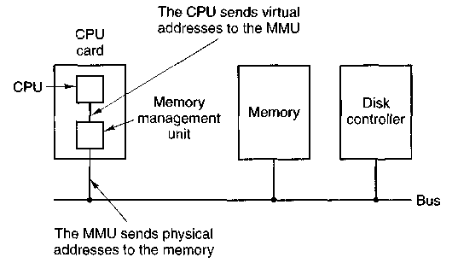
Figure 4-7. The position and function of the MMU.
A very simple example of how this mapping works is shown in Fig. 4-8. In this example, we have a computer that can generate 16-bit addresses, from 0 up to 64K. These are the virtual addresses. This computer, however, has only 32K of physical memory, so although 64K programs can be written, they cannot be loaded into memory in their entirety and run. A complete copy of a program's core image, up to 64K, must be present on the disk, however, so that pieces can be brought in as needed.
The virtual address space is divided up into units called pages. The corresponding units in the physical memory are called page frames. The pages and page frames are always exactly the same size. In this example they are 4K, but page sizes from 512 bytes to 64K are commonly used in existing systems. With 64K of virtual address space and 32K of physical memory, we have 16 virtual pages and 8 page frames. Transfers between memory and disk are always in units of a page.
When the program tries to access address 0, for example, using the instruction
MOVE REG,0
the virtual address 0 is sent to the MMU. The MMU sees that this virtual address falls in page 0 (0 to 4095), which according to its mapping is page frame 2 (8192 to 12287). It thus transforms the address to 8192 and outputs address 8192 onto the bus. The memory board knows nothing at all about the MMU and just sees a
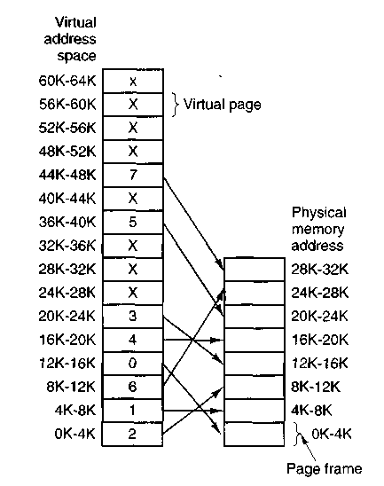
Figure 4-8. The relation between virtual addresses and physical memory addresses is given by the page table.
request for reading or writing address 8192, which it honors. Thus, the MMU has effectively mapped all virtual addresses between 0 and 4095 onto physical addresses 8192 to 12287.
Similarly, an instruction
MOVE REG,8192
is effectively transformed into
MOVE REG,24576
because virtual address 8192 is in virtual page 2 and this page is mapped onto physical page frame 6 (physical addresses 24576 to 28671). As a third example, virtual address 20500 is 20 bytes from the start of virtual page 5 (virtual addresses 20480 to 24575) and maps onto physical address 12288 + 20 = 12308.
By itself, this ability to map the 16 virtual pages onto any of the eight page frames by setting the MMU's map appropriately does not solve the problem that the virtual address space is larger than the physical memory. Since we have only eight physical page frames, only eight of the virtual pages in Fig. 4-8 are mapped
onto physical memory. The others, shown as a cross in the figure, are not mapped. In the actual hardware, a Present/absent bit in each entry keeps track of whether the page is mapped or not.
What happens if the program tries to use an unmapped page, for example, by using the instruction
MOVE REG.32780
which is byte 12 within virtual page 8 (starting at 32768)? The MMU notices that the page is unmapped (indicated by a cross in the figure), and causes the CPU to trap to the operating system. This trap is called a page fault. The operating system picks a little-used page frame and writes its contents back to the disk. It then fetches the page just referenced into the page frame just freed, changes the map, and restarts the trapped instruction.
For example, if the operating system decided to evict page frame 1, it would load virtual page 8 at physical address 4K and make two changes to the MMU map. First, it would mark virtual page 1's entry as unmapped, to trap any future accesses to virtual addresses between 4K and 8K. Then it would replace the cross in virtual page 8's entry with a 1, so that when the trapped instruction is re-executed, it will map virtual address 32780 onto physical address 4108.
Now let us look inside the MMU to see how it works and why we have chosen to use a page size that is a power of 2. In Fig. 4-9 we see an example of a virtual address, 8196 (0010000000000100 in binary), being mapped using the MMU map of Fig. 4-8. The incoming 16-bit virtual address is split up into a 4-bit page number and a 12-bit offset. With 4 bits for the page number, we can represent 16 pages, and with 12 bits for the offset, we can address all 4096 bytes within a page.
The page number is used as an index into the page table, yielding the number of the page frame corresponding to that virtual page. If the Present/absent bit is 0, a trap to the operating system is caused. If the bit is 1, the page frame number found in the page table is copied to the high-order 3 bits of the output register, along with the 12-bit offset, which is copied unmodified from the incoming virtual address. Together they form a 15-bit physical address. The output register is then put onto the memory bus as the physical memory address.
4.3.2 Page Tables
In theory, the mapping of virtual addresses onto physical addresses is as we have just described it. The virtual address is split into a virtual page number (high-order bits) and an offset (low-order bits). The virtual page number is used as an index into the page table to find the entry for that virtual page. From the
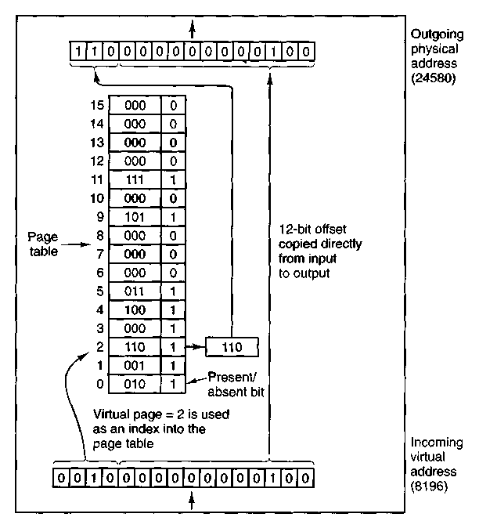
Figure 4-9. The internal operation of the MMU with 16 4K pages.
page table entry, the page frame number (if any) is found. The page frame number is attached to the high-order end of the offset, replacing the virtual page number, to form a physical address that can be sent to the memory.
The purpose of the page table is to map virtual pages onto page frames. Mathematically speaking, the page table is a function, with the virtual page number as argument and the physical frame number as result. Using the result of this function, the virtual page field in a virtual address can be replaced by a page frame field, thus forming a physical memory address.
Despite this simple description, two major issues must be faced:
1. The page table can be extremely large.
2. The mapping must be fast.
The first point follows from the fact that modern computers use virtual addresses of at least 32 bits. With, say, a 4K page size, a 32-bit address space has 1 million
pages, and a 64-bit address space has more than you want to contemplate. With 1 million pages in the virtual address space, the page table must have 1 million entries. And remember that each process needs its own page table.
The second point is a consequence of the fact that the virtual-to-physical mapping must be done on every memory reference. A typical instruction has an instruction word, and often a memory operand as well. Consequently, it is necessary to make 1, 2, or sometimes more page table references per instruction. If an instruction takes, say, 10 nsec, the page table lookup must be done in a few nanoseconds to avoid becoming a major bottleneck.
The need for large, fast page mapping is a significant constraint on the way computers are built. Although the problem is most serious with top-of-the-line machines, it is also an issue at the low end as well, where cost and price/performance are critical. In this section and the following ones, we will look at page table design in detail and show a number of hardware solutions that have been used in actual computers.
The simplest design (at least conceptually) is to have a single page table consisting of an array of fast hardware registers, with one entry for each virtual page, indexed by virtual page number. When a process is started up, the operating system loads the registers with the process' page table, taken from a copy kept in main memory. During process execution, no more memory references are needed for the page table. The advantages of this method are that it is straightforward and requires no memory references during mapping. A disadvantage is that it is potentially expensive (if the page table is large). Having to load the page table at every context switch can also hurt performance.
At the other extreme, the page table can be entirely in main memory. All the hardware needs then is a single register that points to the start of the page table. This design allows the memory map to be changed at a context switch by reloading one register. Of course, it has the disadvantage of requiring one or more memory references to read page table entries during the execution of each instruction. For this reason, this approach is rarely used in its most pure form, but below we will study some variations that have much better performance.
Multilevel Page Tables
To get around the problem of having huge page tables in memory all the time, many computers use a multilevel page table. A simple example is shown in Fig. 4-10. In Fig. 4-10(a) we have a 32-bit virtual address that is partitioned into a 10-bit PT1 field, a 10-bit PT2 field, and a 12-bit Offset field. Since offsets are 12 bits, pages are 4K, and there are a total of 2²⁰ of them.
The secret to the multilevel page table method is to avoid keeping all the page tables in memory all the time. In particular, those that are not needed should not be kept around. Suppose, for example, that a process needs 12 megabytes, the bottom 4 megabytes of memory for program text, the next 4 megabytes for data,
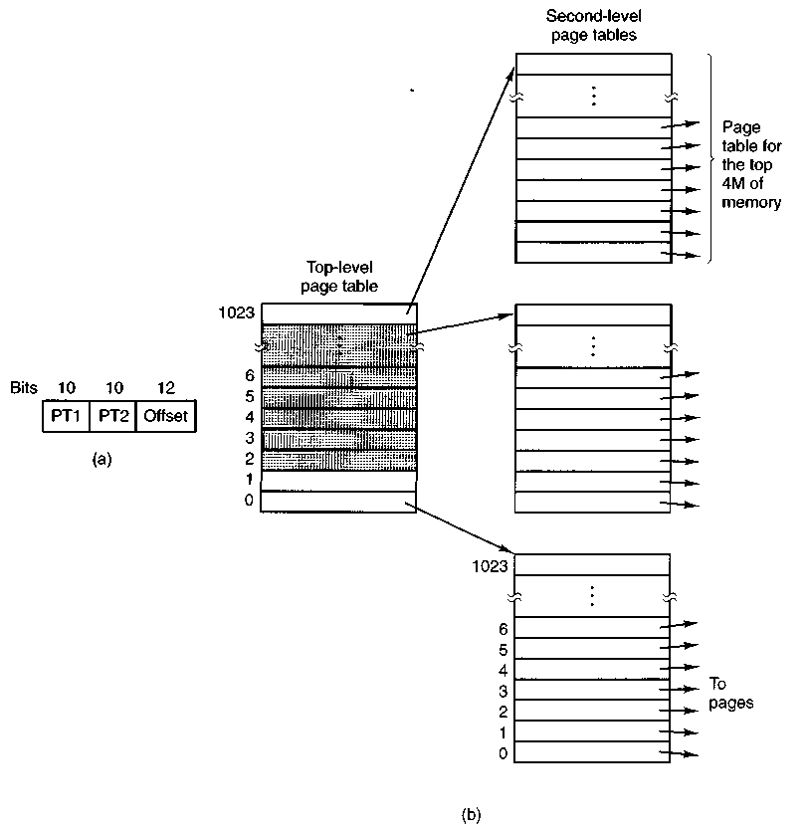
Figure 4-10. (a) A 32-bit address with two page table fields, (b) Two-level page tables.
and the top 4 megabytes for the stack. In between the top of the data and the bottom of the stack is a gigantic hole that is not used.
In Fig. 4-10(b) we see how the two-level page table works in this example. On the left we have the top-level page table, with 1024 entries, corresponding to the 10-bit PT1 field. When a virtual address is presented to the MMU. it first extracts the PT1 field and uses this value as an index into the top-level page table. Each of these 1024 entries represents 4M because the entire 4-gigabyte (i.e., 32-bit) virtual address space has been chopped into chunks of 1024 bytes.
The entry located by indexing into the top-level page table yields the address or the page frame number of a second-level page table. Entry 0 of the top-level page table points to the page table for the program text, entry 1 points to the page table for the data, and entry 1023 points to the page table for the stack. The other (shaded) entries are not used. The PT2 field is now used as an index into the selected second-level page table to find the page frame number for the page itself.
As an example, consider the 32-bit virtual address 0x00403004 (4,206,596 decimal), which is 12,292 bytes into the data. This address corresponds to PT1 = 1, PT2 = 3, and Offset = 4. The MMU first uses PT1 to index into the top-level page table and obtain entry 1, which corresponds to addresses 4M to 8M. It then uses PT2 to index into the second-level page table just found and extract entry 3, which corresponds to addresses 12288 to 16383 within its 4M chunk (i.e., absolute addresses 4,206,592 to 4,210,687). This entry contains the page frame number of the page containing virtual address 0x00403004. If that page is not in memory, the Present/absent bit in the page table entry will be zero, causing a page fault. If the page is in memory, the page frame number taken from the second-level page table is combined with the offset (4) to construct a physical address. This address is put on the bus and sent to memory.
The interesting thing to note about Fig. 4-10 is that although the address space contains over a million pages, only four page tables are actually needed: the top-level table, and the second-level tables for 0 to 4M, 4M to 8M, and the top 4M. The Present/absent bits in 1021 entries of the top-level page table are set to 0, forcing a page fault if they are ever accessed. Should this occur, the operating system will notice that the process is trying to reference memory that it is not supposed to and will take appropriate action, such as sending it a signal or killing it. In this example we have chosen round numbers for the various sizes and have picked PT1 equal to PT2 but in actual practice other values are also possible, of course.
The two-level page table system of Fig. 4-10 can be expanded to three, four, or more levels. Additional levels give more flexibility, but it is doubtful that the additional complexity is worth it beyond three levels.
Let us now turn from the structure of the page tables in the large, to the details of a single page table entry. The exact layout of an entry is highly machine dependent, but the kind of information present is roughly the same from machine to machine. In Fig. 4-11 we give a sample page table entry. The size varies from computer to computer, but 32 bits is a common size. The most important field is the Page frame number. After all, the goal of the page mapping is to locate this value. Next to it we have the Present/absent bit. If this bit is 1, the entry is valid and can be used. If it is 0, the virtual page to which the entry belongs is not currently in memory. Accessing a page table entry with this bit set to 0 causes a page fault.
The Protection bits tell what kinds of access are permitted. In the simplest form, this field contains 1 bit, with 0 for read/write and 1 for read only. A more
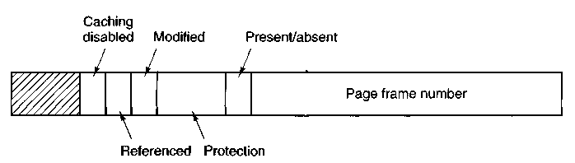
Figure 4-11. A typical page table entry.
sophisticated arrangement is having 3 bits, one bit each for enabling reading, writing, and executing the page.
The Modified and Referenced bits keep track of page usage. When a page is written to, the hardware automatically sets the Modified bit. This bit is of value when the operating system decides to reclaim a page frame. If the page in it has been modified (i.e., is "dirty"), it must be written back to the disk. If it has not been modified (i.e., is "clean"), it can just be abandoned, since the disk copy is still valid. The bit is sometimes called the dirty bit, since it reflects the page's state.
The Referenced bit is set whenever a page is referenced, either for reading or writing. Its value is to help the operating system choose a page to evict when a page fault occurs. Pages that are not being used are better candidates than pages that are, and this bit plays an important role in several of the page replacement algorithms that we will study later in this chapter.
Finally, the last bit allows caching to be disabled for the page. This feature is important for pages that map onto device registers rather than memory. If the operating system is sitting in a tight loop waiting for some I/O device to respond to a command it was just given, it is essential that the hardware keep fetching the word from the device, and not use an old cached copy. With this bit, caching can be turned off. Machines that have a separate I/O space and do not use memory mapped I/O do not need this bit.
Note that the disk address used to hold the page when it is not in memory is not part of the page table. The reason is simple. The page table holds only that information the hardware needs to translate a virtual address to a physical address. Information the operating system needs to handle page faults is kept in software tables inside the operating system.
4.3.3 TLBs—Translation Lookaside Buffers
In most paging schemes, the page tables are kept in memory, due to their large size. Potentially, this design has an enormous impact on performance. Consider, for example, an instruction that copies one register to another. In the absence of paging, this instruction makes only one memory reference, to fetch the
instruction. With paging, additional memory references will be needed to access the page table. Since execution speed is generally limited by the rate the CPU can get instructions and data out of the memory, having to make two page table references per memory reference reduces performance by 2/3. Under these conditions, no one would use it.
Computer designers have known about this problem for years and have come up with a solution. Their solution is based on the observation that most programs tend to make a large number of references to a small number of pages, and not the other way around. Thus only a small fraction of the page table entries are heavily read; the rest are barely used at all.
The solution that has been devised is to equip computers with a small hardware device for mapping virtual addresses to physical addresses without going through the page table. The device, called a TLB (Translation Lookaside Buffer) or sometimes an associative memory, is illustrated in Fig. 4-12. It is usually inside the MMU and consists of a small number of entries, eight in this example, but rarely more than 64. Each entry contains information about one page, in particular, the virtual page number, a bit that is set when the page is modified, the protection code (read/write/execute permissions), and the physical page frame in which the page is located. These fields have a one-to-one correspondence with the fields in the page table. Another bit indicates whether the entry is valid (i.e., in use) or not.
Valid | Virtual page | Modified | Protection | Page frame
1 | 140 | 1 | RW | 31
1 | 20 | 0 | R X | 38
1 | 130 | 1 | RW | 29
1 | 129 | 1 | RW | 62
1 | 19 | 0 | ——————— R X | 50
1 | 21 | 0 | R X | 45
1 | 860 | 1 | RW | 14
1 | 861 | 1 | RW | 75
Figure 4-12. A TLB to speed up paging.
An example that might generate the TLB of Fig. 4-12 is a process in a loop that spans virtual pages 19, 20, and 21, so these TLB entries have protection codes for reading and executing. The main data currently being used (say. an array being processed) are on pages 129 and 130. Page 140 contains the indices used in the array calculations. Finally, the stack is on pages 860 and 861.
Let us now see how the TLB functions. When a virtual address is presented to the MMU for translation, the hardware first checks to see if its virtual page
number is present in the TLB by comparing it to all the entries simultaneously (i.e., in parallel). If a valid match is found and the access does not violate the protection bits, the page frame is taken directly from the TLB, without going to the page table. If the virtual page number is present in the TLB but the instruction is trying to write on a read-only page, a protection fault is generated, the same way as it would be from the page table itself.
The interesting case is what happens when the virtual page number is not in the TLB. The MMU detects the miss and does an ordinary page table lookup. It then evicts one of the entries from the TLB and replaces it with the page table entry just looked up. Thus if that page is used again soon, the second time it will result in a hit rather than a miss. When an entry is purged from the TLB, the modified bit is copied back into the page table entry in memory. The other values are already there. When the TLB is loaded from the page table, all the fields are taken from memory.
Software TLB Management
Up until now, we have assumed that every machine with paged virtual memory has page tables recognized by the hardware, plus a TLB. In this design, TLB management and handling TLB faults are done entirely by the MMU hardware. Traps to the operating system occur only when a page is not in memory.
In the past, this assumption was true. However, some modern RISC machines, including the MIPS, Alpha, and HP PA, do nearly all of this page management in software. On these machines, the TLB entries are explicitly loaded by the operating system. When a TLB miss occurs, instead of the MMU just going to the page tables to find and fetch the needed page reference, it just generates a TLB fault and tosses the problem into the lap of the operating system. The system must find the page, remove an entry from the TLB, enter the new one, and restart the instruction that faulted. And, of course, all of this must be done in a handful of instructions because TLB misses occur much more frequently than page faults.
Surprisingly enough, if the TLB is reasonably large (say, 64 entries) to reduce the miss rate, software management of the TLB turns out to be quite efficient. The main gain here is a much simpler MMU, which frees up a considerable amount of area on the CPU chip for caches and other features that can improve performance. Software TLB management is discussed at length by Uhlig et al. (1994).
Various strategies have been developed to improve performance on machines that do TLB management in software. One approach attacks both reducing TLB misses and reducing the cost of a TLB miss when it does occur (Bala et al.. 1994). To reduce TLB misses, sometimes the operating system can use its intuition to figure out which pages are likely to be used next and to preload entries for them in the TLB. For example, when a client process does an RPC to a server process on
the same machine, it is very likely that the server will have to run soon. Knowing this, while processing the trap to do the RFC, the system can also check to see where the server's code, data, and stack pages are, and map them in before they can cause TLB faults.
The normal way to process a TLB miss, whether in hardware or in software, is to go to the page table and perform the indexing operations to locate the page referenced. The problem with doing this search in software is that the pages holding the page table may not be in the TLB, which will cause additional TLB faults during the processing. These faults can be reduced by maintaining a large (e.g., 4K) software cache of TLB entries in a fixed location whose page is always kept in the TLB. By first checking the software cache, the operating system can substantially reduce TLB misses.
4.3.4 Inverted Page Tables
Traditional page tables of the type described so far require one entry per virtual page, since they are indexed by virtual page number. If the address space consists of 2³² bytes, with 4096 bytes per page, then over 1 million page table entries are needed. As a bare minimum, the page table will have to be at least 4 megabytes. On larger systems, this size is probably doable.
However, as 64-bit computers become more common, the situation changes drastically. If the address space is now 2⁶⁴ bytes, with 4K pages, we need over 10¹⁵ bytes for the page table. Tying up 1 million gigabytes just for the page table is not doable, not now and not for decades to come, if ever. Consequently, a different solution is needed for 64-bit paged virtual address spaces.
One such solution is the inverted page table. In this design, there is one entry per page frame in real memory, rather than one entry per page of virtual address space. For example, with 64-bit virtual addresses, a 4K page, and 32 MB of RAM, an inverted page table only requires 8192 entries. The entry keeps track of which (process, virtual page) is located in the page frame.
Although inverted page tables save vast amounts of space, at least when the virtual address space is much larger than the physical memory, they have a serious downside: virtual-to-physical translation becomes much harder. When process n references virtual page p, the hardware can no longer find the physical page by using p as an index into the page table. Instead, it must search the entire inverted page table for an entry (n, p). Furthermore, this search must be done on every memory reference, not just on page faults. Searching an 8K table on every memory reference is not the way to make your machine blindingly fast.
The way out of this dilemma is to use the TLB. If the TLB can hold all of the heavily used pages, translation can happen just as fast as with regular page tables. On a TLB miss, however, the inverted page table has to be searched. Using a hash table as an index into the inverted page table, this search can be made reasonably fast, however. Inverted page tables are currently used on some IBM and
Hewlett-Packard workstations and will become more common as 64-bit machines become widespread.
Other approaches to handling large virtual memories can be found in (Huck and Hays, 1993; Talluri and Hill, 1994; and Talluri et al., 1995).
4.4 PAGE REPLACEMENT ALGORITHMS
When a page fault occurs, the operating system has to choose a page to remove from memory to make room for the page that has to be brought in. If the page to be removed has been modified while in memory, it must be rewritten to the disk to bring the disk copy up to date. If, however, the page has not been changed (e.g., a page contains program text), the disk copy is already up to date, so no rewrite is needed. The page to be read in just overwrites the page being evicted.
While it would be possible to pick a random page to replace at each page fault, system performance is much better if a page that is not heavily used is chosen. If a heavily used page is removed, it will probably have to be brought back in quickly, resulting in extra overhead. Much work has been done on the subject of page replacement algorithms, both theoretical and experimental. Below we will describe some of the most important algorithms.
4.4.1 The Optimal Page Replacement Algorithm
The best possible page replacement algorithm is easy to describe but impossible to implement. It goes like this. At the moment that a page fault occurs, some set of pages is in memory. One of these pages will be referenced on the very next instruction (the page containing that instruction). Other pages may not be referenced until 10, 100, or perhaps 1000 instructions later. Each page can be labeled with the number of instructions that will be executed before that page is first referenced.
The optimal page algorithm simply says that the page with the highest label should be removed. If one page will not be used for 8 million instructions and another page will not be used for 6 million instructions, removing the former pushes the page fault that will fetch it back as far into the future as possible. Computers, like people, try to put off unpleasant events for as long as they can.
The only problem with this algorithm is that it is unrealizable. At the time of the page fault, the operating system has no way of knowing when each of the pages will be referenced next. (We saw a similar situation earlier with the shortest job first scheduling algorithm—how can the system tell which job is shortest?) Still, by running a program on a simulator and keeping track of all page references, it is possible to implement optimal page replacement on the second run by using the page reference information collected during the first run.
In this way it is possible to compare the performance of realizable algorithms with the best possible one. If an operating system achieves a performance of, say, only 1 percent worse than the optimal algorithm, effort spent in looking for a better algorithm will yield at most a 1 percent- improvement.
To avoid any possible confusion, it should be made clear that this log of page references refers only to the one program just measured. The page replacement algorithm derived from it is thus specific to that one program. Although this method is useful for evaluating page replacement algorithms, it is of no use in practical systems. Below we will study algorithms that are useful on real systems.
4.4.2 The Not Recently Used Page Replacement Algorithm
In order to allow the operating system to collect useful statistics about which pages are being used and which ones are not, most computers with virtual memory have two status bits associated with each page. R is set whenever the page is referenced (read or written). M is set when the page is written to (i.e., modified). The bits are contained in each page table entry, as shown in Fig. 4-11. It is important to realize that these bits must be updated on every memory reference, so it is essential that they be set by the hardware. Once a bit has been set to 1, it stays 1 until the operating system resets it to 0 in software.
If the hardware does not have these bits, they can be simulated as follows. When a process is started up, all of its page table entries are marked as not in memory. As soon as any page is referenced, a page fault will occur. The operating system then sets the R bit (in its internal tables), changes the page table entry to point to the correct page, with mode READ ONLY, and restarts the instruction. If the page is subsequently written on, another page fault will occur, allowing the operating system to set the M bit and change the page's mode to READ/WRITE.
The R and M bits can be used to build a simple paging algorithm as follows. When a process is started up, both page bits for all its pages are set to 0 by the operating system. Periodically (e.g., on each clock interrupt), the R bit is cleared, to distinguish pages that have not been referenced recently from those that have been.
When a page fault occurs, the operating system inspects all the pages and divides them into four categories based on the current values of their R and M bits:
Class 0: not referenced, not modified. Class 1: not referenced, modified. Class 2: referenced, not modified. Class 3: referenced, modified.
Although class 1 pages seem, at first glance, impossible, they occur when a class 3 page has its R bit cleared by a clock interrupt. Clock interrupts do not clear the
M bit because this information is needed to know whether the page has to be rewritten to disk or not.
The NRU (Not Recently Used) algorithm removes a page at random from the lowest numbered nonempty class. Implicit in this algorithm is that it is better to remove a modified page that has not been referenced in at least one clock tick (typically 20 msec) than a clean page that is in heavy use. The main attraction of NRU is that it is easy to understand, efficient to implement, and gives a performance that, while certainly not optimal, is often adequate.
4.4.3 The First-In, First-Out (FIFO) Page Replacement Algorithm
Another low-overhead paging algorithm is the FIFO (First-In, First-Out) algorithm. To illustrate how this works, consider a supermarket that has enough shelves to display exactly k different products. One day, some company introduces a new convenience food—instant, freeze-dried, organic yogurt that can be reconstituted in a microwave oven. It is an immediate success, so our finite supermarket has to get rid of one old product in order to stock it.
One possibility is to find the product that the supermarket has been stocking the longest (i.e., something it began selling 120 years ago) and get rid of it on the grounds that no one is interested any more. In effect, the supermarket maintains a linked list of all the products it currently sells in the order they were introduced. The new one goes on the back of the list; the one at the front of the list is dropped.
As a page replacement algorithm, the same idea is applicable. The operating system maintains a list of all pages currently in memory, with the page at the head of the list the oldest one and the page at the tail the most recent arrival. On a page fault, the page at the head is removed and the new page added to the tail of the list. When applied to stores, FIFO might remove mustache wax, but it might also remove flour, salt, or butter. When applied to computers the same problem arises. For this reason, FIFO in its pure form is rarely used.
4.4.4 The Second Chance Page Replacement Algorithm
A simple modification to FIFO that avoids the problem of throwing out a heavily used page is to inspect the R bit of the oldest page. If it is 0, the page is both old and unused, so it is replaced immediately. If the R bit is 1, the bit is cleared, the page is put onto the end of the list of pages, and its load time is updated as though it had just arrived in memory. Then the search continues.
The operation of this algorithm, called second chance, is shown in Fig. 4-13. In Fig. 4-13(a) we see pages A through H kept on a linked list and sorted by the time they arrived in memory.
Suppose that a page fault occurs at time 20. The oldest page is A, which arrived at time 0, when the process started. If A has the R bit cleared, it is evicted from memory, either by being written to the disk (if it is dirty), or just abandoned
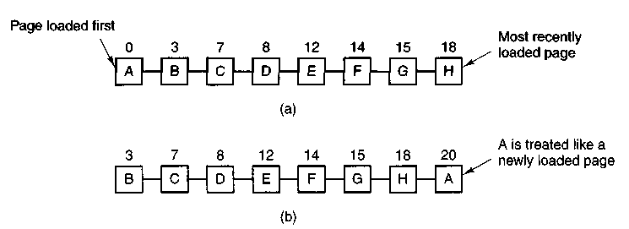
Figure 4-13. Operation of second chance, (a) Pages sorted in FIFO order, (b) Page list if a page fault occurs at time 20 and A has its R bit set.
(if it is clean). On the other hand, if the R bit is set, A is put onto the end of the list and its "load time" is reset to the current time (20). The R bit is also cleared. The search for a suitable page continues with B.
What second chance is doing is looking for an old page that has not been referenced in the previous clock interval. If all the pages have been referenced, second chance degenerates into pure FIFO. Specifically, imagine that all the pages in Fig. 4-13(a) have their R bits set. One by one, the operating system moves the pages to the end of the list, clearing the R bit each time it appends a page to the end of the list. Eventually, it comes back to page A, which now has its R bit cleared. At this point A is evicted. Thus the algorithm always terminates.
4.4.5 The Clock Page Replacement Algorithm
Although second chance is a reasonable algorithm, it is unnecessarily inefficient because it is constantly moving pages around on its list. A better approach is to keep all the pages on a circular list in the form of a clock, as shown in Fig. 4-14. A hand points to the oldest page.
When a page fault occurs, the page being pointed to by the hand is inspected. If its R bit is 0, the page is evicted, the new page is inserted into the clock in its place, and the hand is advanced one position. If R is 1, it is cleared and the hand is advanced to the next page. This process is repeated until a page is found with R = 0. Not surprisingly, this algorithm is called clock. It differs from second chance only in the implementation.
4.4.6 The Least Recently Used (LRU) Page Replacement Algorithm
A good approximation to the optimal algorithm is based on the observation that pages that have been heavily used in the last few instructions will probably be heavily used again in the next few. Conversely, pages that have not been used for
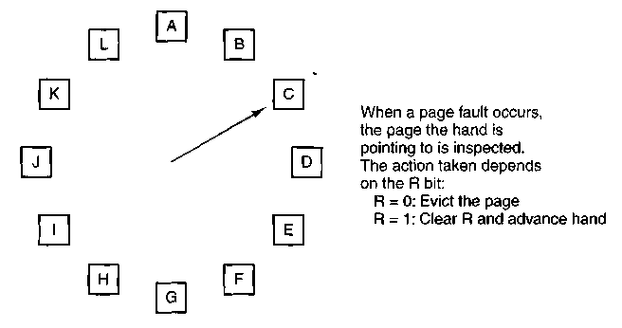
Figure 4-14. The clock page replacement algorithm.
ages will probably remain unused for a long time. This idea suggests a realizable algorithm: when a page fault occurs, throw out the page that has been unused for the longest time. This strategy is called LRU (Least Recently Used) paging.
Although LRU is theoretically realizable, it is not cheap. To fully implement LRU, it is necessary to maintain a linked list of all pages in memory, with the most recently used page at the front and the least recently used page at the rear. The difficulty is that the list must be updated on every memory reference. Finding a page in the list, deleting it, and then moving it to the front is a very time consuming operation, even in hardware (assuming that such hardware could be built).
However, there are other ways to implement LRU with special hardware. Let us consider the simplest way first. This method requires equipping the hardware with a 64-bit counter, C, that is automatically incremented after each instruction. Furthermore, each page table entry must also have a field large enough to contain the counter. After each memory reference, the current value of C is stored in the page table entry for the page just referenced. When a page fault occurs, the operating system examines all the counters in the page table to find the lowest one. That page is the least recently used.
Now let us look at a second hardware LRU algorithm. For a machine with n page frames, the LRU hardware can maintain a matrix of n x n bits, initially all zero. Whenever page frame k is referenced, the hardware first sets all the bits of row k to 1, then sets all the bits of column k to 0. At any instant, the row whose binary value is lowest is the least recently used, the row whose value is next lowest is next least recently used, and so forth. The workings of this algorithm are given in Fig. 4-15 for four page frames and page references in the order
0123210323
After page 0 is referenced we have the situation of Fig. 4-15(a), and so forth.
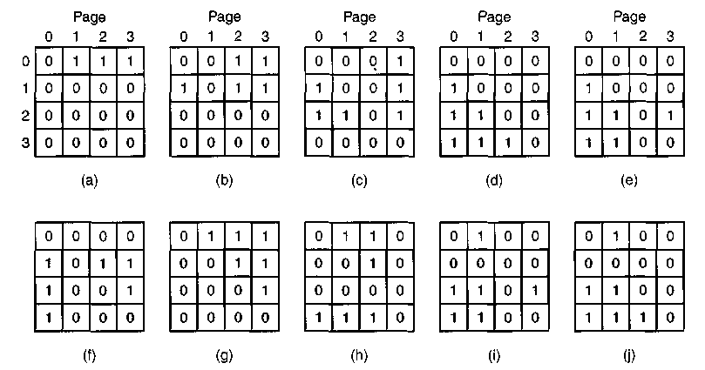
Figure 4-15. LRU using a matrix.
4.4.7 Simulating LRU in Software
Although both of the previous LRU algorithms are realizable in principle, few, if any, machines have this hardware, so they are of little use to the operating system designer who is making a system for a machine that does not have this hardware. Instead, a solution that can be implemented in software is needed. One possibility is called the Not Frequently Used or NFU algorithm. It requires a software counter associated with each page, initially zero. At each clock interrupt, the operating system scans all the pages in memory. For each page, the R bit, which is 0 or 1, is added to the counter. In effect, the counters are an attempt to keep track of how often each page has been referenced. When a page fault occurs, the page with the lowest counter is chosen for replacement.
The main problem with NFU is that it never forgets anything. For example, in a multipass compiler, pages that were heavily used during pass 1 may still have a high count well into later passes. In fact, if pass 1 happens to have the longest execution time of all the passes, the pages containing the code for subsequent passes may always have lower counts than the pass 1 pages. Consequently, the operating system will remove useful pages instead of pages no longer in use.
Fortunately, a small modification to NFU makes it able to simulate LRU quite well. The modification has two parts. First, the counters are each shifted right 1 bit before the R bit is added in. Second, the R bit is added to the leftmost, rather than the rightmost bit.
Figure 4-16 illustrates how the modified algorithm, known as aging, works. Suppose that after the first clock tick the R bits for pages 0 to 5 have the values 1,
0, 1, 0, 1, and 1 respectively (page 0 is 1, page 1 is 0, page 2 is 1, etc.). In other words, between tick 0 and tick 1, pages 0, 2, 4, and 5 were referenced, setting their,/? bits to 1, while the other ones remain 0. After the six corresponding counters have been shifted and the R bit inserted" at the left, they have the values shown in Fig. 4-16(a). The four remaining columns show the six counters after the next four clock ticks.
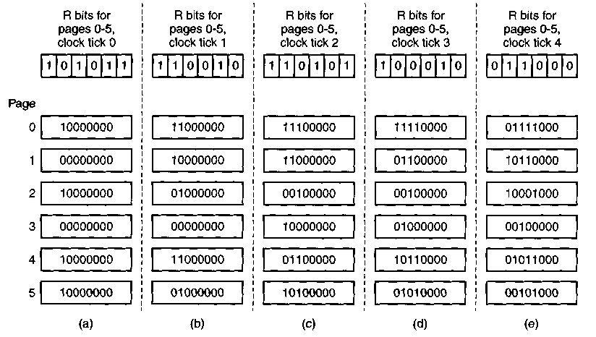
Figure 4-16. The aging algorithm simulates LRU in software. Shown are six pages for five clock ticks. The five clock ticks are represented by (a) to (e).
When a page fault occurs, the page whose counter is the lowest is removed. It is clear that a page that has not been referenced for, say, four clock ticks will have four leading zeroes in its counter, and thus will have a lower value than a counter that has not been referenced for three clock ticks.
This algorithm differs from LRU in two ways. Consider pages 3 and 5 in Fig. 4-16(e). Neither has been referenced for two clock ticks; both were referenced in the tick prior to that. According to LRU, if a page must be replaced, we should choose one of these two. The trouble is, we do not know which of these two was referenced last in the interval between tick 1 and tick 2. By recording only one bit per time interval, we have lost the ability to distinguish references early in the clock interval from those occurring later. All we can do is remove page 3, because page 5 was also referenced two ticks earlier and page 3 was not.
The second difference between LRU and aging is that in aging the counters have a finite number of bits, 8 bits in this example. Suppose that two pages each have a counter value of 0. All we can do is pick one of them at random. In
reality, it may well be that one of the pages was last referenced 9 ticks ago and the other was last referenced 1000 ticks ago. We have no way of seeing that. In practice, however, 8 bits is generally enough if a clock tick is around 20 msec. If a page has not been referenced in 160 msec, it probably is not that important.
4.5 DESIGN ISSUES FOR PAGING SYSTEMS
In the previous sections we have explained how paging works and have given a few of the basic page replacement algorithms. But knowing the bare mechanics is not enough. To design a system, you have to know a lot more to make it work well. It is like the difference between knowing how to move the rook, knight, bishop, and other pieces in chess, and being a good player. In the following sections, we will look at other issues that operating system designers must consider carefully in order to get good performance from a paging system.
4.5.1 The Working Set Model
In the purest form of paging, processes are started up with none of their pages in memory. As soon as the CPU tries to fetch the first instruction, it gets a page fault, causing the operating system to bring in the page containing the first instruction. Other page faults for global variables and the stack usually follow quickly. After a while, the process has most of the pages it needs and settles down to run with relatively few page faults. This strategy is called demand paging because pages are loaded only on demand, not in advance.
Of course, it is easy enough to write a test program that systematically reads all the pages in a large address space, causing so many page faults that there is not enough memory to hold them all. Fortunately, most processes do not work this way. They exhibit a locality of reference, meaning that during any phase of execution, the process references only a relatively small fraction of its pages. Each pass of a multipass compiler, for example, references only a fraction of all the pages, and a different fraction at that.
The set of pages that a process is currently using is called its working set (Denning, 1968a; Denning, 1980). If the entire working set is in memory, the process will run without causing many faults until it moves into another execution phase (e.g., the next pass of the compiler). If the available memory is too small to hold the entire working set, the process will cause many page faults and run slowly since executing an instruction often takes a few nanoseconds and reading in a page from the disk typically takes tens of milliseconds. At a rate of one or two instructions per 20 milliseconds, it will take ages to finish. A program causing page faults every few instructions is said to be thrashing (Denning, 1968b).
In a timesharing system, processes are frequently moved to disk (i.e., all their pages are removed from memory) to let other processes have a turn at the CPU.
The question arises of what to do when a process is brought back in again. Technically, nothing need be done. The process will just cause page faults until its working set has been loaded. The problem is that having 20, 50, or even 100 page faults every time a process is loaded is slow, and it also wastes considerable CPU time, since it takes the operating system a few milliseconds of CPU time to process a page fault.
Therefore, many paging systems try to keep track of each process' working set and make sure that it is in memory before letting the process run. This approach is called the working set model (Denning, 1970). It is designed to greatly reduce the page fault rate. Loading the pages before letting processes run is also called prepaging.
To implement the working set model, it is necessary for the operating system to keep track of which pages are in the working set. One way to monitor this information is to use the aging algorithm discussed above. Any page containing a 1 bit among the high order n bits of the counter is considered to be a member of the working set. If a page has not been referenced in n consecutive clock ticks, it is dropped from the working set. The parameter n has to be determined experimentally for each system, but the system performance is usually not especially sensitive to the exact value.
Information about the working set can be used to improve the performance of the clock algorithm. Normally, when the hand points to a page whose R bit is 0, the page is evicted. The improvement is to check to see if that page is part of the working set of the current process. If it is, the page is spared. This algorithm is called wsclock.
4.5.2 Local versus Global Allocation Policies
In the preceding sections we have discussed several algorithms for choosing a page to replace when a fault occurs. A major issue associated with this choice (which we have carefully swept under the rug until now) is how memory should be allocated among the competing runnable processes.
Take a look at Fig. 4-17(a). In this figure, three processes, A, B, and C, make up the set of runnable processes. Suppose A gets a page fault. Should the page replacement algorithm try to find the least recently used page considering only the six pages currently allocated to A, or should it consider all the pages in memory? If it looks only at A's pages, the page with the lowest age value is A5, so we get the situation of Fig. 4-17(b).
On the other hand, if the page with the lowest age value is removed without regard to whose page it is, page B3 will be chosen and we will get the situation of Fig. 4-17(c). The algorithm of Fig. 4-17(b) is said to be a local page replacement algorithm, whereas Fig. 4-17(c) is said to be a global algorithm. Local algorithms effectively correspond to allocating every process a fixed fraction of the memory.
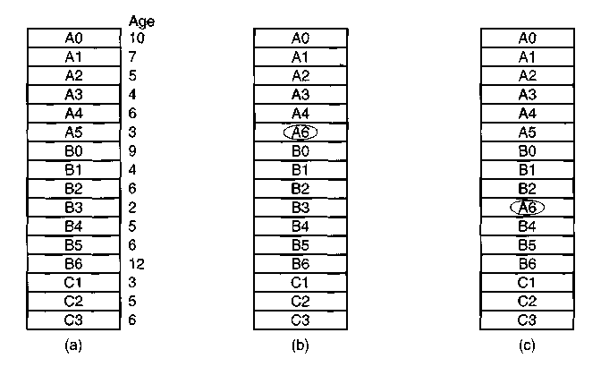
Figure 4-17. Local versus global page replacement, (a) Original configuration. (b) Local page replacement, (c) Global page replacement.
Global algorithms dynamically allocate page frames among the runnable processes. Thus the number of page frames assigned to each process varies in time.
In general, global algorithms work better, especially when the working set size can vary over the lifetime of a process. If a local algorithm is used and the working set grows, thrashing will result, even if there are plenty of free page frames. If the working set shrinks, local algorithms waste memory. If a global algorithm is used, the system must continually decide how many page frames to assign to each process. One way is to monitor the working set size as indicated by the aging bits, but this approach does not necessarily prevent thrashing. The working set may change size in microseconds, whereas the aging bits are a crude measure spread over a number of clock ticks.
Another approach is to have an algorithm for allocating page frames to processes. One way is to periodically determine the number of running processes and allocate each process an equal share. Thus with 475 available (i.e., non-operating system) page frames and 10 processes, each process gets 47 frames. The remaining 5 go into a pool to be used when page faults occur.
Although this method seems fair, it makes little sense to give equal shares of the memory to a 10K process and a 300K process. Instead, pages can be allocated in proportion to each process' total size, with a 300K process getting 30 times the allotment of a 10K process. It is probably wise to give each process some minimum number, so it can run, no matter how small it is. On some machines, for example, a single instruction may need as many as six pages because the instruction itself, the source operand, and the destination operand may all straddle page
boundaries. With an allocation of only five pages, programs containing such instructions cannot execute at all.
Neither the equal allocation nor the proportional allocation method directly deals with the thrashing problem. A more'direct way to control it is to use the Page Fault Frequency or PFF allocation algorithm. For a large class of page replacement algorithms, including LRU, it is known that the fault rate decreases as more pages are assigned, as we discussed above. This property is illustrated in Fie. 4-18.
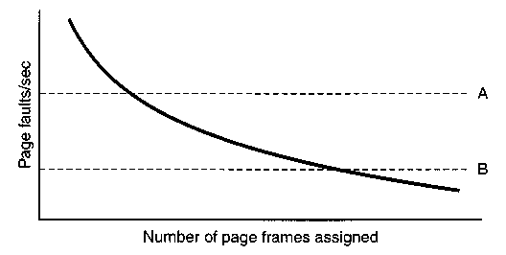
Figure 4-18. Page fault rate as a function of the number of page frames assigned.
The dashed line marked A corresponds to a page fault rate that is unaccept-ably high, so the faulting process is given more page frames to reduce the fault rate. The dashed line marked B corresponds to a page fault rate so low that it can be concluded that the process has too much memory. In this case page frames may be taken away from it. Thus, PFF tries to keep the paging rate within acceptable bounds.
If it discovers that there are so many processes in memory that it is not possible to keep all of them below A, then some process is removed from memory, and its page frames are divided up among the remaining processes or put into a pool of available pages that can be used on subsequent page faults. The decision to remove a process from memory is a form of load control. It shows that even with paging, swapping is still needed, only now swapping is used to reduce potential demand for memory, rather than to reclaim blocks of it for immediate use.
4.5.3 Page Size
The page size is often a parameter that can be chosen by the operating system. Even if the hardware has been designed with, for example, 512-byte pages, the operating system can easily regard pages 0 and 1, 2 and 3, 4 and 5, and so on, as IK pages by always allocating two consecutive 512-byte page frames for them.
Determining the optimum page size requires balancing several competing factors. To start with, a randomly chosen text, data, or stack segment will not fill an
integral number of pages. On the average, half of the final page will be empty. The extra space in that page is wasted This wastage is called internal fragmentation. With n segments in memory and a page size of p bytes, np/2 bytes will be wasted on internal fragmentation. This reasoning argues for a small page size.
Another argument for a small page size becomes apparent if we think about a program consisting of eight sequential phases of 4K each. With a 32K page size, the program must be allocated 32K all the time. With a 16K page size, it needs only 16K. With a page size of 4K or smaller, it requires only 4K at any instant. In general, a large page size will cause more unused program to be in memory than a small page size.
On the other hand, small pages mean that programs will need many pages, hence a large page table. A 32K program needs only four 8K pages, but 64 512-byte pages. Transfers to and from the disk are generally a page at a time, with most of the time being for the seek and rotational delay, so that transferring a small page takes almost as much time as transferring a large page. It might take 64 X 15 msec to load 64 512-byte pages, but only 4 X 25 msec to load four 8K pages.
On some machines, the page table must be loaded into hardware registers every time the CPU switches from one process to another. On these machines having a small page size means that the time required to load the page registers gets longer as the page size gets smaller. Furthermore, the space occupied by the page table increases as the page size decreases.
This last point can be analyzed mathematically. Let the average process size be s bytes and the page size be p bytes. Furthermore, assume that each page entry requires e bytes. The approximate number of pages needed per process is then s/p, occupying se/p bytes of page table space. The wasted memory in the last page of the process due to internal fragmentation is p/2. Thus, the total overhead due to the page table and the internal fragmentation loss is given by
overhead = se/p + p/2
The first term (page table size) is large when the page size is small. The second term (internal fragmentation) is large when the page size is large. The optimum must lie somewhere in between. By taking the first derivative with respect to p and equating it to zero, we get the equation
-se/p² + 1/2 = 0
From this equation we can derive a formula that gives the optimum page size (considering only memory wasted in fragmentation and page table size). The result is:
p = ^2se
For s - 128K and e = 8 bytes per page table entry, the optimum page size is 1448 bytes. In practice IK or 2K would be used, depending on the other factors (e.g., disk speed). Most commercially available computers use page sizes ranging from 512 bytes to 64K.
4.5.4 Virtual Memory Interface
Up until now, our whole discussion has assumed that virtual memory is transparent to processes and programmers, that is, all they see is a large virtual address space on a computer with a small(er) physical memory. With many systems, that is true, but in some advanced systems, programmers have some control over the memory map and can use it in nontraditional ways. In this section, we will briefly look at a few of these.
One reason for giving programmers control over their memory map is to allow two or more processes to share the same memory. If programmers can name regions of their memory, it may be possible for one process to give another process the name of a memory region so that process can also map it in. With two (or more) processes sharing the same pages, high bandwidth sharing becomes possible—one process writes into the shared memory and another one reads from it.
Sharing of pages can also be used to implement a high-performance message-passing system. Normally, when messages are passed, the data are copied from one address space to another, at considerable cost. If processes can control their page map, a message can be passed by having the sending process unmap the page(s) containing the message, and the receiving process mapping them in. Here only the page names have to be copied, instead of all the data.
Yet another advanced memory management technique is distributed shared memory (Feeley et al., 1995; Li and Hudak, 1989; Zekauskas et al., 1994). The idea here is to allow multiple processes over a network to share a set of pages, possibly, but not necessarily, as a single shared linear address space. When a process references a page that is not currently mapped in, it gets a page fault. The page fault handler, which may be in the kernel or in user space, then locates the machine holding the page and sends it a message asking it to unmap the page and send it over the network. When the page arrives, it is mapped in and the faulting instruction is restarted.
4.6 SEGMENTATION
The virtual memory discussed so far is one-dimensional because the virtual addresses go from 0 to some maximum address, one address after another. For many problems, having two or more separate virtual address spaces may be much
better than having only one. For example, a compiler has many tables that are built up as compilation proceeds, possibly including
1. The source text being saved for the printed listing (on batch systems).
2. The symbol table, containing the names and attributes of variables.
3. The table containing all the integer and floating-point constants used.
4. The parse tree, containing the syntactic analysis of the program.
5. The stack used for procedure calls within the compiler.
Each of the first four tables grows continuously as compilation proceeds. The last one grows and shrinks in unpredictable ways during compilation. In a one-dimensional memory, these five tables would have to be allocated contiguous chunks of virtual address space, as in Fig. 4-19.
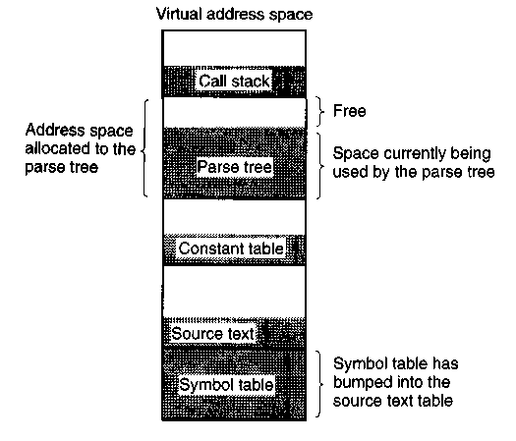
Figure 4-19. In a one-dimensional address space with growing tables, one table may bump into another.
Consider what happens if a program has an exceptionally large number of variables. The chunk of address space allocated for the symbol table may fill up, but there may be lots of room in the other tables. The compiler could, of course, simply issue a message saying that the compilation cannot continue due to too many variables, but doing so does not seem very sporting when unused space is left in the other tables.
Another possibility is to play Robin Hood, taking space from the tables with an excess of room and giving it to the tables with little room. This shuffling can
be done, but it is analogous to managing one's own overlays—a nuisance at best and a great deal of tedious, unrewarding work at worst.
What is really needed is a way of freeing the programmer from having to manage the expanding and contracting tables; in the same way that virtual memory eliminates the worry of organizing the program into overlays.
A straightforward and extremely general solution is to provide the machine with many completely independent address spaces, called segments. Each segment consists of a linear sequence of addresses, from 0 to some maximum. The length of each segment may be anything from 0 to the maximum allowed. Different segments may, and usually do, have different lengths. Moreover, segment lengths may change during execution. The length of a stack segment may be increased whenever something is pushed onto the stack and decreased whenever something is popped off the stack.
Because each segment constitutes a separate address space, different segments can grow or shrink independently, without affecting each other. If a stack in a certain segment needs more address space to grow, it can have it, because there is nothing else in its address space to bump into. Of course, a segment can fill up but segments are usually very large, so this occurrence is rare. To specify an address in this segmented or two-dimensional memory, the program must supply a two-part address, a segment number, and an address within the segment. Figure 4-20 illustrates a segmented memory being used for the compiler tables discussed earlier.
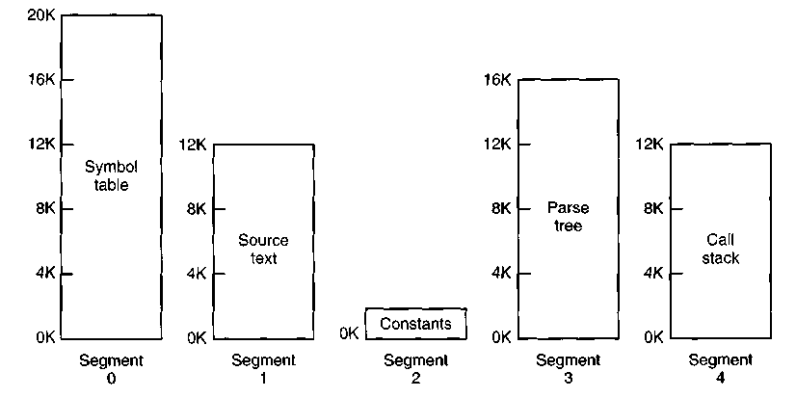
Figure 4-20. A segmented memory allows each table to grow or shrink independently of the other tables.
We emphasize that a segment is a logical entity, which the programmer is aware of and uses as a logical entity. A segment might contain a procedure, or an
array, or a stack, or a collection of scalar variables, but usually it does not contain a mixture of different types.
A segmented memory has other advantages besides simplifying the handling of data structures that are growing or shrinking. If each procedure occupies a separate segment, with address 0 as its starting address, the linking up of procedures compiled separately is greatly simplified. After all the procedures that constitute a program have been compiled and linked up, a procedure call to the procedure in segment n will use the two-part address (n, 0) to address word 0 (the entry point).
If the procedure in segment n is subsequently modified and recompiled, no other procedures need be changed (because no starting addresses have been modified), even if the new version is larger than the old one. With a one-dimensional memory, the procedures are packed tightly next to each other, with no address space between them. Consequently, changing one procedure's size can affect the starting address of other, unrelated procedures. This, in turn, requires modifying all procedures that call any of the moved procedures, in order to incorporate their new starting addresses. If a program contains hundreds of procedures, this process can be costly.
Segmentation also facilitates sharing procedures or data between several processes. A common example is the shared library. Modern workstations that run advanced window systems often have extremely large graphical libraries compiled into nearly every program. In a segmented system, the graphical library can be put in a segment and shared by multiple processes, eliminating the need for having it in every process' address space. While it is also possible to have shared libraries in pure paging systems, it is much more complicated. In effect, these systems do it by simulating segmentation.
Because each segment forms a logical entity of which the programmer is aware, such as a procedure, or an array, or a stack, different segments can have different kinds of protection. A procedure segment can be specified as execute only, prohibiting attempts to read from it or store into it. A floating-point array can be specified as read/write but not execute, and attempts to jump to it will be caught. Such protection is helpful in catching programming errors.
You should try to understand why protection makes sense in a segmented memory but not in a one-dimensional paged memory. In a segmented memory the user is aware of what is in each segment. Normally, a segment would not contain a procedure and a stack, for example, but one or the other. Since each segment contains only one type of object, the segment can have the protection appropriate for that particular type. Paging and segmentation are compared in Fig. 4-21.
The contents of a page are, in a sense, accidental. The programmer is unaware of the fact that paging is even occurring. Although putting a few bits in each entry of the page table to specify the access allowed would be possible, to utilize this feature the programmer would have to keep track of where in his address space the page boundaries were. That is precisely the sort of administration
Paging
Segmentation
Consideration

Need the programmer be aware that this technique is being used? | No | Yes
How many linear address spaces are there? | 1 | Many
Can the total address space exceed the size of physical memory? | Yes | Yes
Can procedures and data be distinguished and separately protected? | No | Yes
Can tables whose size fluctuates be accommodated easily? | No | Yes
Is sharing of procedures between users facilitated? | No | Yes
Why was this technique invented? | To get a large linear address space without having to buy more physical memory | To allow programs and data to be broken up into logically independent address spaces and to aid sharing and protection
Figure 4-21. Comparison of paging and segmentation.
that paging was invented to eliminate. Because the user of a segmented memory has the illusion that all segments are in main memory all the time—that is, he can address them as though they were—he can protect each segment separately, without having to be concerned with the administration of overlaying them.
4.6.1 Implementation of Pure Segmentation
The implementation of segmentation differs from paging in an essential way: pages are fixed size and segments are not. Figure 4-22(a) shows an example of physical memory initially containing five segments. Now consider what happens if segment 1 is evicted and segment 7, which is smaller, is put in its place. We arrive at the memory configuration -of Fig. 4-22(b). Between segment 7 and segment 2 is an unused area—that is, a hole. Then segment 4 is replaced by segment 5, as in Fig. 4-22(c), and segment 3 is replaced by segment 6, as in Fig. 4-22(d). After the system has been running for a while, memory will be divided up into a number of chunks, some containing segments and some containing holes. This phenomenon, called checkerboarding or external fragmentation, wastes memory in the holes. It can be dealt with by compaction, as shown in Fig. 4-22(e).

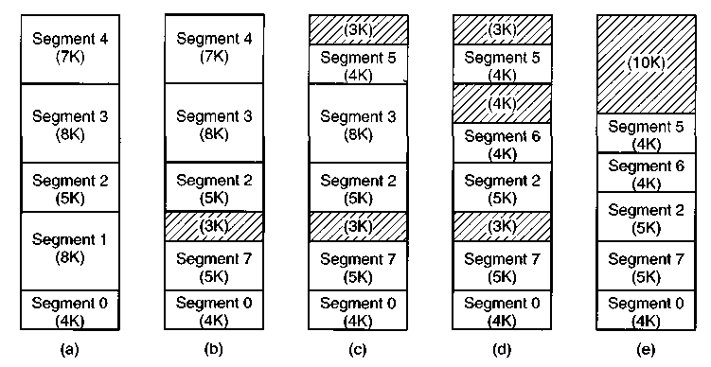
Figure 4-22. (a)-(d) Development of checkerboarding, (e) Removal of the checkerboarding by compaction.
4.6.2 Segmentation with Paging: MULTICS
If the segments are large, it may be inconvenient, or even impossible, to keep them in main memory in their entirety. This leads to the idea of paging them, so that only those pages that are actually needed have to be around. Several significant systems have supported paged segments. In this section we will describe the first one: MULTICS. In the next one we will discuss a more recent one: the Intel Pentium.
MULTICS ran on the Honeywell 6000 machines and their descendants and provided each program with a virtual memory of up to 2¹⁸ segments (more than 250,000), each of which could be up to 65,536 (36-bit) words long. To implement this, the MULTICS designers chose to treat each segment as a virtual memory and to page it, combining the advantages of paging (uniform page size and not having to keep the whole segment in memory if only part of it is being used) with the advantages of segmentation (ease of programming, modularity, protection, and sharing).
Each MULTICS program has a segment table, with one descriptor per segment. Since there are potentially more than a quarter of a million entries in the table, the segment table is itself a segment and is paged. A segment descriptor contains an indication of whether the segment is in main memory or not. If any part of the segment is in memory, the segment is considered to be in memory, and its page table will be in memory. If the segment is in memory, its descriptor contains an 18-bit pointer to its page table [see Fig. 4-23(a)]. Because physical addresses are 24 bits and pages are aligned on 64-byte boundaries (implying that the low-order 6 bits of page addresses are 000000), only 18 bits are needed in the descriptor to
store a page table address. The descriptor also contains the segment size, the protection bits, and a few other items. Figure 4-23(b) illustrates a MULTICS segment descriptor. The address of the segment in secondary memory is not in the segment descriptor but in another table used by the segment fault handler.
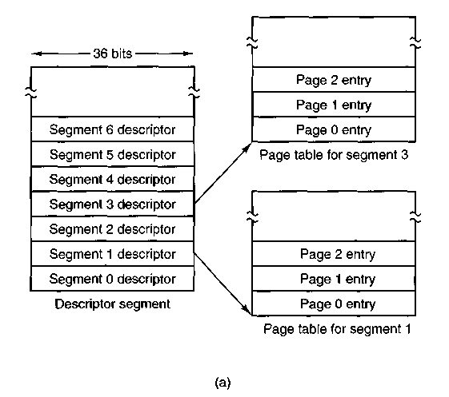
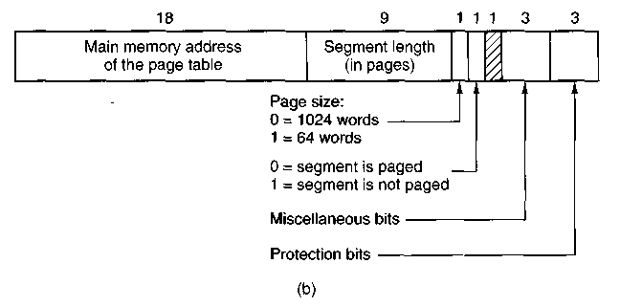
Figure 4-23. The multics virtual memory, (a) The descriptor segment points to the page tables, (b) A segment descriptor. The numbers are the field lengths.
Each segment is an ordinary virtual address space and is paged in the same way as the nonsegmented paged memory described earlier in this chapter. The normal page size is 1024 words (although a few small segments used by MULTICS itself are not paged or are paged in units of 64 words to save physical memory).
An address in MULTICS consists of two parts: the segment and the address within the segment. The address within the segment is further divided into a page number and a word within the page, as shown in Fig. 4-24. When a memory reference occurs, the following algorithm is carried out.
1. The segment number is used to find the segment descriptor.
2. A check is made to see if the segment's page table is in memory. If the page table is in memory, it is located. If it is not, a segment fault occurs. If there is a protection violation, a fault (trap) occurs.
3. The page table entry for the requested virtual page is examined. If the page is not in memory, a page fault occurs. If it is in memory, the main memory address of the start of the page is extracted from the page table entry.
4. The offset is added to the page origin to give the main memory address where the word is located.
5. The read or store finally takes place.
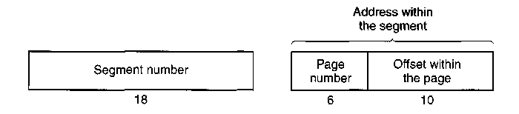
Figure 4-24. A 34-bit multics virtual address.
This process is illustrated in Fig. 4-25. For simplicity, the fact that the descriptor segment is itself paged has been omitted. What really happens is that a register (the descriptor base register), is used to locate the descriptor segment's page table, which, in turn, points to the pages of the descriptor segment. Once the descriptor for the needed segment has been found, the addressing proceeds as shown in Fig. 4-25.
As you have no doubt guessed by now, if the preceding algorithm were actually carried out by the operating system on every instruction, programs would not run very fast. In reality, the MULTICS hardware contains a 16-word high-speed TLB that can search all its entries in parallel for a given key. It is illustrated in Fig. 4-26. When an address is presented to the computer, the addressing hardware first checks to see if the virtual address is in the TLB. If so, it gets the page frame number directly from the TLB and forms the actual address of the referenced word without having to look in the descriptor segment or page table.
The addresses of the 16 most recently referenced pages are kept in the TLB. Programs whose working set is smaller than the TLB size will come to equilibrium with the addresses of the entire working set in the TLB and therefore will
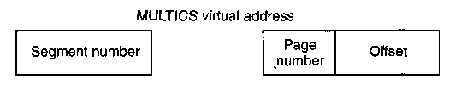
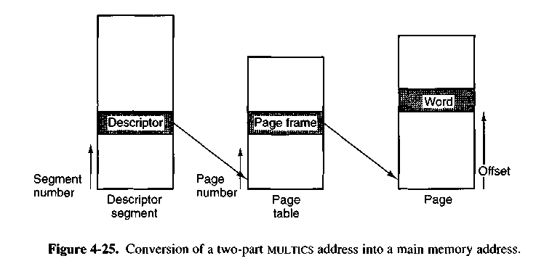
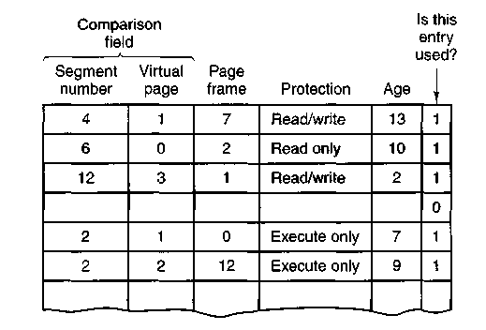
Figure 4-26. A simplified version of the multics TLB. The existence of two page sizes makes the actual TLB more complicated.
run efficiently. If the page is not in the TLB, the descriptor and page tables are actually referenced to find the page frame address, and the TLB is updated to include this page, the least recently used page being thrown out. The age field keeps track of which entry is the least recently used. The reason that a TLB is used is for comparing the segment and page number of all the entries in parallel.
4.6.3 Segmentation with Paging: The Intel Pentium
In many ways, the virtual memory on the Pentium (and Pentium Pro) resembles MULTICS, including the presence of both segmentation and paging. Whereas MULTICS has 256K independent segments, each up to 64K 36-bit words, the Pentium has 16K independent segments, each holding up to 1 billion 32-bit words. Although there are fewer segments, the larger segment size is far more important, as few programs need more than 1000 segments, but many programs need segments holding megabytes.
The heart of the Pentium virtual memory consists of two tables, the LOT (Local Descriptor Table) and the GDT (Global Descriptor Table). Each program has its own LDT, but there is a single GDT, shared by all the programs on the computer. The LDT describes segments local to each program, including its code, data, stack, and so on, whereas the GDT describes system segments, including the operating system itself.
To access a segment, a Pentium program first loads a selector for that segment into one of the machine's six segment registers. During execution, the CS register holds the selector for the code segment and the DS register holds the selector for the data segment. The other segment registers are less important. Each selector is a 16-bit number, as shown in Fig. 4-27.
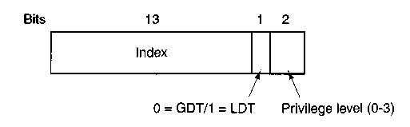
Figure 4-27. A Pentium selector.
One of the selector bits tells whether the segment is local or global (i.e., whether it is in the LDT or GDT). Thirteen other bits specify the LDT or GDT entry number, so these tables are each restricted to holding 8K segment descriptors. The other 2 bits relate to protection, and will be described later. Descriptor 0 is forbidden. It may be safely loaded into a segment register to indicate that the segment register is not currently available. It causes a trap if used.
At the time a selector is loaded into a segment register, the corresponding descriptor is fetched from the LDT or GDT and stored in microprogram registers, so it can be accessed quickly. A descriptor consists of 8 bytes, including the segment's base address, size, and other information, as depicted in Fig. 4-28.
The format of the selector has been cleverly chosen to make locating the descriptor easy. First either the LDT or GDT is selected, based on selector bit 2. Then the selector is copied to an internal scratch register, and the 3 low-order bits set to 0. Finally, the address of either the LDT or GDT table is added to it, to give
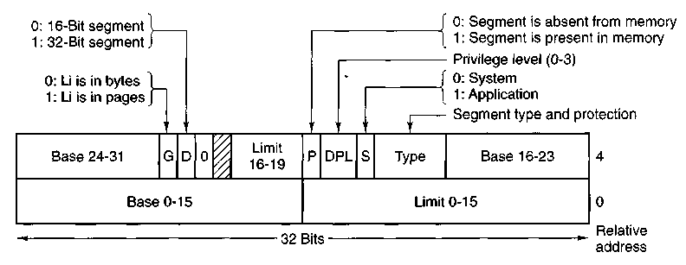
Figure 4-28. Pentium code segment descriptor. Data segments differ slightly.
a direct pointer to the descriptor. For example, selector 72 refers to entry 9 in the GDI, which is located at address GDT + 72.
Let us trace the steps by which a (selector, offset) pair is converted to a physical address. As soon as the microprogram knows which segment register is being used, it can find the complete descriptor corresponding to that selector in its internal registers. If the segment does not exist (selector 0), or is currently paged out, a trap occurs.
It then checks to see if the offset is beyond the end of the segment, in which case a trap also occurs. Logically, there should simply be a 32-bit field in the descriptor giving the size of the segment, but there are only 20 bits available, so a different scheme is used. If the Gbit (Granularity) field is 0, the Limit field is the exact segment size, up to 1 MB. If it is 1, the Limit field gives the segment size in pages instead of bytes. The Pentium page size is fixed at 4K bytes, so 20 bits are enough for segments up to 2³² bytes.
Assuming that the segment is in memory and the offset is in range, the Pentium then adds the 32-bit Base field in the descriptor to the offset to form what is called a linear address, as shown in Fig. 4-29. The Base field is broken up into three pieces and spread all over the descriptor for compatibility with the 286, in which the Base is only 24 bits. In effect, the Base field allows each segment to start at an arbitrary place within the 32-bit linear address space.
If paging is disabled (by a bit in a global control register), the linear address is interpreted as the physical address and sent to the memory for the read or write. Thus with paging disabled, we have a pure segmentation scheme, with each segment's base address given in its descriptor. Segments are permitted to overlap, incidentally, probably because it would be too much trouble and take too much time to verify that they were all disjoint.
On the other hand, if paging is enabled, the linear address is interpreted as a virtual address and mapped onto the physical address using page tables. prett> much as in our earlier examples. The only real complication is that with a 32-bh
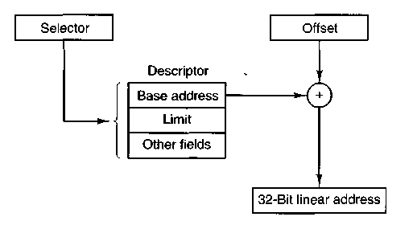
Figure 4-29. Conversion of a (selector, offset) pair to a linear address.
virtual address and a 4K page, a segment might contain 1 million pages, so a two-level mapping is used to reduce the page table size for small segments.
Each running program has a page directory consisting of 1024 32-bit entries. It is located at an address pointed to by a global register. Each entry in this directory points to a page table also containing 1024 32-bit entries. The page table entries point to page frames. The scheme is shown in Fig. 4-30.
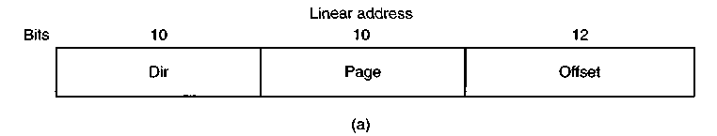
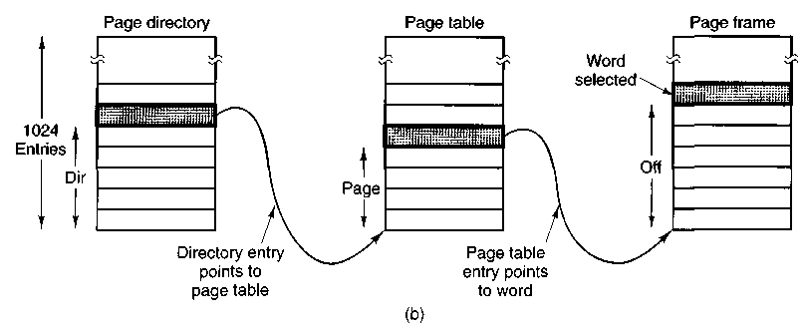
Figure 4-30. Mapping of a linear address onto a physical address.
In Fig. 4-30(a) we see a linear address divided into three fields, Dir, Page, and Off. The Dir field is used to index into the page directory to locate a pointer
to the proper page table. Then the Page field is used as an index into the page table to find the physical address of the page frame. Finally, Off is added to the address of the page frame to get the physical address of the byte or word needed.
The page table entries are 32 bits each, 20 of which contain a page frame number. The remaining bits contain access and dirty bits, set by the hardware for the benefit of the operating system, protection bits, and other utility bits.
Each page table has entries for 1024 4K page frames, so a single page table handles 4 megabytes of memory. A segment shorter than 4M will have a page directory with a single entry, a pointer to its one and only page table. In this way, the overhead for short segments is only two pages, instead of the million pages that would be needed in a one-level page table.
To avoid making repeated references to memory, the Pentium, like MULTICS, has a small TLB that directly maps the most recently used Dir-Page combinations onto the physical address of the page frame. Only when the current combination is not present in the TLB is the mechanism of Fig. 4-30 actually carried out and the TLB updated.
A little thought will reveal the fact that when paging is used, there is really no point in having the Base field in the descriptor be nonzero. All that Base does is cause a small offset to use an entry in the middle of the page directory, instead of at the beginning. The real reason for including Base at all is to allow pure (non-paged) segmentation, and for compatibility with the 286, which always has paging disabled (i.e., the 286 has only pure segmentation, but not paging).
It is also worth noting that if some application does not need segmentation but is content with a single, paged, 32-bit address space, that model is possible. All the segment registers can be set up with the same selector, whose descriptor has Base = 0 and Limit set to the maximum. The instruction offset will then be the linear address, with only a single address space used—in effect, normal paging.
All in all, one has to give credit to the Pentium designers. Given the conflicting goals of implementing pure paging, pure segmentation, and paged segments, while at the same time being compatible with the 286, and doing all of this efficiently, the resulting design is surprisingly simple and clean.
Although we have covered the complete architecture of the Pentium virtual memory, albeit briefly, it is worth saying a few words about protection, since this subject is intimately related to the virtual memory. Just as the virtual memory scheme is closely modeled on MULTICS, so is the protection system. The Pentium supports four protection levels with level 0 being the most privileged and level 3 the least. These are shown in Fig. 4-31. At each instant, a running program is at a certain level, indicated by a 2-bit field in its PSW. Each segment in the system also has a level.
As long as a program restricts itself to using segments at its own level, everything works fine. Attempts to access data at a higher level are permitted. Attempts to access data at a lower level are illegal and cause traps. Attempts to call procedures at a different level (higher or lower) are allowed, but in a carefully
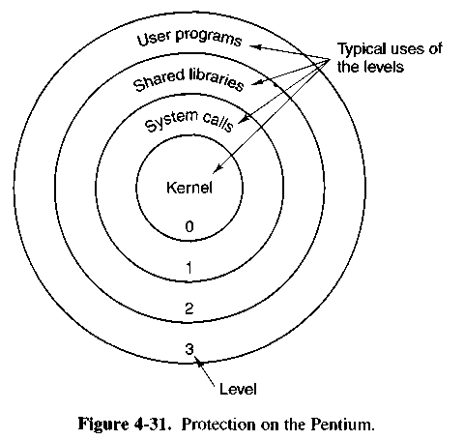
controlled way. To make an interlevel call, the CALL instruction must contain a selector instead of an address. This selector designates a descriptor called a call gate, which gives the address of the procedure to be called. Thus it is not possible to jump into the middle of an arbitrary code segment at a different level. Only official entry points may be used. The concepts of protection levels and call gates were pioneered inMULTlCS, where they were viewed as protection rings.
A typical use for this mechanism is suggested in Fig. 4-31. At level 0, we find the kernel of the operating system, which handles I/O, memory management, and other critical matters. At level 1, the system call handler is present. User programs may call procedures here to have system calls carried out, but only a specific and protected list of procedures may be called. Level 2 contains library procedures, possibly shared among many running programs. User programs may call these procedures and read their data, but they may not modify them. Finally, user programs run at level 3, which has the least protection.
Traps and interrupts use a mechanism similar to the call gates. They, too, reference descriptors, rather than absolute addresses, and these descriptors point to specific procedures to be executed. The Type field in Fig. 4-28 distinguishes between code segments, data segments, and the various kinds of gates.
4.7 OVERVIEW OF MEMORY MANAGEMENT IN MINIX
Memory management in MINIX is simple: neither paging nor swapping is used. The memory manager maintains a list of holes sorted in memory address order. When memory is needed, either due to a FORK or an EXEC system call, the
hole list is searched using first fit for a hole that is big enough. Once a process has been placed in memory, it remains in exactly the same place until it terminates. It is never swapped out and also never moved to another place in memory. Nor does the allocated area ever grow or shrink.
This strategy deserves some explanation. It derives from three factors: (1) the idea that minix is for personal computers, rather than for large timesharing systems, (2) the desire to have MINIX work on all IBM PCs, and (3) a desire to make the system straightforward to implement on other small computers.
The first factor means that, on the average, the number of running processes will be small, so that typically enough memory will be available to hold all the processes with room left over. Swapping will not be needed then. Since it adds complexity to the system, not swapping leads to simpler code.
The desire to have MINIX run on all IBM PC-compatible computers also had substantial impact on the memory management design. The simplest systems in this family use the 8088 processor, whose memory management architecture is very primitive. It does not support virtual memory in any form and does not even detect stack overflow, a defect that has major implications for the way processes are laid out in memory. These limitations do not exist in later designs which use the 80386, 80486, or Pentium processors. However, taking advantage of these features would make minix incompatible with many low-end machines that are still serviceable and in use.
The portability issue argues for as simple a memory management scheme as possible. If MINIX used paging or segmentation, it would be difficult, if not impossible, to port it to machines not having these features. By making a minimal number of assumptions about what the hardware can do, the number of machines to which MINIX can be ported is increased.
Another unusual aspect of MINIX is the way the memory management is implemented. It is not part of the kernel. Instead, it is handled by the memory manager process, which runs in user space and communicates with the kernel by the standard message mechanism. The position of the memory manager in the server level is shown in Fig. 2-26.
Moving the memory manager out of the kernel is an example of the separation of policy and mechanism. The decisions about which process will be placed where in memory (policy) are made by the memory manager. The actual setting of memory maps for processes (mechanism) is done by the system task within the kernel. This split makes it relatively easy to change the memory management policy (algorithms, etc.) without having to modify the lowest layers of the operating system.
Most of the memory manager code is devoted to handling the MINIX system calls that involve memory management, primarily FORK and EXEC, rather than just manipulating lists of processes and holes. In the next section we will look at the memory layout, and in subsequent sections we will take a bird's-eye view of how the memory management system calls are processed by the memory manager.
4.7.1 Memory Layout
Simple MINIX processes use combined I and D space, in which all parts of the process (text, data, and stack) share a block- of memory which is allocated and released as one block. Processes can also be compiled to use separate I and D space. For clarity, allocation of memory for the simpler model will be discussed first. Processes using separate I and D space can use memory more efficiently, but taking advantage of this feature complicates things. We will discuss the complications after the simple case has been outlined.
Memory is allocated in minix on two occasions. First, when a process forks, the amount of memory needed by the child is allocated. Second, when a process changes its memory image via the EXEC system call, the old image is returned to the free list as a hole, and memory is allocated for the new image. The new image may be in a part of memory different from the released memory. Its location will depend upon where an adequate hole is found. Memory is also released whenever a process terminates, either by exiting or by being killed by a signal.
Figure 4-32 shows both ways of allocating memory. In Fig. 4-32(a) we see two processes, A and B, in memory. If A forks, we get the situation of Fig. 4-32(b). The child is an exact copy of A. If the child now executes the file C, the memory looks like Fig. 4-32(c). The child's image is replaced by C.
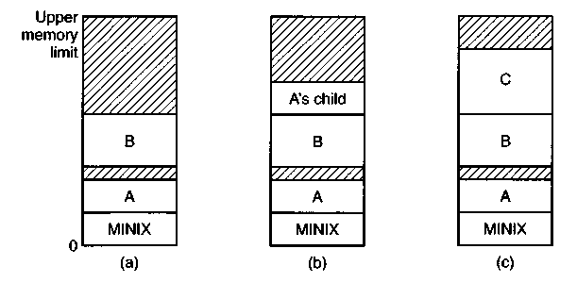
Figure 4-32. Memory allocation, (a) Originally, (b) After a sy fork, (c) After the child does an exec . The shaded regions are unused memory. The process is a common I&D one.
Note that the old memory for the child is released before the new memory for C is allocated, so that C can use the child's memory. In this way, a series of FORK and EXEC pairs (such as the shell setting up a pipeline) results in all the processes being adjacent, with no holes between them, as would have been the case had the new memory been allocated before the old memory had been released.
When memory is allocated, either by the FORK or EXEC system calls, a certain amount of it is taken for the new process. In the former case, the amount taken is
identical to what the parent process has. In the latter case, the memory manager takes the amount specified in the header of the file executed. Once this allocation has been made, under no conditions is the process ever allocated any more total memory.
What has been said so far applies to programs that have been compiled with combined I and D space. Programs with separate I and D space take advantage of an enhanced mode of memory management called shared text. When such a process does a FORK, only the amount of memory needed for a copy of the new process' data and stack is allocated. Both the parent and the child share the executable code already in use by the parent. When such a process does an EXEC, a search is made of the process table to see if another process already is using the executable code needed. If one is found, new memory is allocated only for the data and stack, and the text already in memory is shared. Shared text complicates termination of a process. When a process terminates it always releases the memory occupied by its data and stack. But it only releases the memory occupied by its text segment after a search of the process table reveals that no other current process is sharing that memory. Thus a process may be allocated more memory when it starts than it releases when it terminates, if it loaded its own text when it started but that text is being shared by one or more other processes when the first process terminates.
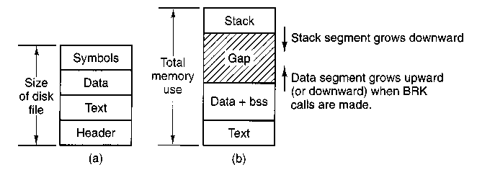
Figure 4-33. (a) A program as stored in a disk file, (b) Internal memory layout for a single process. In both parts of the figure the lowest disk or memory address is at the bottom and the highest address is at the top.
Figure 4-33 shows how a program is stored as a disk file and how this is transferred to the internal memory layout of a MINIX process. The header on the disk file contains information about the sizes of the different parts of the image, as well as the total size. In the header of a program with common I and D space, a field specifies the total size of the text and data parts; these parts are copied directly to the memory image. The data part in the image is enlarged by the amount specified in the bss field in the header. This area is cleared to contain all zeroes and is used for uninitialized static data. The total amount of memory to be allocated is specified by the total field in the header. If, for example, a program
has 4K of text, 2K of data plus bss, and 1K of stack, and the header says to allocate 40K total, the gap of unused memory between the data segment and the stack segment will be 33K. A program file on the disk may also contain a symbol table. This is for use in debugging and is not copied into memory.
If the programmer knows that the total memory needed for the combined growth of the data and stack segments for the file a.out is at most 10K, he can give the command
chmem =10240 a.out
which changes the header field so that upon exec the memory manager allocates a space 10240 bytes more than the sum of the initial text and data segments. For the above example, a total of 16K will be allocated on all subsequent EXECs of the file. Of this amount, the topmost IK will be used for the stack, and 9K will be in the gap, where it can be used by growth of the stack, the data area, or both.
For a program using separate I and D space (indicated by a bit in the header that is set by the linker), the total field in the header applies to the combined data and stack space only. A program with 4K of text, 2K of data, 1K of stack, and a total size of 64K will be allocated 68K (4K instruction space, 64K data space), leaving 61K for the data segment and stack to consume during execution. The boundary of the data segment can be moved only by the BRK system call. All BRK does is check to see if the new data segment bumps into the current stack pointer, and if not, notes the change in some internal tables. This is entirely internal to the memory originally allocated to the process; no additional memory is allocated by the operating system. If the new data segment bumps into the stack, the call fails.
This strategy was chosen to make it possible to run MINIX on an IBM PC with an 8088 processor, which does not check for stack overflow in hardware. A user program can push as many words as it wants onto the stack without the operating system being aware of it. On computers with more sophisticated memory management hardware, the stack is allocated a certain amount of memory initially. If it attempts to grow beyond this amount, a trap to the operating system occurs, and the system allocates another piece of memory to the stack, if possible. This trap does not exist on the 8088, making it dangerous to have the stack adjacent to anything except a large chunk of unused memory, since the stack can grow quickly and without warning. MINIX has been designed so that when it is implemented on a computer with better memory management, it is straightforward to change the MINIX memory manager.
This is a good place to mention a possible semantic difficulty. When we use the word "segment," we refer to an area of memory defined by the operating system. The Intel 80x86 processors have a set of internal "segment registers" and (in the more advanced processors) "segment descriptor tables" which provide hardware support for "segments." The Intel hardware designers' concept of a segment is similar to, but not always the same as, the segments used and defined by minix. All references to segments in this text should be interpreted as references
to memory areas delineated by MINIX data structures. We will refer explicitly to segment registers or segment descriptors when talking about the hardware.
This warning can be generalized. Hardware designers often try to provide support for the operating systems that they expect to be used on their machines, and the terminology used to describe registers and other aspects of a processor's architecture usually reflects an idea of how the features will be used. Such features are often useful to the implementor of an operating system, but they may not be used in the same way the hardware designer foresaw. This can lead to misunderstandings when the same word has different meanings when used to describe an aspect of an operating system or of the underlying hardware.
4.7.2 Message Handling
Like all the other components of MINIX, the memory manager is message driven. After the system has been initialized, the memory manager enters its main loop, which consists of waiting for a message, carrying out the request contained in the message, and sending a reply. Figure 4-34 gives the list of legal message types, their input parameters, and the value sent back in the reply message.
FORK, exit, WAIT, WAITPID, BRK, and EXEC are clearly closely related to memory allocation and deallocation. The calls KILL, ALARM, and PAUSE are all related to signals, as are sigaction, sigsuspend, sigpending, sigmask, and SIGRETURN. These also can affect what is in memory, because when a signal kills a process the process' memory is deallocated. REBOOT has effects throughout the operating system, but its first job is to send signals to terminate all processes in a controlled way, so the memory manager is a good place for it. The seven GET/SET calls have nothing to do with memory management at all. They also have nothing to do with the file system. But they had to go either in the file system or the memory manager, since each system call is handled by one or the other. They were put here simply because the file system was large enough already. PTRACE, which is used in debugging, is here for the same reason.
The final message, ksig. is not a system call. KSIG is the message type used by the kernel to inform the memory manager of a signal originating in the kernel, such as SIGINT, SIGQUIT, or SIGALRM.
Although there is a library routine sbrk, there is no system call SBRK. The library routine computes the amount of memory needed by adding the increment or decrement specified as parameter to the current size and makes a BRK call to set the size. Similarly, there are no separate system calls for geteuid and getegid. The calls GETUID and GETGID return both the effective and real identifiers. In like manner, GETPID returns the pid of both the calling process and its parent.
A key data structure used for message processing is the table call_vec declared in table.c (line 16515). It contains pointers to the procedures that handle the various message types. When a message comes in to the memory manager,
Message type | Input parameters | Reply value
FORK | (none) | Child's pid, (to child: 0)
EXIT | Exit status | (No reply if successful)
WAIT | (none) | Status
WAITPID | (none) | Status
BRK | New size | New size
EXEC | Pointer to initial stack | (No reply if successful)
KILL | Process identifier and signal | Status
ALARM | Number of seconds to wait | Residual time
PAUSE | (none) | (No reply if successful)
SIGACTION | Sig. number, action, old action | Status
SIGSUSPEND | Signal mask | (No reply if successful)
SIGPENDING | (none) | Status
SIGMASK | How, set, old set | Status
SIGRETURN | Context | Status
GETUID | (none) | Uid, effective uid
GETGID | (none) | Gid, effective gid
GETPID | (none) | Pid, parent pid
SETUID | New uid | Status
SETGID | New gid | Status
SETSID | New sid | Process group
GETPGRP | New gid | Process group
PTRACE | Request, pid, address, data | Status
REBOOT | How (halt, reboot, or panic) | (No reply if successful)
KSIG | Process slot and signals | (No reply)
Figure 4-34. The message types, input parameters, and reply values used for communicating with the memory manager.
the main loop extracts the message type and puts it in the global variable mm_call. This value is then used to index into callvec to find the pointer to the procedure that handles the newly arrived message. That procedure is then called to execute the system call. The value that it returns is sent back to the caller in the reply message to report on the success or failure of the call. This mechanism is similar to that of Fig. 1-16, only in user space rather than in the kernel.
4.7.3 Memory Manager Data Structures and Algorithms
The memory manager has two key data structures: the process table and the hole table. We will now look at each of these in turn.
In Fig. 2-4 we saw that some process table fields are needed for process management, others for memory management, and yet others for the file system. In MINIX, each of these three pieces of the operating system has its own process table, containing just those fields that it needs. The entries correspond exactly, to keep things simple. Thus, slot k of the memory manager's table refers to the same process as slot k of the file system's table. When a process is created or destroyed, all three parts update their tables to reflect the new situation, in order to keep them synchronized.
The memory manager's process table is called mproc; its definition is in /usr/src/mm/mproc.h. It contains all the fields related to a process' memory allocation, as well as some additional items. The most important field is the array mp^seg, which has three entries, for the text, data, and stack segments, respectively. Each entry is a structure containing the virtual address, physical address, and length of the segment, all measured in clicks rather than in bytes. The size of a click is implementation dependent; for standard MINIX it is 256 bytes. All segments must start on a click boundary and occupy an integral number of clicks.
The method used for recording memory allocation is shown in Fig. 4-35. In this figure we have a process with 3K of text, 4K of data, a gap of IK, and then a 2K stack, for a total memory allocation of 10K. In Fig. 4-35(b) we see what the virtual, physical, and length fields for each of the three segments are, assuming that the process does not have separate I and D space. In this model, the text segment is always empty, and the data segment contains both text and data. When a process references virtual address 0, either to jump to it or to read it (i.e., as instruction space or as data space), physical address 0x32000 (in decimal, 200K) will be used. This address is at click 0x320.
Note that the virtual address at which the stack begins depends initially on the total amount of memory allocated to the process. If the chmem command were used to modify the file header to provide a larger dynamic allocation area (bigger gap between data and stack segments), the next time the file was executed, the stack would start at a higher virtual address. If the stack grows longer by one click, the stack entry should change from the triple (0x20, 0x340, 0x8) to the triple (OxIF, Ox33F, 0x9).
The 8088 hardware does not have a stack limit trap, and MINIX defines the stack in a way that will not trigger the trap on 32-bit processors until the stack has already overwritten the data segment. Thus, this change will not be made until the next BRK system call, at which point the operating system explicitly reads SP and recomputes the segment entries. On a machine with a stack trap, the stack segment's entry could be updated as soon as the stack outgrew its segment. This is not done by MINIX on 32-bit Intel processors, for reasons we will now discuss.
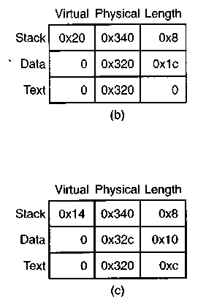
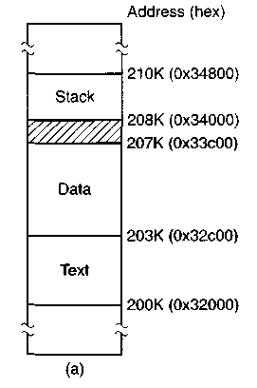

Figure 4-35. (a) A process in memory, (b) Its memory representation for nonseparate I and D space, (c) Its memory representation for separate I and D space.
We mentioned previously that the efforts of hardware designers may not always produce exactly what the software designer needs. Even in protected mode on a Pentium, MINIX does not trap when the stack outgrows its segment. Although in protected mode the Intel hardware detects attempted access to memory outside a segment (as defined by a segment descriptor such as the one in Fig. 4-28), in MINIX the data segment descriptor and the stack segment descriptor are always identical. The MINIX-defined data and stack each use part of this space, and thus either or both can expand into the gap between them. However, only MINIX can manage this. The CPU has no way to detect errors involving the gap, since as far as the hardware is concerned the gap is a valid part of both the data area and the stack area. Of course, the hardware can detect a very large error, such as an attempt to access memory outside the combined data-gap-stack area. This will protect one process from another process' mistakes but is not enough to protect a process from itself.
A design decision was made here. We recognize an argument can be made for abandoning the shared hardware-defined segment that allows MINIX to dynamically reallocate the gap area. The alternative, using the hardware to define nono-verlapping stack and data segments, would offer somewhat more security from certain errors but would make MINIX more memory-hungry. The source code is available to anybody who wants to evaluate the other approach.
Fig. 4-35(c) shows the segment entries for the memory layout of Fig. 4-35(a) for separate I and D space. Here both the text and data segments are nonzero in length. The mp^seg array shown in Fig. 4-35(b) or (c) is primarily used to map

virtual addresses onto physical memory addresses. Given a virtual address and the space to which it belongs, it is a simple matter to see whether the virtual address is legal or not (i.e., falls inside a segment), and if legal, what the corresponding physical address is. The kernel procedure umap performs this mapping for the I/O tasks and for copying to and from user space, for example.
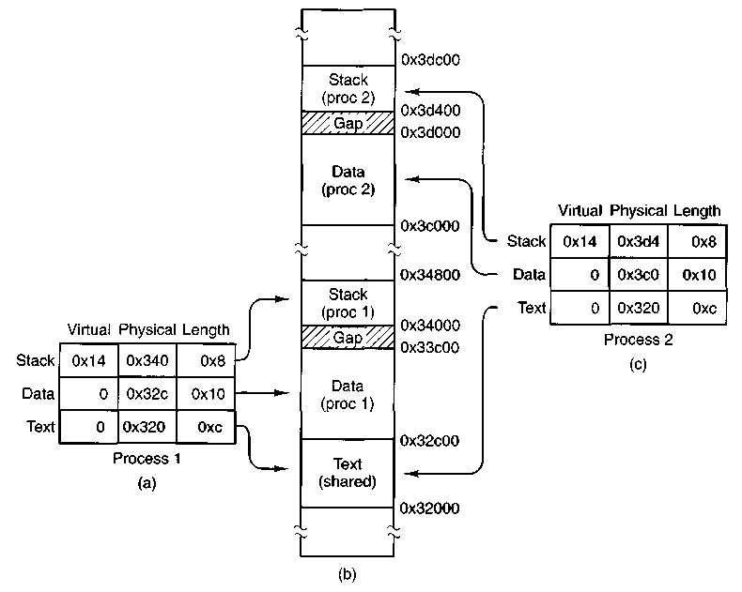
Figure 4-36. (a) The memory map of a separate I and D space process, as in the previous figure, (b) The layout in memory after a second process starts, executing the same program image with shared text, (c) The memory map of the second process.
The contents of the data and stack areas belonging to a process may change as the process executes, but the text does not change. It is common for several processes to be executing copies of the same program, for instance several users may be executing the same shell. Memory efficiency is improved by using shared text. When EXEC is about to load a process, it opens the file holding the disk image of the program to be loaded and reads the file header. If the process uses separate I and D space, a search of the mp_dev, mp_ino, and mp^ctime fields in each slot of mproc is made. These hold the device and i-node numbers and changed-status times of the images being executed by other processes. If a process already
loaded is found to be executing the same program that is about to be loaded, there is no need to allocate memory for another copy of the text. Instead the mp_seg[T] portion of the new process' memory map is initialized to point to the same place where the text segment is already loaded, and only the data and stack portions are set up in a new memory allocation. This is shown in Fig. 4-36. If the program uses combined I and D space or no match is found, memory is allocated as shown in Fig. 4-35 and the text and data for the new process are copied in from the disk.
In addition to the segment information, mproc also holds the process ID (pid) of the process itself and of its parent, the uids and gids (both real and effective), information about signals, and the exit status, if the process has already terminated but its parent has not yet done a WAIT for it.
The other major memory manager table is the hole table, hole, defined in alloc.c, which lists every hole in memory in order of increasing memory address. The gaps between the data and stack segments are not considered holes; they have already been allocated to processes. Consequently, they are not contained in the free hole list. Each hole list entry has three fields: the base address of the hole, in clicks; the length of the hole, in clicks; and a pointer to the next entry on the list. The list is singly linked, so it is easy to find the next hole starting from any given hole, but to find the previous hole, you have to search the entire list from the beginning until you come to the given hole.
The reason for recording everything about segments and holes in clicks rather than bytes is simple: it is much more efficient. In 16-bit mode, 16-bit integers are used for recording memory addresses, so with 256-bit clicks, up to 16 MB of memory can be supported. In 32-bit mode, address fields can refer to up to 2⁴⁰ bytes, which is 1024 gigabytes.
The principal operations on the hole list are allocating a piece of memory of a given size and returning an existing allocation. To allocate memory, the hole list is searched, starting at the hole with the lowest address, until a hole that is large enough is found (first fit). The segment is then allocated by reducing the hole by the amount needed for the segment, or in the rare case of an exact fit, removing the hole from the list. This scheme is fast and simple but suffers from both a small amount of internal fragmentation (up to 255 bytes may be wasted in the final click, since an integral number of clicks is always taken) and external fragmentation.
When a process terminates and is cleaned up, its data and stack memory are returned to the free list. If it uses common I and D, this releases all its memory, since such programs never have a separate allocation of memory for text. If the program uses separate I and D and a search of the process table reveals no other process is sharing the text, the text allocation will also be returned. Since with shared text the text and data regions are not necessarily contiguous, two regions of memory may be returned. For each region returned, if either or both of the region's neighbors are holes, they are merged, so adjacent holes never occur. In this way, the number, location, and sizes of the holes vary continuously during
system operation. Whenever all user processes have terminated, all of available memory is once again ready for allocation. This isn't necessarily a single hole, however, since physical memory may be interrupted by regions unusable by the operating system, as in IBM compatible -systems where read-only memory (ROM) and memory reserved for I/O transfers separate usable memory below address 640K from memory above 1M.
4.7.4 The FORK, EXIT, and WAIT System Calls
When processes are created or destroyed, memory must be allocated or deallocated. Also, the process table must be updated, including the parts held by the kernel and FS. The memory manager coordinates all this activity. Process creation is done by FORK, and carried out in the series of steps shown in Fig. 4-37.
1 . Check to see if process table is full.

2. Try to allocate memory for the child's data and stack.

3. Copy the parent's data and stack to the child's memory.

4. Find a free process slot and copy parent's slot to it.

5. Enter child's memory map in process table.

6. Choose a pid for the child.

7. Tell kernel and file system about child.

8. Report child's memory map to kernel.

9. Send reply messages to parent and child.

Figure 4-37. The steps required to carry out the fork system call.
It is difficult and inconvenient to stop a FORK call part way through, so the memory manager maintains a count at all times of the number of processes currently in existence in order to see easily if a process table slot is available. If the table is not full, an attempt is made to allocate memory for the child. If the program is one with separate I and D space, only enough memory for new data and stack allocations is requested. If this step also succeeds, the FORK is guaranteed to work. The newly allocated memory is then filled in, a process slot is located and filled in, a pid is chosen, and the other parts of the system are informed that a new process has been created.
A process fully terminates when two events have both happened: (1) the process itself has exited (or has been killed by a signal), and (2) its parent has executed a WAIT system call to find out what happened. A process that has exited or has been killed, but whose parent has not (yet) done a wait for it, enters a kind of suspended animation, sometimes known as zombie state. It is prevented from being scheduled and has its alarm timer turned off (if it was on), but it is not
removed from the process table. Its memory is freed. Zombie state is temporary and rarely lasts long. When the parent finally does the WAIT, the process table slot is freed, and the file system and kernel are informed.
A problem arises if the parent of an exiting process is itself already dead. If no special action were taken, the exiting process would remain a zombie forever. Instead, the tables are changed to make it a child of the init process. When the system comes up, init reads the /etc/ttytab file to get a list of all terminals, and then forks off a login process to handle each one. It then blocks, waiting for processes to terminate. In this way, orphan zombies are cleaned up quickly.
4.7.5 The EXEC System Call
When a command is typed at the terminal, the shell forks off a new process, which then executes the command requested. It would have been possible to have a single system call to do both FORK and EXEC at once, but they were provided as two distinct calls for a very good reason: to make it easy to implement I/O redirection. When the shell forks, if standard input is redirected, the child closes standard input and then opens the new standard input before executing the command. In this way the newly started process inherits the redirected standard input. Standard output is handled the same way.
EXEC is the most complex system call in MLNIX. It must replace the current memory image with a new one, including setting up a new stack. It carries out its job in a series of steps, as shown in Fig. 4-38.
1 . Check permissions — is the file executable?

2. Read the header to get the segment and total sizes.

3. Fetch the arguments and environment from the caller.

4. Allocate new memory and release unneeded old memory.

5. Copy stack to new memory image.

6. Copy data (and possibly text) segment to new memory image.

7. Check for and handle setuid, selgid bits.

8. Fix up process table entry.

9. Tell kernel that process is now runnable.

Figure 4-38. The steps required to carry out the exec system call.
Each step consists, in turn, of yet smaller steps, some of which can fail. For example, there might be insufficient memory available. The order in which the tests are made has been carefully chosen to make sure the old memory image is not released until it is certain that the exec will succeed, to avoid the embarrassing situation of not being able to set up a new memory image, but not having the
old one to go back to, either. Normally EXEC does not return, but if it fails, the calling process must get control again, with an error indication.
There are a few steps in Fig. 4-38 that deserve some more comment. First is the question of whether or not there is-enough room or not. After determining how much memory is needed, which requires determining if the text memory of another process can be shared, the hole list is searched to check whether there is sufficient physical memory before freeing the old memory—if the old memory were freed first and there were insufficient memory, it would be hard to get the old image back again.
However, this test is overly strict. It sometimes rejects EXEC calls that, in fact, could succeed. Suppose, for example, the process doing the EXEC call occupies 20K and its text is not shared by any other process. Further suppose that there is a 30K hole available and that the new image requires 50K. By testing before releasing, we will discover that only 30K is available and reject the call. If we had released first, we might have succeeded, depending on whether or not the new 20K hole were adjacent to, and thus now merged with, the 30K hole. A more sophisticated implementation could handle this situation a little better.
Another possible improvement would be to search for two holes, one for the text segment and one for the data segment, if the process to be EXECed uses separate I and D space. There is no need for the segments to be contiguous.
A more subtle issue is whether the executable file fits in the virtual address space. The problem is that memory is allocated not in bytes, but in 256-byte clicks. Each click must belong to a single segment, and may not be, for example, half data, half stack, because the entire memory administration is in clicks.
To see how this restriction can give trouble, note that the address space on 16-bit systems (8088 and 80286) is limited to 64K, which can be divided into 256 clicks. Suppose that a separate I and D space program has 40,000 bytes of text, 32,770 bytes of data, and 32,760 bytes of stack. The data segment occupies 129 clicks, of which the last one is only partially used; still, the whole click is part of the data segment. The stack segment is 128 clicks. Together they exceed 256 clicks, and thus cannot co-exist, even though the number of bytes needed fits in the virtual address space (barely). In theory this problem exists on all machines whose click size is larger than 1 byte, but in practice it rarely occurs on Pentium-class processors, since they permit large (4-GB) segments.
Another important issue is how the initial stack is set up. The library call normally used to invoke EXEC with arguments and an environment is
execve(name, argv, envp);
where name is a pointer to the name of the file to be executed, argv is a pointer to an array of pointers, each one pointing to an argument, and envp is a pointer to an array of pointers, each one pointing to an environment string.
It would be easy enough to implement EXEC by just putting the three pointers in the message to the memory manager and letting it fetch the file name and two
arrays by itself. Then it would have to fetch each argument and each string one al a time. Doing it this way requires at least one message to the system task pei argument or string and probably more, since the memory manager has no way oi knowing how big each one is in advance.
To avoid the overhead of multiple messages to read all these pieces, a completely different strategy has been chosen. The execve library procedure builds the entire initial stack inside itself and passes its base address and size to the memory manager. Building the new stack within the user space is highly efficient, because references to the arguments and strings are just local memory references, not references to a different address space.
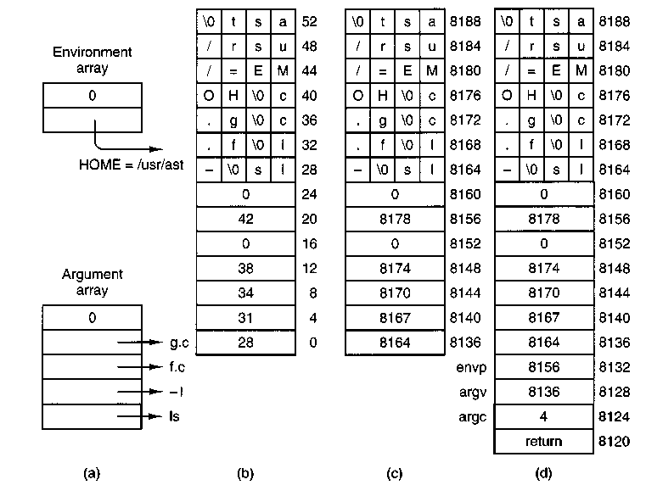
Figure 4-39. (a) The arrays passed to execve. (b) The stack built by execve. (c) The stack after relocation by the memory manager, (d) The stack as it appears to main at the start of execution.
To make this mechanism clearer, consider an example. When a user types Is-I f.c g.c
to the shell, the shell interprets it and then makes the call execve("/bin/ls", argv, envp);
to the library procedure. The contents of the two pointer arrays are shown in Fig. 4-39(a). The procedure execve, within the shell's address space, now builds
the initial stack, as shown in Fig. 4-39(b). This stack is eventually copied intact to the memory manager during the processing of the EXEC call.
When the stack is finally copied to the user process, it will not be put at virtual address 0. Instead, it will be put at the end of the memory allocation, as determined by the total memory size field in the executable file's header. As an example, let us arbitrarily assume that the total size is 8192 bytes, so the last byte available to the program is at address 8191. It is up to the memory manager to relocate the pointers within the stack so that when deposited into the new address, the stack looks like Fig. 4-39(c).
When the EXEC call completes and the program starts running, the stack will indeed look exactly like Fig. 4-39(c), with the stack pointer having the value 8136. However, another problem is yet to be dealt with. The main program of the executed file is probably declared something like this:
main(argc, argv, envp);
As far as the C compiler is concerned, main is just another function. It does not know that main is special, so it compiles code to access the three parameters on the assumption that they will be passed according to the standard C calling convention, last parameter first. With one integer and two pointers, the three parameters are expected to occupy the three words just before the return address. Of course, the stack of Fig. 4-39(c) does not look like that at all.
The solution is that programs do not begin with main. Instead, a small, assembly language routine called the C run-time, start-off procedure, crtso, is always linked in at text address 0 so it gets control first. Its job is to push three more words onto the stack and then to call main using the standard call instruction. This results in the stack of Fig. 4-39(d) at the time that main starts executing. Thus, main is tricked into thinking it was called in the usual way (actually, it is not really a trick; it is called that way).
If the programmer neglects to call exit at the end of main, control will pass back to the C run-time, start-off routine when main is finished. Again, the compiler just sees main as an ordinary procedure and generates the usual code to return from it after the last statement. Thus main returns to its caller, the C runtime, start-off routine which then calls exit itself. Most of the code of 32-bit crtso is shown in Fig. 4-40. The comments should make its operation clear. All that has been left out is the code that loads the registers that are pushed and a few lines that set a flag that indicates if a floating point coprocessor is present or not.
4.7.6 The BRK System Call
The library procedures brk and sbrk are used to adjust the upper bound of the data segment. The former takes an absolute size (in bytes) and calls BRK. The latter takes a positive or negative increment to the current size, computes the new data segment size, and then calls BRK. There is no actual sbrk system call.
push ecx ! push environ
push edx ! push argv
push eax ! push argc
call _main ! main(argc, argv, envp)
push eax ! push exit status
call _exit
hit ! force a trap if exit fails
Figure 4-40. The key part of the C run-time, start-off routine.
An interesting question is: "How does sbrk keep track of the current size, so it can compute the new size?" The answer is that a variable, brksize, always holds the current size so sbrk can find it. This variable is initialized to a compiler generated symbol giving the initial size of text plus data (nonseparate I and D) or just data (separate I and D). The name, and, in fact, very existence of such a symbol is compiler dependent, and thus it will not be found defined in any header file in the source file directories. It is defined in the library, in the file brksize.s. Exactly where it will be found depends on the system, but it will be in the same directory as crtso.s.
Carrying out BRK is easy for the memory manager. All that must be done is to check to see that everything still fits in the address space, adjust the tables, and tell the kernel.
4.7.7 Signal Handling
In Chap. 1 signals were described as a mechanism to convey information to a process that is not necessarily waiting for input. There is a defined set of signals, and each signal has a default action—either kill the process to which it is directed, or ignore the signal. Signal processing would be easy to understand and to implement if these were the only alternatives. However, processes can use system calls that alter these responses. A process can request that any signal (except for the special sigkill signal) be ignored. Furthermore, a process can prepare to catch a signal by requesting that a signal handler procedure internal to the process be activated instead of the default action for any signal (except, again, for sigkill). Thus to the programmer it appears that there are two distinct times when the operating system deals with signals: a preparation phase when a process may modify its response to a future signal, and a response phase when a signal is generated and acted upon. The action can be execution of a custom-written signal handler. There is actually a third phase. When a user-written handler terminates, a special system call cleans up and restores normal operation of the signaled process. The programmer does not need to know about this third phase. He writes a signal handler just like any other function. The operating system takes care of the details of invoking and terminating the handler and managing the stack.
In the preparation phase there are several system calls that a process can execute at any time to change its response to a signal. The most general of these is SIGACTION, which can specify that the process ignore some signal, catch some signal (replacing the default action with execution of user-defined signal-handling code within the process), or restore the default response to some signal. Another system call, SIGPROCMASK, can block a signal, causing it to be queued and to be acted upon only when and if the process unblocks that particular signal at a later time. These calls may be made at any time, even from within a signal catching function. In MINIX the preparation phase of signal processing is handled entirely by the memory manager, since the necessary data structures are all in the memory manager's part of the process table. For each process there are several sigset_t variables, in which each possible signal is represented by a bit. One such variable defines a set of signals to be ignored, another defines a set to be caught, and so on. For each process there is also an array of sigaction structures, one for each signal. Each element of the sigaction structure contains a variable to hold the address of a custom handler for that signal and an additional sigset_t variable to map signals to be blocked while that handler is executing. The field used for the address of the handler can instead hold special values signifying that the signal is to be ignored or is to be handled in the default way defined for that signal.
When a signal is generated, multiple parts of the MINIX system may become involved. The response begins in the memory manager, which figures out which processes should get the signal using the data structures just mentioned. If the signal is to be caught, it must be delivered to the target process. This requires saving information about the state of the process, so normal execution can be resumed. The information is stored on the signaled process' stack, and a check must be made to determine that there is sufficient stack space. The memory manager does this checking, since this is within its realm, and then calls the system task in the kernel to put the information on the stack. The system task also manipulates the process' program counter, so the process can execute the handler code. When the handler terminates, a SIGRETURN system call is made. Through this call, both the memory manager and the kernel participate in restoring the process' signal context and registers so it can resume normal execution. If the signal is not caught, the default action is taken, which may involve calling the file system to produce a core dump (writing the process' image to a file that may be examined with a debugger), as well as killing the process, which involves all of the memory manager, file system, and kernel. Finally, the memory manager may direct one or more repetitions of these actions, since a single signal may need to be delivered to a group of processes.
The signals known to MINIX are defined in /usr/include/signal.h, a file required by the POSix standard. They are listed in Fig. 4-41. All of the POSlx-re-quired signals are defined in MINIX, but not all of them are currently supported. For instance, POSIX requires several signals related to job control, the ability to put a running program into the background and bring it back. MINIX does not support
job control, but programs that might generate these signals can be ported to MINIX. These signals will be ignored if generated. MINIX also defines some non-POSix signals and some synonyms for POSIX names for compatibility with older source code.
Signal | Description | Generated by
SIGHUP | Hangup | KILL system call
SIGINT | Interrupt | Kernel
SIGQUIT | Quit | Kernel
SIGILL | Illegal instruction | Kernel (*)
SIGTRAP | Trace trap | Kernel (M)
SIGABRT | Abnormal termination | Kernel
SIGFPE | Floating point exception | Kernel (*)
SIGKILL | Kill (cannot be caught or ignored) | KILL system call
SIGUSR1 | User-defined signal # 1 | Not supported
SIGSEGV | Segmentation violation | Kernel (*)
SIGUSR2 | User defined signal # 2 | Not supported
SIGPIPE | Write on a pipe with no one to read it | Kernel
SIGALRM | Alarm clock, timeout | Kernel
SIGTERM | Software termination signal from kill | KILL system call
SIGCHLD | Child process terminated or stopped | Not supported
SIGCONT | Continue if stopped | Not supported
SIGSTOP | Stop signal | Not supported
SIGTSTP | Interactive stop signal | Not supported
SIGTTIN | Background process wants to read | Not supported
SIGTTOU | Background process wants to write | Not supported
Figure 4-41. Signals defined by posix and minix. Signals indicated by (*) depend upon hardware support. Signals marked (M) are not defined by posix, but are defined by minix for compatibility with older programs. Several obsolete names and synonyms are not listed here.
Signals can be generated in two ways: by the kill system call, and by the kernel. The signals generated by the MINIX kernel always include sigint, SIGQUIT, and SIGALRM. Other kernel signals depend upon hardware support. For instance, the 8086 and 8088 processors do not support detection of illegal instruction operation codes, but this capability is available on the 286 and above, which trap on an attempt to execute an illegal opcode. This service is provided by the hardware.
The implementor of the operating system must provide code to generate a signal in response to the trap. We saw in Chap. 2 that kernel/exception.c contains code to do just this for a number of different conditions. Thus a SIGILL signal can be generated in response to an illegal instruction when MINIX runs on a 286 or higher processor, but this signal will never be seen when MINIX runs on an 8088.
Just because the hardware can trap on a certain condition does not mean the capability can be used fully by the operating system implementor. For instance, several kinds of violations of memory integrity result in exceptions on all Intel processors beginning with the 286. Code in kernel/exception.c translates these exceptions into SIGSEGV signals. There are separate exceptions generated for violations of the limits of the hardware-defined stack segment and for other segments, since these might need to be treated differently. However, because of the way minix uses memory, the hardware cannot detect all the errors that might occur. The hardware defines a base and a limit for each segment. The hardware-defined data segment base is the same as the minix data segment base, but the hardware-defined data segment limit is higher than the limit that MINIX enforces in software. In other words, the hardware defines the data segment as the maximum amount of memory that MINIX could possibly use for data, if somehow the stack could shrink to nothing. Similarly the hardware defines the stack as the maximum amount of memory the MINIX stack could use if the data area could shrink to nothing. Although certain violations can be detected by the hardware, the hardware cannot detect the most probable stack violation, growth of the stack into the data area, since as far as the hardware registers and descriptor tables are concerned the data area and the stack area overlap.
Conceivably some code could be added to the kernel that would check each process' registers after each time the process gets a chance to run and generate a SIGSEGV signal upon detection of a violation of the integrity of the MINIX-defined data or stack areas. Whether this would be worthwhile is unclear; hardware traps can catch a violation immediately. A software check might not get a chance to do its work until many thousands of additional instructions had been executed, and at that point there might be very little a signal handler could do to try to recover.
Whatever their origin, the memory manager processes all signals the same way. For each process to be signaled, a variety of checks are made to see if the signal is feasible. One process can signal another if the signaler is the super-user or if the real or effective uid of the signaler is equal to either the real or effective uid of the signaled process. But there are several conditions that can prevent a signal being sent. Zombies cannot be signaled, for example. A process cannot be signaled if it has explicitly called SIGACTION to ignore the signal or SIGPROCMASK to block it. Blocking a signal is distinct from ignoring it; receipt of a blocked signal is remembered, and it is delivered when and if the signaled process removes the block. Finally, if its stack space is not adequate the signaled process is killed.
If all the conditions are met, the signal can be sent. If the process has not arranged for the signal to be caught, no information needs to be passed to the
process. In this case the memory manager executes the default action for the signal, which is usually to kill the process, possibly also producing a core dump. For a few signals the default action is to ignore the signal. The signals marked "Not supported" in Fig. 4-41 are required to be "defined by POSix but are ignored by MINIX.
Catching a signal means executing the process' custom signal-handling code, the address of which is stored in a sigaction structure in the process table. In Chap. 2 we saw how a process' stackframe within its process table entry receives the information needed to restart the process when it is interrupted. By modifying the stackframe of a process to be signaled, it can be arranged that when the process next is allowed to execute the signal handler will run. By modifying the process' own stack in user space, it can be arranged that when the signal handler terminates the SIGRETURN system call will be made. This system call is never invoked by user-written code. It is executed after the kernel puts its address on the stack in such a way that its address becomes the return address popped from the stack when a signal handler terminates. SIGRETURN restores the original stackframe of the signaled process, so it can resume execution at the point where it was interrupted by the signal.
Although the final stage of sending a signal is done by the system task, this is a good place to summarize how it is done, since the data used are passed to the kernel from the memory manager. Catching a signal requires something much like the context switch that occurs when one process is taken out of execution and another process is put into execution, since when the handler terminates the process ought to be able to continue as if nothing had happened. However, there is only one place in the process table to store the contents of all the CPU registers that are needed to restore the process to its original state. The solution to this problem is shown in Fig. 4-42. Part (a) of the figure is a simplified view of the stack of a process and part of its process table entry just after it has been taken out of execution following an interrupt. At the time of suspension the contents of all of the CPU registers are copied into the stackframe structure in the process' process table entry in the kernel's part of the process table. This will be the situation at the moment a signal is generated, since a signal is generated by a process or task different from the intended recipient.
In preparation for handling the signal, the stackframe from the process table is copied onto the process' own stack as a sigcontext structure, thus preserving it. Then a sigframe structure is placed on the stack. This structure contains information to be used by SIGRETURN after the handler finishes. It also contains the address of the library procedure that invokes SIGRETURN itself, ret addrl, and another return address, ret addr2, which is the address where execution of the interrupted program will resume. As will be seen, however, the latter address is not used during normal execution.
Although the handler is written as an ordinary procedure by the programmer, it is not called by a call instruction. The instruction pointer (program counter)
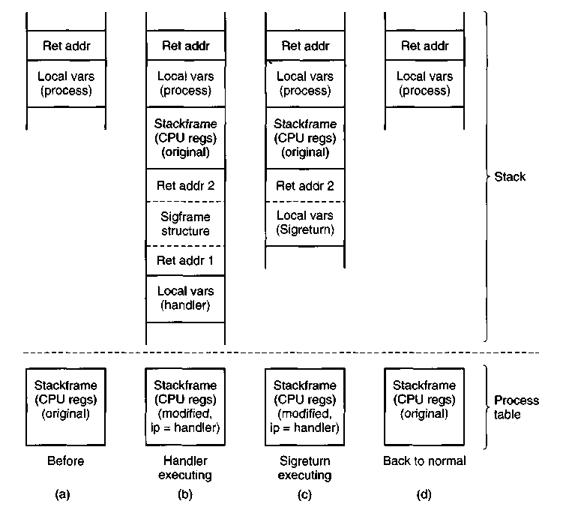
Figure 4-42. A process' stack (above) and its stackframe in the process table (below) corresponding to phases in handling a signal, (a) State as process is taken out of execution, (b) State as handler begins execution, (c) State while SIGRETURN is executing, (d) State after sigreturn completes execution.
field in the stackframe in the process table is altered to cause the signal handler to begin executing when restart puts the signaled process back into execution. Figure 4-42(b) shows the situation after this preparation has been completed and as the signal handler executes. Recall that the signal handler is an ordinary procedure, so when it terminates, ret addrl is popped and SIGRETURN executes.
Part (c) shows the situation while SIGRETURN is executing. The rest of the sigframe structure is now SIGRETURN's local variables. Part of SIGRETURN's action is to adjust its own stack pointer so that if it were to terminate like an ordinary function, it would use ret addr2 as its return address. However, SIGRETURN does not actually terminate this way. It terminates like other system calls, allowing the scheduler in the kernel to decide which process to restart. Eventually, the signaled process will be rescheduled and will restart at this address, because the
address is also in the process' original stackframe. The reason this address is on the stack is that a user might want to trace a program using a debugger, and this fools the debugger into a reasonable interpretation of the stack while a signal handler is being traced. In each phase the stack looks like that of an ordinary process, with local variables on top of a return address.
The real work of SIGRETURN is to restore things to the state they were in before the signal was received, and to clean up. Most importantly, the stackframe in the process table is restored to its original state, using the copy that was saved on the signaled process' stack. When SIGRETURN terminates, the situation will be as in Fig. 4-42(d), which shows the process waiting to be put back into execution in the same state it was in when interrupted.
For most signals the default action is to kill the signaled process. The memory manager takes care of this for any signal that is not ignored by default, and which the recipient process has not been enabled to handle, block, or ignore. If the parent is waiting for it, the killed process is cleaned up and removed from the process table. If the parent is not waiting, it becomes a zombie. For certain signal numbers (e.g., SIGQUIT), the memory manager also writes a core dump of the process to the current directory.
It can easily happen that a signal is sent to a process that is currently blocked waiting for a read on a terminal for which no input is available. If the process has not specified that the signal is to be caught, it is just killed in the usual way. If, however, the signal is caught, the issue arises of what to do after the signal interrupt has been processed. Should the process go back to waiting, or should it continue with the next statement?
What MINIX does is this: the system call is terminated in such a way as to return the error code EINTR, so the process can see that the call was broken off by a signal. Determining that a signaled process was blocked on a system call is not entirely trivial. The memory manager must ask the file system to check for it.
This behavior is suggested, but not required, by POSix, which also allows a read to return the number of bytes read so far at the time of receipt of the signal. Returning EINTR makes it possible to set an alarm and to catch SIGALRM. This is an easy way to implement a timeout, for instance to terminate login and hang up a modem line if a user does not respond within a certain period. The synchronous clock task can be used to do the same thing with less overhead, but it is a minix invention and not as portable as using signals. Also, it is available only to server processes, and not to ordinary user processes.
4.7.8 Other System Calls
The memory manager handles a few more simple system calls. The library functions getuid and geteuid both invoke the GETUID system call, which returns both values in its return message. Similarly, the GETGID system call also returns real and effective values for use by the getgid and getegid functions. GETPID
works the same way to return both the process ID and the ID of the parent process, and SETUID and SETGID can each set both real and effective values in one call. There are two additional system calls in this group, GETPGRP and SETSID. The former returns the process group ID, arid the latter sets it to the current pid value. These seven calls are the simplest minix system calls.
The PTRACE and REBOOT system calls are also handled by the memory manager. The former supports debugging of programs. The latter affects many aspects of the system. It is appropriate to place it in the memory manager because its first action is to send signals to kill all processes except init. After that it calls upon the file system and the system task to complete its work.
4.8 IMPLEMENTATION OF MEMORY MANAGEMENT IN MINIX
Armed with a general overview of how the memory manager works, let us now turn to the code itself. The memory manager is written entirely in C, is straightforward, and contains a substantial amount of commentary in the code itself, so our treatment of most parts need not be long or involved. We will first look briefly at the header files, then the main program, and finally the files for the various system call groups discussed previously.
4.8.1 The Header Files and Data Structures
Several header files in the memory manager source directory have the same names as files in the kernel directory, and these names will be seen again in the file system. These files have similar functions in their own contexts. The parallel structure is designed to make it easier to understand the organization of the whole MINIX system. The memory manager also has a number of headers with unique names. As in other parts of the system, storage for global variables is reserved when the memory manager's version of table.c is compiled. In this section we will look at all of the header files, as well as table.c.
As with the other major parts of MINIX, the memory manager has a master header file, mm.h (line 15800). It is included in every compilation, and it in turn includes all the system-wide header files from /usr/include and its subdirectories that are needed by every object module. Most of the files that are included in kernel/kernel.h are also included here. The memory manager also needs definitions in include/fcntl.h and include/unistd.h. The memory manager's own versions of const.h, type.h, proto.h, and glo.h also are included.
Const.h (line 15900) defines a some constants used by the memory manager, especially when compiled for 16-bit machines. The line
#def4ne printf printk
is contained here so that calls to printf will be compiled as calls to the printk
function. The function is similar to the one we saw in the kernel, and is defined for a similar reason, so the memory manager can display error and debugging messages without calling on the file system for help.
Type.h is currently unused and exists in skeletal form just so the memory manager files will have the same organization as the other parts of minix. Proto.h (line 16100) collects in one place function prototypes needed throughout the memory manager.
The memory manager's global variables are declared in glo.h (line 16200). The same trick used in the kernel with EXTERN is used here, namely, EXTERN is normally a macro that expands to extern, except in the file table.c. There it becomes the null string so storage can be reserved for the variables declared as EXTERN.
The first of these variables, mp, is a pointer to an mproc structure, the MM part of the process table for the process whose system call is being processed. The second variable, dont_repfy, is initialized to FALSE when each new request arrives but can be set to TRUE during the call if it is discovered that no reply message should be sent. No replies are sent for a successful EXEC, for example. The third variable, procs_in_use, keeps track of how many process slots are currently in use, making it easy to see if a FORK call is feasible.
The message buffers mm_in and mm^out are for the request and reply messages, respectively. Who is the index of the current process; it is related to mp by
mp = &mproc[who];
When a message comes in, the system call number is extracted from it and put in mm^call.
The three variables err_code, result2, and res_ptr are used to hold values returned to the caller in the reply message. The most important of these variables is err_code, which is set to OK if the call is completed without error. The last two variables are used when a problem develops. MINIX writes an image of a process to a core file when a process terminates abnormally. Core_name defines the name this file will have, and core_sset is a bit map which defines which signals should produce core dumps.
The memory manager's part of the process table is in the next file, mproc.h (line 16300). Most of the fields are adequately described by their comments. Several fields deal with signal handling. Mp_ignore, mp_catch, mp_sigmask, mp_sigmask2, and mp-sigpending are bit maps, in which each bit represents one of the signals that can be sent to a process. The type sigset_t is a 32-bit integer, so minix could easily support up to 32 signals, but currently only 16 signals are defined, with signal 1 being the least significant (rightmost) bit. In any case, POSlX requires standard functions to add or delete members of the signal sets represented by these bit maps, so all necessary manipulations can be done without the programmer being aware of these details. The array mp_sigact is important for handling signals. There is an element for each signal type, and each element
is a sigaction structure (defined in include/signal.h). Each sigaction structure consists of three fields:
1. The sa_handler field defines .whether the signal is to be handled in the default way, ignored, or handled by a special handler.
2. The sa_mask field is a sigset^t that defines which signals are to be blocked when the signal is being handled by a custom handler.
3. The sa^flags field is a set of flags that apply to the signal.
This array makes possible a great deal of flexibility in handling signals.
The mp^flags field is used to hold a miscellaneous collection of bits, as indicated at the end of the file. This field is an unsigned integer, 16 bits on low-end CPUs or 32 bits on a 386 and up. There is plenty of room for expansion here, even on an 8088, as only 9 bits are used.
The last field in the process table is mp_procargs. When a new process is started, a stack like the one shown in Fig. 4-39 is built, and a pointer to the start of the new process' argv array is stored here. This is used by the ps command. For instance, for the example of Fig. 4-39, the value 8164 would be stored here, making it possible for ps to display the command line,
Is-I f.c g.c
if executed while the Is command is active.
The next file is param.h (line 16400), which contains macros for many of the system call parameters contained in the request message. It also contains four macros for fields in the reply message. When the statement
k = pid;
appears in any file in which param.h is included, the preprocessor converts it to
k = mm_Jn.m1_i1;
before feeding it to the compiler proper.
Before we continue with the executable code, let us look at table, c (line 16500). Its compilation reserves storage for the various EXTERN variables and structures we have seen in glo.h and mproc.h. The statement
#define _TABLE
causes EXTERN to become the null string. This is the same mechanism that we saw in the kernel code.
The other major feature of table.c is the array call_vec (line 16515). When a request message arrives, the system call number is extracted from it and used as an index into call^vec to locate the procedure that carries out that system call. System call numbers that are not valid calls all invoke no-sys, which just returns an error code. Note that although the ^PROTOTYPE macro is used in defining
ca//_vec, this is not a declaration of a prototype; it is definition of an initialized array. However, it is an array of functions, and use of ^PROTOTYPE is the easiest way to do this that is compatible with both classic (Kernighan & Ritchie) C and Standard C.
4.8.2 The Main Program
The memory manager is compiled and linked independently from the kernel and the file system. Consequently, it has its own main program, which is started up after the kernel has finished initializing itself. The main program is in main.c, at line 16627. After doing its own initialization by calling mm_init, the memory manager enters its loop on line 16636. In this loop, it calls get_work to wait for an incoming request message. Then it calls one of its do_XXX procedures via the call_vec table to carry out the request, and finally sends a reply, if needed. This construction should be familiar by now: it is the same one used by the I/O tasks.
The procedures get-work (line 16663) and reply (line 16676) handle the actual receiving and sending, respectively.
The last procedure in this file is mm_init, which initializes the memory manager. It is not used after the system has started running. The call to sys_getmap on line 16730 gets information about the kernel's memory use. The loop on lines 16734 to 16741 initializes all the process table entries for tasks and servers, and the following lines prepare init's process table entry. On line 16749 MM waits for FS to send it a message. As mentioned in the discussion of deadlock handling in MINIX, this is the only time the file system ever sends a request message to the file system. The message tells how much memory is being used for the RAM disk. The call to mem_init on line 16755 initializes the hole list by calling the system task. After this, normal memory management can begin. This call also fills in the total^clicks and free^clicks variables, completing the information mm-init needs to print a message showing total memory, kernel memory use, RAM disk size, and free memory. After printing the message a reply is sent to FS (line 16764), allowing it to continue. Finally, the memory task is given the address of MM's part of the process table, for the benefit of the ps command.
4.8.3 Implementation of FORK, EXIT, and WAIT
The FORK, exit, and WAIT system calls are implemented by the procedures do-fork, do^mm_exit, and do^wait in the fil&forkexit.c. The procedure do^fork (line 16832) follows the steps shown in Fig. 4-37. Notice that the second call to procs^in^use (line 16847) reserves the last few process table slots for the super-user. In computing how much memory the child needs, the gap between the data and stack segments is included, but the text segment is not. Either the parent's text is shared, or, if the process has common I and D space, its text segment is of zero length. After doing the computation, a call is made to alloc_mem to get the
memory. If this is successful, the base addresses of child and parent are converted from clicks into absolute bytes, and sys_copy is called to send a message to the system task to get the copying done.
Now a slot is found in the process table. The test involving procs_in_use earlier guarantees that one will exist. After the slot has been found, it is filled in, first by copying the parent's slot there, and then updating the fields mp_parent, mp-flags, mp-seg, mp_exitstatus, and mp^sigstatus. Some of these fields need special handling. The TRACED bit in the mp__flags field is zeroed, since a child does not inherit trace status. The mp_seg field is an array containing elements for the text, data, and stack segments, and the text portion is left pointing to the parent's text segment if the flags indicate this is a separate I and D program that can share text.
The next step is assigning a pid to the child. The variable next^pid keeps track of the next pid to be assigned. However, the following problem could conceivably occur. After assigning, say, pid 20 to a very long-lived process, 30,000 more processes might be created and destroyed, and next_pid might come back to 20 again. Assigning a pid that was still in use would be a disaster (suppose someone later tried to signal process 20), so we search the whole process table to make sure that the pid to be assigned is not already in use.
The calls to sys^fork and tell_fs inform the kernel and file system, respectively, that a new process has been created, so they can update their process tables. (All the procedures beginning with sys_ are library routines that send a message to the system task in the kernel to request one of the services of Fig. 3-50.) Process creation and destruction are always initiated by the memory manager and then propagated to the kernel and file system when completed.
The reply message to the child is sent explicitly at the end of do-fork. The reply to the parent, containing the child's pid, is sent by the loop in main, as the normal reply to a request.
The next system call handled by the memory manager is exit. The procedure do-mm-exit (line 16912) accepts the call, but most of the work is done by the call to mm_exit, a few lines further down. The reason for this division of labor is that mm_exit is also called to take care of processes terminated by a signal. The work is the same, but the parameters are different, so it is convenient to split things up this way.
The first thing mm_exit does is to stop the timer, if the process has one running. Next, the kernel and file system are notified that the process is no longer runnable (lines 16949 and 16950). The call to the library procedure sys_xit sends a message to the system task telling it to mark the process as no longer runnable, so it will not be scheduled any more. Next the memory is released. A call to find_share determines whether the text segment is being shared by another process, and if not the text segment is released by a call tofree^mem. This is followed by another call to the same procedure to release the data and stack. It is not worth the trouble to decide whether all the memory could be released in one call
to free_mem. If the parent is waiting, cleanup is called to release the process table slot. If the parent is not waiting, the process becomes a zombie, indicated by the HANGING bit in the mp_flags word. Whether the process is completely eliminated or made into a zombie, the final action of mm_exit is to loop through the process table and look for children of the process it has just terminated (lines 16975 to 16982). If any are found, they are disinherited and become children of init. If init is waiting and a child is hanging, cleanup is then called for that child. This deals with situations such as the one shown in Fig. 4-43(a). In this figure we see that process 12 is about to exit, and that its parent, 7, is waiting for it. Cleanup will be called to get rid of 12, so 52 and 53 are turned into children of init, as shown in Fig. 4-43(b). Now we have the situation that 53, which has already exited, is the child of a process doing a WAIT. Consequently, it can also be cleaned up.
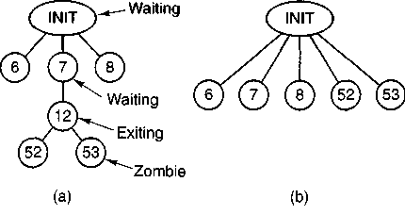
Figure 4-43. (a) The situation as process 12 is about to exit, (b) The situation after it has exited.
When the parent process does a wait or a waitpid, control comes to procedure do_waitpid on line 16992. The parameters supplied by the two calls are different, and the actions expected are also different, but the setup done in lines 17009 to 17011 prepares internal variables so do_waitpid can perform the actions of either call. The loop on lines 17019 to 17041 scans the entire process table to see if the process has any children at all, and if so, checks to see if any are zombies that can now be cleaned up. If a zombie is found (line 17026), it is cleaned up and do_waitpid returns. The flag dont_reply is set because the reply to the parent is sent from inside cleanup, not from the loop in main. If a traced child is found, a reply is sent indicating the process is stopped, and do_waltpid returns. Dont-reply is also set true to prevent a second reply being sent by main.
If the process doing the WAIT has no children, it simply gets an error return (line 17053). If it has children, but none are zombies or are being traced, a test is made to see if do_waitpid was called with a bit set indicating the parent didn't want to wait. If not (the usual case), then a bit is set on line 17047 to indicate that it is waiting, and the parent is suspended until a child terminates.
When a process has exited and its parent is waiting for it, in whichever order these events occur, the procedure cleanup (line 17061) is called to perform the
last rites. There is not much to do by this point. The parent is awakened from its WAIT or WAITPID call and is given the pid of the terminated child, as well as its exit and signal status. The file system has already released the child's memory, and the kernel has already suspended scheduling, so all the kernel now has to do is free up the child's slot in the process table.
4.8.4 Implementation of EXEC
The code for EXEC follows the outline of Fig. 4-38. It is contained in the procedure do_exec (line 17140). After making a few simple validity checks, the memory manager fetches the name of the file to be executed from user space. On line 17172 it sends a special message to the file system, to switch to the user's directory, so that the path just fetched will be interpreted relative to the user's, rather than to MM's, working directory.
If the file is present and executable, the memory manager reads the header to extract the segment sizes. Then it fetches the stack from user space (lines 17188 and 17189), checks to see if the new process can share text with a process that is already running (line 17196), allocates memory for the new image (line 17199), patches up the pointers [see the differences between Fig. 4-39(b) and (c)], and reads in the text segment (if needed) and the data segment (lines 17221 to 17226). Finally, it processes the setuid and setgid bits, updates the process table entry, and tells the kernel that it is finished, so that the process can be scheduled again.
Although the control of all the steps is in do^exec, many of the details are carried out by subsidiary procedures within exec.c. Read^header (line 17272), for example, not only reads the header and returns the segment sizes, it also verifies that the file is a valid MINIX executable for the same CPU type as the operating system is compiled for. This is done by conditional compilation of the appropriate test at the time the memory manager is compiled (lines 17322 to 17327). Read^header also verifies that all the segments fit in the virtual address space.
Procedure new_mem (line 17366) checks to see if sufficient memory is available for the new memory image. It searches for a hole big enough for just the data and stack if the text is being shared; otherwise it searches for a single hole big enough for the combined text, data, and stack. A possible improvement here wduld be to search for two separate holes, one for the text and one for the data and stack, since there is no need for these areas to be contiguous. In earlier versions of MINIX this was required. If sufficient memory is found, the old memory is released and the new memory acquired. If insufficient memory is available, the EXEC call fails. After the new memory is allocated, new_mem updates the memory map (in mp^seg) and reports it to the kernel by calling the library procedure sys^newmap.
The remainder of new_mem is concerned with zeroing the bss segment, gap, and stack segment. (The bss segment is that part of the data segment that contains
all the uninitialized global variables.) Many compilers generate explicit code to zero the bss segment, but doing it here allows MINIX to work even with compilers that do not. The gap between data and stack segments is also zeroed, so that when the data segment is extended by BRK, the newly acquired memory will contain zeroes. This is not only a convenience for the programmer, who can count on new variables having an initial value of zero, it is also a security feature on a multiuser operating system, where a process previously using this memory may have been using data that should not be seen by other processes.
The next procedure is patch^ptr (line 17465), which does the job of relocating the pointers of Fig. 4-39(b) to the form of Fig.4-39(c). The work is simple: examine the stack to find all the pointers and add the base address to each one.
The procedure load_seg (line 17498) is called once or twice per EXEC, possibly to load the text segment and always to load the data segment. Rather than just reading the file block by block and then copying the blocks to the user, a trick is used to allow the file system to load the entire segment directly to the user space. In effect, the call is decoded by the file system in a slightly special way so that it appears to be a read of the entire segment by the user process itself. Only a few lines at the beginning of the file system's read routine know that some monkey business is going on here. Loading is appreciably speeded up by this maneuver.
The final procedure in exec.c is find_share (line 17535). It searches for a process that can share text by comparing the i-node, device, and modification times of the file to be executed with those of existing processes. This is just a straightforward search of the appropriate fields in mproc. Of course, it must ignore the process on behalf of which the search is being made.
4.8.5 Implementation of BRK
As we have just seen, the memory model used by MINIX is quite simple: each process is given a single contiguous allocation for its data and stack when it is created. It is never moved around in memory, it is never swapped out of memory, it never grows, and it never shrinks. All that can happen is that the data segment can eat away at the gap from the low end, and the stack can eat away at it from the high end. Under these circumstances, the implementation of the brk call in break.c is especially easy. It consists of verifying that the new sizes are feasible and then updating the tables to reflect them.
The top-level procedure is do_brk (line 17628), but most of the work is done in adjust (line 17661). The latter checks to see if the stack and data segments have collided. If they have, the BRK call cannot be carried out, but the process is not killed immediately. A safety factor, SAFETY_BYTES, is added to the top of the data segment before making the test, so (hopefully) the decision that the stack has grown too far can be made while there is still enough room on the stack for the process to continue for a short while. It gets control back (with an error message), so it can print appropriate messages and shut down gracefully.
Note that SAFETY_BYTES is defined using a #define statement in the middle of the procedure (line 17693). This use is rather unusual; normally such definitions appear at the beginning of files, or in separate header files. The associated comment reveals that the programmer found deciding upon the size of the safety factor to be difficult. There is no doubt that this definition was done in this way to attract attention and, perhaps, to stimulate additional experimentation.
The base of the data segment is constant, so if adjust has to adjust the data segment, all it does is update the length field. The stack grows downward from a fixed end point, so if adjust also notices that the stack pointer, which is given to it as a parameter, has grown beyond the stack segment (to a lower address), both the origin and length are updated.
The last procedure in this file, size^ok (line 17736) makes a test to see if the segment sizes fit within the address space, in clicks as well as in bytes. The conditional code for 16-bit machines has been retained in the listing in order to show why this is written as a separate function. There would be little point in having this as a separate function for 32-bit MINIX. It is called in only two places, and substituting line 17765 in place of the calls would result in more compact code, since the calls pass several arguments that are not used in the 32-bit implementation.
4.8.6 Implementation of Signal Handling
There are eight system calls relating to signals. They are summarized in Fig. 4-44. These system calls, as well as the signals themselves, are processed in the file signal.c. An additional system call, reboot, is also handled by this file, since it uses signals to terminate all processes.
System call | Purpose
SIGACTION | Modify response to future signal
SIGPROCMASK | Change set of blocked signals
KILL | Send signal to another process
ALARM | Send ALRM signal to self after delay
PAUSE | Suspend self until future signal
SIGSUSPEND | Change set of blocked signals, then PAUSE
SIGPENDING | Examine set of pending (blocked) signals
SIGRETURN | Clean up after signal handler
Figure 4-44. System calls relating to signals.
The SIGACTION call supports the sigaction and signal functions, which allow a process to alter how it will respond to signals. Sigaction is required by POSIX and
is the preferred call for most purposes, but the signal library function is required by Standard C, and programs that must be portable to non-POSIX systems should be written using it. The code for do^sigaction (line 17845) begins with checks for a valid signal number and verification that the call is not an attempt to change the response to a SIGKILL signal (lines 17851 and 17852). (It is not permitted to ignore, catch, or block SIGKILL. SIGKILL is the ultimate means by which a user can control his processes and a system manager can control his users.) sigaction is called with pointers to a sigaction structure, sig^osa, that receives the old signal attributes that were in effect before the call, and another such structure, sig_nsa, containing a new set of attributes.
The first step is to call the system task to copy the current attributes into the structure pointed to by sig^osa. SIGACTION can be called with a NULL pointer in sig^nsa to examine the old signal attributes without changing them. In this case do^sigaction returns immediately (line 17860). If sig_nsa is not NULL, the structure defining the new signal action is copied to the memory manager's space. The code in lines 17867 to 17877 modifies the mp^catch, mp^ignore, and mp^sigpending bit maps according to whether the new action is to be to ignore the signal, to use the default handler, or to catch the signal. The library functions sigaddset and sigdelset are used, although the actions are straightforward bit manipulation operations that could have been implemented with simple macros. However, these functions are required by the POSIX standard in order to make programs that use them easily portable, even to systems in which the number of signals exceeds the number of bits available in an integer. Using the library functions helps to make MINIX itself easily portable to different architectures.
Finally, the other signal-related fields in the memory manager's part of the process table are filled in. For each potential signal there is bit map, the sa_mask, which defines which signals are to be blocked while a handler for that signal is executing. For each signal there is also a pointer, sa^handler. It can contain a pointer to the handler function, or special values to indicate the signal is to be ignored or handled in the default way. The address of the library routine that invokes SIGRETURN when the handler terminates is stored in mp^sigreturn. This address is one of the fields in the message received by the memory manager.
POSIX allows a process to manipulate its own signal handling, even while within a signal handler. This can be used to change signal response to subsequent signals while a signal is being processed, and then to restore the normal set of responses. The next group of system calls support these signal-manipulation features. SIGPENDING is handled by do^sigpending (line 17889), which returns the mp^sigpending bit map, so a process can determine if it has pending signals. SIGPROCMASK, handled by do-sigprocmask, returns the set of signals that are currently blocked, and can also be used to change the state of a single signal in the set, or to replace the entire set with a new one. The moment that a signal is unblocked is an appropriate time to check for pending signals, and this is done by calls to check^pending on line 17927 and line 17933. Do^sigsuspend (line
17949) carries out the SIGSUSPEND system call. This call suspends a process until a signal is received. Like the other functions we have discussed here, it manipulates bit maps. It also sets the SIGSUSPENDED bit in mp_flags, which is all it takes to prevent execution of the process. Again,- this is a good time to make a call to check ^pending. Finally, do ^sigreturn handles SIGRETURN, which is used to return from a custom handler. It restores the signal context that existed when the handler was entered, and it also calls check_pending on line 17980.
Some signals, such as S1GINT, originate in the kernel itself. Such signals are handled in a way that is similar to signals generated by a user process calling KILL. The two procedures, doJdtt (line 17983) and do_ksig (line 17994), are conceptually similar. Both cause the memory manager to send a signal. A single call to KILL may require delivery of signals to a group of processes, and do^kill just calls check_sig, which checks the entire process table for eligible recipients. Do_ksig is called when a message arrives from the kernel. The message contains a bit map, allowing the kernel to generate multiple signals with one message. As with KILL, each of these may need to be delivered to a group of processes. The bit map is processed one bit at a time by the loop on lines 18026 to 18048. Some kernel signals need special attention: the process ID is changed in some cases to cause the signal to be delivered to a group of processes (lines 18030 to 18033). and a SIGALRM is ignored if it hasn't been requested. With that exception, each bit set results in a call to check_sig, just as in do_kill.
The ALARM system call is controlled by do_alarm (line 18056). It calls the next function, set^alarm, which sends a message to the clock task telling it to start the timer. Set-alarm (line 18067) is a separate function because it is also used to turn the timer off when a process exits with the timer still on. When the timer runs out, the kernel announces the fact by sending the memory manager a message of type KSIG, which causes do_ksig to run, as discussed above. The default action of the SIGALRM signal is to kill the process if it is not caught. If the SIGALRM is to be caught, a handler must be installed by SIGACTION. The complete sequence of events for a SIGALRM signal with a custom handler is shown in Fig. 4-45. There are three sequences of messages here. In messages (1), (2), and (3) the user does an ALARM call via a message to the memory manager, the manager sends a request to the clock, and the clock acknowledges. In messages (4). (5), and (6), the clock task sends the alarm to the memory manager, the memory manager calls the system task to prepare the user process' stack for execution of the signal handler (as in Fig. 4-42(b)), and the system task replies. Message (7) is the call to SIGRETURN that occurs when the handler completes execution. In response the memory manager sends message (8) to the system task to have it complete the cleanup, and the system task replies with message (9). Message (6) does not itself cause the handler to execute, but the sequence will be maintained, because the system task, as a task, will be allowed to complete its work due to the priority scheduling algorithm used in MINIX. The handler is part of the user process and will execute only after the system task has completed its work.
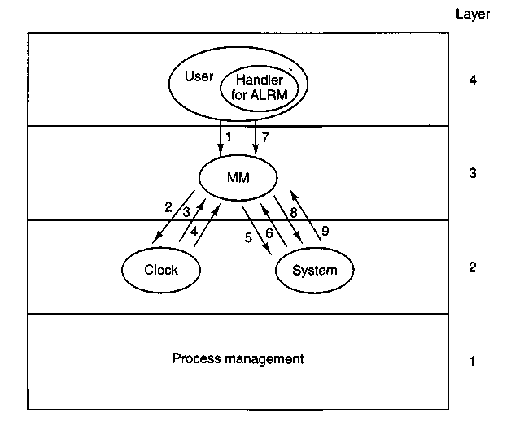
Figure 4-45. Messages for an alarm. The most important are: (1) User does ALARM. (4) After the set time has elapsed, the signal arrives. (7) Handler terminates with call to SIGRETURN. See text for details.
Do-pause takes care of the PAUSE system call (line 18115). All that is necessary is to set a bit and refrain from replying, thus keeping the caller blocked. The kernel need not even be informed, since it knows that the caller is blocked.
The final system call handled in signal.c is REBOOT (line 18128). This call is used only by specialized programs executable by the super-user, but it serves an important function. It ensures that all processes are terminated in an orderly way and that the file system is synched before the system task in the kernel is called to shut down. The termination of processes is done using check_sig to send a SIG-KILL to all processes except init. This is why REBOOT is included in this file.
Several support functions in signal.c have been mentioned in passing. We will now look at them in more detail. By far the most important is sig_proc (line 18168), which actually sends a signal. First a number of tests are made. Attempts to send to dead (lines 18190 to 18192) or hanging (lines 18194 to 18196) processes are serious problems that cause a system panic. A process that is currently being traced is stopped when signaled (lines 18198 to 18202). If the signal is to be ignored, sig_proc's work is complete on line 18204. This is the default action for some signals, for instance, those signals that are required by POSIX but are not supported by minix. If the signal is blocked, the only action that needs to be taken is to set a bit in that process' mp_sigpending bit map. The key test (line
18213) is to distinguish processes that have been enabled to catch signals from those that have not. By this point all other special considerations have been eliminated, and a process that cannot catch the signal will be terminated.
Signals that are eligible to be caught are processed on lines 18214 to 18249. A message is constructed to be sent to the kernel, some parts of which are copies of information in the memory manager's part of the process table. If the process to be signaled was previously suspended by SIGSUSPEND, the signal mask that was saved at the time of suspension is included in the message; otherwise the current signal mask is included (lines 18213 to 18217). Other items included in the message are several addresses in the space of the signaled process space: the signal handler, the address of the sigreturn library routine to be called on completion of the handler, and the current stack pointer.
Next, space is allocated on the process' stack. Figure 4-46 shows the structure that is put on the stack. The sigcontext portion is put on the stack to preserve it for later restoration, since the corresponding structure in the process table itself is altered in preparation for execution of the signal handler. The sigframe part provides a return address for the signal handler and data needed by SIGRETURN to complete restoration of the process' state when the handler is done. The return address and frame pointer are not actually used by any part of MINIX. They are there to fool a debugger if anyone should ever try to trace execution of a signal handler.
The structure to be put on the signaled process' stack is fairly large. The code in lines 18225 and 18226 reserves space for it, following which a call to adjust tests to see whether there is enough room on the process' stack. If there is not enough stack space, the process is killed by jumping to the label determinate using the seldom-used C goto (lines 18228 and 18229).
There is a potential problem with the call to adjust. Recall from our discussion of the implementation of BRK that adjust returns an error if the stack is within SAFETY^BYTES of running into the data segment. The extra margin of error is provided because the validity of the stack can only be checked occasionally by software. This margin of error is probably excessive in the present instance, since it is known exactly how much space is needed on the stack for the signal, and additional space is needed only for the signal handler, presumably a relatively simple function. It is possible that some processes may be terminated unnecessarily because the call to adjust fails. This is certainly better than having programs fail mysteriously at other times, but finer tuning of these tests may be possible.
If there is enough room on the stack, two more flags are checked. The SA_NODEFER flag indicates if the signaled process is to block further signals of the same type while handling a signal. The SA_RESETHAND flag tells if the signal handler is to be reset upon receiving this signal. (This provides faithful emulation of the old signal call. Although this "feature" is often considered a fault in the old call, support of old features requires supporting their faults as well.) The kernel is then notified, using the library routine sys_sendsig (line 18242). Finally,
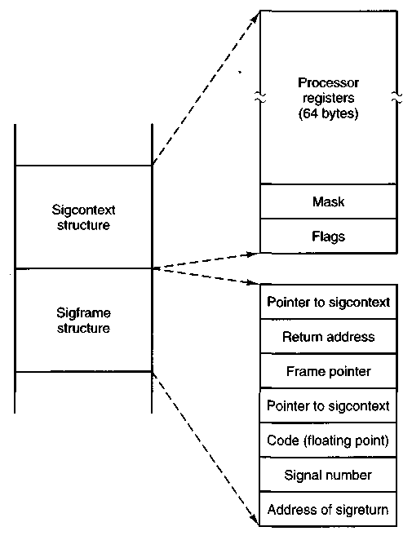
Figure 4-46. The sigcontext and sigframe structures pushed on the stack to prepare for a signal handler. The processor registers are a copy of the stack-frame used during a context switch.
the bit indicating a signal is pending is cleared, and unpause is called to terminate any system call on which the process may be hanging. When the signaled process next executes, the signal handler will run.
Now let us look at the termination code, marked by the label doterminate (line 18250). The label and a goto are the easiest way to handle the possible failure of the call to adjust. Here signals are processed that for one reason or another cannot or should not be caught. The action may include a core dump, if that is appropriate to the signal, and always ends with termination of the process as if it had exited, through a call to mm_exit (line 18258).
Check_sig (line 18265) is where the memory manager checks to see if a signal can be sent. The call
kill(0, sig);
causes the indicated signal to be sent to all the processes in the caller's group (i.e.,
all the processes started from the same terminal). Signals originating in the kernel and REBOOT also may affect multiple processes. For this reason, check_sig loops on lines 18288 to 18318 to scan through the process table to find all the processes to which a signal should be sent. The loop contains a large number of tests. Only if all of them are passed is the signal sent, by calling sig_proc on line 18315.
Check-pending (line 18330) is another function called several times in the code we have just reviewed. It loops through all the bits in the mp_sigpending bit map for the process referred to by do_sigmask, do_sigreturn, or do_sigsuspend, to see if any blocked signal has become unblocked. It calls sig_proc to send the first unblocked pending signal it finds. Since all signal handlers eventually cause execution of do_sigreturn, this suffices eventually to deliver all pending unmasked signals.
The procedure unpause (line 18359) has to do with signals that are sent to processes suspended on PAUSE, WAIT, READ, WRITE, or SIGSUSPEND calls. PAUSE, WAIT, and SIGSUSPEND can be checked by consulting the memory manager's part of the process table, but if none of these are found, the file system must be asked to use its own do^unpause function to check for a possible hangup on READ or WRITE. In every case the action is the same: an error reply is sent to the waiting call and the flag bit that corresponds to the cause of the wait is reset so the process may resume execution and process the signal.
The final procedure in this file is dump_core (line 18402), which writes core dumps to the disk. A core dump consists of a header with information about the size of the segments occupied by a process, a copy of all the process' state information, obtained by copying the kernel process table information for the process, and the memory image of each of the segments. A debugger can interpret this information to help the programmer determine what went wrong during execution of the process. The code to write the file is straightforward. The potential problem mentioned in the previous section again raises its head, but in a somewhat different form. To be sure the stack segment to be recorded in the core dump is up to date, adjust is called on line 18428. This call may fail because of the safety margin built into it. The success of the call is not checked by dump_core, so the core dump will be written in any case, but within the file the information about the stack may be incorrect.
4.8.7 Implementation of the Other System Calls
The file getset.c contains one procedure, do_getset (line 18515), which carries out the seven remaining memory manager calls. They are shown in Fig. 4-47. They are all so simple that they are not worth an entire procedure each. The GETUID and GETGID calls both return the real and effective uid or gid.
Setting the uid or gid is slightly more complex than just reading it. A check has to be made to see if the caller is authorized to set the uid or gid. If the caller passes the test, the file system must be informed of the new uid or gid, since file
System Call | Description
GETUID | Return real and effective uid
GETGID | Return real and effective gid
GETPID | Return pids of process and its parent
SETUID | Set caller's real and effective uid
SETGID | Set caller's real and effective gid
SETSID | Create new session, return pid
GETPGRP | Return ID of process group
Figure 4-47. The system calls supported in mm/getset.c.
protection depends on it. The setsid call creates a new session, and a process which is already a process group leader is not allowed to do this. The test on line 18561 checks this. The file system completes the job of making a process into a session leader with no controlling terminal.
Minimal debugging support, by means of the PTRACE system call, is in the file trace, c. There are eleven commands that can be given as a parameter to the PTRACE system call. They are shown in Fig. 4-48. In the memory manager do_trace processes four of them: enable, exit, resume, step. Requests to enable or exit tracing are completed here. All other commands are passed on to the system task, which has access to the kernel's part of the process table. This is done by the call to the sys^trace library function on line 18669. Two support functions for tracing are provided at the end of trace.c. Stop_proc is used to stop a traced process when it is signaled, andfindproc supports do_trace by searching the process table for the process to be traced.
4.8.8 Memory Manager Utilities
The remaining files contain utility routines and tables. The file alloc.c is where the system keeps track of which parts of memory are in use and which are free. It has four entry points:
1. alloc_mem - request a block of memory of a given size.
2. free_mem - return memory that is no longer needed.
3. max^hole - compute the size of the largest available hole.
4. mem_init - initialize the free list when the memory manager starts running.
As we have said before, alloc^mem (line 18840) just uses first fit on a list of holes sorted by memory address. If it finds a piece that is too big, it takes what it
Command | Description
T_STOP | Stop the process
T_OK | Enable tracing by parent for this process
T_GETINS | Return value from text (instruction) space
T_GETDATA | Return value from data space
T_GETUSER | Return value from user process table
T_SETINS | Set value in instruction space
T_SETDATA | Set value in data space
T SETUSER | Set value in user process table
T.RESUME | Resume execution
T_EXIT | Exit
T_STEP | Set trace bit
Figure 4-48. Debugging commands supported by mm/trace.c.
needs and leaves the rest on the free list, but reduced in size by the amount taken. If an entire hole is needed, del-slot (line 18926) is called to remove the entry from the free list.
Free_mem's job is to check if a newly released piece of memory can be merged with holes on either side. If it can, merge (line 18949) is called to join the holes and update the lists.
Max^hole (line 18985) scans the hole list and returns the largest item it finds. Mem-init (line 19005) builds the initial free list, consisting of all available memory-
The next file is utility.c, which holds a few miscellaneous procedures used in various places in the memory manager. The procedure allowed (line 19120) checks to see if a given access is allowed to a file. For example, do_exec needs to know if a file is executable.
The procedure no_sys (line 19161) should never be called. It is provided just in case a user ever calls the memory manager with a system call number that is invalid or is not handled by the memory manager.
Panic (line 19172) is called only when the memory manager has detected an error from which it cannot recover. It reports the error to the system task, which then brings MINIX to a screeching halt. It is not called lightly.
The last function in utility.c is tell_fs, which constructs a message and sends it to the file system when the latter needs to be informed of events handled by the memory manager.
The two procedures in the file putk.c are also utilities, although of quite a different character from the previous ones. From time to time, calls to print/ are
inserted into the memory manager, mostly for debugging. Also, panic calls print/. As mentioned earlier, the name printf is actually a macro defined as printk, so that calls to printf do not use the standard I/O library procedure that sends messages to the file system. Printk calls putk to communicate directly with the terminal task, something that is forbidden to ordinary users. We saw a routine of the same name in the kernel code.
4.9 SUMMARY
In this chapter we have examined memory management, both in general and in minix. We saw that the simplest systems do not swap or page at all. Once a program is loaded into memory, it remains there until it finishes. Some operating systems allow only one process at a time in memory, while others support multiprogramming.
The next step up is swapping. When swapping is used, the system can handle more processes than it has room for in memory. Processes for which there is no room are swapped out to the disk. Free space in memory and on disk can be kept track of with a bit map or a hole list.
More advanced computers often have some form of virtual memory. In the simplest form, each process' address space is divided up into uniform sized blocks called pages, which can be placed into any available page frame in memory. There are many page replacement algorithms, two of the better known ones being second chance and aging. To make paging systems work well, choosing an algorithm is not enough; attention to issues such as determining the working set, memory allocation policy, and page size are required.
Segmentation helps in handling data structures that change size during execution and simplifies linking and sharing. It also facilitates providing different protection for different segments. Sometimes segmentation and paging are combined to provide a two-dimensional virtual memory. The MULTICS system and the Intel Pentium support segmentation and paging.
Memory management in MINIX is simple. Memory is allocated when a process executes a FORK or exec system call. The memory so allocated is never increased or decreased as long as the process lives. On Intel processors there are two memory models used by MINIX. Small programs can have instructions and data in the same memory segment. Larger programs use separate instruction and data space (separate I and D). Processes with separate I and D space can share the text portion of their memory, so only data and stack memory must be allocated during a FORK. This may also be true during an EXEC if another process already is using the text needed by the new program.
Most of the work of the memory manager is concerned not with keeping track of free memory, which it does using a hole list and the first fit algorithm, but rather with carrying out the system calls relating to memory management. A
number of system calls support POSlx-style signals, and since the default action of most signals is to terminate the signaled process, it is appropriate to handle them in the memory manager, which initiates termination of all processes. Several system calls not directly related to memory are also handled by the memory manager, mainly because it is smaller than the file system, and thus it was most convenient to put them here.
PROBLEMS
1. A computer system has enough room to hold four programs in its main memory. These programs are idle waiting for I/O half the time. What fraction of the CPU time is wasted?
2. Consider a swapping system in which memory consists of the following hole sizes in memory order: 10K, 4K, 20K, 18K, 7K, 9K, 12K, and 15K. Which hole is taken for successive segment requests of
(a) 12K
(b) 10K
(c)9K
for first fit? Now repeat the question for best fit, worst fit, and next fit.
3. What is the difference between a physical address and a virtual address?
4. Using the page table of Fig. 4-8, give the physical address corresponding to each of the following virtual addresses:
(a) 20
(b) 4100
(c) 8300
5. The Intel 8086 processor does not support virtual memory. Nevertheless, some companies previously sold systems that contained an unmodified 8086 CPU and do paging. Make an educated guess as to how they did it. (Hint: think about the logical location of the MMU.)
6. If an instruction takes 1 microsec and a page fault takes an additional n microsec, give a formula for the effective instruction time if page faults occur every k instructions.
7. A machine has a 32-bit address space and an 8K page. The page table is entirely in hardware, with one 32-bit word per entry. When a process starts, the page table is copied to the hardware from memory, at one word every 100 nsec. If each process runs for 100 msec (including the time to load the page table), what fraction of the CPU time is devoted to loading the page tables?
8. A computer with a 32-bit address uses a two-level page table. Virtual addresses are split into a 9-bit top-level page table field, an 11-bit second-level page table field, and an offset. How large are the pages and how many are there in the address space?
9. Below is the listing of a short assembly language program for a computer with 512-byte pages. The program is located at address 1020, and its stack pointer is at 8192 (the stack grows toward 0). Give the page reference string generated by this program. Each instruction occupies 4 bytes (1 word), and'both instruction and data references count in the reference string.
Load word 6144 into register 0
Push register 0 onto the stack
Call a procedure at 5120, stacking the return address
Subtract the immediate constant 16 from the stack pointer
Compare the actual parameter to the immediate constant 4
Jump if equal to 5152
10. Suppose that a 32-bit virtual address is broken up into four fields, a, b, c, and d. The first three are used for a three-level page table system. The fourth field, d, is the offset. Does the number of pages depend on the sizes of all four fields? If not, which ones matter and which ones do not?
11. A computer whose processes have 1024 pages in their address spaces keeps its page tables in memory. The overhead required for reading a word from the page table is 500 nsec. To reduce this overhead, the computer has a TLB, which holds 32 (virtual page, physical page frame) pairs, and can do a look up in 100 nsec. What hit rate is needed to reduce the mean overhead to 200 nsec?
12. The TLB on the VAX does not contain an R bit. Why?
13. A machine has 48-bit virtual addresses and 32-bit physical addresses. Pages are 8K. How many entries are needed for the page table?
14. A computer has four page frames. The time of loading, time of last access, and the R and M bits for each page are as shown below (the times are in clock ticks):
Page Loaded Lastref. R M
0 126 279 0 0
1 230 260 1 0
2 120 272 1 1
3 160 280 1 1
(a) Which page will NRU replace?
(b) Which page will FIFO replace?
(c) Which page will LRU replace?
(d) Which page will second chance replace?
15. If FIFO page replacement is used with four page frames and eight pages, how many page faults will occur with the reference string 0172327103 if the four frames are initially empty? Now repeat this problem for LRU.
16. A small computer has four page frames. At the first clock tick, the R bits are 0111 (page 0 is 0, the rest are 1). At subsequent clock ticks, the values are 1011, 1010, 1101, 0010, 1010, 1100, and 0001. If the aging algorithm is used with an 8-bit counter, give the values of the four counters after the last tick.
17. How long does it take to load a 64K program from a disk whose average seek time is 30 msec, whose rotation time is 20 msec, and whose tracks hold 32K
(a) for a 2K page size?
(b) for a 4K page size?
The pages are spread randomly around the disk.
18. One of the first timesharing machines, the PDP-1, had a memory of 4K 18-bit words. It held one process at a time in memory. When the scheduler decided to run another process, the process in memory was written to a paging drum, with 4K 18-bit words around the circumference of the drum. The drum could start writing (or reading) at any word, rather than only at word 0. Why do you suppose this drum was chosen?
19. A computer provides each process with 65,536 bytes of address space divided into pages of 4096 bytes. A particular program has a text size of 32,768 bytes, a data size of 16,386 bytes, and a stack size of 15,870 bytes. Will this program fit in the address space? If the page size were 512 bytes, would it fit? Remember that a page may not contain parts of two different segments.
20. It has been observed that the number of instructions executed between page faults is directly proportional to the number of page frames allocated to a program. If the available memory is doubled, the mean interval between page faults is also doubled. Suppose that a normal instruction takes 1 microsec, but if a page fault occurs, it takes 2001 microsec (i.e., 2 msec to handle the fault). If a program takes 60 sec to run, during which time it gets 15,000 page faults, how long would it take to run if twice as much memory were available?
21. A group of operating system designers for the Frugal Computer Company are thinking about ways of reducing the amount of backing store needed in their new operating system. The head guru has just suggested not bothering to save the program text in the swap area at all, but just page it in directly from the binary file whenever it is needed. Are there any problems with this approach?
22. Explain the difference between internal fragmentation and external fragmentation. Which one occurs in paging systems? Which one occurs in systems using pure segmentation?
23. When segmentation and paging are both being used, as in multics, first the segment descriptor must be looked up, then the page descriptor. Does the TLB also work this way, with two levels of lookup?
24. Why does the MINIX memory management scheme make it necessary to have a program like chmeml
25. Modify MINIX to release a zombie's memory as soon as it enters the zombie state, rather than waiting until the parent waits for it.
26. In the current implementation of MINIX, when an exec system call is made, the memory manager checks to see if a hole large enough to contain the new memory image is currently available. If not, the call is rejected. A better algorithm would be to see if a sufficiently large hole would be available after the current memory image were released. Implement this algorithm.
27. When carrying out an EXEC system call, MINIX uses a trick to have the file system read in entire segments at once. Devise and implement a similar trick to allow core dumps to be written in a similar way.
28. Modify MINIX to do swapping.
29. In Sec. 4.7.5, it was pointed out that on an EXEC call, by testing for an adequate hole before releasing the current process' memory, a suboptimal implementation is achieved. Reprogram this algorithm to do better.
30. In Sec. 4.8.4, it was pointed out that it would be better to search for holes for the text and data segments separately. Implement this improvement.
31. Redesign adjust to avoid the problem of signaled processes being killed unnecessarily because of a too-strict test for stack space.
5
FILE SYSTEMS
All computer applications need to store and retrieve information. While a process is running, it can store a limited amount of information within its own address space. However, the storage capacity is restricted to the size of the virtual address space. For some applications this size is adequate, but for others, such as airline reservations, banking, or corporate record keeping, it is far too small.
A second problem with keeping information within a process' address space is that when the process terminates, the information is lost. For many applications, (e.g., for data bases), the information must be retained for weeks, months, or even forever. Having it vanish when the process using it terminates is unacceptable. Furthermore, it must not go away when a computer crash kills the process.
A third problem is that it is frequently necessary for multiple processes to access (parts of) the information at the same time. If we have an on-line telephone directory stored inside the address space of a single process, only that process can access it. The way to solve this problem is to make the information itself independent of any one process.
Thus we have three essential requirements for long-term information storage:
1. It must be possible to store a very large amount of information.
2. The information must survive the termination of the process using it.
3. Multiple processes must be able to access the information concurrently. The usual solution to all these problems is to store information on disks and other
external media in units called files. Processes can then read them and write new ones if need be. Information stored in files must be persistent, that is, not be affected by process creation and termination. A file should only disappear when its owner explicitly removes it.
Files are managed by the operating system. How they are structured, named, accessed, used, protected, and implemented are major topics in operating system design. As a whole, that part of the operating system dealing with files is known as the file system and is the subject of this chapter.
From the users' standpoint, the most important aspect of a file system is how it appears to them, that is, what constitutes a file, how files are named and protected, what operations are allowed on files, and so on. The details of whether linked lists or bit maps are used to keep track of free storage and how many sectors there are in a logical block are of less interest, although they are of great importance to the designers of the file system. For this reason, we have structured the chapter as several sections. The first two are concerned with the user interface to files and directories, respectively. Then comes a detailed discussion of how the file system is implemented. After that we will look at security and protection mechanisms in file systems. Finally we will look at the file system.
5.1 FILES
In this section we will look at files from the user's point of view, that is, how they are used and what properties they have.
5.1.1 File Naming
Files are an abstraction mechanism. They provide a way to store information on the disk and read it back later. This must be done in such a way as to shield the user from the details of how and where the information is stored, and how the disks actually work.
Probably the most important characteristic of any abstraction mechanism is the way the objects being managed are named, so we will start our examination of file systems with the subject of file naming. When a process creates a file, it gives the file a name. When the process terminates, the file continues to exist and can be accessed by other processes using its name.
The exact rules for file naming vary somewhat from system to system, but all operating systems allow strings of one to eight letters as legal file names. Thus andrea, brace, and cathy are possible file names. Frequently digits and special characters are also permitted, so names like 2, urgent!, and Fig.2-14 are often valid as well. Many file systems support names as long as 255 characters.
Some file systems distinguish between upper case letters and lower case letters, whereas others do not. UNIX falls in the first category; MS-DOS falls in the
second. Thus a UNIX system can have all of the following as distinct files: bar-bara, Barbara, BARBARA, BARbara, and BarBaRa. In MS-DOS they all designate the same file.
Many operating systems support two:part file names, with the two parts separated by a period, as in prog.c. The part following the period is called the file extension and usually indicates something about the file. In MS-DOS, for example, file names are 1 to 8 characters, plus an optional extension of 1 to 3 characters. In UNIX, the size of the extension, if any, is up to the user, and a file may even have two or more extensions, as in prog.c.Z, where .Z is commonly used to indicate that the file (prog.c) has been compressed using the Ziv-Lempel compression algorithm. Some of the more common file extensions and their meanings are shown in Fig. 5-1.
Extension | Meaning
file.bak | Backup file
file.c | C source program
file.f77 | Fortran 77 program
file.gif | CompuServe Graphical Interchange Format image
file.hlp | Help file
file.html | World Wide Web HyperText Markup Language document
file.mpg | Movie encoded with the MPEG standard
file.o | Object file (compiler output, not yet linked)
file.ps | PostScript file
file.tex | Input for the TEX formatting program
file.txl | General text file
file.zip | Compressed archive
Figure 5-1. Some typical file extensions.
In some cases, the file extensions are just conventions and are not enforced in any way. A file named file.txt is probably some kind of text file, but that name is more to remind the owner than to convey any specific information to the computer. On the other hand, a C compiler may actually insist that the files it is to compile end in .c, and it may refuse to compile them if they do not.
Conventions like this are especially useful when the same program can handle several different kinds of files. The C compiler, for example, can be given a list of several files to compile and link together, some of them C files and some of them assembly language files. The extension then becomes essential for the compiler to tell which are C files, which are assembly files, and which are other files.
5.1.2 File Structure
Files can be structured in any of several ways. Three common possibilities are depicted in Fig. 5-2. The file in Fig. 5-2(a) is an unstructured sequence of bytes. In effect, the operating system does not know or care what is in the file. All it sees are bytes. Any meaning must be imposed by user-level programs. Both unix and MS-DOS use this approach. As an aside, WINDOWS 95 basically uses the MS-DOS file system, with a little syntactic sugar added (e.g., long file names), so nearly everything said in this chapter about MS-DOS also holds for WINDOWS 95. WINDOWS NT is completely different, however.
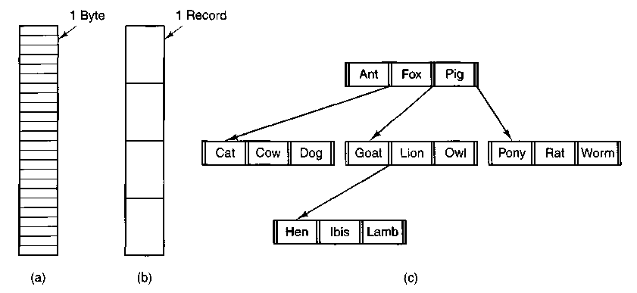
Figure 5-2. Three kinds of files, (a) Byte sequence, (b) Record sequence, (c) Tree.
Having the operating system regard files as nothing more than byte sequences provides the maximum flexibility. User programs can put anything they want in files and name them any way that is convenient. The operating system does not help, but it also does not get in the way. For users who want to do unusual things, the latter can be very important.
The first step up in structure is shown in Fig. 5-2(b). In this model, a file is a sequence of fixed-length records, each with some internal structure. Central to the idea of a file being a sequence of records is the idea that the read operation returns one record and the write operations overwrites or appends one record. In years gone by, when the 80-column punched card was king, many operating systems based their file systems on files consisting of 80-character records, in effect, card images. These systems also supported files of 132-character records, which were intended for the line printer (which in those days were big chain printers having 132 columns). Programs read input in units of 80 characters and wrote it in units of 132 characters, although the final 52 could be spaces, of course.
An (old) system that viewed files as sequences of fixed-length records was CP/M. It used a 128-character record. Nowadays, the idea of a file as a sequence of fixed length records is pretty much gone, although it was once the norm.
The third kind of file structure is shown in Fig. 5-2(c). In this organization, a file consists of a tree of records, not necessarily all the same length, each containing a key field in a fixed position in the record. The tree is sorted on the key field, to allow rapid searching for a particular key.
The basic operation here is not to get the "next" record, although that is also possible, but to get the record with a specific key. For the zoo file of Fig. 5-2(c), one could ask the system to get the record whose key is pony, for example, without worrying about its exact position in the file. Furthermore, new records can be added to the file, with the operating system, and not the user, deciding where to place them. This type of file is clearly quite different from the unstructured byte streams used in UNIX and MS-DOS but is widely used on the large mainframe computers still used in some commercial data processing.
5.1.3 File Types
Many operating systems support several types of files. unix and MS-DOS, for example, have regular files and directories. UNIX also has character and block special files. Regular files are the ones that contain user information. All the files of Fig. 5-2 are regular files. Directories are system files for maintaining the structure of the file system. We will study directories below. Character special files are related to input/output and used to model serial I/O devices such as terminals, printers, and networks. Block special files are used to model disks. In this chapter we will be primarily interested in regular files.
Regular files are generally either ASCII files or binary files. ASCII files consist of lines of text. In some systems each line is terminated by a carriage return character. In others, the line feed character is used. Occasionally, both are required. Lines need not all be of the same length.
The great advantage of ASCII files is that they can be displayed and printed as is, and they can be edited with an ordinary text editor. Furthermore, if large numbers of programs use ASCII files for input and output, it is easy to connect the output of one program to the input of another, as in shell pipelines. (The interprocess plumbing is not any easier, but interpreting the information certainly is if a standard convention, such as ASCII, is used for expressing it.)
Other files are binary files, which just means that they are not ASCII files. Listing them on the printer gives an incomprehensible listing full of what is apparently random junk. Usually, they have some internal structure.
For example, in Fig. 5-3(a) we see a simple executable binary file taken from an early version of UNIX. Although technically the file is just a sequence of bytes, the operating system will only execute a file if it has the proper format. It has five sections: header, text, data, relocation bits, and symbol table. The header starts
with a so-called magic number, identifying the file as an executable file (to prevent the accidental execution of a file not in this format). Then come 16-bit integers giving the sizes of the various pieces of the file, the address at which execution starts, and some flag bits. Following the header are the text and data of the program itself. These are loaded into memory and relocated using the relocation bits. The symbol table is used for debugging.
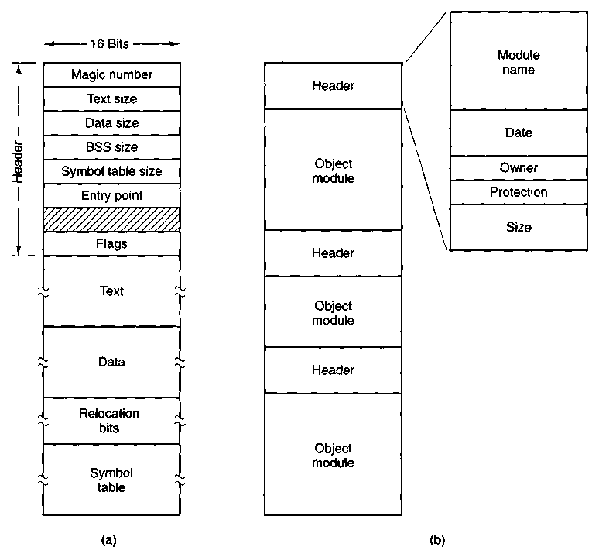
Figure 5-3. (a) An executable file, (b) An archive.
Our second example of a binary file is an archive, also from UNIX. It consists of a collection of library procedures (modules) compiled but not linked. Each one is prefaced by a header telling its name, creation date, owner, protection code, and size. Just as with the executable file, the module headers are full of binary numbers. Copying them to the printer would produce complete gibberish.
All operating systems must recognize one file type, their own executable file, but some recognize more. The old TOPS-20 system went so far as to examine the
creation time of any file to be executed. Then it located the source file and saw if the source had been modified since the binary was made. If it had been, it automatically recompiled the source. In UNIX terms, the make program had been built into the shell. The file extensions were mandatory so the operating system could tell which binary program was derived from which source.
In a similar vein, when a WINDOWS user double clicks on a file name, an appropriate program is launched with the file as parameter. The operating system determines which program to run based on the file extension.
Having strongly typed files like this causes problems whenever the user does anything that the system designers did not expect. Consider, as an example, a system in which program output files have type dat (data files). If a user writes a program formatter that reads a .pas file, transforms it (e.g., by converting it to a standard indentation layout), and then writes the transformed file as output, the output file will be of type .dat. If the user tries to offer this to the Pascal compiler to compile it, the system will refuse because it has the wrong extension. Attempts to copy file.dat tofile.pas will be rejected by the system as invalid (to protect the user against mistakes).
While this kind of "user friendliness" may help novices, it drives experienced users up the wall since they have to devote considerable effort to circumventing the operating system's idea of what is reasonable and what is not.
5.1.4 File Access
Early operating systems provided only one kind of file access: sequential access. In these systems, a process could read all the bytes or records in a file in order, starting at the beginning, but could not skip around and read them out of order. Sequential files can be rewound, however, so they can be read as often as needed. Sequential files are convenient when the storage medium is magnetic tape, rather than disk.
When disks came into use for storing files, it became possible to read the bytes or records of a file out of order, or to access records by key, rather than by position. Files whose bytes or records can be read in any order are called random access files.
Random access files are essential for many applications, for example, data base systems. If an airline customer calls up and wants to reserve a seat on a particular flight, the reservation program must be able to access the record for that flight without having to read the records for thousands of other flights first.
Two methods are used for specifying where to start reading. In the first one, every READ operation gives the position in the file to start reading at. In the second one, a special operation, SEEK, is provided to set the current position. After a SEEK, the file can be read sequentially from the now-current position.
In some older mainframe operating systems, files are classified as being either sequential or random access at the time they are created. This allows the system
to use different storage techniques for the two classes. Modern operating systems do not make this distinction. All their files are automatically random access.
5.1.5 File Attributes
Every file has a name and its data. In addition, all operating systems associate other information with each file, for example, the date and time the file was created and the file's size. We will call these extra items the file's attributes. The list of attributes varies considerably from system to system. The table of Fig. 5-4 shows some of the possibilities, but other ones also exist. No existing system has all of these, but each one is present in some system.
Field | Meaning
Protection | Who can access the file and in what way
Password | Password needed to access the file
Creator | Id of the person who created the file
Owner | Current owner
Read-only flag | 0 for read/write; 1 for read only
Hidden flag | 0 for normal; 1 for do not display in listings
System flag | 0 for normal files; 1 for system file
Archive flag | 0 for has been backed up; 1 for needs to be backed up
ASCII/binary flag | 0 for ASCII file; 1 for binary file
Random access flag | 0 for sequential access only; 1 for random access
Temporary flag | 0 for normal; 1 for delete file on process exit
Lock flags | 0 for unlocked; nonzero for locked
Record length | Number of bytes in a record
Key position | Offset of the key within each record
Key length | Number of bytes in the key field
Creation time | Date and time the file was created
Time of last access | Date and time the file was last accessed
Time of last change | Date and time the file has last changed
Current size | Number of bytes in the file
Maximum size | Number of bytes the file may grow to
Figure 5-4. Some possible file attributes.
The first four attributes relate to the file's protection and tell who may access it and who may not. All kinds of schemes are possible, some of which we will
study later. In some systems the user must present a password to access a file, in which case the password must be one of the attributes.
The flags are bits or short fields that control or enable some specific property. Hidden files, for example, do not appear in- listings of all the files. The archive flag is a bit that keeps track of whether the file has been backed up. The backup program clears it, and the operating system sets it whenever a file is changed. In this way, the backup program can tell which files need backing up. The temporary flag allows a file to be marked for automatic deletion when the process that created it terminates.
The record length, key position, and key length fields are only present in files whose records can be looked up using a key. They provide the information required to find the keys.
The various times keep track of when the file was created, most recently accessed and most recently modified. These are useful for a variety of purposes. For example, a source file that has been modified after the creation of the corresponding object file needs to be recompiled. These fields provide the necessary information.
The current size tells how big the file is at present. Some mainframe operating systems require the maximum size to be specified when the file is created, to let the operating system reserve the maximum amount of storage in advance. Workstation and personal computer operating systems are clever enough to do without this feature.
5.1.6 File Operations
Files exist to store information and allow it to be retrieved later. Different systems provide different operations to allow storage and retrieval. Below is a discussion of the most common system calls relating to files.
1. CREATE. The file is created with no data. The purpose of the call is to announce that the file is coming and to set some of the attributes.
2. DELETE. When the file is no longer needed, it has to be deleted to free up disk space. There is always a system call for this purpose.
3. OPEN. Before using a file, a process must open it. The purpose of the OPEN call is to allow the system to fetch the attributes and list of disk addresses into main memory for rapid access on later calls.
4. CLOSE. When all the accesses are finished, the attributes and disk addresses are no longer needed, so the file should be closed to free up internal table space. Many systems encourage this by imposing a maximum number of open files on processes. A disk is written in blocks, and closing a file forces writing of the file's last block, even though that block may not be entirely full yet.
5. READ. Data are read from file. Usually, the bytes come from the current position. The caller must specify how much data are needed and must also provide a buffer to put them in.
6. WRITE. Data are written to the file, again, usually at the current position. If the current position is the end of the file, the file's size increases. If the current position is in the middle of the file, existing data are overwritten and lost forever.
7. APPEND. This call is a restricted form of WRITE. It can only add data to the end of the file. Systems that provide a minimal set of system calls do not generally have APPEND, but many systems provide multiple ways of doing the same thing, and these systems sometimes have APPEND.
8. SEEK. For random access files, a method is needed to specify from where to take the data. One common approach is a system call, SEEK, that repositions the pointer to the current position to a specific place in the file. After this call has completed, data can be read from, or written to, that position.
9. GET ATTRIBUTES. Processes often need to read file attributes to do their work. For example, the UNIX make program is commonly used to manage software development projects consisting of many source files. When make is called, it examines the modification times of all the source and object files and arranges for the minimum number of compilations required to bring everything up to date. To do its job, it must look at the attributes, namely, the modification times.
10. SET ATTRIBUTES. Some of the attributes are user settable and can be changed after the file has been created. This system call makes that possible. The protection mode information is an obvious example. Most of the flags also fall in this category.
11. RENAME. It frequently happens that a user needs to change the name of an existing file. This system call makes that possible. It is not always strictly necessary, because the file can usually be copied to a new file with the new name, and the old file then deleted.
5.2 DIRECTORIES
To keep track of files, file systems normally have directories, which, in many systems, are themselves files. In this section we will discuss directories, their organization, their properties, and the operations that can be performed on them.
5.2.1 Hierarchical Directory Systems
A directory typically contains a number of entries, one per file. One possibility is shown in Fig. 5-5(a), in which each, entry contains the file name, the file attributes, and the disk addresses where the data are stored. Another possibility is shown in Fig. 5-5(b). Here a directory entry holds the file name and a pointer to another data structure where the attributes and disk addresses are found. Both of these systems are commonly used.
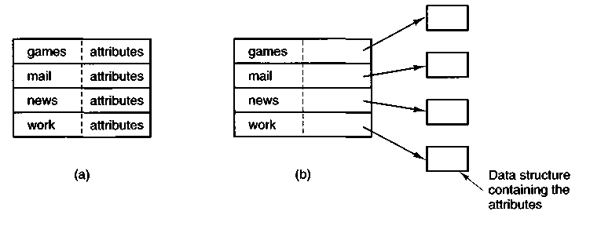
Figure 5-5. (a) Attributes in the directory entry, (b) Attributes elsewhere.
When a file is opened, the operating system searches its directory until it finds the name of the file to be opened. It then extracts the attributes and disk addresses, either directly from the directory entry or from the data structure pointed to, and puts them in a table in main memory. All subsequent references to the file use the information in main memory.
The number of directories varies from system to system. The simplest design is for the system to maintain a single directory containing all the files of all the users, as illustrated in Fig. 5-6(a). If there are many users, and they choose the same file names (e.g., mail and games), conflicts and confusion will quickly make the system unworkable. This system model was used by the first microcomputer operating systems but is rarely seen any more.
An improvement on the idea of having a single directory for all files in the entire system is to have one directory per user [see Fig. 5-6(b)]. This design eliminates name conflicts among users but is not satisfactory for users with a large number of files. It is quite common for users to want to group their files together in logical ways. A professor, for example, might have a collection of files that together form a book that he is writing for one course, a second collection of files containing student programs submitted for another course, a third group of files containing the code of an advanced compiler-writing system he is building, a fourth group of files containing grant proposals, as well as other files for electronic mail, minutes of meetings, papers he is writing, games, and so on. Some way is needed to group these files together in flexible ways chosen by the user.
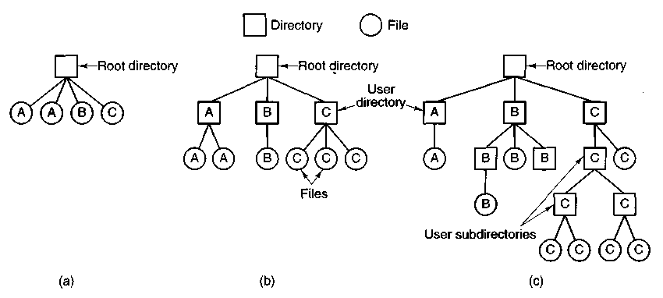
Figure 5-6. Three file system designs, (a) Single directory shared by all users, (b) One directory per user, (c) Arbitrary tree per user. The letters indicate the directory or file's owner.
What is needed is a general hierarchy (i.e., a tree of directories). With this approach, each user can have as many directories as are needed so that files can be grouped together in natural ways. This approach is shown in Fig. 5-6(c). Here, the directories A, B, and C contained in the root directory each belong to a different user, two of whom have created subdirectories for projects they are working on.
5.2.2 Path Names
When the file system is organized as a directory tree, some way is needed for specifying file names. Two different methods are commonly used. In the first method, each file is given an absolute path name consisting of the path from the root directory to the file. As an example, the path /usr/ast/mailbox means that the root directory contains a subdirectory usr, which in turn contains a subdirectory ast, which contains the file mailbox. Absolute path names always start at the root directory and are unique. In UNIX the components of the path are separated by /. In MS-DOS the separator is \. In MULTICS it is >. No matter which character is used, if the first character of the path name is the separator, then the path is absolute.
The other kind of name is the relative path name. This is used in conjunction with the concept of the working directory (also called the current directory). A user can designate one directory as the current working directory, in which case all path names not beginning at the root directory are taken relative to the working directory. For example, if the current working directory is /usr/ast,
then the file whose absolute path is /mr/ast/mailbox can be referenced simply as mailbox. In other words, the UNIX command
cp /usr/ast/mailbox /usr/ast/mailbox.bak
and the command
cp mailbox mailbox.bak
do exactly the same thing if the working directory is /usr/ast. The relative form is often more convenient, but it does the same thing as the absolute form.
Some programs need to access a specific file without regard to what the working directory is. In that case, they should always use absolute path names. For example, a spelling checker might need to read /usr/lib/dictionary to do its work. It should use the full, absolute path name in this case because it does not know what the working directory will be when it is called. The absolute path name will always work, no matter what the working directory is.
Of course, if the spelling checker needs a large number of files from /usr/lib, an alternative approach is for it to issue a system call to change its working directory to /usr/lib, and then use just dictionary as the first parameter to open. By explicitly changing the working directory, it knows for sure where it is in the directory tree, so it can then use relative paths.
In most systems, each process has its own working directory, so when a process changes its working directory and later exits, no other processes are affected and no traces of the change are left behind in the file system. In this way it is always perfectly safe for a process to change its working directory whenever that is convenient. On the other hand, if a library procedure changes the working directory and does not change back to where it was when it is finished, the rest of the program may not work since its assumption about where it is may now be invalid. For this reason, library procedures rarely change the working directory, and when they must, they always change it back again before returning.
Most operating systems that support a hierarchical directory system have two special entries in every directory, "." and "..", generally pronounced "dot" and "dotdot." Dot refers to the current directory; dotdot refers to its parent. To see how these are used, consider the UNIX file tree of Fig. 5-7. A certain process has /usr/ast as its working directory. It can use .. to go up the tree. For example, it can copy the file /usr/lib/dictionary to its own directory using the shell command
cp ../lib/dictionary.
The first path instructs the system to go upward (to the usr directory), then to go down to the directory lib to find the file dictionary.
The second argument names the current directory. When the cp command gets a directory name (including dot) as its last argument, it copies all the files there. Of course, a more normal way to do the copy would be to type
cp /usr/lib/dictionary.
Here the use of dot saves the user the trouble of typing dictionary a second time.
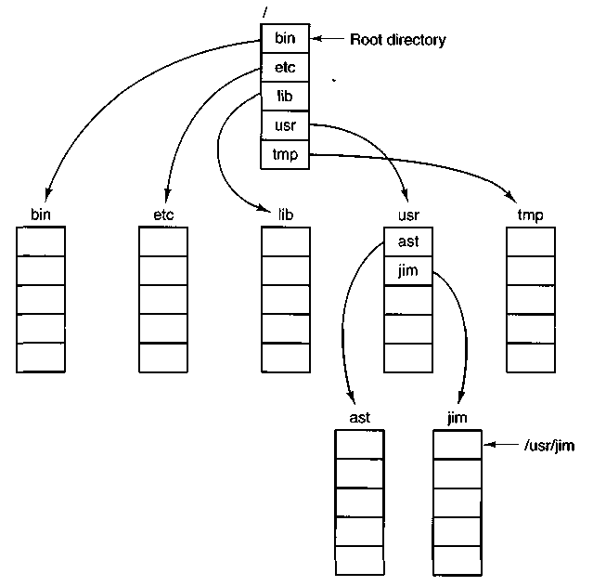
Figure 5-7. A unix directory tree.
5.2.3 Directory Operations
The allowed system calls for managing directories exhibit more variation from system to system than system calls for files. To give an impression of what they are and how they work, we will give a sample (taken from unix).
1. CREATE. A directory is created. It is empty except for dot and dot-dot, which are put there automatically by the system (or in a few cases, by the mkdir program).
2. DELETE. A directory is deleted. Only an empty directory can be deleted. A directory containing only dot and dotdot is considered empty as these usually cannot be deleted.
3. OPENDIR. Directories can be read. For example, to list all the files in a directory, a listing program opens the directory to read out the names of all the files it contains. Before a directory can be read, it must be opened, analogous to opening and reading a file.
4. CLOSEDIR. When a directory has been read, it should be closed to free up internal table space.
5. READDIR. This call returns the next entry in an open directory. Formerly, it was possible to read directories using the usual READ system call, but that approach has the disadvantage of forcing the programmer to know and deal with the internal structure of directories. In contrast, READDIR always returns one entry in a standard format, no matter which of the possible directory structures is being used.
6. RENAME. In many respects, directories are just like files and can be renamed the same way files can be.
7. LINK. Linking is a technique that allows a file to appear in more than one directory. This system call specifies an existing file and a path name, and creates a link from the existing file to the name specified by the path. In this way, the same file may appear in multiple directories.
8. UNLINK. A directory entry is removed. If the file being unlinked is only present in one directory (the normal case), it is removed from the file system. If it is present in multiple directories, only the path name specified is removed. The others remain. In unix, the system call for deleting files (discussed earlier) is, in fact, UNLINK.
The above list gives the most important calls, but there are a few others as well, for example, for managing the protection information associated with a directory.
5.3 FILE SYSTEM IMPLEMENTATION
Now it is time to turn from the user's view of the file system to the implementor's view. Users are concerned with how files are named, what operations are allowed on them, what the directory tree looks like, and similar interface issues. Implementors are interested in how files and directories are stored, how disk space is managed, and how to make everything work efficiently and reliably. In the following sections we will examine a number of these areas to see what the issues and trade-offs are.
5.3.1 Implementing Files
Probably the most important issue in implementing file storage is keeping track of which disk blocks go with which file. Various methods are used in different operating systems. In this section, we will examine a few of them.
Contiguous Allocation
The simplest allocation scheme is to store each file as a contiguous block of data on the disk. Thus on a disk with IK blocks, a 50K file would be allocated 50 consecutive blocks. This scheme has two significant advantages. First, it is simple to implement because keeping track of where a file's blocks are is reduced to remembering one number, the disk address of the first block. Second, the performance is excellent because the entire file can be read from the disk in a single operation.
Unfortunately, contiguous allocation also has two equally significant drawbacks. First, it is not feasible unless the maximum file size is known at the time the file is created. Without this information, the operating system does not know how much disk space to reserve. In systems where files must be written in a single blow, it can be used to great advantage, however.
The second disadvantage is the fragmentation of the disk that results from this allocation policy. Space is wasted that might otherwise have been used. Compaction of the disk is usually prohibitively expensive, although it can conceivably be done late at night when the system is otherwise idle.
Linked List Allocation
The second method for storing files is to keep each one as a linked list of disk blocks, as shown in Fig. 5-8. The first word of each block is used as a pointer to the next one. The rest of the block is for data.
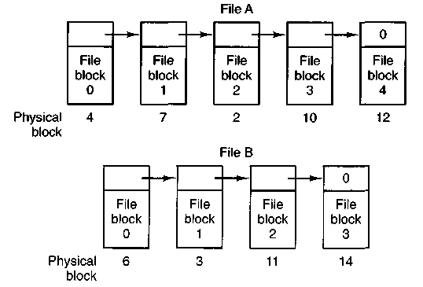
Figure 5-8. Storing a file as a linked list of disk blocks.
Unlike contiguous allocation, every disk block can be used in this method. No space is lost to disk fragmentation (except for internal fragmentation in the last
block). Also, it is sufficient for the directory entry to merely store the disk address of the first block. The rest can be found starting there.
On the other hand, although reading a file sequentially is straightforward, random access is extremely slow. Also, the amount of data storage in a block is no longer a power of two because the pointer takes up a few bytes. While not fatal, having a peculiar size is less efficient because many programs read and write in blocks whose size is a power of two.
Linked List Allocation Using an Index
Both disadvantages of the linked list allocation can be eliminated by taking the pointer word from each disk block and putting it in a table or index in memory. Figure 5-9 shows what the table looks like for the example of Fig. 5-8. In both figures, we have two files. File A uses disk blocks 4, 7, 2, 10, and 12, in that order, and file B uses disk blocks 6, 3, 11, and 14, in that order. Using the table of Fig. 5-9, we can start with block 4 and follow the chain all the way to the end. The same can be done starting with block 6.
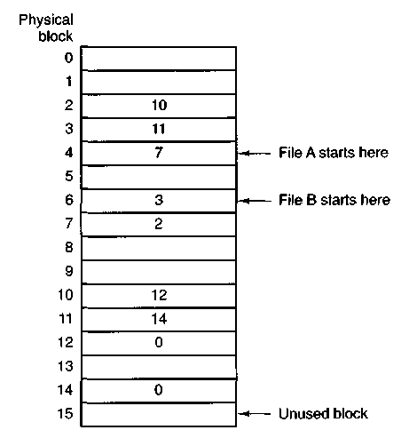
Figure 5-9. Linked list allocation using a table in main memory.
Using this organization, the entire block is available for data. Furthermore, random access is much easier. Although the chain must still be followed to find a given offset within the file, the chain is entirely in memory, so it can be followed without making any disk references. Like the previous method, it is sufficient for
the directory entry to keep a single integer (the starting block number) and still be able to locate all the blocks, no matter how large the file is. MS-DOS uses this method for disk allocation.
The primary disadvantage of this method is that the entire table must be in memory all the time to make it work. With a large disk, say, 500,000 IK blocks (500M), the table will have 500,000 entries, each of which will have to be a minimum of 3 bytes. For speed in lookup, they should be 4 bytes. Thus the table will take up 1.5 or 2 megabytes all the time depending on whether the system is optimized for space or time. Although MS-DOS uses this mechanism, it avoids huge tables by using large blocks (up to 32K) on large disks.
I-nodes
Our last method for keeping track of which blocks belong to which file is to associate with each file a little table called an i-node (index-node), which lists the attributes and disk addresses of the file's blocks, as shown in Fig. 5-10.
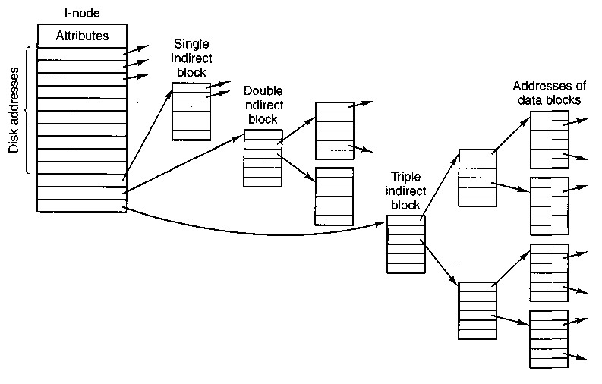
Figure 5-10. An i-node.
The first few disk addresses are stored in the i-node itself, so for small files, all the necessary information is right in the i-node, which is fetched from disk to main memory when the file is opened. For somewhat larger files, one of the addresses in the i-node is the address of a disk block called a single indirect block. This block contains additional disk addresses. If this still is not enough, another
address in the i-node, called a double indirect block, contains the address of a block that contains a list of single indirect blocks. Each of these single indirect blocks points to a few hundred data blocks. If even this is not enough, a triple indirect block can also be used. unix uses this scheme.
5.3.2 Implementing Directories
Before a file can be read, it must be opened. When a file is opened, the operating system uses the path name supplied by the user to locate the directory entry. The directory entry provides the information needed to find the disk blocks. Depending on the system, this information may be the disk address of the entire file (contiguous allocation), the number of the first block (both linked list schemes), or the number of the i-node. In all cases, the main function of the directory system is to map the ASCII name of the file onto the information needed to locate the data.
A closely related issue is where the attributes should be stored. One obvious possibility is to store them directly in the directory entry. Many systems do precisely that. For systems that use i-nodes, another possibility is to store the attributes in the i-node, rather than in the directory entry. As we shall see later, this method has certain advantages over putting them in the directory entry.
Directories in CP/M
Let us start our study of directories with a particularly simple example, that of CP/M (Golden and Pechura, 1986), illustrated in Fig. 5-11. In this system, there is only one directory, so all the file system has to do to look up a file name is search the one and only directory. When it finds the entry, it also has the disk block numbers, since they are stored right in the directory entry, as are all the attributes. If the file uses more disk blocks than fit in one entry, the file is allocated additional directory entries.
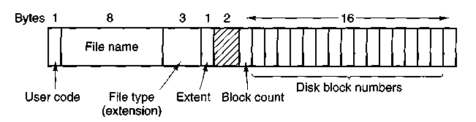
Figure 5-11. A directory entry that contains the disk block numbers for each file.
The fields in Fig. 5-11 have the following meanings. The User code field keeps track of which user owns the file. During a search, only those entries belonging to the currently logged-in user are checked. The next two fields give the name and extension of the file. The Extent field is needed because a file
larger than 16 blocks occupies multiple directory entries. This field is used to tell which entry comes first, second, and so on. The Block count field tells how many of the 16 potential disk block entries are in use. The final 16 fields contain the disk block numbers themselves. The last block may not be full, so the system has no way to determine the exact size of a file down to the last byte (i.e., it keeps track of file sizes in blocks, not bytes).
Directories in MS-DOS
Now let us consider some examples of systems with hierarchical directory trees. Figure 5-12 shows an MS-DOS directory entry. It is 32 bytes long and contains the file name, attributes, and the number of the first disk block. The first block number is used as an index into a table of the type of Fig. 5-9. By following the chain, all the blocks can be found.
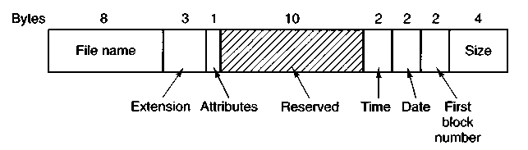
Figure 5-12. The MS-DOS directory entry.
In MS-DOS, directories may contain other directories, leading to a hierarchical file system. It is common in MS-DOS that different application programs each start out by creating a directory in the root directory and putting all their files there, so that different applications do not conflict.
Directories in unix
The directory structure traditionally used in unix is extremely simple, as shown in Fig. 5-13. Each entry contains just a file name and its i-node number. All the information about the type, size, times, ownership, and disk blocks is contained in the i-node. Some unix systems have a different layout, but in all cases, a directory entry ultimately contains only an ASCII string and an i-node number.
When a file is opened, the file system must take the file name supplied and locate its disk blocks. Let us consider how the path name /usr/ast/mbox is looked up. We will use UNIX as an example, but the algorithm is basically the same for all hierarchical directory systems. First the file system locates the root directory. In UNIX its i-node is located at a fixed place on the disk.
Then it looks up the first component of the path, usr, in the root directory to find the i-node number of the file /usr. Locating an i-node from its number is
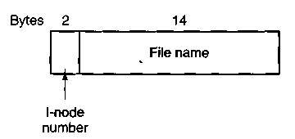
Figure 5-13. A UNIX directory entry.
straightforward, since each one has a fixed location on the disk. From this i-node, the system locates the directory for /usr and looks up the next component, ast, in it. When it has found the entry for ast, it has the i-node for the directory /usr/ast. From this i-node it can find the directory itself and look up mbox. The i-node for this file is then read into memory and kept there until the file is closed. The lookup process is illustrated in Fig. 5-14.
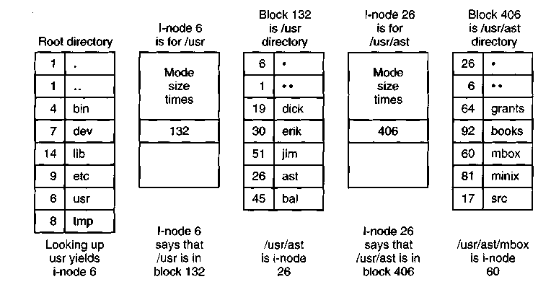
Figure 5-14. The steps in looking up /usr/ast/mbox.
Relative path names are looked up the same way as absolute ones, only starting from the working directory instead of starting from the root directory. Every directory has entries for . and .. which are put there when the directory is created. The entry . has the i-node number for the current directory, and the entry for .. has the i-node number for the parent directory. Thus, a procedure looking up ../dick/prog.c simply looks up .. in the working directory, finds the i-node number for the parent directory, and searches that directory for dick. No special mechanism is needed to handle these names. As far as the directory system is concerned, they are just ordinary ASCII strings, just the same as any other names.
5.3.3 Disk Space Management
Files are normally stored on disk, so management of disk space is a major concern to file system designers. Two general strategies are possible for storing an n byte file: n consecutive bytes of disk space are allocated, or the file is split up into a number of (not necessarily) contiguous blocks. The same trade-off is present in memory management systems between pure segmentation and paging.
Storing a file as a contiguous sequence of bytes has the obvious problem that if a file grows, it will probably have to be moved on the disk. The same problem holds for segments in memory, except that moving a segment in memory is a relatively fast operation compared to moving a file from one disk position to another. For this reason, nearly all file systems chop files up into fixed-size blocks that need not be adjacent.
Block Size
Once it has been decided to store files in fixed-size blocks, the question arises of how big the block should be. Given the way disks are organized, the sector, the track and the cylinder are obvious candidates for the unit of allocation. In a paging system, the page size is also a major contender.
Having a large allocation unit, such as a cylinder, means that every file, even a 1-byte file, ties up an entire cylinder. Studies (Mullender and Tanenbaum, 1984) have shown that the median file size in UNIX environments is about IK, so allocating a 32K cylinder for each file would waste 31/32 or 97 percent of the total disk space. On the other hand, using a small allocation unit means that each file will consist of many blocks. Reading each block normally requires a seek and a rotational delay, so reading a file consisting of many small blocks will be slow.
As an example, consider a disk with 32,768 bytes per track, a rotation time of 16.67 msec, and an average seek time of 30 msec. The time in milliseconds to read a block of k bytes is then the sum of the seek, rotational delay, and transfer times:
30 + 8.3 + (£732768) x 16.67
The solid curve of Fig. 5-15 shows the data rate for such a disk as a function of block size. If we make the gross assumption that all files are IK (the measured median size), the dashed curve of Fig. 5-15 gives the disk space efficiency. The bad news is that good space utilization (block size < 2K) means low data rates and vice versa. Time efficiency and space efficiency are inherently in conflict.
The usual compromise is to choose a block size of 512, IK or 2K bytes. If a IK block size is chosen on a disk with a 512-byte sector size, then the file system will always read or write two consecutive sectors and treat them as a single, indivisible unit. Whatever decision is made, it should probably be re-evaluated periodically, since, as with all aspects of computer technology, users take advantage
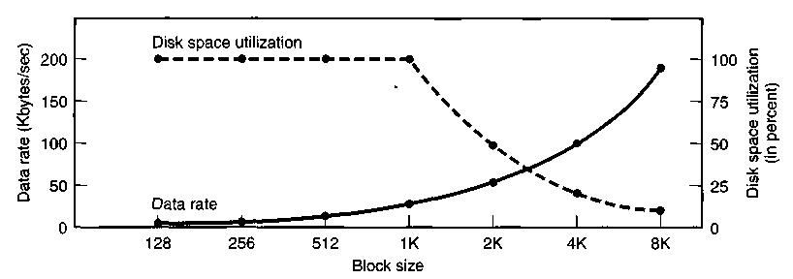
Figure 5-15. The solid curve (left-hand scale) gives the data rate of a disk. The dashed curve (right-hand scale) gives the disk space efficiency. All files are IK.
of more abundant resources by demanding even more. One system manager reports that the average size of files in the university system he manages has increased slowly over the years, and that in 1997 the average size of files has grown to 12K for students and 15K for faculty.
Keeping Track of Free Blocks
Once a block size has been chosen, the next issue is how to keep track of free blocks. Two methods are widely used, as shown in Fig. 5-16. The first one consists of using a linked list of disk blocks, with each block holding as many free disk block numbers as will fit. With a IK block and a 32-bit disk block number, each block on the free list holds the numbers of 255 free blocks. (One slot is needed for the pointer to the next block). A 200M disk needs a free list of maximum 804 blocks to hold all 200K disk block numbers. Often free blocks are used to hold the free list.
The other free space management technique is the bit map. A disk with n blocks requires a bit map with n bits. Free blocks are represented by Is in the map, allocated blocks by Os (or vice versa). A 200M disk requires 200K bits for the map, which requires only 25 blocks. It is not surprising that the bit map requires less space, since it uses 1 bit per block, versus 32 bits in the linked list model. Only if the disk is nearly full will the linked list scheme require fewer blocks than the bit map.
If there is enough main memory to hold the bit map, that method is generally preferable. If, however, only 1 block of memory can be spared for keeping track of free disk blocks, and the disk is nearly full, then the linked list may be better. With only 1 block of the bit map in memory, it may turn out that no free blocks can be found on it, causing disk accesses to read the rest of the bit map. When a fresh block of the linked list is loaded into memory, 255 disk blocks can be allocated before having to go to the disk to fetch the next block from the list.
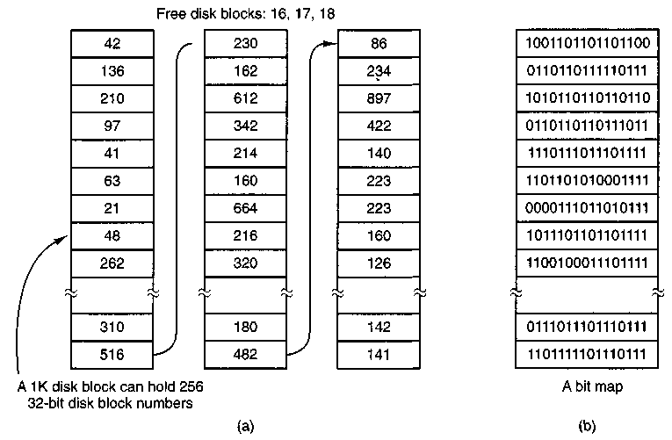
Figure 5-16. (a) Storing the free list on a linked list, (b) A bit map.
5.3.4 File System Reliability
Destruction of a file system is often a far greater disaster than destruction of a computer. If a computer is destroyed by fire, lightning surges, or a cup of coffee poured onto the keyboard, it is annoying and will cost money, but generally a replacement can be purchased with a minimum of fuss. Inexpensive personal computers can even be replaced within a few hours by just going to the dealer (except at universities where issuing a purchase order takes three committees, five signatures, and 90 days).
If a computer's file system is irrevocably lost, whether due to hardware, software, or rats gnawing on the floppy disks, restoring all the information will be difficult, time consuming, and in many cases, impossible. For the people whose programs, documents, customer files, tax records, data bases, marketing plans, or other data are gone forever, the consequences can be catastrophic. While the file system cannot offer any protection against physical destruction of the equipment and media, it can help protect the information. In this section we will look at some of the issues involved in safeguarding the file system.
Disks may have bad blocks, as we pointed out in Chap. 3. Floppy disks are generally perfect when they leave the factory, but they can develop bad blocks during use. Winchester disks frequently have bad blocks right from the start: it is just too expensive to manufacture them completely free of all defects. In fact, older hard disks used to be supplied with a list of the bad blocks discovered by the
manufacturer's tests. On such disks a sector is reserved for a bad block list. When the controller is first initialized, it reads the bad block list and picks a spare block (or track) to replace the defective ones, recording the mapping in the bad block list. Henceforth, all requests for the bad block will use the spare. When new errors are discovered this list is updated as part of a low-level format.
There has been a steady improvement in manufacturing techniques, so bad blocks are less common than they once were. However, they still occur. The controller on a modern disk drive is very sophisticated, as noted in Chap. 3. On these disks, tracks are at least one sector bigger than needed, so that at least one bad spot can be skipped by leaving it in a gap between two consecutive sectors. There are also a few spare sectors per cylinder so the controller can do automatic sector remapping if it notices that a sector needs more than a certain number of retries to be read or written. Thus the user is usually unaware of bad blocks or their management. Nevertheless, when a modern IDE or SCSI disk fails, it will usually fail horribly, because it has run out of spare sectors. SCSI disks provide a "recovered error" when they remap a block. If the driver notes this and prints a message on the keyboard the user will know it is time to buy a new disk when these messages begin to appear frequently.
There is a simple software solution to the bad block problem, suitable for use on older disks. This approach requires the user or file system to carefully construct a file containing all the bad blocks. This technique removes them from the free list, so they will never occur in data files. As long as the bad block file is never read or written, no problems will arise. Care has to be taken during disk backups to avoid reading this file.
Backups
Even with a clever strategy for dealing with bad blocks, it is important to back up the files frequently. After all, automatically switching to a spare track after a crucial data block has been ruined is somewhat akin to locking the barn door after the prize race horse has escaped.
File systems on floppy disk can be backed up by just copying the entire floppy disk to a blank one. File systems on small Winchester disks can be backed up by dumping the entire disk to magnetic tape. Current technologies include 150M cartridge tapes, and 8G Exabyte or DAT tapes.
For large Winchesters (e.g., 10 GB), backing up the entire drive on tape is awkward and time consuming. One strategy that is easy to implement but wastes half the storage is to provide each computer with two drives instead of one. Both drives are divided into two halves: data and backup. Each night the data portion of drive 0 is copied to the backup portion of drive 1, and vice versa, as shown in Fig. 5-17. In this way, if one drive is completely ruined, no information is lost.
An alternative to dumping the entire file system every day is to make incremental dumps. The simplest form of incremental dumping is to make a complete
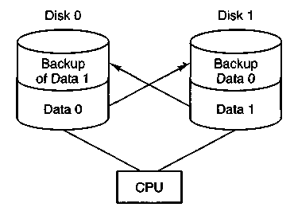
Figure 5-17. Backing up each drive on the other one wastes half the storage.
dump periodically, say weekly or monthly, and to make a daily dump of only those files that have been modified since the last full dump. A better scheme is to dump only those files that have changed since they were last dumped.
To implement this method, a list of the dump times for each file must be kept on disk. The dump program then checks each file on the disk. If it has been modified since it was last dumped, it is dumped again and its time-of-last-dump is changed to the current time. If done on a monthly cycle, this method requires 31 daily dump tapes, one per day, plus enough tapes to hold a full dump, made once a month. Other more complex schemes that use fewer tapes are also in use.
Automatic methods using multiple disks are also used. For example, mirroring uses two disks. Writes go to both disks, and reads come from one. The write to the mirror disk is delayed a bit, so it can be done when the system is idle. Such a system can continue to run in "degraded mode" when one disk fails, allowing a failed disk to be swapped and data to be recovered with no downtime.
File System Consistency
Another area where reliability is an issue is file system consistency. Many file systems read blocks, modify them, and write them out later. If the system crashes before all the modified blocks have been written out, the file system can be left in an inconsistent state. This problem is especially critical if some of the blocks that have not been written out are i-node blocks, directory blocks, or blocks containing the free list.
To deal with the problem of inconsistent file systems, most computers have a utility program that checks file system consistency. It can be run whenever the system is booted, especially after a crash. The description below tells how such a utility works in UNIX and MINIX; other systems have something similar. These file system checkers verify each file system (disk) independently of the other ones.
Two kinds of consistency checks can be made: blocks and files. To check for block consistency, the program builds two tables, each one containing a counter
for each block, initially set to 0. The counters in the first table keep track of how many times each block is present in a file; the counters in the second table record how often each block is present in the free list (or the bit map of free blocks).
The program then reads all the i-nodes. Starting from an i-node, it is possible to build a list of all the block numbers used in the corresponding file. As each block number is read, its counter in the first table is incremented. The program then examines the free list or bit map, to find all the blocks that are not in use. Each occurrence of a block in the free list results in its counter in the second table being incremented.
If the file system is consistent, each block will have a 1 either in the first table or in the second table, as illustrated in Fig. 5-18(a). However, as a result of a crash, the tables might look like Fig. 5-18(b), in which block 2 does not occur in either table. It will be reported as being a missing block. While missing blocks do no real harm, they do waste space and thus reduce the capacity of the disk. The solution to missing blocks is straightforward: the file system checker just adds them to the free list.
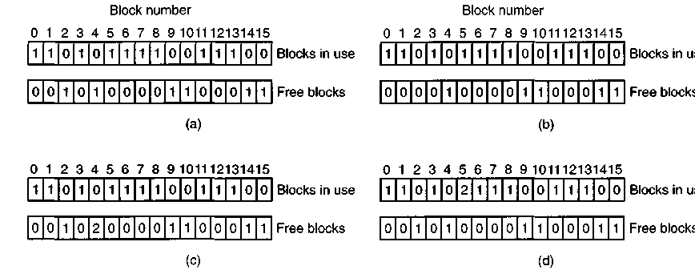
Figure 5-18. File system states, (a) Consistent, (b) Missing block, (c) Duplicate block in free list, (d) Duplicate data block.
Another situation that might occur is that of Fig. 5-18(c). Here we see a block, number 4, that occurs twice in the free list. (Duplicates can occur only if the free list is really a list; with a bit map it is impossible.) The solution here is also simple: rebuild the free list.
The worst thing that can happen is that the same data block is present in two or more files, as shown in Fig. 5-18(d) with block 5. If either of these files is removed, block 5 will be put on the free list, leading to a situation in which the same block is both in use and free at the same time. If both files are removed, the block will be put onto the free list twice.
The appropriate action for the file system checker to take is to allocate a free block, copy the contents of block 5 into it, and insert the copy into one of the files.
In this way, the information content of the files is unchanged (although almost assuredly garbled), but the file system structure is at least made consistent. The error should be reported, to allow the user to inspect the damage.
In addition to checking to see that each-block is properly accounted for, the file system checker also checks the directory system. It too, uses a table of counters, but these are per file, rather than per block. It starts at the root directory and recursively descends the tree, inspecting each directory in the file system. For every file in every directory, it increments the counter for that file's i-node (see Fig. 5-13 for the layout of a directory entry).
When it is all done, it has a list, indexed by i-node number, telling how many directories point to that i-node. It then compares these numbers with the link counts stored in the i-nodes themselves. In a consistent file system, both counts will agree. However, two kinds of errors can occur: the link count in the i-node can be too high or it can be too low.
If the link count is higher than the number of directory entries, then even if all the files are removed from the directories, the count will still be nonzero and the i-node will not be removed. This error is not serious, but it wastes space on the disk with files that are not in any directory. It should be fixed by setting the link count in the i-node to the correct value.
The other error is potentially catastrophic. If two directory entries are linked to a file, but the i-node says that there is only one, when either directory entry is removed, the i-node count will go to zero. When an i-node count goes to zero, the file system marks it as unused and releases all of its blocks. This action will result in one of the directories now pointing to an unused i-node, whose blocks may soon be assigned to other files. Again, the solution is just to force the link count in the i-node to the actual number of directory entries.
These two operations, checking blocks and checking directories, are often integrated for efficiency reasons (i.e., only one pass over the i-nodes is required). Other heuristic checks are also possible. For example, directories have a definite format, with i-node numbers and ASCII names. If an i-node number is larger than the number of i-nodes on the disk, the directory has been damaged.
Furthermore, each i-node has a mode, some of which are legal but strange, such as 0007, which allows the owner and his group no access at all, but allows outsiders to read, write, and execute the file. It might be useful to at least report files that give outsiders more rights than the owner. Directories with more than, say, 1000 entries are also suspicious. Files located in user directories, but which are owned by the super-user and have the SETUID bit on, are potential security problems. With a little effort, one can put together a fairly long list of legal, but peculiar, situations that might be worth reporting.
The previous paragraphs have discussed the problem of protecting the user against crashes. Some file systems also worry about protecting the user against himself. If the user intends to type
rm *.o
to remove all the files ending with .o (compiler generated object files), but accidentally types
rm * .0
(note the space after the asterisk), rm will remove all the files in the current directory and then complain that it cannot find .o. In MS-DOS and some other systems, when a file is removed, all that happens is that a bit is set in the directory or i-node marking the file as removed. No disk blocks are returned to the free list until they are actually needed. Thus, if the user discovers the error immediately, it is possible to run a special utility program that "unremoves" (i.e., restores) the removed files. In WINDOWS 95, files that are removed are placed in a special recycled directory, from which they can later be retrieved if need be. Of course, no storage is reclaimed until they are actually deleted from this directory.
5.3.5 File System Performance
Access to disk is much slower than access to memory. Reading a memory word typically takes tens of nanoseconds. Reading a block from a hard disk may take fifty microseconds, a factor of four slower per 32-bit word, but to this must be added 10 to 20 milliseconds to seek to the track and then wait for the desired sector to arrive under the read head. If only a single word is needed, the memory access is of the order of 100,000 times as fast as disk access. As a result of this difference in access time, many file systems have been designed to reduce the number of disk accesses needed.
The most common technique used to reduce disk accesses is the block cache or buffer cache. (Cache is pronounced "cash," and is derived from the French cacher, meaning to hide.) In this context, a cache is a collection of blocks that logically belong on the disk but are being kept in memory for performance reasons.
Various algorithms can be used to manage the cache, but a common one is to check all read requests to see if the needed block is in the cache. If it is, the read request can be satisfied without a disk access. If the block is not in the cache, it is first read into the cache, and then copied to wherever it is needed. Subsequent requests for the same block can be satisfied from the cache.
When a block has to be loaded into a full cache, some block has to be removed and rewritten to the disk if it has been modified since being brought in. This situation is very much like paging, and all the usual paging algorithms described in Chap. 4, such as FIFO, second chance, and LRU, are applicable. One pleasant difference between paging and caching is that cache references are relatively infrequent, so that it is feasible to keep all the blocks in exact LRU order with linked lists.
Unfortunately, there is a catch. Now that we have a situation in which exact LRU is possible, it turns out that LRU is undesirable. The problem has to do with
the crashes and file system consistency discussed in the previous section. If a critical block, such as an i-node block, is read into the cache and modified, but not rewritten to the disk, a crash will leave the file system in an inconsistent state. If the i-node block is put at the end of the LRU chain, it may be quite a while before it reaches the front and is rewritten to the disk.
Furthermore, some blocks, such as double indirect blocks, are rarely referenced two times within a short interval. These considerations lead to a modified LRU scheme, taking two factors into account:
1. Is the block likely to be needed again soon?
2. Is the block essential to the consistency of the file system?
For both questions, blocks can be divided into categories such as i-node blocks, indirect blocks, directory blocks, full data blocks, and partly full data blocks. Blocks that will probably not be needed again soon go on the front, rather than the rear of the LRU list, so their buffers will be reused quickly. Blocks that might be needed again soon, such as a partly full block that is being written, go on the end of the list, so they will stay around for a long time.
The second question is independent of the first one. If the block is essential to the file system consistency (basically, everything except data blocks), and it has been modified, it should be written to disk immediately, regardless of which end of the LRU list it is put on. By writing critical blocks quickly, we greatly reduce the probability that a crash will wreck the file system.
Even with this measure to keep the file system integrity intact, it is undesirable to keep data blocks in the cache too long before writing them out. Consider the plight of someone who is using a personal computer to write a book. Even if our writer periodically tells the editor to write the file being edited to the disk, there is a good chance that everything will still be in the cache and nothing on the disk. If the system crashes, the file system structure will not be corrupted, but a whole day's work will be lost.
This situation need not happen very often before we have a fairly unhappy user. Systems take two approaches to dealing with it. The UNIX way is to have a system call, SYNC, which forces all the modified blocks out onto the disk immediately. When the system is started up, a program, usually called update, is started up in the background to sit in an endless loop issuing SYNC calls, sleeping for 30 sec between calls. As a result, no more than 30 seconds of work is lost due to a crash.
The MS-DOS way is to write every modified block to disk as soon as it has been written. Caches in which all modified blocks are written back to the disk immediately are called write-through caches. They require much more disk I/O than nonwrite-through caches. The difference between these two approaches can be seen when a program writes a IK block full, one character at a time. UNIX will collect all the characters in the cache and write the block out once every 30
seconds, or whenever the block is removed from the cache. MS-DOS will make a disk access for every character written. Of course, most programs do internal buffering, so they normally write not a character, but a line or a larger unit on each WRITE system call.
A consequence of this difference in caching strategy is that just removing a (floppy) disk from a unix system without doing a SYNC will almost always result in lost data, and frequently in a corrupted file system as well. With MS-DOS, no problem arises. These differing strategies were chosen because UNIX was developed in an environment in which all disks were hard disks and not removable, whereas MS-DOS started out in the floppy disk world. As hard disks become the norm, even on small microcomputers, the UNIX approach, with its better efficiency, will definitely be the way to go.
Caching is not the only way to increase the performance of a file system. Another important technique is to reduce the amount of disk arm motion by putting blocks that are likely to be accessed in sequence close to each other, preferably in the same cylinder. When an output file is written, the file system has to allocate the blocks one at a time, as they are needed. If the free blocks are recorded in a bit map, and the whole bit map is in main memory, it is easy enough to choose a free block as close as possible to the previous block. With a free list, part of which is on disk, it is much harder to allocate blocks close together.
However, even with a free list, some block clustering can be done. The trick is to keep track of disk storage not in blocks, but in groups of consecutive blocks. If a track consists of 64 sectors of 512 bytes, the system could use IK blocks (2 sectors), but allocate disk storage in units of 2 blocks (4 sectors). This is not the same as having a 2K disk block, since the cache would still use IK blocks and disk transfers would still be IK but reading a file sequentially on an otherwise idle system would reduce the number of seeks by a factor of two, considerably improving performance.
A variation on the same theme is to take account of rotational positioning. When allocating blocks, the system attempts to place consecutive blocks in a file in the same cylinder, but interleaved for maximum throughput. Thus, if a disk has a rotation time of 16.67 msec and it takes about 4 msec for a user process to request and get a disk block, each block should be placed at least a quarter of the way around from its predecessor.
Another performance bottleneck in systems that use i-nodes or anything equivalent to i-nodes is that reading even a short file requires two disk accesses: one for the i-node and one for the block. The usual i-node placement is shown in Fig. 5-19(a). Here all the i-nodes are near the beginning of the disk, so the average distance between an i-node and its blocks will be about half the number of cylinders, requiring long seeks.
One easy performance improvement is to put the i-nodes in the middle of the disk, rather than at the start, thus reducing the average seek between the i-node and the first block by a factor of two. Another idea, shown in Fig. 5-19(b), is to
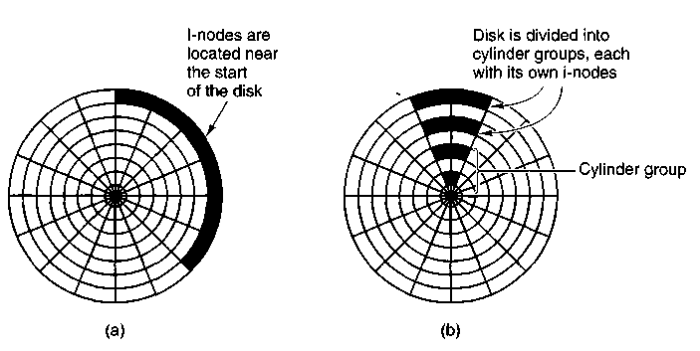
Figure 5-19. (a) I-nodes placed at the start of the disk, (b) Disk divided into cylinder groups, each with its own blocks and i-nodes.
divide the disk into cylinder groups, each with its own i-nodes, blocks, and free list (McKusick et al., 1984). When creating a new file, any i-node can be chosen, but an attempt is made to find a block in the same cylinder group as the i-node. If none is available, then a block in a nearby cylinder group is used.
5.3.6 Log-Structured File Systems
Changes in technology are putting pressure on current file systems. In particular, CPUs keep getting faster, disks are becoming much bigger and cheaper (but not much faster), and memories are growing exponentially in size. The one parameter that is not improving by leaps and bounds is disk seek time. The combination of these factors means that a performance bottleneck is arising in many file systems. Research done at Berkeley attempted to alleviate this problem by designing a completely new kind of file system, LFS (the Log-structured File System). In this section we will briefly describe how LFS works. For a more complete treatment, see (Rosenblum and Ousterhout, 1991).
The idea that drove the LFS design is that as CPUs get faster and RAM memories get larger, disk caches are increasingly rapidly. As a consequence, it is now possible to satisfy a very substantial fraction of all read requests directly from the file system cache, with no disk access needed. It follows from this observation, that in the future, most disk accesses will be writes, so the read-ahead mechanism used in some file systems to fetch blocks before they are needed no longer gains much performance.
To make matters worse, in most file systems, writes are done in very small chunks. Small writes are highly inefficient, since a 50-microsec disk write is typically preceded by a 10-msec seek and a 6-msec rotational delay. With these parameters, disk efficiency drops to a fraction of 1 percent.
To see where all the small writes come from, consider creating a new file on a unix system. To write this file, the i-node for the directory, the directory block, the i-node for the file, and the file itself must all be written. While these writes can be delayed, doing so exposes the file System to serious consistency problems if a crash occurs before the writes are done. For this reason, the i-node writes are generally done immediately.
From this reasoning, the LFS designers decided to re-implement the UNIX file system in such a way as to achieve the full bandwidth of the disk, even in the face of a workload consisting in large part of small random writes. The basic idea is to structure the entire disk as a log. Periodically, and when there is a special need for it, all the pending writes being buffered in memory are collected into a single segment and written to the disk as a single contiguous segment at the end of the log. A single segment may thus contain i-nodes, directory blocks, and data blocks, all mixed together. At the start of each segment is a segment summary, telling what can be found in the segment. If the average segment can be made to be about 1 MB, almost the full bandwidth of the disk can be utilized.
In this design, i-nodes still exist and have the same structure as in UNIX, but they are now scattered all over the log, instead of being at a fixed position on the disk. Nevertheless, when an i-node is located, locating the blocks is done in the usual way. Of course, finding an i-node is now much harder, since its address cannot simply be calculated from its i-number, as in UNIX. To make it possible to find i-nodes, an i-node map, indexed by i-number, is maintained. Entry i in this map points to i-node i on the disk. The map is kept on disk, but it is also cached, so the most heavily used parts will be in memory most of the time.
To summarize what we have said so far, all writes are initially buffered in memory, and periodically all the buffered writes are written to the disk in a single segment, at the end of the log. Opening a file now consists of using the map to locate the i-node for the file. Once the i-node has been located, the addresses of the blocks can be found from it. All of the blocks will themselves be in segments, somewhere in the log.
If disks were infinitely large, the above description would be the entire story. However, real disks are finite, so eventually the log will occupy the entire disk, at which time no new segments can be written to the log. Fortunately, many existing segments may have blocks that are no longer needed, for example, if a file is overwritten, its i-node will now point to the new blocks, but the old ones will still be occupying space in previously written segments.
To deal with both of these problems, LFS has a cleaner thread that spends its time scanning the log circularly to compact it. It starts out by reading the summary of the first segment in the log to see which i-nodes and files are there. It then checks the current i-node map to see if the i-nodes are still current and file blocks are still in use. If not, that information is discarded. The i-nodes and blocks that are still in use go into memory to be written out in the next segment. The orginal segment is then marked as free, so the log can use it for new data. In
this manner, the cleaner moves along the log, removing old segments from the back and putting any live data into memory for rewriting in the next segment. Consequently, the disk is a big circular buffer, with the writer thread adding new segments to the front and the cleaner thread removing old ones from the back.
The bookkeeping here is nontrivial, since when a file block is written back to a new segment, the i-node of the file (somewhere in the log) must be located, updated, and put into memory to be written out in the next segment. The i-node map must then be updated to point to the new copy. Nevertheless, it is possible to do the administration, and the performance results show that all this complexity is worthwhile. Measurements given in the papers cited above show that LFS outperforms unix by an order of magnitude on small writes, while having a performance that is as good or better than unix for reads and large writes.
5.4 SECURITY
File systems often contain information that is highly valuable to their users. Protecting this information against unauthorized usage is therefore a major concern of all file systems. In the following sections we will look at a variety of issues concerned with security and protection. These issues apply equally well to timesharing systems as to networks of personal computers connected to shared servers via local area networks.
5.4.1 The Security Environment
The terms "security" and "protection" are often used interchangeably. Nevertheless, it is frequently useful to make a distinction between the general problems involved in making sure that files are not read or modified by unauthorized persons, which include technical, managerial, legal, and political issues on the one hand, and the specific operating system mechanisms used to provide security, on the other. To avoid confusion, we will use the term security to refer to the overall problem, and the term protection mechanisms to refer to the specific operating system mechanisms used to safeguard information in the computer. The boundary between them is not well defined, however. First we will look at security; later on in the chapter we will look at protection.
Security has many facets. Two of the more important ones are data loss and intruders. Some of the common causes of data loss are:
1. Acts of God: fires, floods, earthquakes, wars, riots, or rats gnawing tapes or floppy disks.
2. Hardware or software errors: CPU malfunctions, unreadable disks or tapes, telecommunication errors, program bugs.
3. Human errors: incorrect data entry, wrong tape or disk mounted, wrong program run, lost disk or tape, or some other mistake.
Most of these can be dealt with by maintaining adequate backups, preferably far away from the original data.
A more interesting problem is what to do about intruders. These come in two varieties. Passive intruders just want to read files they are not authorized to read. Active intruders are more malicious; they want to make unauthorized changes to data. When designing a system to be secure against intruders, it is important to keep in mind the kind of intruder one is trying to protect against. Some common categories are:
1. Casual prying by nontechnical users. Many people have terminals to timesharing systems or networked personal computers on their desks, and human nature being what it is, some of them will read other people's electronic mail and other files if no barriers are placed in the way. Most UNIX systems, for example, have the default that all files are publicly readable.
2. Snooping by insiders. Students, system programmers, operators, and other technical personnel often consider it to be a personal challenge to break the security of the local computer system. They often are highly skilled and are willing to devote a substantial amount of time to the effort.
3. Determined attempt to make money. Some bank programmers have attempted to break into a banking system to steal from the bank. Schemes have varied from changing the software to truncate rather than round interest, keeping the fraction of a cent for themselves, to siphoning off accounts not used in years, to blackmail ("Pay me or I will destroy all the bank's records.").
4. Commercial or military espionage. Espionage refers to a serious and well-funded attempt by a competitor or a foreign country to steal programs, trade secrets, patents, technology, circuit designs, marketing plans, and so forth. Often this attempt will involve wiretapping or even erecting antennas directed at the computer to pick up its electromagnetic radiation.
It should be clear that trying to keep a hostile foreign government from stealing military secrets is quite a different matter from trying to keep students from inserting a funny message-of-the-day into the system. The amount of effort that one puts into security and protection clearly depends on who the enemy is thought to be.
Another aspect of the security problem is privacy: protecting individuals from misuse of information about them. This quickly gets into many legal and moral issues. Should the government compile dossiers on everyone in order to catch X-cheaters, where X is "welfare" or "tax," depending on your politics? Should the
police be able to look up anything on anyone in order to stop organized crime? Do employers and insurance companies have rights? What happens when these rights conflict with individual rights? All of these issues are extremely important but are beyond the scope of this book.
5.4.2 Famous Security Flaws
Just as the transportation industry has the Titanic and the Hindenburg, computer security experts have a few things they would rather forget about. In this section we will look at some interesting security problems that have occurred in three different operating systems: UNIX, TENEX, and OS/360.
The UNIX utility Ipr, which prints a file on the line printer, has an option to remove the file after it has been printed. In early versions of unix it was possible for anyone to use Ipr to print, and then have the system remove, the password file.
Another way to break into UNIX was to link a file called core in the working directory to the password file. The intruder then forced a core dump of a SETUID program, which the system wrote on the core file, that is, on top of the password file. In this way, a user could replace the password file with one containing a few strings of his own choosing (e.g., command arguments).
Yet another subtle flaw in UNIX involved the command
mkdir foo
Mkdir, which was a SETUID program owned by the root, first created the i-node for the directory foo with the system call MKNOD and then changed the owner of foo from its effective uid (i.e., root) to its real uid (the user's uid). When the system was slow, it was sometimes possible for the user to quickly remove the directory i-node and make a link to the password file under the name foo after the MKNOD but before the CHOWN. When mkdir did the CHOWN it made the user the owner of the password file. By putting the necessary commands in a shell script, they could be tried over and over until the trick worked.
The TENEX operating system used to be very popular on the DEC-10 computers. It is no longer used, but it will live on forever in the annals of computer security due to the following design error. TENEX supported paging. To allow users to monitor the behavior of their programs, it was possible to instruct the system to call a user function on each page fault.
tenex also used passwords to protect files. To access a file, a program had to present the proper password. The operating system checked passwords one character at a time, stopping as soon as it saw that the password was wrong. To break into TENEX an intruder would carefully position a password as shown in Fig. 5-20(a), with the first character at the end of one page, and the rest at the start of the next page.
The next step was to make sure that the second page was not in memory, for example, by referencing so many other pages that the second page would surely
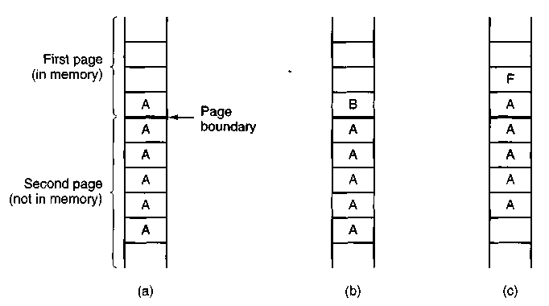
Figure 5-20. The TENEX password problem.
be evicted to make room for them. Now the program tried to open the victim's file, using the carefully aligned password. If the first character of the real password was anything but A, the system would stop checking at the first character and report back with ILLEGAL PASSWORD. If, however, the real password did begin with A, the system continued reading, and got a page fault, about which the intruder was informed.
If the password did not begin with A, the intruder changed the password to that of Fig. 5-20(b) and repeated the whole process to see if it began with B. It took at most 128 tries to go through the whole ASCII character set and thus determine the first character.
Suppose that the first character was an F. The memory layout of Fig. 5-20(c) allowed the intruder to test strings of the form FA, FB, and so on. Using this approach it took at most 128o tries to guess an n character ASCII password, instead of 128".
Our last flaw concerns OS/360. The description that follows is slightly simpli-. fied but preserves the essence of the flaw. In this system it was possible to start up a tape read and then continue computing while the tape drive was transferring data to the user space. The trick here was to carefully start up a tape read and then do a system call that required a user data structure, for example, a file to read and its password.
The operating system first verified that the password was indeed the correct one for the given file. Then it went back and read the file name again for the actual access (it could have saved the name internally, but it did not). Unfortunately, just before the system went to fetch the file name the second time, the file name was overwritten by the tape drive. The system then read the new file, for which no password had been presented. Getting the timing right took some
practice, but it was not that hard. Besides, if there is one thing that computers are good at, it is repeating the same operation over and over ad nauseam .
In addition to these examples, many other security problems and attacks have turned up over the years. One that has appeared in many contexts is the Trojan horse, in which a seemingly innocent program that is widely distributed also performs some unexpected and undesirable function, such as stealing data and email-ing it to some distant site where it can be collected later.
Another security problem in these times of job insecurity is the logic bomb. This device is a piece of code written by one of a company's (currently employed) programmers and secretly inserted into the production operating system. As long as the programmer feeds it its daily password, it does nothing. However, if the programmer is suddenly fired and physically removed from the premises without warning, the next day the logic bomb does not get its password, so it goes off.
Going off might involve clearing the disk, erasing files at random, carefully making hard-to-detect changes to key programs, or encrypting essential files. In the latter case, the company has a tough choice about whether to call the police (which may or may not result in a conviction many months later) or to give in to this blackmail and to rehire the ex-programmer as a "consultant" for an astronomical sum to fix the problem (and hope that he does not plant new logic bombs while doing so).
Probably the greatest computer security violation of all time began in the evening of Nov. 2, 1988 when a Cornell graduate student, Robert Tappan Morris, released a worm program into the Internet that eventually brought down thousands of machines all over the world.
The worm consisted of two programs, the bootstrap and the worm proper. The bootstrap was 99 lines of C called 11. c. It was compiled and executed on the system under attack. Once running, it connected to the machine from which it came, uploaded the main worm, and executed it. After going to some trouble to hide its existence, the worm then looked through its new host's routing tables to see what machines that host was connected to and attempted to spread the bootstrap to those machines.
Once established on a machine, the worm tried to break user passwords. Morris did not have to do much research on how to accomplish this. All he had to do was ask his father, a security expert at the National Security Agency, the U.S. government's top-secret code breaking agency, for a reprint of a classic paper on the subject that Morris Sr. and Ken Thompson had written a decade earlier at Bell Labs (Morris and Thompson, 1979). Each broken password allowed the worm to log in on any machines the password's owner had accounts on.
Morris was caught when one of his friends spoke with the New York Times computer reporter, John Markoff, and tried to convince Markoff that the incident was an accident, the worm was harmless, and the author was sorry. The next day the story was the lead on page one, even upstaging the presidential election three days later. Morris was tried and convicted in federal court. He was sentenced to
a 10,000 dollar fine, 3 years probation, and 400 hours of community service. His legal costs probably exceeded 150,000 dollars.
This sentence generated a great deal of controversy. Many in the computer community felt that he was a bright graduate student whose harmless prank had gotten out of control. Nothing in the worm suggested that Morris was trying to steal or damage anything. Others felt he was a serious criminal and should have gone to jail.
One permanent effect of this incident was the establishment of CERT (Computer Emergency Response Team), which provides a central place to report break-in attempts, and a group of experts to analyze security problems and design fixes. While this action was certainly a step forward, it also has its downside. CERT collects information about system flaws that can be attacked and how to fix them. Of necessity, it circulates this information widely to thousands of system administrators on the Internet, which means that the bad guys may also be able to get it and exploit the loopholes in the hours (or even days) before they are closed.
5.4.3 Generic Security Attacks
The flaws described above have been fixed but the average operating system still leaks like a sieve. The usual way to test a system's security is to hire a group of experts, known as tiger teams or penetration teams, to see if they can break in. Hebbard et al. (1980) tried the same thing with graduate students. In the course of the years, these penetration teams have discovered a number of areas in which systems are likely to be weak. Below we have listed some of the more common attacks that are often successful. When designing a system, be sure it can withstand attacks like these.
1. Request memory pages, disk space, or tapes and just read them. Many systems do not erase them before allocating them, and they may be full of interesting information written by the previous owner.
2. Try illegal system calls, or legal system calls with illegal parameters, or even legal system calls with legal but unreasonable parameters. Many systems can easily be confused.
3. Start logging in and then hit DEL, RUBOUT or BREAK halfway through the login sequence. In some systems, the password checking program will be killed and the login considered successful.
4. Try modifying complex operating system structures kept in user space (if any). In some systems (especially on mainframes), to open a file, the program builds a large data structure containing the file name and many other parameters and passes it to the system. As the file is read and written, the system sometimes updates the structure itself. Changing these fields can wreak havoc with the security.
5. Spoof the user by writing a program that types "login:" on the screen and go away. Many users will walk up to the terminal and willingly tell it their login name and password, which the program carefully records for its evil master. -
6. Look for manuals that say "Do not do X." Try as many variations of X as possible.
7. Convince a system programmer to change the system to skip certain vital security checks for any user with your login name. This attack is known as a trapdoor.
8. All else failing, the penetrator might find the computer center director's secretary and offer a large bribe. The secretary probably has easy access to all kinds of wonderful information, and is usually poorly paid. Do not underestimate problems caused by personnel.
These and other attacks are discussed by Linde (1975). Viruses
A special category of attack is the computer virus, which has become a major problem for many computer users. A virus is a program fragment that is attached to a legitimate program with the intention of infecting other programs. It differs from a worm only in that a virus piggybacks on an existing program, whereas a worm is a complete program in itself. Viruses and worms both attempt to spread themselves and both can do severe damage.
A typical virus works as follows. The person writing the virus first produces a useful new program, often a game for MS-DOS. This program contains the virus code hidden away in it. The game is then uploaded to a public bulletin board system or offered for free or for a modest price on floppy disk. The program is then advertised, and people begin downloading and using it. Constructing a virus is not easy, so the people doing this are invariably quite bright, and the quality of the game or other program is often excellent.
When the program is started up, it immediately begins examining all the binary programs on the hard disk to see if they are already infected. When an uninfected program is found, it is infected by attaching the virus code to the end of the file, and replacing the first instruction with a jump to the virus. When the virus code is finished executing, it executes the instruction that had previously been first and then jumps to the second instruction. In this way, every time an infected program runs, it tries to infect more programs.
In addition to just infecting other programs, a virus can do other things, such as erasing, modifying, or encrypting files. One virus even displayed an extortion note on the screen, telling the user to send 500 dollars in cash to a post office box in Panama or face the permanent loss of his data and damage to the hardware.
It is also possible for a virus to infect the hard disk's boot sector, making it impossible to boot the computer. Such a virus may ask for a password, which the virus' writer may offer to supply in exchange for some small unmarked bills.
Virus problems are easier to prevent than to cure. The safest course is to buy only shrink-wrapped software from respectable stores. Uploading free software from bulletin boards or getting pirated copies on floppy disk is asking for trouble. Commercial antivirus packages exist, but some of these work by just looking for specific known viruses.
A more general approach is to first reformat the hard disk completely, including the boot sector. Next, install all the trusted software and compute a checksum for each file. The algorithm does not matter, as long as it has enough bits (at least 32). Store the list of (file, checksum) pairs in a safe place, either offline on a floppy disk, or online but encrypted. Starting at that point, whenever the system is booted, all the checksums should be recomputed and compared to the secure list of original checksums. Any file whose current checksum differs from the original one is immediately suspect. While this approach does not prevent infection, it at least allows early detection.
Infection can be made more difficult if the directory where binary programs reside is made unwritable for ordinary users. This technique makes it difficult for the virus to modify other binaries. Although it can be used in UNIX, it is not applicable to MS-DOS because the latter's directories cannot be made unwritable at all.
5.4.4 Design Principles for Security
Viruses mostly occur on desktop systems. On larger systems other problems occur and other methods are needed for dealing with them. Saltzer and Schroeder (1975) have identified several general principles that can be used as a guide to designing secure systems. A brief summary of their ideas (based on experience with MULTICS) is given below.
First, the system design should be public. Assuming that the intruder will not know how the system works serves only to delude the designers.
Second, the default should be no access. Errors in which legitimate access is refused will be reported much faster than errors in which unauthorized access is allowed.
Third, check for current authority. The system should not check for permission, determine that access is permitted, and then squirrel away this information for subsequent use. Many systems check for permission when a file is opened, and not afterward. This means that a user who opens a file, and keeps it open for weeks, will continue to have access, even if the owner has long since changed the file protection.
Fourth, give each process the least privilege possible. If an editor has only the authority to access the file to be edited (specified when the editor is invoked),
editors with Trojan horses will not be able to do much damage. This principle implies a fine-grained protection scheme. We will discuss such schemes later in this chapter.
Fifth, the protection mechanism should be simple, uniform, and built into the lowest layers of the system. Trying to retrofit security to an existing insecure system is nearly impossible. Security, like correctness, is not an add-on feature.
Sixth, the scheme chosen must be psychologically acceptable. If users feel that protecting their files is too much work, they just will not do it. Nevertheless, they will complain loudly if something goes wrong. Replies of the form "It is your own fault" will generally not be well received.
5.4.5 User Authentication
Many protection schemes are based on the assumption that the system knows the identity of each user. The problem of identifying users when they log in is called user authentication. Most authentication methods are based on identifying something the user knows, something the user has, or something the user is.
Passwords
The most widely used form of authentication is to require the user to type a password. Password protection is easy to understand and easy to implement. In UNIX it works like this. The login program asks the user to type his name and password. The password is immediately encrypted. The login program then reads the password file, which is a series of ASCII lines, one per user, until it finds the line containing the user's login name. If the (encrypted) password contained in this line matches the encrypted password just computed, the login is permitted, otherwise it is refused.
Password authentication is easy to defeat. One frequently reads about groups of high school, or even junior high school students who, with the aid of their trusty home computers, have just broken into some top secret system owned by a giant corporation or government agency. Virtually all the time the break-in consists of guessing a user name and password combination.
Although more recent studies have been made (e.g., Klein, 1990) the classic work on password security remains the one done by Morris and Thompson (1979) on UNIX systems. They compiled a list of likely passwords: first and last names, street names, city names, words from a moderate-sized dictionary (also words spelled backward), license plate numbers, and short strings of random characters.
They then encrypted each of these using the known password encryption algorithm and checked to see if any of the encrypted passwords matched entries in their list. Over 86 percent of all passwords turned up in their list.
If all passwords consisted of 7 characters chosen at random from the 95 printable ASCII characters, the search space becomes 95⁷, which is about 7x 10¹³.
At 1000 encryptions per second, it would take 2000 years to build the list to check the password file against. Furthermore, the list would fill 20 million magnetic tapes. Even requiring passwords to contain at least one lowercase character, one uppercase character, and one special character, and be at least seven or eight characters long would be a major improvement over unrestricted user-chosen passwords.
Even if it is considered politically impossible to require users to pick reasonable passwords, Morris and Thompson have described a technique that renders their own attack (encrypting a large number of passwords in advance) almost useless. Their idea is to associate an n-bit random number with each password. The random number is changed whenever the password is changed. The random number is stored in the password file in unencrypted form, so that everyone can read it. Instead of just storing the encrypted password in the password file, the password and the random number are first concatenated and then encrypted together. This encrypted result is stored in the password file.
Now consider the implications for an intruder who wants to build up a list of likely passwords, encrypt them, and save the results in a sorted file, /, so that any encrypted password can be looked up easily. If an intruder suspects that Marilyn might be a password, it is no longer sufficient just to encrypt Marilyn and put the result in/. He has to encrypt 2" strings, such as MarilynOOOO, MarilynOOOl, Mari-Iyn0002, and so forth and enter all of them in/. This technique increases the size of/by 2". UNIX uses this method with n = 12. It is known as salting the password file. Some versions of unix make the password file itself unreadable but provide a program to look up entries upon request, adding just enough delay to greatly slow down any attacker.
Although this method offers protection against intruders who try to precom-pute a large list of encrypted passwords, it does little to protect a user David whose password is also David. One way to encourage people to pick better passwords is to have the computer offer advice. Some computers have a program that generates random easy-to-pronounce nonsense words, such as fatally, garbungy, or bipitty that can be used as passwords (preferably with some upper case and special characters thrown in).
Other computers require users to change their passwords regularly, to limit the damage done if a password leaks out. The most extreme form of this approach is the one-time password. When one-time passwords are used, the user gets a book containing a list of passwords. Each login uses the next password in the list. If an intruder ever discovers a password, it will not do him any good, since next time a different password must be used. It is suggested that the user try to avoid losing the password book.
It goes almost without saying that while a password is being typed in, the computer should not display the typed characters, to keep them from prying eyes near the terminal. What is less obvious is that passwords should never be stored in the computer in unencrypted form. Furthermore, not even the computer center
management should have unencrypted copies. Keeping unencrypted passwords anywhere is looking for trouble.
A variation on the password idea is to have each new user provide a long list of questions and answers that are then stored in the computer in encrypted form. The questions should be chosen so that the user does not need to write them down. Typical questions are:
1. Who is Marjolein's sister?
2. On what street was your elementary school?
3. What did Mrs. Woroboff teach?
At login, the computer asks one of them at random and checks the answer.
Another variation is challenge-response. When this is used, the user picks an algorithm when signing up as a user, for example x². When the user logs in, the computer types an argument, say 7, in which case the user types 49. The algorithm can be different in the morning and afternoon, on different days of the week, from different terminals, and so on.
Physical Identification
A completely different approach to authorization is to check to see if the user has some item, normally a plastic card with a magnetic stripe on it. The card is inserted into the terminal, which then checks to see whose card it is. This method can be combined with a password, so a user can only log in if he (1) has the card and (2) knows the password. Automated cash-dispensing machines usually work this way.
Yet another approach is to measure physical characteristics that are hard to forge. For example, a fingerprint or a voiceprint reader in the terminal could verify the user's identity. (It makes the search go faster if the user tells the computer who he is, rather than making the computer compare the given fingerprint to the entire data base.) Direct visual recognition is not yet feasible but may be one day.
Another technique is signature analysis. The user signs his name with a special pen connected to the terminal, and the computer compares it to a known specimen stored on line. Even better is not to compare the signature, but compare the pen motions made while writing it. A good forger may be able to copy the signature, but will not have a clue as to the exact order in which the strokes were made.
Finger length analysis is surprisingly practical. When this is used, each terminal has a device like the one of Fig. 5-21. The user inserts his hand into it, and the length of all his fingers is measured and checked against the data base.
We could go on and on with more examples, but two more will help make an important point. Cats and other animals mark off their territory by urinating around its perimeter. Apparently cats can identify each other this way. Suppose
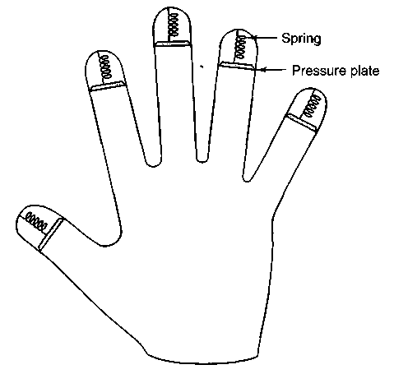
Figure 5-21. A device for measuring finger length.
that someone comes up with a tiny device capable of doing an instant urinalysis, thereby providing a foolproof identification. Each terminal could be equipped with one of these devices, along with a discreet sign reading: "For login, please deposit sample here." This might be an absolutely unbreakable system, but it would probably have a fairly serious user acceptance problem.
The same could be said of a system consisting of a thumbtack and a small spectrograph. The user would be requested to press his thumb against the thumbtack, thus extracting a drop of blood for spectrographic analysis. The point is that any authentication scheme must be psychologically acceptable to the user community. Finger-length measurements probably will not cause any problem, but even something as nonintrusive as storing fingerprints on line may be unacceptable to many people.
Countermeasures
Computer installations that are really serious about security, something that frequently happens the day after an intruder has broken in and done major damage, often take steps to make unauthorized entry much harder. For example, each user could be allowed to log in only from a specific terminal, and only during certain days of the week and hours of the day.
Dial-up telephone lines could be made to work as follows. Anyone can dial up and log in, but after a successful login, the system immediately breaks the connection and calls the user back at an agreed upon number. This measure means
than an intruder cannot just try breaking in from any phone line; only the user's (home) phone will do. In any event, with or without call back, the system should take at least 10 seconds to check any password typed in on a dial-up line, and should increase this time after several consecutive unsuccessful login attempts, in order to reduce the rate at which intruders can try. After three failed login attempts, the line should be disconnected for 10 minutes and security personnel notified.
All logins should be recorded. When a user logs in, the system should report the time and terminal of the previous login, so he can detect possible break ins.
The next step up is laying baited traps to catch intruders. A simple scheme is to have one special login name with an easy password (e.g., login name: guest, password: guest). Whenever anyone logs in using this name, the system security specialists are immediately notified. Other traps can be easy-to-find bugs in the operating system and similar things, designed for the purpose of catching intruders in the act. Stoll (1989) has written an entertaining account of the traps he set to track down a spy who broke into a university computer in search of military secrets.
5.5 PROTECTION MECHANISMS
In the previous sections we have looked at many potential problems, some of them technical and some of them not. In the following sections we will concentrate on some of the detailed technical ways that are used in operating systems to protect files and other things. All of these techniques make a clear distinction between policy (whose data are to be protected from whom) and mechanism (how the system enforces the policy). The separation of policy and mechanism is discussed in (Levin et al., 1975). Our emphasis will be on the mechanism, not the policy. For more advanced material, see (Sandhu, 1993).
In some systems, protection is enforced by a program called a reference monitor. Every time an access to a potentially protected resource is attempted, the system first asks the reference monitor to check its legality. The reference monitor then looks at its policy tables and makes a decision. Below we will describe the environment in which a reference monitor operates.
5.5.1 Protection Domains
A computer system contains many "objects" that need to be protected. These objects can be hardware (e.g., CPUs, memory segments, disk drives, or printers), or they can be software (e.g., processes, files, data bases, or semaphores).
Each object has a unique name by which it is referenced, and a finite set of operations that processes are allowed to carry out on it. READ and WRITE are operations appropriate to a file; UP and DOWN make sense on a semaphore.
It is obvious that a way is needed to prohibit processes from accessing objects that they are not authorized to access. Furthermore, this mechanism must also make it possible to restrict processes to a subset of the legal operations when that is needed. For example, process A may be entitled to read, but not write, file F.
In order to discuss different protection mechanisms, it is useful to introduce the concept of a domain. A domain is a set of (object, rights) pairs. Each pair specifies an object and some subset of the operations that can be performed on it. A right in this context means permission to perform one of the operations.
Figure 5-22 shows three domains, showing the objects in each domain and the rights [Read, Write, eXecute] available on each object. Note that Printer! is in two domains at the same time. Although not shown in this example, it is possible for the same object to be in multiple domains, with different rights in each one.
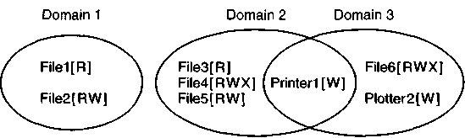
Figure 5-22. Three protection domains.
At every instant of time, each process runs in some protection domain. In other words, there is some collection of objects it can access, and for each object it has some set of rights. Processes can also switch from domain to domain during execution. The rules for domain switching are highly system dependent.
To make the idea of a protection domain more concrete, let us look at unix. In UNIX, the domain of a process is defined by its uid and gid. Given any (uid, gid) combination, it is possible to make a complete list of all objects (files, including I/O devices represented by special files, etc.) that can be accessed, and whether they can be accessed for reading, writing, or executing. Two processes with the same (uid, gid) combination will have access to exactly the same set of objects. Processes with different (uid, gid) values will have access to a different set of files, although there will be considerable overlap in most cases.
Furthermore, each process in UNIX has two halves: the user part and the kernel part. When the process does a system call, it switches from the user part to the kernel part. The kernel part has access to a different set of objects from the user part. For example, the kernel can access all the pages in physical memory, the entire disk, and all the other protected resources. Thus, a system call causes a domain switch.
When a process does an exec on a file with the SETUID or SETGID bit on, it acquires a new effective uid or gid. With a different (uid, gid) combination, it has a different set of files and operations available. Running a program with SETUID or SETGID is also a domain switch, since the rights available are now different.
An important question is how the system keeps track of which object belongs to which domain. Conceptually, at least, one can envision a large matrix, with the rows being the domains and the columns being the objects. Each box lists the rights, if any, that the domain contains for the object. The matrix for Fig. 5-22 is shown in Fig. 5-23. Given this matrix and the current domain number, the system can tell if an access to a given object in a particular way from a specified domain is allowed.
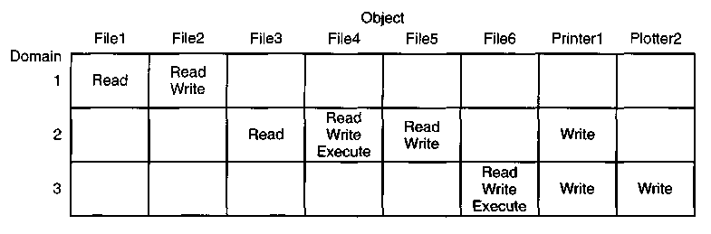
Figure 5-23. A protection matrix.
Domain switching itself can be easily included in the matrix model by realizing that a domain is itself an object, with the operation ENTER. Figure 5-24 shows the matrix of Fig. 5-23 again, only now with the three domains as objects themselves. Processes in domain 1 can switch to domain 2, but once there, they cannot go back. This situation models executing a SETUID program in UNIX. No other domain switches are permitted in this example.
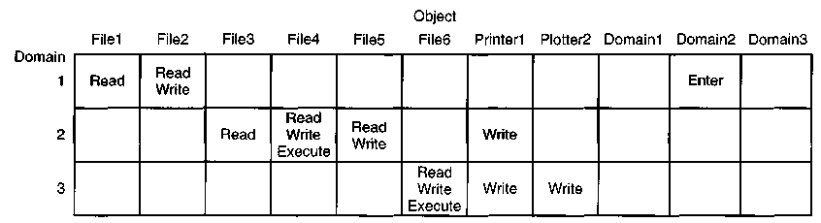
Figure 5-24. A protection matrix with domains as objects.
5.5.2 Access Control Lists
In practice, actually storing the matrix of Fig. 5-24 is rarely done because it is large and sparse. Most domains have no access at all to most objects, so storing a very large, mostly empty, matrix is a waste of disk space. Two methods that are
practical, however, are storing the matrix by rows or by columns, and then storing only the nonempty elements. The two approaches are surprisingly different. In this section we will look at storing it by column; in the next one we will study storing it by row.
The first technique consists of associating with each object an (ordered) list containing all the domains that may access the object, and how. This list is called the Access Control List or ACL. If it were to be implemented in unix, the easiest way would be to put the ACL for each file in a separate disk block and include the block number in the file's i-node. As only the nonempty entries of the matrix are stored, the total storage required for all the ACLs combined is much less than what would be needed for the whole matrix.
As an example of how ACLs work, let us continue to imagine that they were used in UNIX, where a domain is specified by a (uid, gid) pair. Actually, ACLs were used in UNIX' role model, MULTICS, more or less in the way we will describe, so the example is not so hypothetical.
Let us now assume that we have four users (i.e., uids) Jan, Els, Jelle, and Maaike, who belong to groups system, staff, student, and student, respectively. Suppose that some files have the following ACLs:
FileO: (Jan, *, RWX)
Filel: (Jan, system, RWX)
File2: (Jan, *, RW-), (Els, staff, RW-), (Maaike, *, RW-)
File3: (*, student, R—)
File4: (Jelle, *, ——), (*, student, R—)
Each ACL entry, in parentheses, specifies a uid, a gid, and the allowed accesses (Read, Write, eXecute). An asterisk means all uids or gids. FileO can be read, written, or executed by any process with uid = Jan, and any gid. Filel can be accessed only by processes with uid = Jan and gid = system. A process that has uid = Jan and gid = staff can access FileO but not Filel. File2 can be read or written by processes with uid = Jan and any gid, read by processes with uid = Els and gid = staff, or by processes with uid = Maaike and any gid. File3 can be read by any student. File4 is especially interesting. It says that anyone with uid = Jelle, in any group, has no access at all, but all other students can read it. By using ACLs it is possible to prohibit specific uids or gids from accessing an object, while allowing everyone else in the same class.
So much for what UNIX does not do. Now let us look at what it does do. It provides three bits, rwx, per file for the owner, the owner's group, and others. This scheme is just the ACL again, but compressed to 9 bits. It is a list associated with the object saying who may access it and how. While the 9-bit unix scheme is clearly less general than a full-blown ACL system, in practice it is adequate, and its implementation is much simpler and cheaper.
The owner of an object can change its ACL at any time, thus making it easy to prohibit accesses that were previously allowed. The only problem is that
changing the ACL will most probably not affect any users who are currently using the object (e.g., currently have the file open).
5.5.3 Capabilities
The other way of slicing up the matrix of Fig. 5-24 is by rows. When this method is used, associated with each process is a list of objects that may be accessed, along with an indication of which operations are permitted on each, in other words, its domain. This list is called a capability list, and the individual items on it are called capabilities (Dennis and Van Horn, 1966; Fabry, 1974).
A typical capability list is shown in Fig. 5-25. Each capability has a Type field, which tells what kind of an object it is, a Rights field, which is a bit map indicating which of the legal operations on this type of object are permitted, and an Object field, which is a pointer to the object itself (e.g., its i-node number). Capability lists are themselves objects and may be pointed to from other capability lists, thus facilitating sharing of subdomains. Capabilities are often referred to by their position in the capability list. A process might say: "Read IK from the file pointed to by capability 2." This form of addressing is similar to using file descriptors in UNIX.
# | Type | Rights | Object
0 | File | R — | Pointer to FileS
1 | File | RWX | Pointer to File4
2 | File | RW- | Pointer to FileS
3 | Pointer | -W- | Pointer to Printer!
Figure 5-25. The capability list for domain 2 in Fig. 5-23.
It is fairly obvious that capability lists, or C-lists as they are often called, must be protected from user tampering. Three methods have been proposed to protect them. The first way requires a tagged architecture, a hardware design in which each memory word has an extra (or tag) bit that tells whether the word contains a capability or not. The tag bit is not used by arithmetic, comparison, or similar ordinary instructions, and it can be modified only by programs running in kernel mode (i.e., the operating system).
The second way is to keep the C-list inside the operating system and just have processes refer to capabilities by their slot number, as mentioned above. Hydra (Wulf et al., 1974) worked this way.
The third way is to keep the C-list in user space, but encrypt each capability with a secret key unknown to the user. This approach is particularly suited to distributed systems, and is used extensively by Amoeba (Tanenbaum et al., 1990).
In addition to the specific object-dependent rights, such as read and execute, capabilities usually have generic rights which are applicable to all objects. Examples of generic rights are
1. Copy capability: create a new capability for the same object.
2. Copy object: create a duplicate object with a new capability.
3. Remove capability: delete an entry from the C-list; object unaffected.
4. Destroy object: permanently remove an object and a capability.
A last remark worth making about capability systems is that revoking access to an object is quite difficult. It is hard for the system to find all the outstanding capabilities for any object to take them back, since they may be stored in C-lists all over the disk. One approach is to have each capability point to an indirect object, rather than to the object itself. By having the indirect object point to the real object, the system can always break that connection, thus invalidating the capabilities. (When a capability to the indirect object is later presented to the system, the user will discover that the indirect object is now pointing to a null object.)
Another way to achieve revocation is the scheme used in Amoeba. Each object contains a long random number, which is also present in the capability. When a capability is presented for use, the two are compared. Only if they agree is the operation allowed. The owner of an object can request that the random number in the object be changed, thus invalidating existing capabilities. Neither scheme allows selective revocation, that is, taking back, say, John's permission, but nobody else's.
5.5.4 Covert Channels
Even with access control lists and capabilities, security leaks can occur. In this section we discuss one class of problem. These ideas are due to Lampson (1973).
Lampson's model involves three processes and is primarily applicable to large timesharing systems. The first process is the client, which wants some work performed by the second one, the server. The client and the server do not entirely trust each other. For example, the server's job is to help clients with filling out their tax forms. The clients are worried that the server will secretly record their financial data, for example, maintaining a secret list of who earns how much, and then selling the list. The server is worried that the clients will try to steal the valuable tax program.
The third process is the collaborator, which is conspiring with the server to indeed steal the client's confidential data. The collaborator and server are typically owned by the same person. These three processes are shown in Fig. 5-26.
The object of this exercise is to design a system in which it is impossible for the server to leak to the collaborator the information that it has legitimately received from the client. Lampson called this the confinement problem.
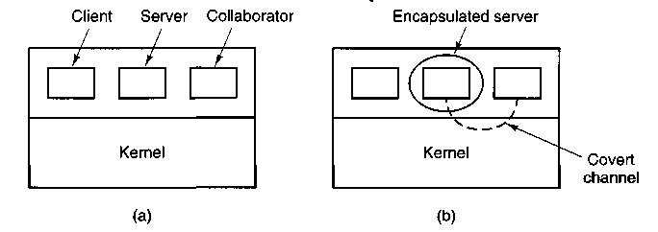
Figure 5-26. (a) The client, server, and collaborator processes, (b) The encapsulated server can still leak to the collaborator via covert channels.
From the system designer's point of view, the goal is to encapsulate or confine the server in such a way that it cannot pass information to the collaborator. Using a protection matrix scheme we can easily guarantee that the server cannot communicate with the collaborator by writing a file to which the collaborator has read access. We can probably also ensure that the server cannot communicate with the collaborator using the system's interprocess communication mechanism.
Unfortunately, more subtle communication channels may be available. For example, the server can try to communicate a binary bit stream as follows. To send a 1 bit, it computes as hard as it can for a fixed interval of time. To send a 0 bit, it goes to sleep for the same length of time.
The collaborator can try to detect the bit stream by carefully monitoring its response time. In general, it will get better response when the server is sending a 0 than when the server is sending a 1. This communication channel is known as a covert channel, and is illustrated in Fig. 5-26(b).
Of course, the covert channel is a noisy channel, containing a lot of extraneous information, but information can be reliably sent over a noisy channel by using an error-correcting code (e.g., a Hamming code, or even something more sophisticated). The use of an error-correcting code reduces the already low bandwidth of the covert channel even more, but it still may be enough to leak substantial information. It is fairly obvious that no protection model based on a matrix of objects and domains is going to prevent this kind of leakage.
Modulating the CPU usage is not the only covert channel. The paging rate can also be modulated (many page faults for a 1, no page faults for a 0). In fact, almost any way of degrading system performance in a clocked way is a candidate. If the system provides a way of locking files, then the server can lock some file to indicate a 1, and unlock it to indicate a 0. On some systems, it may be possible for a process to detect the status of a lock even on a file that it cannot access.
Acquiring and releasing dedicated resources (tape drives, plotters, etc.) can also be used for signaling. The server acquires the resource to send a 1 and releases it to send a 0. In UNIX, the server could create a file to indicate a 1 and remove it to indicate a 0; the collaborator could use the ACCESS system call to see if the file exists. This call works even though the collaborator has no permission to use the file. Unfortunately, many other covert channels exist.
Lampson also mentions a way of leaking information to the (human) owner of the server process. Presumably the server process will be entitled to tell its owner how much work it did on behalf of the client, so the client can be billed. If the actual computing bill is, say, 100 dollars and the client's income is 53K dollars, the server could report the bill as 100.53 to its owner.
Just finding all the covert channels, let alone blocking them, is extremely difficult. In practice, there is little that can be done. Introducing a process that causes page faults at random, or otherwise spends its time degrading system performance in order to reduce the bandwidth of the covert channels is not an attractive proposition.
5.6 OVERVIEW OF THE MINIX FILE SYSTEM
Like any file system, the MINIX file system must deal with all the issues we have just studied. It must allocate and deallocate space for files, keep track of disk blocks and free space, provide some way to protect files against unauthorized usage, and so on. In the remainder of this chapter we will look closely at minix to see how it accomplishes these goals.
In the first part of this chapter, we have repeatedly referred to UNIX rather than to MINIX for the sake of generality, although the external interface of the two is virtually identical. Now we will concentrate on the internal design of minix. For information about the UNIX internals, see Thompson (1978), Bach (1987), Lions (1996), and Vahalia (1996).
The MINIX file system is just a big C program that runs in user space (see Fig. 2-26). To read and write files, user processes send messages to the file system telling what they want done. The file system does the work and then sends back a reply. The file system is, in fact, a network file server that happens to be running on the same machine as the caller.
This design has some important implications. For one thing, the file system can be modified, experimented with, and tested almost completely independently of the rest of MINIX. For another, it is very easy to move the whole file system to any computer that has a C compiler, compile it there, and use it as a free-standing UNIX-like remote file server. The only changes that need to be made are in the area of how messages are sent and received, which differs from system to system.
In the following sections, we will present an overview of many of the key areas of the file system design. Specifically, we will look at messages, the file
system layout, the bit maps, i-nodes, the block cache, directories and paths, file descriptors, file locking, and special files (plus pipes). After studying all of these topics, we will show a simple example of how the pieces fit together by tracing what happens when a user process executes the read system call.
5.6.1 Messages
The file system accepts 39 types of messages requesting work. All but two are for minix system calls. The two exceptions are messages generated by other parts of MINIX. Of the system calls, 31 are accepted from user processes. Six system call messages are for system calls which are handled first by the memory manager, which then calls the file system to do a part of the work. Two other messages are also processed by the file system. The messages are shown in Fig. 5-27
The structure of the file system is basically the same as that of the memory manager and all the I/O tasks. It has a main loop that waits for a message to arrive. When a message arrives, its type is extracted and used as an index into a table containing pointers to the procedures within the file system that handle all the types. Then the appropriate procedure is called, it does its work and returns a status value. The file system then sends a reply back to the caller and goes back to the top of the loop to wait for the next message.
5.6.2 File System Layout
A MINIX file system is a logical, self-contained entity with i-nodes, directories, and data blocks. It can be stored on any block device, such as a floppy disk or a (portion of a) hard disk. In all cases, the layout of the file system has the same structure. Figure 5-28 shows this layout for a 360K floppy disk with 128 i-nodes and a IK block size. Larger file systems, or those with more or fewer i-nodes or a different block size, will have the same six components in the same order, but their relative sizes may be different.
Each file system begins with a boot block. This contains executable code. When the computer is turned on, the hardware reads the boot block from the boot device into memory, jumps to it, and begins executing its code. The boot block code begins the process of loading the operating system itself. Once the system has been booted, the boot block is not used any more. Not every disk drive can be used as a boot device, but to keep the structure uniform, every block device has a block reserved for boot block code. At worst this strategy wastes one block. To prevent the hardware from trying to boot an unbootable device a magic number is placed at a known location in the boot block when and only when the executable code is written to the device. When booting from a device, the hardware
Messages from users | Input parameters | Reply value
ACCESS | File name, access mode | Status
CHDIR | Name of new working-directory | Status
CHMOD | File name, new mode | Status
CHOWN | File name, new owner, group | Status
CHROOT | Name of new root directory | Status
CLOSE | File descriptor of file to close | Status
GREAT | Name of file to be created, mode | File descriptor
DUP | File descriptor (for dup2, two fds) | New file descriptor
FCNTL | File descriptor, function code, arg | Depends on function
FSTAT | Name of file, buffer | Status
IOCTL | File descriptor, function code, arg | Status
LINK | Name of file to link to, name of link | Status
LSEEK | File descriptor, offset, whence | New position
MKDIR | File name, mode | Status
MKNOD | Name of dir or special, mode, address | Status
MOUNT | Special file, where to mount, ro flag | Status
OPEN | Name of file to open, r/w flag | File descriptor
PIPE | Pointer to 2 file descriptors (modified) | Status
READ | File descriptor, buffer, how many bytes | # Bytes read
RENAME | File name, file name | Status
RMDIR | File name | Status
STAT | File name, status buffer | Status
STIME | Pointer to current time | Status
SYNC | (None) | Always OK
TIME | Pointer to place where current time goes | Status
TIMES | Pointer to buffer for process and child times | Status
UMASK | Complement of mode mask | Always OK
UMOUNT | Name of special file to unmount | Status
UNLINK | Name of file to unlink | Status
UTIME | File name, file times | Always OK
WRITE | File descriptor, buffer, how many bytes | # Bytes written
Messages from MM | Input parameters | Reply value
EX EC | Pid | Status
EXIT | Pid | Status
FORK | Parent pid, child pid | Status
SETGID | Pid, real and effective gid | Status
SETSID | Pid | Status
SETUID | Pid, real and effective uid | Status
Other messages | Input parameters | Reply value
REVIVE | Process to revive | (No reply)
UNPAUSE | Process to check | (See text)
Figure 5-27. File system messages. File name parameters are always pointers to the name. The code status as reply value means OK or ERROR.
Figure 5-28. Disk layout for the simplest disk: a 360K floppy disk, with 128 i-nodes and a IK block size (i.e., two consecutive 512-byte sectors are treated as a single block).
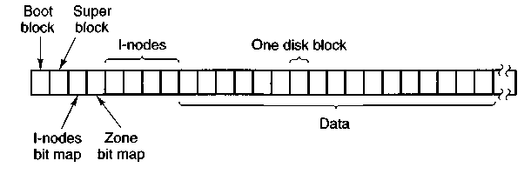
(actually, the BIOS code) will refuse to attempt to load from a device lacking the magic number. Doing this prevents inadvertently using garbage as a boot program.
The super-block contains information describing the layout of the file system. It is illustrated in Fig. 5-29. The main function of the super-block is to tell the file system how big the various pieces of the file system are. Given the block size and the number of i-nodes, it is easy to calculate the size of the i-node bit map and the number of blocks of i-nodes. For example, for a IK block, each block of the bit map has 1K bytes (8K bits), and thus can keep track of the status of up to 8192 i-nodes. (Actually the first block can handle only up to 8191 i-nodes, since there is no Oth inode, but it is given a bit in the bit map, anyway). For 10,000 i-nodes, two bit map blocks are needed. Since i-nodes each occupy 64 bytes, a IK block holds up to 16 i-nodes. With 128 usable i-nodes, 8 disk blocks are needed to contain them all.
We will explain the difference between zones and blocks in detail later, but for the time being it is sufficient to say that disk storage can be allocated in units (zones) of 1, 2, 4, 8, or in general 2" blocks. The zone bit map keeps track of free storage in zones, not blocks. For all standard floppy disks used by minix the zone and block sizes are the same (IK), so for a first approximation a zone is the same as a block on these devices. Until we come to the details of storage allocation later in the chapter, it is adequate to think "block" whenever you see "zone."
Note that the number of blocks per zone is not stored in the super-block, as it is never needed. All that is needed is the base 2 logarithm of the zone to block ratio, which is used as the shift count to convert zones to blocks and vice versa. For example, with 8 blocks per zone, Iog₂8 = 3, so to find the zone containing block 128 we shift 128 right 3 bits to get zone 16.
The zone bit map includes only the data zones (i.e., the blocks used for the bit maps and i-nodes are not in the map), with the first data zone designated zone 1 in the bit map. As with the i-node bit map, bit 0 in the map is unused, so the first block in the zone bit map can map 8191 zones and subsequent blocks can map 8192 zones each. If you examine the bit maps on a newly formatted disk, you will
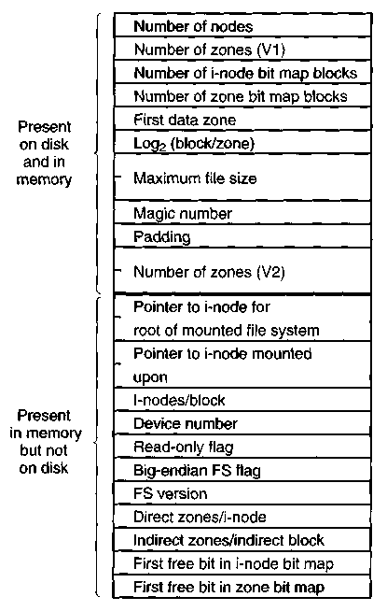
Figure 5-29. The MINIX super-block.
find that both the i-node and zone bit maps have 2 bits set to 1. One is for the nonexistent Oth i-node or zone; the other is for the i-node and zone used by the root directory on the device, which is placed there when the file system is created.
The information in the super-block is redundant because sometimes it is needed in one form and sometimes in another. With IK devoted to the super-block, it makes sense to compute this information in all the forms it is needed, rather than having to recompute it frequently during execution. The zone number of the first data zone on the disk, for example, can be calculated from the block size, zone size, number of i-nodes, and number of zones, but it is faster just to keep it in the super-block. The rest of the super-block is wasted anyhow, so using up another word of it costs nothing.
When MINIX is booted, the super-block for the root device is read into a table in memory. Similarly, as other file systems are mounted, their super-blocks are also brought into memory. The super-block table holds a number of fields not present on the disk. These include flags that allow a device to be specified as read-only or as following a byte-order convention opposite to the standard, and
fields to speed access by indicating points in the bit maps below which all bits are marked used. In addition, there is a field describing the device from which the super-block came.
Before a disk can be used as a MINIX fHe system, it must be given the structure of Fig. 5-28. The utility program mkfs has been provided to build file systems. This program can be called either by a command like
mkfs/dev/fd1 1440
to build an empty 1440 block file system on the floppy disk in drive 1, or it can be given a prototype file listing directories and files to include in the new file system. This command also puts a magic number in the super-block to identify the file system as a valid Minix file system. The Minix file system has evolved, and some aspects of the file system (for instance, the size of i-nodes) were different in earlier versions. The magic number identifies the version of mkfs that created the file system, so differences can be accomodated. Attempts to mount a file system not in minix format, such as an MS-DOS diskette, will be rejected by the MOUNT system call, which checks the super-block for a valid magic number and other things.
5.6.3 Bit Maps
MINIX keeps tracks of which i-nodes and zones are free by using two bit maps (see Fig. 5-29). When a file is removed, it is then a simple matter to calculate which block of the bit map contains the bit for the i-node being freed and to find it using the normal cache mechanism. Once the block is found, the bit corresponding to the freed i-node is set to 0. Zones are released from the zone bit map in the same way.
Logically, when a file is to be created, the file system must search through the bit-map blocks one at a time for the first free i-node. This i-node is then allocated for the new file. In fact, the in-memory copy of the super-block has a field which points to the first free i-node, so no search is necessary until after a node is used, when the pointer must be updated to point to the new next free i-node, which will often turn out to be the next one, or a close one. Similarly, when an i-node is freed, a check is made to see if the free i-node comes before the currently-pointed-to one, and the pointer is updated if necessary. If every i-node slot on the disk is full, the search routine returns a 0, which is why i-node 0 is not used (i.e., so it can be used to indicate the search failed). (When mkfs creates a new file system, it zeroes i-node 0 and sets the lowest bit in the bit map to 1, so the file system will never attempt to allocate it.) Everything that has been said here about the i-node bit maps also applies to the zone bit map; logically it is searched for the first free zone when space is needed, but a pointer to the first free zone is maintained to eliminate most of the need for sequential searches through the bit map.
With this background, we can now explain the difference between zones and blocks. The idea behind zones is to help ensure that disk blocks that belong to the same file are located on the same cylinder, to improve performance when the file is read sequentially. The approach chosen is to make it possible to allocate several blocks at a time. If, for example, the block size is IK and the zone size is 4K, the zone bit map keeps track of zones, not blocks. A 20M disk has 5K zones of 4K, hence 5K bits in its zone map.
Most of the file system works with blocks. Disk transfers are always a block at a time, and the buffer cache also works with individual blocks. Only a few parts of the system that keep track of physical disk addresses (e.g., the zone bit map and the i-nodes) know about zones.
Some design decisions had to be made in developing the MINIX file system. In 1985, when MINIX was conceived, disk capacities were small, and it was expected that many users would have only floppy disks. A decision was made to restrict disk addresses to 16 bits in the V1 file system, primarily to be able to store many of them in the indirect blocks. With a 16-bit zone number and a IK zone, only 64K zones can be addressed, limiting disks to 64M. This was an enormous amount of storage in those days, and it was thought that as disks got larger, it would be easy to switch to 2K or 4K zones, without changing the block size. The 16-bit zone numbers also made it easy to keep the i-node size to 32 bytes.
As MINIX developed, and larger disks became much more common, it was obvious that changes were desirable. Many files are smaller than IK, so increasing the block size would mean wasting disk bandwidth, reading and writing mostly empty blocks and wasting precious main memory storing them in the buffer cache. The zone size could have been increased, but a larger zone size means more wasted disk space, and it was still desirable to retain efficient operation on small disks. Another reasonable alternative would have been to have different zone sizes on large and small devices.
In the end it was decided to increase the size of disk pointers to 32 bits. This makes it possible for the minix V2 file system to deal with device sizes up to 4 terabytes as IK blocks and zones. In part this decision was driven by other decisions about what should be in the i-node, which made increasing the size of the i-node to 64 bytes reasonable.
Zones also introduce an unexpected problem, best illustrated by a simple example, again with 4K zones and IK blocks. Suppose that a file is of length IK, meaning that 1 zone has been allocated for it. The blocks between IK and 4K contain garbage (residue from the previous owner), but no harm is done because the file size is clearly marked in the i-node as IK. In fact, the blocks containing garbage will not be read into the block cache, since reads are done by blocks, not by zones. Reads beyond the end of a file always return a count of 0 and no data.
Now someone seeks to 32768 and writes 1 byte. The file size is now changed to 32769. Subsequent seeks to IK followed by attempts to read the data will now be able to read the previous contents of the block, a major security breach.
The solution is to check for this situation when a write is done beyond the end of a file, and explicitly zero all the not-yet-allocated blocks in the zone that was previously the last one. Although this situation rarely occurs, the code has to deal with it, making the system slightly more complex.
5.6.4 I-nodes
The layout of the minix i-node is given in Fig. 5-30. It is almost the same as a standard unix i-node. The disk zone pointers are 32-bit pointers, and there are only 9 pointers, 7 direct and 2 indirect. The MINIX i-nodes occupy 64 bytes, the same as standard UNIX i-nodes, and there is space available for a 10th (triple indirect) pointer, although its use is not supported by the standard version of the FS. The minix i-node access, modification time and i-node change times are standard, as in UNIX. The last of these is updated for almost every file operation except a read of the file.
When a file is opened, its i-node is located and brought into the inode table in memory, where it remains until the file is closed. The inode table has a few additional fields not present on the disk, such as the i-node's device and number, so the file system knows where to rewrite it if it is modified while in memory. It also has a counter per i-node. If the same file is opened more than once, only one copy of the i-node is kept in memory, but the counter is incremented each time the file is opened and decremented each time the file is closed. Only when the counter finally reaches zero is the i-node removed from the table. If it has been modified since being loaded into memory, it is also rewritten to the disk.
The main function of a file's i-node is to tell where the data blocks are. The first seven zone numbers are given right in the i-node itself. For the standard distribution, with zones and blocks both IK, files up to 7K do not need indirect blocks. Beyond 7K, indirect zones are needed, using the scheme of Fig. 5-10, except that only the single and double indirect blocks are used. With IK blocks and zones and 32-bit zone numbers, a single indirect block holds 256 entries, representing a quarter megabyte of storage. The double indirect block points to 256 single indirect blocks, giving access to up to 64 megabytes. The maximum size of a MINIX file system is 1G, so modification to use the triple indirect block or larger zone sizes could both be useful if it were desirable to access very large files on a MINIX system.
The i-node also holds the mode information, which tells what kind of a file it is (regular, directory, block special, character special, or pipe), and gives the protection and SETUID and SETGID bits. The link field in the i-node records how many directory entries point to the i-node, so the file system knows when to release the file's storage. This field should not be confused with the counter (present only in the inode table in memory, not on the disk) that tells how many times the file is currently open, typically by different processes.
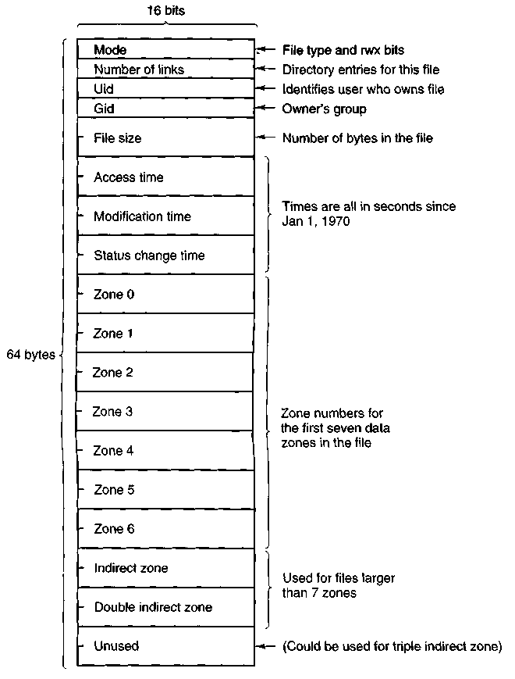
Figure 5-30. The MINIX i-node.
5.6.5 The Block Cache
MINIX uses a block cache to improve file system performance. The cache is implemented as an array of buffers, each consisting of a header containing pointers, counters, and flags, and a body with room for one disk block. All the buffers that are not in use are chained together in a double-linked list, from most recently used (MRU) to least recently used (LRU) as illustrated in Fig. 5-31.
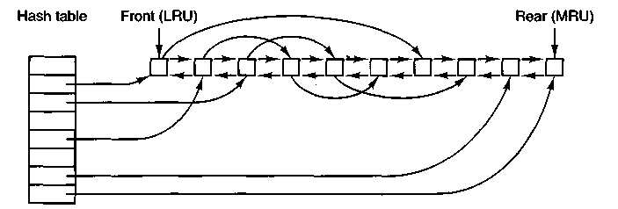
Figure 5-31. The linked lists used by the block cache.
In addition, to be able to quickly determine if a given block is in the cache or not, a hash table is used. All the buffers containing a block that has hash code k are linked together on a single-linked list pointed to by entry k in the hash table. The hash function just extracts the low-order n bits from the block number, so blocks from different devices appear on the same hash chain. Every buffer is on one of these chains. When the file system is initialized after MINIX is booted, all buffers are unused, of course, and all are in a single chain pointed to by the Oth hash table entry. At that time all the other hash table entries contain a null pointer, but once the system starts, buffers will be removed from the Oth chain and other chains will be built.
When the file system needs a block, it calls a procedure, get_block, which computes the hash code for that block and searches the appropriate list. Get-block is called with a device number as well as a block number, and the search compares both numbers with the corresponding fields in the buffer chain. If a buffer containing the block is found, a counter in the buffer header is incremented to show that the block is in use, and a pointer to it is returned. If a block is not found on the hash list, the first buffer on the LRU list can be used; it is guaranteed not to be still in use, and the block it contains may be evicted to free up the buffer.
Once a block has been chosen for eviction, another flag in its header is checked to see if the block has been modified since being read in. If so, it is rewritten to the disk. At this point the block needed is read in by sending a message to the disk task. The file system is suspended until the block arrives, at which time it continues and a pointer to the block is returned to the caller.
When the procedure that requested the block has completed its job, it calls another procedure, put_block, to free the block. Normally, a block will be used immediately and then released, but since it is possible that additional requests for a block will be made before it has been released, put-block decrements the use counter and puts the buffer back onto the LRU list only when the use counter has gone back to zero. While the counter is nonzero, the block remains in limbo.
One of the parameters to put-block tells what class of block (e.g., i-nodes, directory, data) is being freed. Depending on the class, two key decisions are made:
1. Whether to put the block on the front or rear of the LRU list.
2. Whether to write the block (if modified) to disk immediately or not.
Blocks that are not likely to be needed again soon, such as super-blocks, go on the front of the list so they will be claimed the next time a free buffer is needed. All other blocks go on the rear of the list in true LRU fashion.
A modified block is not rewritten until either one of two events occurs:
1. It reaches the front of the LRU chain and is evicted.
2. A SYNC system call is executed.
SYNC does not traverse the LRU chain but instead indexes through the array of buffers in the cache. Even if a buffer has not been released yet, if it has been modified, SYNC will find it and ensure that the copy on disk is updated.
There is an exception, however. A modified super-block is written to disk immediately. In an older version of minix a super-block was modified when a file system was mounted, and the purpose of the immediate write was to reduce the chance of corrupting the file system in the event of a crash. Super-blocks are not modified now, so the code to write them immediately is an anachronism. In the standard configuration, no other blocks are written immediately. However, by modifying the default definition of ROBUST in the system configuration file, include/minix/config.h, the file system can be compiled to mark i-node, directory, indirect, and bit-map blocks so they will be written immediately upon release. This is intended to make the file system more robust; the price paid is slower operation. Whether this will be effective is not clear. A power failure occurring when all blocks have not been yet been written is going to cause a headache whether it is an i-node or a data block that is lost.
Note that the header flag indicating that a block has been modified is set by the procedure within the file system that requested and used the block. The procedures get_block and put^block are concerned just with manipulating the linked lists. They have no idea which file system procedure wants which block or why.
5.6.6 Directories and Paths
Another important subsystem within the file system is the management of directories and path names. Many system calls, such as OPEN, have a file name as a parameter. What is really needed is the i-node for that file, so it is up to the file system to look up the file in the directory tree and locate its i-node.
A MINIX directory consists of a file containing 16-byte entries. The first 2 bytes form a 16-bit i-node number, and the remaining 14 bytes are the file name.
This is the same as the traditional UNIX directory entry we saw in Fig. 5-13. To look up the path /usr/ast/mbox, the system first looks up usr in the root directory, then it looks up ast in /usr, and finally it looks up mbox in /usr/ast. The actual lookup proceeds one path component at a time, as illustrated in Fig. 5-14.
The only complication is what happens when a mounted file system is encountered. The usual configuration for MINIX and many other UNIX-like systems is to have a small root file system containing the files needed to start the system and to do basic system maintenance, and to have the majority of the files, including users' directories, on a separate device mounted on /usr. This is a good time to look at how mounting is done. When the user types the command
mount /dev/hd2c /usr
on the terminal, the file system contained on hard disk partition 2 is mounted on top of /usr in the root file system. The file systems before and after mounting are shown in Fig. 5-32.
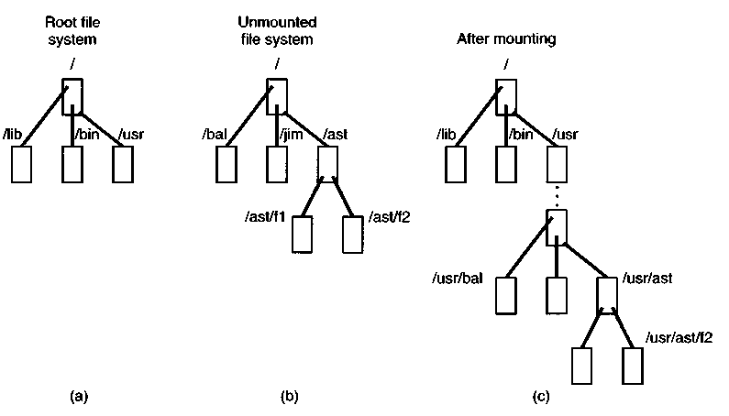
Figure 5-32. (a) Root file system, (b) An unmounted file system, (c) The result of mounting the file system of (b) on /usr.
The key to the whole mount business is a flag set in the memory copy of the i-node of /usr after a successful mount. This flag indicates that the i-node is mounted on. The MOUNT call also loads the super-block for the newly mounted file system into the super-block table and sets two pointers in it. Furthermore, it puts the root i-node of the mounted file system in the inode table.
In Fig. 5-29 we see that super-blocks in memory contain two fields related to mounted file systems. The first of these, the i-node-of-the-mounted-file-system, is set to point to the root i-node of the newly mounted file system. The second, the i-node-mounted-on, is set to point to the i-node mounted on, in this case, the i-node for /usr. These two pointers serve to connect the mounted file system to the root and represent the "glue" that holds the mounted file system to the root [shown as the dots in Fig. 5-32(c)]. This glue is what makes mounted file systems work.
When a path such as /usr/ast/f2 is being looked up, the file system will see a flag in the i-node for /usr and realize that it must continue searching at the root i-node of the file system mounted on /usr. The question is: "How does it find this root i-node?"
The answer is straightforward. The system searches all the super-blocks in memory until it finds the one whose i-node mounted on field points to /usr. This must be the super-block for the file system mounted on /usr. Once it has the super-block, it is easy to follow the other pointer to find the root i-node for the mounted file system. Now the file system can continue searching. In this example, it looks for ast in the root directory of hard disk partition 2.
5.6.7 File Descriptors
Once a file has been opened, a file descriptor is returned to the user process for use in subsequent READ and WRITE calls. In this section we will look at how file descriptors are managed within the file system.
Like the kernel and the memory manager, the file system maintains part of the process table within its address space. Three of its fields are of particular interest. The first two are pointers to the i-nodes for the root directory and the working directory. Path searches, such as that of Fig. 5-14, always begin at one or the other, depending on whether the path is absolute or relative. These pointers are changed by the CHROOT and CHDIR system calls to point to the new root or new working directory, respectively.
The third interesting field in the process table is an array indexed by file descriptor number. It is used to locate the proper file when a file descriptor is presented. At first glance, it might seem sufficient to have the &-th entry in this array just point to the i-node for the file belonging to file descriptor k. After all, the i-node is fetched into memory when the file is opened and kept there until it is closed, so it is sure to be available.
Unfortunately, this simple plan fails because files can be shared in subtle ways in MINIX (as well as in UNIX). The trouble arises because associated with each file is a 32-bit number that indicates the next byte to be read or written. It is this number, called the file position, that is changed by the LSEEK system call. The problem can be stated easily: "Where should the file pointer be stored?"
The first possibility is to put it in the i-node. Unfortunately, if two or more processes have the same file open at the same time, they must all have their own file pointers, since it would hardly do to have an LSEEK by one process affect the next read of a different process. Conclusion:-the file position cannot go in the i-node.
What about putting it in the process table? Why not have a second array, paralleling the file descriptor array, giving the current position of each file? This idea does not work either, but the reasoning is more subtle. Basically, the trouble comes from the semantics of the FORK system call. When a process forks, both the parent and the child are required to share a single pointer giving the current position of each open file.
To understand the problem better, consider the case of a shell script whose output has been redirected to a file. When the shell forks off the first program, its file position for standard output is 0. This position is then inherited by the child, which writes, say, IK of output. When the child terminates, the shared file position must now be IK.
Now the shell reads some more of the shell script and forks off another child. It is essential that the second child inherit a file position of IK from the shell, so it will begin writing at the place where the first program left off. If the shell did not share the file position with its children, the second program would overwrite the output from the first one, instead of appending to it.
As a result, it is not possible to put the file position in the process table. It really must be shared. The solution used in minix is to introduce a new, shared table, filp, which contains all the file positions. Its use is illustrated in Fig. 5-33. By having the file position truly shared, the semantics of FORK can be implemented correctly, and shell scripts work properly.
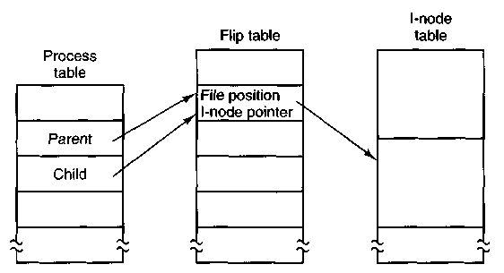
Figure 5-33. How file positions are shared between a parent and a child.
Although the only thing that the filp table really must contain is the shared file position, it is convenient to put the i-node pointer there, too. In this way, all that the file descriptor array in the process table contains is a pointer to a filp entry.
The filp entry also contains the file mode (permission bits), some flags indicating whether the file was opened in a special mode, and a count of the number of processes using it, so the file system can tell when the last process using the entry has terminated, in order to reclaim the slot.
5.6.8 File Locking
There is yet another aspect of file system management that requires a special table. This is file locking. MINIX supports the posix interprocess communication mechanism of advisory file locking. This permits any part, or multiple parts, of a file to be marked as locked. The operating system does not enforce locking, but processes are expected to be well behaved and to look for locks on a file before doing anything that would conflict with another process.
The reasons for providing a separate table for locks are similar to the justifications for the filp table discussed in the previous section. A single process can have more than one lock active, and different parts of a file may be locked by more than one process (although, of course, the locks cannot overlap), so neither the process table nor the filp table is a good place to record locks. Since a file may have more than one lock placed upon it, the i-node is not a good place either.
MINIX uses another table, the file_lock table, to record all locks. Each slot in this table has space for a lock type, indicating if the file is locked for reading or writing, the process ID holding the lock, a pointer to the i-node of the locked file, and the offsets of the first and last bytes of the locked region.
5.6.9 Pipes and Special Files
Pipes and special files differ from ordinary files in an important way. When a process tries to read or write from a disk file, it is certain that the operation will complete within a few hundred milliseconds at most. In the worst case, two or three disk accesses might be needed, not more. When reading from a pipe, the situation is different: if the pipe is empty, the reader will have to wait until some other process puts data in the pipe, which might take hours. Similarly, when reading from a terminal, a process will have to wait until somebody types something.
As a consequence, the file system's normal rule of handling a request until it is finished does not work. It is necessary to suspend these requests and restart them later. When a process tries to read or write from a pipe, the file system can check the state of the pipe immediately to see if the operation can be completed. If it can be, it is, but if it cannot be, the file system records the parameters of the system call in the process table, so it can restart the process when the time comes.
Note that the file system need not take any action to have the caller suspended. All it has to do is refrain from sending a reply, leaving the caller blocked waiting for the reply. Thus, after suspending a process, the file system goes back to its main loop to wait for the next system call. As soon as another process
modifies the pipe's state so that the suspended process can complete, the file system sets a flag so that next time through the main loop it extracts the suspended process' parameters from the process table and executes the call.
The situation with terminals and other character special files is slightly different. The i-node for each special file contains two numbers, the major device and the minor device. The major device number indicates the device class (e.g., RAM disk, floppy disk, hard disk, terminal). It is used as an index into a file system table that maps it onto the number of the corresponding task (i.e., I/O driver). In effect, the major device determines which I/O driver to call. The minor device number is passed to the driver as a parameter. It specifies which device is to be used, for example, terminal 2 or drive 1.
In some cases, most notably terminal devices, the minor device number encodes some information about a category of devices handled by a task. For instance, the primary MINIX console, /dev/console, is device 4, 0 (major, minor). Virtual consoles are handled by the same part of the driver software. These are devices /dev/ttycl (4,1), /dev/ttyc2 (4,2), and so on. Serial line terminals need different low-level software, and these devices, /dev/ttyOO, and /dev/ttyOl are assigned device numbers 4, 16 and 4, 17. Similarly, network terminals use pseudo-terminal drivers, and these also need different low-level software. In MINIX these devices, ttypO, ttypl, etc., are assigned device numbers such as 4, 128 and 4, 129. These pseudo devices each have an associated device, ptypO, ptypl, etc. The major, minor device number pairs for these are 4,192, 4,193, and so on. These numbers are chosen to make it easy for the driver task to call the low-level functions required for each group of devices. There is no expectation that anyone is going to equip a MINIX system with 192 or more terminals.
When a process reads from a special file, the file system extracts the major and minor device numbers from the file's i-node, and uses the major device number as an index into a file system table to map it onto the corresponding task number. Once it has the task number, the file system sends the task a message, including as parameters the minor device, the operation to be performed, the caller's process number and buffer address, and the number of bytes to be transferred. The format is the same as in Fig. 3-15, except that POSITION is not used.
If the driver is able to carry out the work immediately (e.g., a line of input has already been typed on the terminal), it copies the data from its own internal buffers to the user and sends the file system a reply message saying that the work is done. The file system then sends a reply message to the user, and the call is finished. Note that the driver does not copy the data to the file system. Data from block devices go through the block cache, but data from character special files do not.
On the other hand, if the driver is not able to carry out the work, it records the message parameters in its internal tables, and immediately sends a reply to the file system saying that the call could not be completed. At this point, the file system is in the same situation as having discovered that someone is trying to read from
an empty pipe. It records the fact that the process is suspended and waits for the next message.
When the driver has acquired enough data to complete the call, it transfers them to the buffer of the still-blocked user and then sends the file system a message reporting what it has done. All the file system has to do is send a reply message to the user to unblock it and report the number of bytes transferred.
5.6.10 An Example: The READ System Call
As we shall see shortly, most of the code of the file system is devoted to carrying out system calls. Therefore, it is appropriate that we conclude this overview with a brief sketch of how the most important call, READ, works.
When a user program executes the statement
n = read(fd, buffer, nbytes);
to read an ordinary file, the library procedure read is called with three parameters. It builds a message containing these parameters, along with the code for READ as the message type, sends the message to the file system, and blocks waiting for the reply. When the message arrives, the file system uses the message type as an index into its tables to call the procedure that handles reading.
This procedure extracts the file descriptor from the message and uses it to locate the/i'/p entry and then the i-node for the file to be read (see Fig. 5-33). The request is then broken up into pieces such that each piece fits within a block. For example, if the current file position is 600 and IK bytes have been requested, the request is split into two parts, for 600 to 1023, and for 1024 to 1623 (assuming IK blocks).
For each of these pieces in turn, a check is made to see if the relevant block is in the cache. If the block is not present, the file system picks the least recently used buffer not currently in use and claims it, sending a message to the disk task to rewrite it if it is dirty. Then the disk task is asked to fetch the block to be read.
Once the block is in the cache, the file system sends a message to the system task asking it to copy the data to the appropriate place in the user's buffer (i.e., bytes 600 to 1023 to the start of the buffer, and bytes 1024 to 1623 to offset 424 within the buffer). After the copy has been done, the file system sends a reply message to the user specifying how many bytes have been copied.
When the reply comes back to the user, the library function read extracts the reply code and returns it as the function value to the caller.
There is one extra step that is not really part of the READ call itself. After the file system completes a read and sends a reply, it then initiates a read of the next block, provided that the read is from a block device and certain other conditions are met. Since sequential file reads are common, it is reasonable to expect that the next block in a file will be requested in the next read request, and this makes it likely that the desired block will already be in the cache when it is needed.
5.7 IMPLEMENTATION OF THE MINIX FILE SYSTEM
The MINIX file system is relatively large (more than 100 pages of C) but quite straightforward. Requests to carry out system calls come in, are carried out, and replies are sent. In the following sections we will go through it a file at a time, pointing out the highlights. The code itself contains many comments to aid the reader.
In looking at the code for other parts of MINIX we have generally looked at the main loop of a process first and then looked at the routines that handle the different message types. We will organize our approach to the file system differently. First we will go through the major subsystems (cache management, i-node management, etc.). Then we will look at the main loop and the system calls that operate upon files. Next we will look at system call that operate upon directories. Finally, we will discuss the remaining system calls that fall into neither category.
5.7.1 Header Files and Global Data Structures
Like the kernel and memory manager, various data structures and tables used in the file system are defined in header files. Some of these data structures are placed in system-wide header files in include/ and its subdirectories. For instance, include/sys/stat.h defines the format by which system calls can provide i-node information to other programs and the structure of a directory entry is defined in include/'sys/dir.h. Both of these files are required by POSIX. The file system is affected by a number of definitions contained in the global configuration file include/minix/config.h, such as the ROBUST macro which defines whether important file system data structures will always be written immediately to the disk, and NR_BUFS and NR_BUF_HASH, which control the size of the block cache.
File System Headers
The file system's own header files are in the file system source directory src/fs/. Many file names will be familiar from studying other parts of the MINIX system. The FS master header file, fs.h (line 19400), is very similar to src/kernel/kernel.h and src/mm/mm.h. It includes other header files needed by all the C source files in the file system. As in the other parts of minix, the file system master header includes the file system's own const.h, type.h, proto.h, and glo.h. We will look at these next.
Const.h (line 19500) defines some constants, such as table sizes and flags, that are used throughout the file system. MINIX already has a history. An earlier version had a different file system, and for users who want to access files written by the earlier version, support is provided for both the old VI and the current V2 file systems. The super-block of a file system contains a magic number so the
operating system can identify the type; the constants SUPER_MAGIC and SUPER_V2 define these numbers. Support of old versions is not something one reads about in theoretical texts, but it is always a concern for the implementor of a new version of any software. One must decide how much effort to devote to making life easier for users of the old version. We will see several places in the file system where support for the old version is an issue.
Type.h (line 19600) defines both the old VI and new V2 i-node structures as they are laid out on the disk. The V2 i-node is twice as big as the old one, which was designed for compactness on systems with no hard drive and 360-KB diskettes. The new version provides space for the three time fields which UNIX systems provide. In the VI i-node there was only one time field, but a stat or fstat would "fake it" and return a slat structure containing all three fields. There is a minor difficulty in providing support for the two file system versions. This is flagged by the comment on line 19616. Older MINIX software expects the gid-t type to be an 8-bit quantity, so d2_gid must be declared as type u!6_t.
Proto.h (line 19700) provides function prototypes in forms acceptable to either old K&R or newer ANSI Standard C compilers. It is a long file, but not of great interest. However, there is one point to note: because there are so many different system calls handled by the file system, and because of the way the file system is organized, the various do^xxx functions are scattered through a number of files. Proto.h is organized by file and is a handy way to find the file to consult when you want to see the code that handles a particular system call.
Finally, glo.h (line 19900) defines global variables. The message buffers for the incoming and reply messages are also here. The now-familiar trick with the EXTERN macro is used, so these variables can be accessed by all parts of the file system. As in the other parts of MINIX the storage space will be reserved when table.c is compiled.
The file system's part of the process table is contained mfproc.h (line 20000). The fproc array is declared with the EXTERN macro. It holds the mode mask, pointers to the i-nodes for the current root directory and working directory, the file descriptor array, uid, gid, and terminal number for each process. The process id and the process group id are also found here. These are duplicated in parts of the process table located in the kernel and the memory manager.
Several fields are used to store the parameters of system calls that may be suspended part way through, such as reads from an empty pipe. The fields fp_suspended and fp-revived actually require only single bits, but nearly all compilers generate better code for characters than bit fields. There is also a field for the FD^CLOEXEC bits called for by the POSIX standard. These are used to indicate that a file should be closed when an EXEC call is made.
Now we come to files that define other tables maintained by the file system. The first, buf.h (line 20100), defines the block cache. The structures here are all declared with EXTERN. The array buf holds all the buffers, each of which contains a data part, b, and a header full of pointers, flags, and counters. The data
part is declared as a union of five types (line 20117) because sometimes it is convenient to refer to the block as a character array, sometimes as a directory, etc.
The proper way to refer to the data part of buffer 3 as a character array is buf[3].b.b_ -.data because buf[3].b refers to the union as a whole, from which the Zj_ -data field is selected. Although this syntax is correct, it is cumbersome, so on line 20142 we define a macro b_data, which allows us to write buf[3].b_data instead. Note that fc_ _data (the field of the union) contains two underscores, whereas b_data (the macro) contains just one, to distinguish them. Macros for other ways of accessing the block are defined on lines 20143 to 20148.
The buffer hash table, buf_hash, is defined on line 20150. Each entry points to a list of buffers. Originally all the lists are empty. The macros at the end of buf.h (lines 20160 to 20166) define different block types. When a block is returned to the buffer cache after use, one of these values is supplied to tell the cache manager whether to put the block on the front or rear of the LRU list, and whether to write it to disk immediately or not. The WRITE^IMMED bit signals that a block must be rewritten to the disk immediately if it is changed. The super-block is the only structure unconditionally marked with this. What about the other structures marked with MAYBE_WRITE_IMMED1 This is defined in include/minix/config.h to be equal to WRITE_IMMED if ROBUST is true, or 0 otherwise. In the standard configuration of MINIX. ROBUST is defined as 0, and these blocks will be written when data blocks are written.
Finally, in the last line (line 20168) HASH_MASK is defined, based upon the value ofNR_BUF_HASH configured in include/minix/config.h. HASH_MASK is ANDed with a block number to determine which entry in buf_hash to use as the starting point in a search for a block buffer.
The next file, dev.h (line 20200), defines the dmap table. The table itself is declared in table.c with initial values, so that version cannot be included in several files. This is why dev.h is needed. Dmap is declared here with extern, instead of EXTERN. The table provides the mapping between the major device number and the corresponding task.
File.h (line 20300) contains the intermediate table////? (declared as EXTERN), used to hold the current file position and i-node pointer (see Fig. 5-33). It also tells whether the file was opened for reading, writing, or both, and how many file descriptors are currently pointing to the entry.
The file locking table, file_lock (declared as EXTERN), is in lock.h (line 20400). The size of the array is determined by NR_LOCKS, which is defined as 8 in const.h. This number should be increased if it is desired to implement a multiuser data base on a MINIX system.
In inode.h (line 20500) the i-node table inode is declared (using EXTERN). It holds i-nodes that are currently in use. As we said earlier, when a file is opened its i-node is read into memory and kept there until the file is closed. The inode structure definition provides for information that is kept in memory, but not written to the disk i-node. Notice that there is only one version, and nothing is
version-specific here. When the i-node is read in from the disk, differences between VI and V2 file systems are handled. The rest of the file system does not need to know about the file system format on the disk, at least until the time comes to write back modified information".
Most of the fields should be self-explanatory at this point. However, i_seek deserves some comment. It was mentioned earlier that, as an optimization, when the file system notices that a file is being read sequentially, it tries to read blocks into the cache even before they are asked for. For randomly accessed files there is no read ahead. When an LSEEK call is made, the field i_seek is set to inhibit read ahead.
The file param.h (line 20600) is analogous to the file of the same name in the memory manager. It defines names for message fields containing parameters, so the code can refer to, for example, buffer, instead of m.ml_pl, which selects one of the fields of the message buffer m.
In super, h (line 20700), we have the declaration of the super-block table. When the system is booted, the super-block for the root device is loaded here. As file systems are mounted, their super-blocks go here as well. As with other tables, super_block is declared as EXTERN.
File System Storage Allocation
The last file we will discuss in this section is not a header. However, as we did when discussing the memory manager, it seems appropriate to discuss table, c immediately after reviewing the header files, since they are all included when table.c is compiled. Most of the data structures we have mentioned—the block cache, the////? table, and so on—are defined with the EXTERN macro, as are also the file system's global variables and the file system's part of the process table. In the same way we have seen in other parts of the minix system, the storage is actually reserved when table.c is compiled. This file also contains two major initialized arrays. Call-vector contains the pointer array used in the main loop for determining which procedure handles which system call number. We saw a similar table inside the memory manager.
Something new, however, is the table dmap on line 20914. This table has one row for each major device, starting at zero. When a device is opened, closed, read, or written, it is this table that provides the name of the procedure to call to handle the operation. All of these procedures are located in the file system's address space. Many of these procedures do nothing, but some call a task to actually request I/O. The task number corresponding to each major device is also provided by the table.
Whenever a new major device is added to minix, a line must be added to this table telling what action, if any, is to be taken when the device is opened, closed, read, or written. As a simple example, if a tape drive is added to minix, when its special file is opened, the procedure in the table could check to see if the tape
drive is already in use. In order to spare users the effort of modifying this table when reconfiguring, a macro, DT, is defined to automate the process (line 20900). There is a line in the table for each possible major device, and each line is written with the macro. Required devices have a 1 as the value of the enable argument to the macro. Some entries are not used, either because a planned driver is not yet ready or because an old driver has been removed. These entries are defined with a value of 0 for enable. Entries for devices that may be configured in include/minix/config.h use the enabling macro for the device, for instance, ENABLE_WINI on line 20920.
5.7.2 Table Management
Associated with each of the main tables—blocks, i-nodes, super-blocks, and so forth—is a file that contains procedures that manage the table. These procedures are heavily used by the rest of the file system and form the principal interface between tables and the file system. For this reason, it is appropriate to begin our study of the file system code with them.
Block Management
The block cache is managed by the procedures in the file cache.c. This file contains the nine procedures listed in Fig. 5-34. The first one, get_block (line 21027), is the standard way the file system gets data blocks. When a file system procedure needs to read a user data block, a directory block, a super-block, or any other kind of block, it calls get_block, specifying the device and block number.
Procedure | Function
get_block | Fetch a block for reading or writing
put_block | Return a block previously requested with get_block
alloc_zone | Allocate a new zone (to make a file longer)
free_zone | Release a zone (when a file is removed)
rw_block | Transfer a block between disk and cache
invalidate | Purge all the cache blocks for some device
flushall | Flush all dirty blocks for one device
rw_scattered | Read or write scattered data from or to a device
rm^lru | Remove a block from its LRU chain
Figure 5-34. Procedures used for block management.
When get_block is called, it first examines the block cache to see if the requested block is there. If so, it returns a pointer to it. Otherwise, it has to read
the block in. The blocks in the cache are linked together on NR_BUF_HASH linked lists. NR_BUF_HASH is a tunable parameter, along with NR-BUFS, the size of the block cache. Both of these are set in include/minix/config.h. At the end of this section we will say a few words about optimizing the size of the block cache and the hash table. The HASH_MASK is NR_BUF_HASH - 1. With 256 hash lists, the mask is 255, so all the blocks on each list have block numbers that end with the same string of 8 bits, that is 00000000, 00000001, ..., or 11111111.
The first step is usually to search a hash chain for a block, although there is a special case, when a hole in a sparse file is being read, where this search is skipped. This its the reason for the test on line 21055. Otherwise, the next two lines set bp to point to the start of the list on which the requested block would be, if it were in the cache, applying HASH-MASK to the block number. The loop on the next line searches this list to see if the block can be found. If it is found and is not in use, it is removed from the LRU list. If it is already in use, it is not on the LRU list anyway. The pointer to the found block is returned to the caller on line 21063.
If the block is not on the hash list, it is not in the cache, so the least recently used block from the LRU list is taken. The buffer chosen is removed from its hash chain, since it is about to acquire a new block number and hence belongs on a different hash chain. If it is dirty, it is rewritten to the disk on line 21095. Doing this with a call to flushall rewrites any other dirty blocks for the same device. Blocks that are currently in use are never chosen for eviction, since they are not on the LRU chain. Blocks will hardly ever be found to be in use, however; normally a block is released by put-block immediately upon being used.
As soon as the buffer is available, all of the fields, including b_dev, are updated with the new parameters (lines 21099 to 21104), and the block may be read in from the disk. However, there are two occasions when it may not be necessary to read the block from the disk. Get-block is called with a parameter only^search. This may indicate that this is a prefetch. During a prefetch an available buffer is found, writing the old contents to the disk if necessary, and a new block number is assigned to the buffer, but the b_dev field is set to NO_DEV to signal there are as yet no valid data in this block. We will see how this is used when we discuss the rw-scattered function. Only_search can also be used to signal that the file system needs a block just to rewrite all of it. In this case it is wasteful to first read the old version in. In either of these cases the parameters are updated, but the actual disk read is omitted (lines 21107 to 21111). When the new block has been read in, get-block returns to its caller with a pointer to it.
Suppose that the file system needs a directory block temporarily, to look up a file name. It calls get-block to acquire the directory block. When it has looked up its file name, it calls put-block (line 21119) to return the block to the cache, thus making the buffer available in case it is needed later for a different block.
Put_block takes care of putting the newly returned block on the LRU list, and in some cases, rewriting it to the disk. At line 21144 a decision is made to put it on the front or rear of the LRU list, depending on block-type, a flag provided by
the caller telling what kind of a block it is. Blocks that may be needed again soon go on the rear, so they will stay around for a while. Blocks that are not likely to be needed again soon are put on the front, where they will be reused quickly. Currently, only super-blocks are treated this way.
After the block has been repositioned on the LRU list, another check is made (lines 21172 and 21173) to see if the block should be rewritten to disk immediately. In the standard configuration only super-blocks are marked for immediate writing, but the only time a super-block is modified and needs to be written is when a RAM disk is resized at system initialization. In that case the write is to the RAM disk, and it is unlikely the super-block of a RAM disk will ever need to be read again. Thus, this capability is hardly used. However, the ROBUST macro in include/minix/config.h can be edited to mark for immediate writing i-nodes, directory blocks, and other blocks that are essential for the correct functioning of the file system itself.
As a file grows, from time to time a new zone must be allocated to hold the new data. The procedure alloc_zone (line 21180) takes care of allocating new zones. It does this by finding a free zone in the zone bit map. There is no need to search through the bit map if this is to be the first zone in a file; the s_zsearch field in the super-block, which always points to the first available zone on the device, is consulted. Otherwise an attempt is made to find a zone close to the last existing zone of the current file, in order to keep the zones of a file together. This is done by starting the search of the bit map at this last zone (line 21203). The mapping between the bit number in the bit map and the zone number is handled on line 21215, with bit 1 corresponding to the first data zone.
When a file is removed, its zones must be returned to the bit map. Free_zone (line 21222) is responsible for returning these zones. All it does is call free-bit, passing the zone map and the bit number as parameters. Free-bit is also used to return free i-nodes, but then with the i-node map as the first parameter, of course.
Managing the cache requires reading and writing blocks. To provide a simple disk interface, the procedure rw_block (line 21243) has been provided. It reads or writes one block. Analogously, rw^inode exists to read and write i-nodes.
The next procedure in the file is invalidate (line 21280). It is called when a disk is unmounted, for example, to remove from the cache all the blocks belonging to the file system just unmounted. If this were not done, then when the device were reused (with a different floppy disk), the file system might find the old blocks instead of the new ones.
Flushall (line 21295) is called by the SYNC system call to flush to disk all dirty buffers belonging to a specific device. It is called once for each mounted device. It treats the buffer cache as a linear array, so all dirty buffers are found, even ones that are currently in use and are not in the LRU list. All buffers in the cache are scanned, and those that belong to the device to be flushed and that need to be written are added to an array of pointers, dirty. This array is declared as static to keep it off the stack. It is then passed to rw-scattered.
Rw-scattered (line 21313) receives a device identifier, a pointer to an array of pointers to buffers, the size of the array, and a flag indicating whether to read or write. The first thing it does is sort the array it receives on the block numbers, so the actual read or write operation will be performed in an efficient order. It is called with the WRITING flag only from the flushall function described above. In this case the origin of these block numbers is easy to understand. They are buffers which contain data from blocks previously read but now modified. The only call to rw^scattered for a read operation is from rahead in read.c. At this point, we just need to know that before calling rw_scattered, get^block has been called repeatedly in prefetch mode, thus reserving a group of buffers. These buffers contain block numbers, but no valid device parameter. This is not a problem, since rw^scattered is called with a device parameter as one of its arguments.
There is an important difference in the way a device driver may respond to a read (as opposed to a write) request, from rw^scattered. A request to write a number of blocks must be honored completely, but a request to read a number of blocks may be handled differently by different drivers, depending upon what is most efficient for the particular driver. Rahead often calls rw ^scattered with a request for a list of blocks that may not actually be needed, so the best response is to get as many blocks as can be gotten easily, but not to go wildly seeking all over a device that may have a substantial seek time. For instance, the floppy driver may stop at a track boundary, and many other drivers will read only consecutive blocks. When the read is complete, rw_scattered marks the blocks read by filling in the device number field in their block buffers.
The last function in Fig. 5-34 is rm_lru (line 21387). This function is used to remove a block from the LRU list. It is used only by get-block in this file, so it is declared PRIVATE instead of PUBLIC to hide it from procedures outside the file.
Before we leave the block cache, let us say a few words about fine-tuning it. NR-BUF_HASH must be a power of 2. If it is larger than NR-BUFS, the average length of a hash chain will be less than one. If there is enough memory for a large number of buffers, there is space for a large number of hash chains, so the usual choice is to make NR_BUF_HASH the next power of 2 greater than NR_BUFS. The listing in the text shows settings of 512 blocks and 1024 hash lists. The optimal size depends upon how the system is used, since that determines how much must be buffered. Empirically it was found that increasing the number of buffers beyond 1024 did not improve performance when recompiling the MINIX system, so apparently this is large enough to hold the binaries for all compiler passes. For some other kind of work a smaller size might be adequate or a larger size might improve performance.
The binary files for the minix system on the CD-ROM are compiled with a much smaller block cache. This is because the distribution binary is meant to run on as many machines as possible. It was desired to produce a distribution version of MINIX that could be installed in a system with only 2 MB of RAM memory. A system compiled with a 1024-block cache requires more than 2 MB of RAM. The
distributed binary also includes every possible hard disk driver and other drivers that may not be useful in a particular installation. Most users will want to edit include/minix/config.h and recompile the system soon after installation, leaving out unnecessary drivers and enlarging the block cache as much as possible.
While on the subject of the block cache, we will point out that the 64 KB limit on memory segment size on 16-bit Intel processors makes a large cache impossible on these machines. It is possible to configure the file system to use the RAM disk as a secondary cache, to hold blocks that are pushed out of the primary cache. We do not discuss this here because it is not necessary on a 32-bit Intel system; when possible, a large primary cache will give the best performance. A secondary cache can be helpful, however, on a machine (such as a 286) that does not have room for a large primary cache within the file system's virtual address space. A secondary cache should perform better than a conventional RAM disk. A cache holds only data that is needed at least once, and if large enough can make a big improvement in system performance. "Large enough" cannot be defined in advance; it can only be measured by seeing if further increases in size result in further increases in performance. The time command, which measures the time used in running a program, is a useful tool when trying to optimize a system.
I-node Management
The block cache is not the only table that needs support procedures. The i-node table does, too. Many of the procedures are similar in function to the block management procedures. They are listed in Fig. 5-35.
Procedure | Function
get_inode | Fetch an i-node into memory
put_inode | Return an i-node that is no longer needed
alloc_inode | Allocate a new i-node (for a new file)
wipe_inode | Clear some fields in an i-node
free_inode | Release an i-node (when a file is removed)
update_times | Update time fields in an i-node
rw_inode | Transfer an i-node between memory and disk
old_icopy | Convert i-node contents to write to V1 disk i-node
new_icopy | Convert data read from V1 file system disk i-node
dup_inode | Indicate that someone else is using an i-node
Figure 5-35. Procedures used for i-node management.
The procedure get_inode (line 21534) is analogous to get-block. When any part of the file system needs an i-node, it calls get-inode to acquire it. Get^inode
first searches the inode table to see if the i-node is already present. If so, it increments the usage counter and returns a pointer to it. This search is contained on lines 21546 to 21556. If the i-node is not present in memory, the i-node is loaded by calling rw-inode.
When the procedure that needed the i-node is finished with it, the i-node is returned by calling the procedure put_inode (line 21578), which decrements the usage count i-count. If the count is then zero, the file is no longer in use, and the i-node can be removed from the table. If it is dirty, it is rewritten to disk.
If the i_link field is zero, no directory entry is pointing to the file, so all its zones can be freed. Note that the usage count going to zero and the number of links going to zero are different events, with different causes and different consequences. If the i-node is for a pipe, all the zones must be released, even though the number of links may not be zero. This happens when a process reading from a pipe releases the pipe. There is no sense in having a pipe for one process.
When a new file is created, an i-node must be allocated by alloc-inode (line 21605). minix allows mounting of devices in read-only mode, so the super-block is checked to make sure the device is writable. Unlike zones, where an attempt is made to keep the zones of a file close together, any i-node will do. In order to save the time of searching the i-node bit map, advantage is taken of the field in the super-block where the first unused i-node is recorded.
After the i-node has been acquired, get_inode is called to fetch the i-node into the table in memory. Then its fields are initialized, partly in-line (lines 21641 to 21648) and partly using the procedure wipe-inode (line 21664). This particular division of labor has been chosen because wipe-inode is also needed elsewhere in the file system to clear certain i-node fields (but not all of them).
When a file is removed, its i-node is freed by calling free-inode (line 21684). All that happens here is that the corresponding bit in the i-node bit map is set to 0 and the super-block's record of the first unused i-node is updated.
The next function, update_times (line 21704), is called to get the time from the system clock and change the time fields that require updating. Update-times is also called by the STAT and FSTAT system calls, so it is declared PUBLIC.
The procedure rw-inode (line 21731) is analogous to rw^block. Its job is to fetch an i-node from the disk. It does its work by carrying out the following steps:
1. Calculate which block contains the required i-node.
2. Read in the block by calling get-block.
3. Extract the i-node and copy it to the inode table.
4. Return the block by calling put-block.
Rw-inode is a bit more complex than the basic outline given above, so some additional functions are needed. First, because getting the current time is expensive, any need for a change to the time fields in the i-node is only marked by
setting bits in the i-node's i_update field while the i-node is in memory. If this field is nonzero when an i-node must be written, update-times is called.
Second, MINIX' history adds a complication: In the old VI version of the file system the i-nodes on the disk have a different structure from V2. Two functions, old^icopy (line 21774) and new_icopy (line 21821) take care of the conversions. The first converts between i-node information in memory and the format used by the VI filesystem. The second does the same conversion for V2 filesystem disks. Both of these functions are called only from within this file, so they are declared PRIVATE. Each function handles conversions in both directions (disk to memory or memory to disk). MINIX has been implemented on systems which use a different byte order from Intel processors. Every implementation uses the native byte order on its disk; the sp->native field in the super-block identifies which order is used. Both old_icopy and new^icopy call functions conv2 and conv4 to swap byte orders, if necessary.
The procedure dup_inode (line 21865) just increments the usage count of the i-node. It is called when an open file is opened again. On the second open, the i-node need not be fetched from disk again.
Super-block Management
The file super, c contains procedures that manage the super-block and the bit maps. There are five procedures in this file, listed in Fig. 5-36.
Procedure | Function
alloc_bit | Allocate a bit from the zone or i-node map
free_bit | Free a bit in the zone or i-node map
get_super | Search the super-block table for a device
mounted | Report whether given i-node is on a mounted (or root) f.s.
read_super | Read a super-block
Figure 5-36. Procedures used to manage the super-block and bit maps.
When an i-node or zone is needed, alloc_inode or alloc_zone is called, as we have seen above. Both of these call alloc_bit (line 21926) to actually search the relevant bit map. The search involves three nested loops, as follows:
1. The outer one loops on all the blocks of a bit map.
2. The middle one loops on all the words of a block.
3. The inner one loops on all the bits of a word.
The middle loop works by seeing if the current word is equal to the one's complement of zero, that is, a complete word full of Is. If so, it has no free i-nodes or
zones, so the next word is tried. When a word with a different value is found, it must have at least one 0 bit in it, so the inner loop is entered to find the free (i.e., 0) bit. If all the blocks have been tried without success, there are no free i-nodes or zones, so the code NO-BIT (0) is returned. Searches like this can consume a lot of processor time, but the use of the super-block fields that point to the first unused i-node and zone, passed to alloc-bit in origin, helps to keep these searches short.
Freeing a bit is simpler than allocating one, because no search is needed. Free-bit (line 22003) calculates which bit map block contains the bit to free and sets the proper bit to 0 by calling get-block, zeroing the bit in memory and then calling put-block.
The next procedure, get-super (line 22047), is used to search the super-block table for a specific device. For example, when a file system is to be mounted, it is necessary to check that it is not already mounted. This check can be performed by asking get-super to find the file system's device. If it does not find the device, then the file system is not mounted.
The next function, mounted (line 22067), is called only when a block device is closed. Normally, all cached data for a device are discarded when it is last closed. But, if the device happens to be mounted, this is not desirable. Mounted is called with a pointer to the i-node for a device. It just returns TRUE if the device is the root device, or if it is a mounted device.
Finally, we have read-super (line 22088). This is partially analogous to rw-block and rw-inode, but it is called only to read. Writing a super-block is not necessary in the normal operation of the system. Read-super checks the version of the file system from which it has just read and performs conversions, if necessary, so the copy of the super-block in memory will have the standard structure even when read from a disk with a different super-block structure.
File Descriptor Management
MINIX contains special procedures to manage file descriptors and the j'Up table (see Fig. 5-33). They are contained in the filefiledes.c. When a file is created or opened, a free file descriptor and a free flip slot are needed. The procedure get-fd (line 22216) is used to find them. They are not marked as in use, however, because many checks must first be made before it is known for sure that the GREAT or OPEN will succeed.
Get_filp (line 22263) is used to see if a file descriptor is in range, and if so, returns its/Up pointer.
The last procedure in this file isfind-filp (line 22277). It is needed to find out when a process is writing on a broken pipe (i.e., a pipe not open for reading by any other process). It locates potential readers by a brute force search of the j'Up table. If it cannot find one, the pipe is broken and the write fails.
File Locking
The POSIX record locking functions are shown in Fig. 5-37. A part of a file can be locked for reading and writing, or for writing only, by an FCNTL call specifying a F_SETLK or F_SETLKW request. Whether a lock exists over a part of a file can be determined using the F_GETLK request.
Operation | Meaning
F_SETLK | Lock region for both reading and writing
F SETLKW | Lock region for writing
F_GETLK | Report if region is locked
Figure 5-37. The POSIX advisory record locking operations. These operations are requested by using an FCNTL system call.
There are only two functions in the file lock.c. Lock_op (line 22319) is called by the FCNTL system call with a code for one of the operations shown in Fig. 5-37. It does some error checking to be sure the region specified is valid. When a lock is being set, it must not conflict with an existing lock, and when a lock is being cleared, an existing lock must not be split in two. When any lock is cleared, the other function in this file, lock_revive (line 22463), is called. It wakes up all the processes that are blocked waiting for locks. This strategy is a compromise; it would take extra code to figure out exactly which processes were waiting for a particular lock to be released. Those processes that are still waiting for a locked file will block again when they start. This strategy is based on an assumption that locking will be used infrequently. If a major multiuser data base were to built upon a MINIX system, it might be desirable to reimplement this.
Lock_revive is also called when a locked file is closed, as might happen, for instance, if a process is killed before it finishes using a locked file.
5.7.3 The Main Program
The main loop of the file system is contained in file main.c, starting at line 22537. Structurally, it is very similar to the main loop of the memory manager and the I/O tasks. The call to get_work waits for the next request message to arrive (unless a process previously suspended on a pipe or terminal can now be handled). It also sets a global variable, who, to the caller's process table slot number and another global variable, fs_call, to the number of the system call to be carried out.
Once back in the main loop, three flags are set: fp points to the caller's process table slot, super_user tells whether the caller is the super-user or not, and dont_reply is initialized to FALSE. Then comes the main attraction—the call to
the procedure that carries out the system call. The procedure to call is selected by using fs^call as an index into the array of procedure pointers, call_vector.
When control comes back to the main loop, if dont^reply has been set, the reply is inhibited (e.g., a process has blo'cked trying to read from an empty pipe). Otherwise a reply is sent. The final statement in the main loop has been designed to detect that a file is being read sequentially and to load the next block into the cache before it is actually requested, to improve performance.
The procedure get^work (line 22572) checks to see if any previously blocked procedures have now been revived. If so, these have priority over new messages. Only if there is no internal work to do does the file system call the kernel to get a message, on line 22598.
After a system call has been completed, successfully or otherwise, a reply is sent back to the caller by reply (line 22608). The process may have been killed by a signal, so the status code returned by the kernel is ignored. In this case there is nothing to be done anyway.
Initialization Functions
The rest of main.c consists of functions that are used only at system startup. Before the file system enters its main loop, it initializes itself by calling fs_init (line 22625), which in turn calls several other functions to initialize the block cache, get the boot parameters, load the RAM disk if necessary, and load the root device super-block. The next step is to initialize the file system's part of the process table for all the tasks and servers, up through init (lines 22643 to 22654). Finally, tests are done on some important constants, to see if they make sense, and a message is sent to the memory task with the address of the file system's part of the process table, for use by the ps program.
The first function called byfs_init is buf_pool (line 22679), which builds the linked lists used by the block cache. Figure 5-31 shows the normal state of the block cache, in which all blocks are linked on both the LRU chain and a hash chain. It may be helpful to see how the situation of Fig. 5-31 comes about. Immediately after the cache is initialized by buf_pool, all the buffers will be on the LRU chain, and all will be linked into the Oth hash chain, as in Fig. 5-38(a). When a buffer is requested, and while it is in use, we have the situation of Fig. 5-38(b), in which we see that a block has been removed from the LRU chain and is now on a different hash chain. Normally, blocks are released and returned to the LRU chain immediately. Figure 5-38(c) shows the situation after the block has been returned to the LRU chain. Although it is no longer in use, it can be accessed again to provide the same data, if need be, and so it is retained on the hash chain. After the system has been in operation for awhile, almost all of the blocks can be expected to have been used and to be distributed among the different hash chains at random. Then the LRU chain will look like Fig. 5-31.
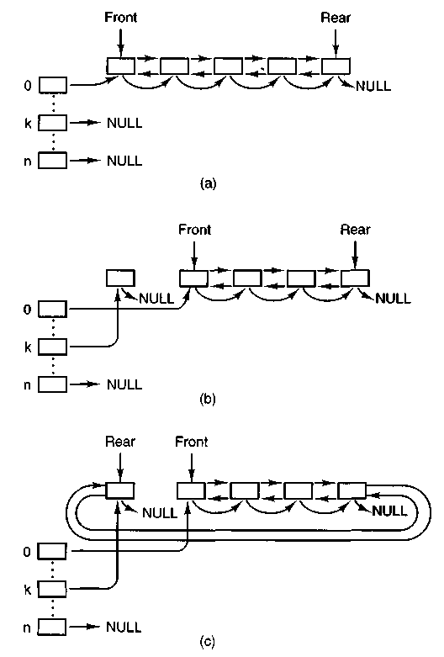
Figure 5-38. Block cache initialization, (a) Before any buffers have been used. (b) After one block has been requested, (c) After the block has been released.
The next function is get_boot-parameters (line 22706). It sends a message to the system task to ask it for a copy of the boot parameters. They are needed by the following function, load_ram (line 22722), which allocates space for a RAM disk. If the boot parameters specify
rootdev = ram
the root device file system is copied from the device named by ramimagedev to the RAM disk block by block, starting with the bootblock, with no interpretation of the various file system data structures. If the ramsize boot parameter is smaller than the size of the root device file system, the RAM disk is made large enough to
hold it. If ramsize specifies a size larger than the boot device file system the specified size is allocated and the RAM disk file system is adjusted to use the full size specified (lines 22819 to 22825). The call to put-block on line 22825 is the only time that the file system ever writes a super-block.
Load_ram allocates space for an empty RAM disk if a nonzero ramsize is specified. In this case, since no file system structures are copied, the RAM device cannot be used as a file system until it has been initialized by the mkfs command. Alternatively, such a RAM disk can be used for a secondary cache if support for this is compiled into the file system.
The last function in main.c is load-super (line 22832). It initializes the super-block table and reads in the super-block of the root device.
5.7.4 Operations on Individual Files
In this section we will look at the system calls that operate on individual files one at a time (as opposed to, say, operations on directories). We will start with how files are created, opened, and closed. After that we will examine in some detail the mechanism by which files are read and written. After that we will look at how pipes and how operations on them differ from those on files.
Creating, Opening, and Closing Files
The file open.c contains the code for six system calls: GREAT, OPEN, MKNOD, MKDIR, CLOSE, and LSEEK. We will examine GREAT and OPEN together, and then look at each of the others.
In older versions of unix, the great and open calls had distinct purposes. Trying to open a file that did not exist was an error, and a new file had to be created with GREAT, which could also be used to truncate an existing file to zero length. The need for two distinct calls is no longer present in a POSIX system, however. Under POSIX, the open call now allows creating a new file or truncating an old file, so the GREAT call now represents a subset of the possible uses of the OPEN call and is really only necessary for compatibility with older programs. The procedures that handle GREAT and OPEN are do_creat (line 22937) and do_open (line 22951). (As in the memory manager, the convention is used in the file system that system call XXX is performed by procedure do^xxx). Opening or creating a file involves three steps:
1. Finding the i-node (allocating and initializing if the file is new).
2. Finding or creating the directory entry.
3. Setting up and returning a file descriptor for the file.
Both the GREAT and the OPEN calls do two things: they fetch the name of a file and then they call common-open which takes care of tasks common to both calls.
Common _open (line 22975) starts by making sure that free file descriptor and flip table slots are available. If the calling function specified creation of a new file (by calling with the O_CREAT bit set), new_node is called on line 22998. New_node returns a pointer to an existing-i-node if the directory entry already exists; otherwise it will create both a new directory entry and i-node. If the i-node cannot be created, new-node sets the global variable err_code. An error code does not always mean an error. If new_node finds an existing file, the error code returned will indicate that the file exists, but in this case that error is acceptable (line 23001). If the O-CREATbit is not set, a search is made for the i-node using an alternative method, the eat_path function in path.c, which we will discuss further on. At this point, the important thing to understand is that if an i-node is not found or successfully created, common-open will terminate with an error before line 23010 is reached. Otherwise, execution continues here with assignment of a file descriptor and claiming of a slot in thefilp table, Following this, if a new file has just been created, lines 23017 to 23094 are skipped.
If the file is not new, then the file system must test to see what kind of a file it is, what its mode is, and so on, to determine whether it can be opened. The call to forbidden on line 23018 first makes a general check of the rwx bits. If the file is a regular file and common_open was called with the O_TRUNC bit set, it is truncated to length zero and forbidden is called again (line 23024), this time to be sure the file may be written. If the permissions allow, wipe_inode and rw_inode are called to re-initialize the i-node and write it to the disk. Other file types (directories, special files, and named pipes) are subjected to appropriate tests. In the case of a device, a call is made on line 23053 (using the dmap structure) to the appropriate routine to open the device. In the case of a named pipe, a call is made to pipe_open (line 23060), and various tests relevant to pipes are made.
The code of common_open, as well as many other file system procedures, contains a large amount of code that checks for various errors and illegal combinations. While not glamorous, this code is essential to having an error-free, robust file system. If something is wrong, the file descriptor and flip slot previously allocated are deallocated and the i-node is released (lines 23098 to 23101). In this case the value returned by common _open will be a negative number, indicating an error. If there are no problems the file descriptor, a positive value, is returned.
This is a good place to discuss in more detail the operation of new_node (line 23111), which does the allocation of the i-node and the entering of the path name into the file system for great and OPEN calls. It is also used for the MKNOD and MKDIR calls, yet to be discussed. The statement on line 23128 parses the path name (i.e., looks it up component by component) as far as the final directory; the call to advance three lines later tries to see if the final component can be opened.
For example, on the call
fd = creat("/usr/ast/foobar", 0755);
last_dir tries to load the i-node for /usr/ast into the tables and return a pointer to
it. If the file does not exist, we will need this i-node shortly in order to addfoobar to the directory. All the other system calls that add or delete files also use last^dir to first open the final directory in the path.
If new_node discovers that the file-does not exist, it calls alloc_inode on line 23134 to allocate and load a new i-node, returning a pointer to it. If no free i-nodes are left, new_node fails and returns NIL^INODE.
If an i-node can be allocated, the operation continues at line 23144, filling in some of the fields, writing it back to the disk, and entering the file name in the final directory (on line 23149). Again we see that the file system must constantly check for errors, and upon encountering one, carefully release all the resources, such as i-nodes and blocks that it is holding. If we were prepared to just let MINIX panic when we ran out of, say, i-nodes, rather than undoing all the effects of the current call and returning an error code to the caller, the file system would be appreciably simpler.
As mentioned above, pipes require special treatment. If there is not at least one reader/writer pair for a pipe, pipe^open (line 23176) suspends the caller. Otherwise, it calls release, which looks through the process table for processes that are blocked on the pipe. If it is successful, the processes are revived.
The MKNOD call is handled by do_mknod (line 23205). This procedure is similar to do_creat, except that it just creates the i-node and makes a directory entry for it. In fact, most of the work is done by the call to new-node on line 23217. If the i-node already exists, an error code will be returned. This is the same error code that was an acceptable result from new^node when it was called by common ^open; in this case, however, the error code is passed back to the caller, which presumably will act accordingly. The case-by-case analysis we saw in common^open is not needed here.
The MKDIR call is handled by the function do_mkdir (line 23226). As with the other system calls we have discussed here, new-node plays an important part. Directories, unlike files, always have links and are never completely empty because every directory must contain two entries from the time of its creation: the "." and ".." entries that refer to the directory itself and to its parent directory. There is a limit to the number of links a file may have, LINK^MAX (defined in include/limits.h as 127 for the standard MINIX system). Since the reference to a parent directory in a child is a link to the parent, the first thing do^mkdir does is to see if it is possible to make another link in the parent directory (line 23240). Once this test has been passed, new_node is called. If new_node succeeds, then the directory entries for "." and ".." are made (lines 23261 and 23262). All of this is straightforward, but there could be failures (for instance, if the disk is full), and to avoid making a mess of things provision is made for undoing the initial stages of the process if it can not be completed.
Closing a file is easier than opening one. The work is done by do_close (line 23286). Pipes and special files need some attention, but for regular files, almost all that needs to be done is to decrement the flip counter and check to see if it is
zero, in which case the i-node is returned with put_inode. The final step is to remove any locks and to revive any process that may have been suspended waiting for a lock on the file to be released.
Note that returning an i-node means that-its counter in the inode table is decremented, so it can be removed from the table eventually. This operation has nothing to do with freeing the i-node (i.e., setting a bit in the bit map saying that it is available). The i-node is only freed when the file has been removed from all directories.
The final procedure in open.c is do_lseek (line 23367). When a seek is done, this procedure is called to set the file position to a new value. On line 23394 reading ahead is inhibited; an explicit attempt to seek to a position in a file is incompatible with sequential access.
Reading a File
Once a file has been opened, it can be read or written. Many functions are used during both reading and writing. These are found in the file read.c. We will discuss these first and then proceed to the following file, write.c, to look at code specifically used for writing. Reading and writing differ in a number of ways, but they have enough similarities that all that is required of do_read (line 23434) is to call the common procedure read-write with a flag set to READING. We will see in the next section that do_write is equally simple.
Read_write begins on line 23443. There is some special code on lines 23459 to 23462 that is used by the memory manager to have the file system load entire segments in user space for it. Normal calls are processed starting on line 23464. Some validity checks follow (e.g., reading from a file opened only for writing) and some variables are initialized. Reads from character special files do not go through the block cache, so they are filtered out on line 23498.
The tests on lines 23507 to 23518 apply only to writes and have to do with files that may get bigger than the device can hold, or writes that will create a hole in the file by writing beyond the end-of-file. As we discussed in the MLNIX overview, the presence of multiple blocks per zone causes problems that must be dealt with explicitly. Pipes are also special and are checked for.
The heart of the read mechanism, at least for ordinary files, is the loop starting on line 23530. This loop breaks the request up into chunks, each of which fits in a single disk block. A chunk begins at the current position and extends until one of the following conditions is met:
1. All the bytes have been read.
2. A block boundary is encountered.
3. The end-of-file is hit. These rules mean that a chunk never requires two disk blocks to satisfy it. Figure
5-39 shows three examples of how the chunk size is determined, for chunk sizes of 6, 2, and 1 bytes, respectively. The actual calculation is done on lines 23632 to 23641.
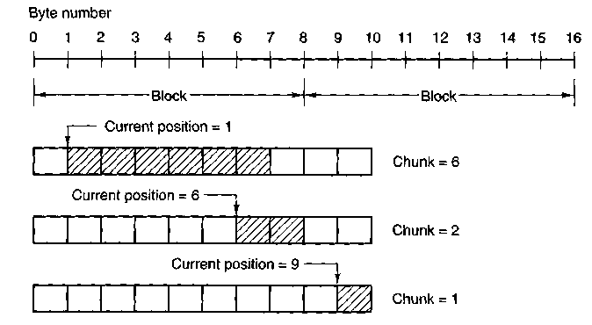
Figure 5-39. Three examples of how the first chunk size is determined for a 10-byte file. The block size is 8 bytes, and the number of bytes requested is 6. The chunk is shown shaded.
The actual reading of the chunk is done by rw_chunk. When control returns, various counters and pointers are incremented, and the next iteration begins. When the loop terminates, the file position and other variables may be updated (e.g., pipe pointers).
Finally, if read ahead is called for, the i-node to read from and the position to read from are stored in global variables, so that after the reply message is sent to the user, the file system can start working on getting the next block. In many cases the file system will block, waiting for the next disk block, during which time the user process will be able to work on the data it just received. This arrangement overlaps processing and I/O and can improve performance substantially.
The procedure nv_chunk (line 23613) is concerned with taking an i-node and a file position, converting them into a physical disk block number, and requesting the transfer of that block (or a portion of it) to the user space. The mapping of the relative file position to the physical disk address is done by read-map, which understands about i-nodes and indirect blocks. For an ordinary file, the variables b and dev on lines 23637 and 23638 contain the physical block number and device number, respectively. The call to get_block on line 23660 is where the cache handler is asked to find the block, reading it in if need be.
Once we have a pointer to the block, the call to sys-.copy on line 23670 takes care of transferring the required portion of it to the user space. The block is then released by put_block, so that it can be evicted from the cache later, when the
time comes. (After being acquired by get-block, it will not be in the LRU queue and it will not be returned there while the counter in the block's header shows that it is in use, so it will be exempt from eviction; put-block decrements the counter and returns the block to the LRU queue when.the counter reaches zero.) The code on line 23680 indicates whether a write operation filled the block. However, the value passed to put-block in n does not affect how the block is placed on the queue; all blocks are now placed on the rear of the LRU chain.
Read^map (line 23689) converts a logical file position to the physical block number by inspecting the i-node. For blocks close enough to the beginning of the file that they fall within one of the first seven zones (the ones right in the i-node), a simple calculation is sufficient to determine which zone is needed, and then which block. For blocks further into the file, one or more indirect blocks may have to be read.
Rd-indir (line 23753) is called to read an indirect block. It is made a separate procedure because there are different formats the data may take on the disk, depending upon the version of the file system and the hardware on which the file system was written. The messy conversions are done here, if necessary, so the rest of the file system sees data in only one form.
Read-ahead (line 23786) converts the logical position to a physical block number, calls get-block to make sure the block is in the cache (or bring it in), and then returns the block immediately. It cannot do anything with the block, after all. It just wants to improve the chance that the block is around if it should be used soon.
Note that read-ahead is called only from the main loop in main. It is not called as part of the processing of the READ system call. It is important to realize that the call to read-ahead is performed after the reply is sent, so that the user will be able to continue running even if the file system has to wait for a disk block while reading ahead.
Read-ahead by itself is designed to ask for just one more block. It calls the last function in read.c, rahead, to actually get the job done. Rahead (line 23805) works according to the theory that if a little more is good, a lot more is better. Since disks and other storage devices often take a relatively long time to locate the first block requested but then can relatively quickly read in a number of adjacent blocks, it may be possible to get many more blocks read with little additional effort. A prefetch request is made to get-block, which prepares the block cache to receive a number of blocks at once. Then rw^scattered is called with a list of blocks. We have previously discussed this; recall that when the device drivers are actually called by rw-scattered, each one is free to answer only as much of the request as it can efficiently handle. This all sounds fairly complicated, but the complications make possible a significant speedup of applications which read large amounts of data from the disk.
Figure 5-40 shows the relations between some of the major procedures involved in reading a file, in particular, who calls whom.
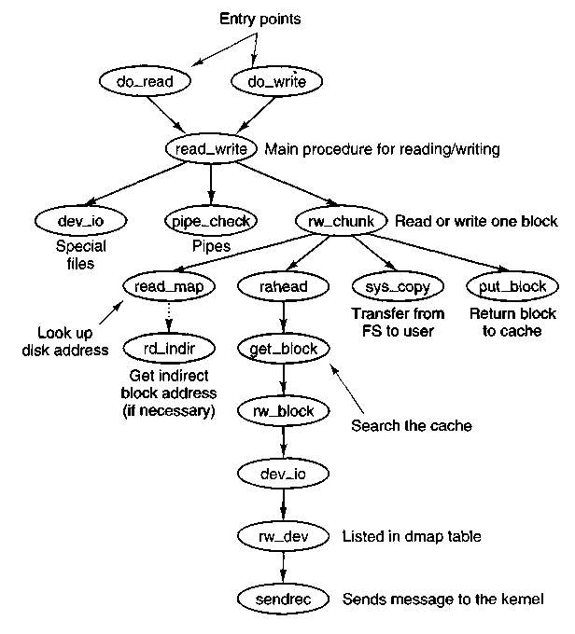
Figure 5-40. Some of the procedures involved in reading a file. Writing a File
The code for writing to files is in write.c. Writing a file is similar to reading one, and do^write (line 24025) just calls read-write with the WRITING flag. A major difference between reading and writing is that writing requires allocating new disk blocks. Write -map (line 24036) is analogous to read^map, only instead of looking up physical block numbers in the i-node and its indirect blocks, it enters new ones there (to be precise, it enters zone numbers, not block numbers).
The code of write_map is long and detailed because it must deal with several cases. If the zone to be inserted is close to the beginning of the file, it is just inserted into the i-node on (line 24058).
The worst case is when a file exceeds the size that can be handled by a single-indirect block, so a double-indirect block is now required. Next, a single-indirect block must be allocated and its address put into the double-indirect block. As with reading, a separate procedure, wr_indir, is called. If the double-indirect
block is acquired correctly, but the disk is full so the single-indirect block cannot be allocated, then the double one must be returned to avoid corrupting the bit map.
Again, if we could just toss in the sponge and panic at this point, the code would be much simpler. However, from the-user's point of view it is much nicer that running out of disk space just returns an error from write, rather than crashing the computer with a corrupted file system.
Wr_indir (line 24127) calls one of the conversion routines, conv2 or conv4 to do any necessary data conversion and puts a new zone number into an indirect block. Keep in mind that the name of this function, like the names of many other functions that involve reading and writing, is not literally true. The actual writing to the disk is handled by the functions that maintain the block cache.
The next procedure in write.c is clear^zone (line 24149), which takes care of the problem of erasing blocks that are suddenly in the middle of a file. This happens when a seek is done beyond the end of a file, followed by a write of some data. Fortunately, this situation does not occur very often.
New_block (line 24190) is called by rw_chunk whenever a new block is needed. Figure 5-41 shows six successive stages of the growth of a sequential file. The block size is IK and the zone size is 2K in this example.
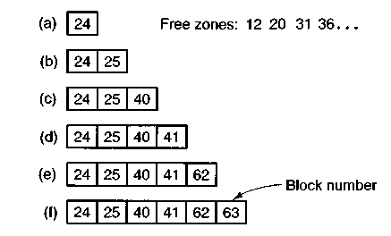
Figure 5-41. (a) - (f) The successive allocation of IK blocks with a 2K zone.
The first time new_block is called, it allocates zone 12 (blocks 24 and 25). The next time it uses block 25, which has already been allocated but is not yet in use. On the third call, zone 20 (blocks 40 and 41) is allocated, and so on. Zero_block (line 24243) clears a block, erasing its previous contents. This description is considerably longer than the actual code.
Pipes
Pipes are similar to ordinary files in many respects. In this section we will focus on the differences. The code we will discuss is all in pipe. c.
First of all, pipes are created differently, by the pipe call, rather than the GREAT call. The PIPE call is handled by do^pipe (line 24332). All do_pipe really
does is allocate an i-node for the pipe and return two file descriptors for it. Pipes are owned by the system, not by the user, and are located on the designated pipe device (configured in include/minix/config.h), which could very well be a RAM disk, since pipe data do not have to be preserved permanently.
Reading and writing a pipe is slightly different from reading and writing a file, because a pipe has a finite capacity. An attempt to write to a pipe that is already full will cause the writer to be suspended. Similarly, reading from an empty pipe will suspend the reader. In effect, a pipe has two pointers, the current position (used by readers) and the size (used by writers), to determine where data come from or go to.
The various checks to see if an operation on a pipe is possible are carried out by pipe-check (line 24385). In addition to the above tests, which may lead to the caller being suspended, pipe^check calls release to see if a process previously suspended due to no data or too much data can now be revived. These revivals are done on line 24413 and line 24452, for sleeping writers and readers, respectively. Writing on a broken pipe (no readers) is also detected here.
The act of suspending a process is done by suspend (line 24463). All it does is save the parameters of the call in the process table and set the flag dont_reply to TRUE, to inhibit the file system's reply message.
The procedure release (line 24490) is called to check if a process that was suspended on a pipe can now be allowed to continue. If it finds one, it calls revive to set a flag so that the main loop will notice it later. This function is not a system call, but is listed in Fig. 5-27(c) because it uses the message passing mechanism.
The last procedure in pipe.c is do_unpause (line 24560). When the memory manager is trying to signal a process, it must find out if that process is hanging on a pipe or special file (in which case it must be awakened with an EINTR error). Since the memory manager knows nothing about pipes or special files, it sends a message to the file system to ask. That message is processed by do_unpause. which revives the process, if it is blocked. Like revive, do^unpause has some similarity to a system call, although it is not one.
5.7.5 Directories and Paths
We have now finished looking at how files are read and written. Our next task is to see how path names and directories are handled.
Converting a Path to an I-node
Many system calls (e.g., OPEN, UNLINK, and MOUNT) have path names (i.e., file names) as a parameter. Most of these calls must fetch the i-node for the named file before they can start working on the call itself. How a path name is
converted to an i-node is a subject we will now look at in detail. We already saw the general outline in Fig. 5-14.
The parsing of path names is done in the file path.c. The first procedure, eat_path (line 24727), accepts a pointer to a path name, parses it, arranges for its i-node to be loaded into memory, and returns a pointer to the i-node. It does its work by calling last_dir to get the i-node to the final directory and then calling advance to get the final component of the path. If the search fails, for example, because one of the directories along the path does not exist, or exists but is protected against being searched, NIL_INODE is returned instead of a pointer to the i-node.
Path names may be absolute or relative and may have arbitrarily many components, separated by slashes. These issues are dealt with by last_dir (line 24754). It begins (line 24771) by examining the first character of the path name to see if it is an absolute path or a relative one. For absolute paths, rip is set to point to the root i-node; for relative ones, it is set to point to the i-node for the current working directory.
At this point, last_dir has the path name and a pointer to the i-node of the directory to look up the first component in. It enters a loop on line 24782 now, parsing the path name, component by component. When it gets to the end, it returns a pointer to the final directory.
Get_name (line 24813) is a utility procedure that extracts components from strings. More interesting is advance (line 24855), which takes as parameters a directory pointer and a string, and looks up the string in the directory. If it finds the string, advance returns a pointer to its i-node. The details of transferring across mounted file systems are handled here.
Although advance controls the string lookup, the actual comparison of the string against the directory entries is done in search _dir (line 24936), which is the only place in the file system where directory files are actually examined. It contains two nested loops, one to loop over the blocks in a directory, and one to loop over the entries in a block. Search_dir is also used to enter and delete names from directories. Figure 5-42 shows the relationships between some of the major procedures used in looking up path names.
Mounting File Systems
Two system calls that affect the file system as a whole are MOUNT and UMOUNT. They allow independent file systems on different minor devices to be "glued" together to form a single, seamless naming tree. Mounting, as we saw in Fig. 5-32, is effectively achieved by reading in the root i-node and super-block of the file system to be mounted and setting two pointers in its super-block. One of them points to the i-node mounted on, and the other points to the root i-node of the mounted file system. These pointers hook the file systems together.
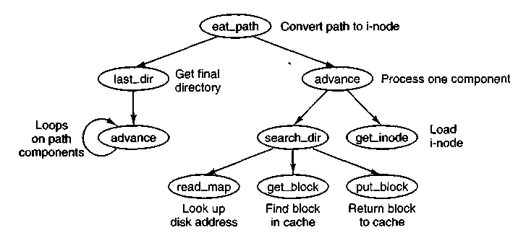
Figure 5-42. Some of the procedures used in looking up path names.
The setting of these pointers is done in the file mount.c by do^mount on lines 25231 and 25232. The two pages of code that precede setting the pointers are almost entirely concerned with checking for all the errors that can occur while mounting a file system, among them:
1. The special file given is not a block device.
2. The special file is a block device but is already mounted.
3. The file system to be mounted has a rotten magic number.
4. The file system to be mounted is invalid (e.g., no i-nodes).
5. The file to be mounted on does not exist or is a special file.
6. There is no room for the mounted file system's bit maps.
7. There is no room for the mounted file system's super-block.
8. There is no room for the mounted file system's root i-node.
Perhaps it seems inappropriate to keep harping on this point, but the reality of any practical operating system is that a substantial fraction of the code is devoted to doing minor chores that are not intellectually very exciting but are crucial to making a system usable. If a user attempts to mount the wrong floppy disk by accident, say, once a month, and this leads to a crash and a corrupted file system, the user will perceive the system as being unreliable and blame the designer, not himself.
Thomas Edison once made a remark that is relevant here. He said that "genius" is 1 percent inspiration and 99 percent perspiration. The difference between a good system and a mediocre one is not the brilliance of the former's scheduling algorithm, but its attention to getting all the details right.
Unmounting a file system is easier than mounting one—there are fewer things that can go wrong. Do-umount (line 25241) handles this. The only real issue is making sure that no process has any open files or working directories on the file system to be removed. This check is straightforward: just scan the whole i-node table to see if any i-nodes in memory belong to the file system to be removed (other than the root i-node). If so, the umount call fails.
The last procedure in mount.c is name^to_dev (line 25299), which takes a special file pathname, gets its i-node, and extracts its major and minor device numbers. These are stored in the i-node itself, in the place where the first zone would normally go. This slot is available because special files do not have zones.
Linking and Unlinking Files
The next file to consider is link.c, which deals with linking and unlinking files. The procedure do_link (line 25434) is very much like do_mount in that nearly all of the code is concerned with error checking. Some of the possible errors that can occur in the call
link(file_name, link_name); are listed below:
1. File_name does not exist or cannot be accessed.
2. File_name already has the maximum number of links.
3. File_name is a directory (only super-user can link to it).
4. Link_name already exists.
5. File_name and link_name are on different devices.
If no errors are present, a new directory entry is made with the string link_name and the i-node number of file_name. In the code, namel corresponds to file_name and name! corresponds to link_name. The actual entry is made by search_dir, called from do_link on line 25485.
Files and directories are removed by unlinking them. The work of both the UNLINK and RMDIR system calls is done by do_unlink (line 25504). Again, a variety of checks must be made; testing that a file exists and that a directory is not a mount point are done by the common code in do_unlink, and then either remove _dir or unlink-file is called, depending upon the system call being supported. We will discuss these shortly.
The other system call supported in linLc is RENAME. UNIX users are familiar with the mv shell command which ultimately uses this call; its name reflects another aspect of the call. Not only can it change the name of a file within a directory, it can also effectively move the file from one directory to another, and it
can do this atomically, which prevents certain race conditions. The work is done by do_rename (line 25563). There are many conditions that must be tested before this command can be completed, among which are:
1. The original file must exist (line 25578).
2. The old pathname must not be a directory above the new pathname in the directory tree (lines 25596 to 25613).
3. Neither . nor .. is acceptable as an old or new name (lines 25618 and 25619).
4. Both parent directories must be on the same device (line 25622).
5. Both parent directories must be writable, searchable, and on a writable device (lines 25625 and 25626).
6. Neither the old nor the new name may be a directory with a file system mounted upon it.
There are some other conditions that must be checked if the new name already exists, most importantly it must be possible to remove the existing file with the new name.
In the code for do_rename there are a few examples of design decisions that were taken to minimize the possibility of certain problems. Renaming a file to a name that already exists could fail on a full disk, even though in the end no additional space is used, if the old file were not removed first, and this is what is done at lines 25660 to 25666. The same logic is used at line 25680, removing the old file name before creating a new name in the same directory, to avoid the possibility that the directory might need to acquire an additional block. However, if the new file and the old file are to be in different directories, that concern is not relevant, and at line 25685 a new file name is created (in a different directory) before the old one is removed, because from a system integrity standpoint a crash that left two filenames pointing to an i-node would be much less serious than a crash that left an i-node not pointed to by any directory entry. The probability of running out of space during a rename operation is low, and that of a system crash even lower, but in these cases it costs nothing more to be prepared for the worst case.
The remaining functions in link.c support the ones that we have already discussed. In addition, the first of them, truncate (line 25717), is called from several other places in the file system. It steps through an i-node one zone at a time, freeing all the zones it finds, as well as the indirect blocks. Remove ^dir (line 25777) carries out a number of additional tests to be sure the directory can be removed, and then it in turn calls unlink_file (line 25818). If no errors are found, the directory entry is cleared and the link count in the i-node is reduced by one.
5.7.6 Other System Calls
The last group of system calls is a mixed bag of things involving status, directories, protection, time, and other services. -
Changing Directories and File Status
The file stadir.c contains the code for four system calls: CHDIR, CHROOT, STAT, and FSTAT. In studying last_dir we saw how path searches start out by looking at the first character of the path, to see if it is a slash or not. Depending on the result, a pointer is then set to the working directory or the root directory.
Changing from one working directory (or root directory) to another is just a matter of changing these two pointers within the caller's process table. These changes are made by do_chdir (line 25924) and do_chroot (line 25963). Both of them do the necessary checking and then call change (line 25978) to open the new directory and replace the old one.
In do^chdir the code on lines 25935 to 25951 is not executed on chdir calls made by user processes. It is specifically for calls made by the memory manager, to change to a user's directory for the purpose of handling EXEC calls. When a user tries to execute a file, say, a.out in his working directory, it is easier for the memory manager to change to that directory than to try to figure out where it is.
The remaining two system calls handled in this file, STAT and FSTAT, are basically the same, except for how the file is specified. The former gives a path name, whereas the latter provides the file descriptor of an open file. The top-level procedures, do_stat (line 26014) and do_fstat (line 26035), both call stat_inode to do the work. Before calling stat_inode, do_stat opens the file to get its i-node. In this way, both do_stat and do_fstat pass an i-node pointer to stat_inode.
All stat_inode (line 26051) does is to extract information from the i-node and copy it into a buffer. The buffer must be explicitly copied to user space by calling sys_copy on line 26088 because it is too large to fit in a message.
Protection
The minix protection mechanism uses the rwx bits. Three sets of bits are present for each file: for the owner, for his group, and for others. The bits are set by the CHMOD system call, which is carried out by do_chmod, in file protect.c (line 26124). After making a series of validity checks, the mode is changed on line 26150.
The CHOWN system call is similar to CHMOD in that both of them change an internal i-node field in some file. The implementation is also similar although do_chown (line 26163) can be used to change the owner only by the super-user. Ordinary users can use this call to change the group of their own files.
The UMASK system call allows the user to set a mask (stored in the process table), which then masks out bits in subsequent GREAT system calls. The complete implementation would be only one statement, line 26209, except that the call must return the old mask value as its result. This additional burden triples the number of lines of code required (lines 26208 to 26210).
The ACCESS system call makes it possible for a process to find out if it can access a file in a specified way (e.g., for reading). It is implemented by do_access (line 26217), which fetches the file's i-node and calls the internal procedure, forbidden (line 26242), to see if the access is forbidden. Forbidden checks the uid and gid, as well as the information in the i-node. Depending on what it finds, it selects one of the three rwx groups and checks to see if the access is permitted or forbidden.
Read-only (line 26304) is a little internal procedure that tells whether the file system on which its i-node parameter is located is mounted read only or read-write. It is needed to prevent writes on file systems mounted read only.
Time
minix has several system calls that involve time: utime, time, STIME, and TIMES. They are summarized in Fig. 5-43. Although most of them do not have anything to do with files, it makes sense to include them in the file system because time information is recorded in a file's i-node.
Call | Function
UTIME | Set a file's time of last modification
TIME | Set the current real time in seconds
STIME | Set the real time clock
TIMES | Get the process accounting times
Figure 5-43. The four system calls involving time.
Associated with each file are three 32-bit numbers. Two of these record the times when the file was last accessed and last modified. The third records when the status of the i-node itself was last changed. This time will change for almost every access to a file except a READ or EXEC. These times are kept in the i-node. With the UTIME system call, the access and modification times can be set by the owner of the file or the super-user. The procedure downtime (line 26422) in file time.c performs the system call by fetching the i-node and storing the time in it. At line 26450 the flags that indicate a time update is required are reset, so the system will not make an expensive and redundant call to clock-time.
The real time is not maintained by the file system. It is maintained by the clock task within the kernel. Consequently, the only way to get or set the real
time is to send a message to the clock task. This is, in fact, what do_time and do^stime both do. The real time is in seconds, since Jan 1, 1970.
The accounting information is also maintained by the kernel. At each clock tick it charges one tick to some process. This information can be retrieved by sending a message to the system task, which is what do_tims (line 26492) does. The procedure is not named do-times because most C compilers add an underscore to the front of all external symbols, and most linkers truncate symbols to eight characters, which would make do^time indistinguishable from do_times.
Leftovers
The file misc.c contains procedures for a few system calls that do not fit in anywhere else. The DUP system call duplicates a file descriptor. In other words, it creates a new file descriptor that points to the same file as its argument. The call has a variant DUP2. Both versions of the call are handled by do_dup (line 26632). This function is included in MINix to support old binary programs. Both of these calls are obsolete. The current version of the MINIX C library will invoke the FCNTL system call when either of these are encountered in a C source file.
Operation | Meaning
F_DUPFD | Duplicate a file descriptor
F_GETFD | Get the close-on-exec flag
F.SETFD | Set the close-on-exec flag
F^GETFL | Get file status flags
F_SETFL | Set file status flags
F_GETLK | Get lock status of a file
F SETLK | Set read/write lock on a file
F_SETLKW | Set write lock on a file
Figure 5-44. The POSIX request parameters for the FCNTL system call.
FCNTL, handled by do_fcntl (line 26670) is the preferred way to request operations on an open file. Services are requested using POSIX-defined flags described in Fig. 5-44. The call is invoked with a file descriptor, a request code, and additional arguments as necessary for the particular request. For instance, the equivalent of the old call
dup2(fd, fd2);
would be
fcntl(fd, F^DUPFD, fd2);
Several of these requests set or read a flag; the code consists of just a few lines.
For instance, the F_SETFD request sets a bit that forces closing of a file when its owner process does an EXEC. The F_GETFD request is used to determine whether a file must be closed when an EXEC call is made. The F_SETFL and F_GETFL requests permit setting flags to indicate a particular file is available in nonblocking mode or for append operations.
Do-fcntl handles file locking, also. A call with the F_GETLK, F^SETLK, or F_SETLKW command specified is translated into a call to lock^op, discussed in an earlier section.
The next system call is SYNC, which copies all blocks and i-nodes that have been modified since being loaded back to the disk. The call is processed by do-sync (line 26730). It simply searches through all the tables looking for dirty entries. The i-nodes must be processed first, since rw_inode leaves its results in the block cache. After all dirty i-nodes are written to the block cache, then all dirty blocks are written to the disk.
The system calls FORK, EXEC, EXIT, and SET are really memory manager calls, but the results have to be posted here as well. When a process forks, it is essential that the kernel, memory manager, and file system all know about it. These "system calls" do not come from user processes, but from the memory manager. Do-fork, do^exit, and do_set record the relevant information in the file system's part of the process table. Do_exec searches for and closes (using do_close) any files marked to be closed-on-exec.
The last function in this file is not really a system call but is handled like one. This is do ^revive (line 26921). It is called when a task that was previously unable to complete work that the file system had requested, such as providing input data for a user process, has now completed the work. The file system then revives the process and sends it the reply message.
5.7.7 The I/O Device Interface
I/O in minix is done by sending messages to the tasks within the kernel. The file system's interface with these tasks is contained in the file device.c. When actual device I/O is needed, dev_io (line 27033) is called from read^write to handle character special files, and from rw_block for block special files. It builds a standard message (see Fig. 3-15) and sends it to the specified task. Tasks are called by the line
(*dmap[major].dmap_rw)(task, &dev^mess);
(line 27056). This calls functions via pointers in the dmap array defined in table.c. The functions that take care of this are all here in device.c. While dev_io is waiting for a reply from the task, the file system waits. It has no internal multiprogramming. Usually, these waits are quite short though (e.g., 50 msec).
Special files may need special processing when they are opened or closed. Exactly what must be done depends upon the type of device. The dmap table is
also used to determine which functions are called for opening and closing each type of major device. The procedure dev_opcl (line 27071) is called for disk devices, whether floppy disks, hard disks, or memory-based devices. The line
mess_ptr->PROC_NR = fp - fproc;
(line 27081) calculates the process number of the caller. The actual work is done by passing the task number and a pointer to the message to call-task, to be discussed below. Dev^opcl is also used to close the same devices. In fact, the only difference in the open and close functions at the level of this function is in what happens after the return from call-task.
Other functions called via the dmap struct include tty_open and tty_close, which service the serial lines, and ctty_open and ctty_close which service the console. The last of these, ctty_close, is almost a dummy routine, as all it does is to return status OK unconditionally.
The SETSID system call requires some work by the file system, and this is performed by do_setsid (line 27164). One system call, IOCTL, is handled primarily in device, c. This call has been put here because it is closely tied to the task interface. When an IOCTL is done, do_ioctl is called to build a message and send it to the proper task.
To control terminal devices one of the functions declared in include/termios.h should be used in programs written to be POSIX compliant. The C library will translate such functions into IOCTL calls. For devices other than terminals IOCTL is used for many operations, many of which were described in Chap. 3.
The next function is the only PRIVATE function in this file. This isfind_dev (line 27228), a little helper procedure that extracts the major and minor device numbers from a full device number.
The actual reading and writing of most devices goes through call-task (line 27245), which directs a message to the appropriate task in the kernel image, by calling sendrec. The attempt may fail if the task is trying to revive a process in response to an earlier request. It will likely be a different process from the one on behalf of which the current request is being made. Call_task will display a message on the console if an inappropriate message is received. These messages hopefully will not be seen during normal operation of MINIX but could appear during attempts to develop a new device driver.
The device /dev/tty does not physically exist. It is a fiction to which any user on a multiuser system can refer, without a need to determine which of all possible real terminals is in use. When a message that refers to /dev/tty must be sent, the next function, call_ctty (line 27311), finds the correct major and minor device and substitutes them into the message before passing the message on via call_task.
Finally, the last function in the file is no_dev (line 27337), which is called from slots in the table for which a device does not exist, for example when a network device is referenced on a machine with no network support. It returns an ENODEV status. It prevents crashes when nonexistent devices are accessed.
5.7.8 General Utilities
The file system contains a few general purpose utility procedures that are used in various places. They are collected together in the file utility.c.
The first procedure is clock_time (line 27428). It sends messages to the clock task to find out what the current real time is. The next procedure, fetch_name (line 27447), is needed because many system calls have a file name as parameter. If the file name is short, it is included in the message from the user to the file system. If it is long, a pointer to the name in user space is put in the message. Fetch-name checks for both cases, and either way, gets the name.
Two functions here handle general classes of errors. No_sys is the error handler that is called when the file system receives a system call that is not one of its calls. Panic prints a message and tells the kernel to throw in the towel when something catastrophic happens.
The last two functions, conv2 and conv4, exist to help MINIX deal with the problem of different byte orders on Intel and Motorola processors. These routines are called when reading from or writing to a disk data structure, such as an i-node or bit map. The byte order in the system that created the disk is recorded in the super-block. If it is different from the order used by the local processor the order will be swapped. The rest of the file system does not need to know anything about the byte order on the disk.
The last file is putk.c. It contains two procedures, both of which have to do with printing messages. The standard library procedures cannot be used, because they send messages to the file system. These procedures send messages directly to the terminal task. We saw an almost identical pair of functions in the memory manager's version of this file.
5.8 SUMMARY
When seen from the outside, a file system is a collection of files and directories, plus operations on them. Files can be read and written, directories can be created and destroyed, and files can be moved from directory to directory. Most modern file systems support a hierarchical directory system, in which directories may have subdirectories ad infinitum.
When seen from the inside, a file system looks quite different. The file system designers have to be concerned with how storage is allocated, and how the system keeps track of which block goes with which file. We have also seen how different systems have different directory structures. File system reliability and performance are also important issues.
Security and protection are of vital concern to both the system users and designers. We discussed some security flaws in older systems, and generic problems that many systems have. We also looked at authentication, with and without
passwords, access control lists, and capabilities, as well as a matrix model for thinking about protection.
Finally, we studied the MINIX file system in detail. It is large but not very complicated. It accepts requests for work "from user processes, indexes into a table of procedure pointers, and calls that procedure to carry out the requested system call. Due to its modular structure and position outside the kernel, it can be removed from MINIX and used as a free-standing network file server with only minor modifications.
Internally, the MINIX buffers data in a block cache and attempts to read ahead when making sequential access to file. If the cache is made large enough, most program text will be found to be already in memory during operations that repeatedly access a particular set of programs, such as a compilation.
PROBLEMS
1. Give 5 different path names for the file /etc/passwd. (Hint: think about the directory entries "." and "..".)
2. Systems that support sequential files always have an operation to rewind files. Do systems that support random access files need this too?
3. Some operating systems provide a system call RENAME to give a file a new name. Is there any difference at all between using this call to rename a file, and just copying the file to a new file with the new name, followed by deleting the old one?
4. Consider the directory tree of Fig. 5-7. If/usr/jim is the working directory, what is the absolute path name for the file whose relative path name is ../ast/xl
5. Contiguous allocation of files leads to disk fragmentation, as mentioned in the text. Is this internal fragmentation or external fragmentation? Make an analogy with something discussed in the previous chapter.
6. An operating system only supports a single directory but allows that directory to have arbitrarily many files with arbitrarily long file names. Can something approximating a hierarchical file system be simulated? How?
7. Free disk space can be kept track of using a free list or a bit map. Disk addresses require D bits. For a disk with B blocks, F of which are free, state the condition under which the free list uses less space than the bit map. For D having the value 16 bits, express your answer as a percentage of the disk space that must be free.
8. It has been suggested that the first part of each UNIX file be kept in the same disk block as its i-node. What good would this do?
9. The performance of a file system depends upon the cache hit rate (fraction of blocks found in the cache). If it takes 1 msec to satisfy a request from the cache, but 40 msec to satisfy a request if a disk read is needed, give a formula for the mean time required to satisfv a reauest if the hit rate is h. Plot this function for values of h from 0 to 1.0.
10. A floppy disk has 40 cylinders. A seek takes 6 msec per cylinder moved. If no attempt is made to put the blocks of a file close to each other, two blocks that are logically consecutive (i.e., follow one another in the file) will be about 13 cylinders apart, on the average. If, however, the operating system makes an attempt to cluster related blocks, the mean interblock distance can be reduced to 2 cylinders (for example). How long does it take to read a 100 block file in both cases, if the rotational latency is 100 msec and the transfer time is 25 msec per block?
11. Would compacting disk storage periodically be of any conceivable value? Explain.
12. How could TENEX be modified to avoid the password problem described in the text?
13. After getting your degree, you apply for a job as director of a large university computer center that has just put its ancient operating system out to pasture and switched over to UNIX. You get the job. Fifteen minutes after starting work, your assistant bursts into your office screaming: "Some students have discovered the algorithm we use for encrypting passwords and posted it on the bulletin board." What should you do?
14. The Morris-Thompson protection scheme with the «-bit random numbers was designed to make it difficult for an intruder to discover a large number of passwords by encrypting common strings in advance. Does the scheme also offer protection against a student user who is trying to guess the super-user password on his machine?
15. A computer science department has a large collection of UNIX machines on its local network. Users on any machine can issue a command of the form
machine4 who
and have it executed on machine4, without having the user log in on the remote machine. This feature is implemented by having the user's kernel send the command and his uid to the remote machine. Is this scheme secure if the kernels are all trustworthy (e.g., large timeshared minicomputers with protection hardware)? What if some of the machines are students' personal computers, with no protection hardware?
16. When a file is removed, its blocks are generally put back on the free list, but they are not erased. Do you think it would be a good idea to have the operating system erase each block before releasing it? Consider both security and performance factors in your answer, and explain the effect of each.
17. Three different protection mechanisms that we have discussed are capabilities, access control lists, and the UNIX rwx bits. For each of the following protection problems, tell which of these mechanisms can be used.
(a) Ken wants his files readable by everyone except his office mate.
(b) Mitch and Steve want to share some secret files.
(c) Linda wants some of her files to be public.
For UNIX, assume that groups are categories such as faculty, students, secretaries, etc.
18. Consider the following protection mechanism. Each object and each process is assigned a number. A process can only access an object if the object has a higher number than the process. Which of the schemes discussed in the text does this resemble? In what essential way does it differ from the scheme in the text?
19. Can the Trojan horse attack work in a system protected by capabilities?
20. Two computer science students, Carolyn and Elinor, are having a discussion about i-nodes. Carolyn maintains that memories have gotten so large and so cheap that when a file is opened, it is simpler and faster just to Tetch a new copy of the i-node into the i-node table, rather than search the entire table to see if it is already there. Elinor disagrees. Who is right?
21. What is the difference between a virus and a worm? How do they each reproduce?
22. Symbolic links are files that point to other files or directories indirectly. Unlike ordinary links such as those currently implemented in MINIX, a symbolic link has its own i-node, which points to a data block. The data block contains the path to the file being linked to, and the i-node makes it possible for the link to have different ownership and permissions from the file linked to. A symbolic link and the file or directory to which it points can be located on different devices. Symbolic links are not part of the 1990 POSIX standard, but it is expected they will be added to posix in the future. Implement symbolic links for minix.
23. You find that the 64 MByte file size limit in minix is not enough for your needs. Extend the file system to use the unused space in the i-node for a triple-indirect block.
24. Show if setting ROBUST makes the file system more or less robust in the face of a crash. Whether this is the case in the current version of MINIX has not been researched, so it may be either way. Take a good look at what happens when a modified block is evicted from the cache. Take into account that a modified data block may be accompanied by a modified i-node and bit map.
25. The size of the flip table is currently defined as a constant, NR^FILPS, infs/const.h. In order to accomodate more users on a networked system you want to increase NR_PROCS in include/minix/config.h. How should NRJ'ILPS be defined as a function of NR-PROCS7
26. Design a mechanism to add support for a "foreign" file system, so that one could, for instance, mount an MS-DOS file system on a directory in the MINIX file system.
27. Suppose that a technological breakthrough occurs, and that nonvolatile RAM, that retains its contents reliably following a power failure, becomes available with no price or performance disadvantage over conventional RAM. What aspects of file system design would be affected by this development?
6
READING LIST AND BIBLIOGRAPHY
In the previous five chapters we have touched upon a variety of topics. This chapter is intended as an aid to readers interested in pursuing their study of operating systems further. Section 6.1 is a list of suggested readings. Section 6.2 is an alphabetical bibliography of all books and articles cited in this book.
In addition to the references given below, the Proceedings of the n-th ACM Symposium on Operating Systems Principles (ACM) held every other year and the Proceedings of the n-th International Conference on Distributed Computing Systems (IEEE) held every year are good places to look for recent papers on operating systems. So is the USENIX Symposium on Operating Systems Design and Implementation. Furthermore, ACM Transactions on Computer Systems and Operating Systems Review are two journals that often have relevant articles.
6.1 SUGGESTIONS FOR FURTHER READING 6.1.1 Introduction and General Works
Brooks, The Mythical Man-Month: Essays on Software Engineering
A witty, amusing, and informative book on how not to write an operating system by someone who learned the hard way. Full of good advice.
Comer, Operating System Design. The Xinu Approach
A book about the Xinu operating system, which runs on the LSI-11 computer. It contains a detailed exposition of the source code, including a complete listing in C.
Corbato, "On Building Systems That Will Fail"
In his Turing Award lecture, the father of timesharing addresses many of the same concerns that Brooks does in the Mythical Man-Month. His conclusion is that all complex systems will ultimately fail, and that to have any chance for success at all, it is absolutely essential to avoid complexity and strive for simplicity and elegance in design.
Deitel, Operating Systems, 2nd Ed.
A general textbook on operating systems. In addition to the standard material, it contains case studies of UNIX, MS-DOS, MVS, VM, OS/2, and the Macintosh operating system.
Finkel, An Operating Systems Vade Mecum
Another general text on operating systems. It is practically oriented and well written and covers many of the topics treated in this book, making it a good place to look for a different perspective on the same subject.
IEEE, Information Technology—Portable Operating System Interface (POSIX), Part 1: System Application Program Interface (API) [C Language]
This is the standard. Some parts are actually quite readable, especially Annex B, "Rationale and Notes," which often sheds light on why things are done as they are. One advantage of referring to the standard document is that, by definition, there are no errors. If a typographical error in a macro name makes it through the editing process it is no longer an error, it is official.
Lampson, "Hints for Computer System Design"
Butler Lampson, one of the world's leading designers of innovative operating systems, has collected many hints, suggestions, and guidelines from his years of experience and put them together in this entertaining and informative article. Like Brooks' book, this is required reading for every aspiring operating system designer.
Lewine, POSIX Programmer's Guide
This book describes the POSIX standard in a much more readable way than the standards document itself, and includes discussions on how to convert older programs to POSIX and how to develop new programs for the POSIX environment. There are numerous examples of code, including several complete programs. All POSlx-required library functions and header files are described.
Silberschatz and Galvin, Operating System Concepts, 4th Ed.
Another textbook on operating systems. It covers processes, storage management, files, and distributed systems. Two case studies are given: UNIX and Mach. The cover is full of dinosaurs. What, if anything, this has to do with operating systems in the 1990s is unclear.
Stallings, Operating Systems, 2nd Ed.
Still another textbook on operating systems. It covers all the usual topics, and also includes a small amount of material on distributed systems, plus an appendix on queueing theory.
Stevens, Advanced Programming in the UNIX Environment
This book tells how to write C programs that use the unix system call interface and the standard C library. Examples are based on the System V Release 4 and the 4.4BSD versions of UNIX. The relationship of these implementations to POSIX is described in detail.
Switzer, Operating Systems, A Practical Approach,
An approach similar to this text. Theoretical concepts are illustrated with pseudocode examples and a large part of the C source code for TUNix, a model operating system. Unlike minix, TUNix is not meant to run on a real machine, it runs on a virtual machine. It is not as realistic as MINIX in its treatment of device drivers, but it does go further than MINIX in other directions, such as implementation of virtual memory.
6.1.2 Processes
Andrews and Schneider, "Concepts and Notations for Concurrent Programming"
A tutorial and survey of processes and interprocess communication, including busy waiting, semaphores, monitors, message passing, and other techniques. The article also shows how these concepts are embedded in various programming languages.
Ben-Ari, Principles of Concurrent Programming
This little book is entirely devoted to the problems of interprocess communication. There are chapters on mutual exclusion, semaphores, monitors, and the dining philosophers problem, among others.
Dubois et al., "Synchronization, Coherence, and Event Ordering in Multiprocessors"
A tutorial on synchronization in shared-memory multiprocessor systems. However, some of the ideas are equally applicable to single processor and distributed memory systems as well.
Silberschatz and Galvin, Operating System Concepts, 4th Ed.
Chapters 4 through 6 cover processes and interprocess communication, including scheduling, critical sections, semaphores, monitors, and classical interprocess communication problems.
6.1.3 Input/Output
Chen et al., "RAID: High Performance Reliable Secondary Storage"
The use of multiple disk drives in parallel for fast I/O is a trend in high end systems. The authors discuss this idea and examine different organizations in terms of performance, cost, and reliability.
Coffman et al., "System Deadlocks"
A short introduction to deadlocks, what causes them, and how they can be prevented or detected.
Finkel, An Operating Systems Vade Mecum. 2nd Ed.
Chapter 5 discusses I/O hardware and device drivers, particularly for terminals and disks.
Geist and Daniel, "A Continuum of Disk Scheduling Algorithms"
A generalized disk arm scheduling algorithm is presented. Extensive simulation and experimental results are given.
Holt, "Some Deadlock Properties of Computer Systems"
A discussion of deadlocks. Holt introduces a directed graph model that can be used to analyze some deadlock situations.
IEEE Computer Magazine, March 1994
This issue of Computer contains eight articles on advanced I/O, and covers simulation, high performance storage, caching, I/O for parallel computers, and multimedia.
Isloor and Marsland, "The Deadlock Problem: An Overview"
A tutorial on deadlocks, with special emphasis on data base systems. A variety of models and algorithms are covered.
Stevens, "Heuristics for Disk Drive Positioning in 4.3BSD"
A detailed study of disk performance in Berkeley unix. As is often the case with computer systems, reality is more complicated than the theory predicts.
Wilkes et al., "The HP AutoRAID Hierarchical Storage System"
An important new development in high-performance disk systems is RAID
(Redundant Array of Inexpensive Disks), in which an array of small disks work together to produce a high-bandwidth system. In this paper, the authors describe in some detail the system they built at HP Labs.
6.1.4 Memory Management
Denning, "Virtual Memory"
A classic paper on many aspects of virtual memory. Denning was one of the pioneers in this field, and was the inventor of the working set concept.
Denning, "Working Sets Past and Present"
A good overview of numerous memory management and paging algorithms. A comprehensive bibliography is included.
Knuth, The Art of Computer Programming Vol. 1
First fit, best fit, and other memory management algorithms are discussed and compared in this book.
Silberschatz and Galvin, Operating System Concepts, 4th Ed.
Chapters 8 and 9 deal with memory management, including swapping, paging, and segmentation. A variety of paging algorithms are mentioned.
6.1.5 File Systems
Denning, "The United States vs. Craig Neidorf"
When a young hacker discovered and published information about how the telephone system works, he was indicted for computer fraud. This article describes the case, which involved many fundamental issues, including freedom of speech. The article is followed by some dissenting views and a rebuttal by Denning.
Hafner and Markoff, Cyberpunk
Three compelling tales of young hackers breaking into computers around the world are told here by the New York Times computer reporter who broke the Internet worm story and his journalist wife.
Harbron, File Systems
A book on file system design, applications, and performance. Both structure and algorithms are covered.
McKusick et al., "A Fast File System for UNIX"
The UNIX file system was completely reimplemented for 4.2 BSD. This paper describes the design of the new file system, with emphasis on its performance.
Silberschatz and Galvin Operating System Concepts, 4th Ed.
Chapters 10 and 11 are about file systems. They cover file operations, access methods, consistency semantics, directories, and protection, and implementation, among other topics.
Stallings, Operating Systems, 2nd Ed.
Chapter 14 contains a fair amount of material about the security environment especially about hackers, viruses and other threats.
6.2 ALPHABETICAL BIBLIOGRAPHY
ANDERSON, T.E., BERSHAD, B.N., LAZOWSKA, E.D., and LEVY, H.M.: "Scheduler Activations: Effective Kernel Support for the User-level Management of Parallelism," ACM Trans. on Computer Systems, vol. 10, pp. 53-79, Feb. 1992.
andrews, G.R., and SCHNEIDER, F.B.: "Concepts and Notations for Concurrent Programming," Computing Surveys, vol. 15, pp. 3-43, March 1983.
BACH, M.J.: The Design of the UNIX Operating System, Englewood Cliffs, NJ: Prentice Hall, 1987.
BALA, K., KAASHOEK, M.F., WEIHL, W.: "Software Prefetching and Caching for Translation Lookaside Buffers," Proc. First Symp. on Operating System Design and Implementation, USENIX, pp. 243-254, 1994.
BAYS, C.: "A Comparison of Next-Fit, First-Fit, and Best-Fit," Commun. of the ACM, vol. 20, pp. 191-192, March 1977.
BEN-ARI, M: Principles of Concurrent Programming, Englewood Cliffs, NJ: Prentice Hall International, 1982.
BRINCH HANSEN, P.: "The Programming Language Concurrent Pascal," IEEE Trans. on Software Engineering, vol. SE-1, pp. 199-207, June 1975.
BROOKS, F. P., Jr.: The Mythical Man-Month: Essays on Software Engineering, Anniversary editition, Reading, MA: Addison-Wesley, 1996.
CADOW, H.: OS/360 Job Control Language, Englewood Cliffs, NJ: Prentice Hall, 1970.
CHEN, P.M., LEE, E.K., GIBSON, G.A., KATZ, R.H., and PATTERSON, D.A.: "RAID: High Performance Reliable Storage," Computing Surveys, vol. 26, pp. 145-185, June 1994.
CHERITON, D.R.: "An Experiment Using Registers for Fast Message-Based Interprocess Communication," Operating Systems Review, vol. 18, pp. 12-20, Oct. 1984.
COFFMAN, E.G., ELPHICK, M.J., and SHOSHANI, A.: "System Deadlocks," Computing Surveys, vol. 3, pp. 67-78, June 1971.
COMER, D.: Operating System. Design. The Xinu Approach, Englewood Cliffs, N.J.: Prentice Hall, 1984.

